These days website is the complex business.
The below mentioned checklist is almost applicable for all types of web applications depending on the business requirements.
The web application testing checklist consists of-
- Usability Testing
- Functional Testing
- Compatibility Testing
- Database Testing
- Security Testing
- Performance Testing
Now let’s look each checklist in detail:

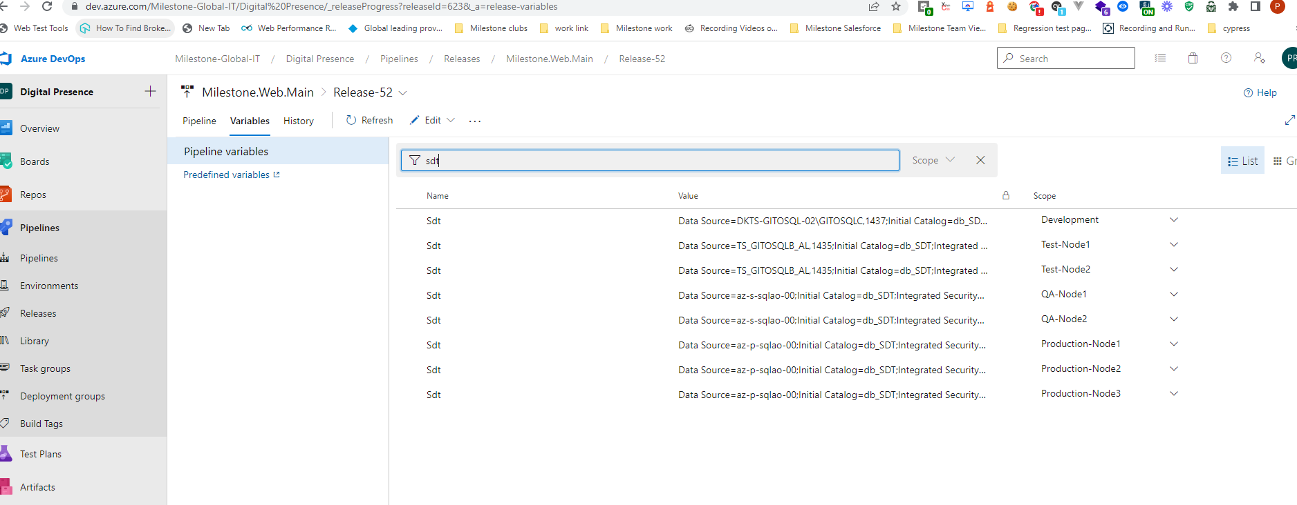

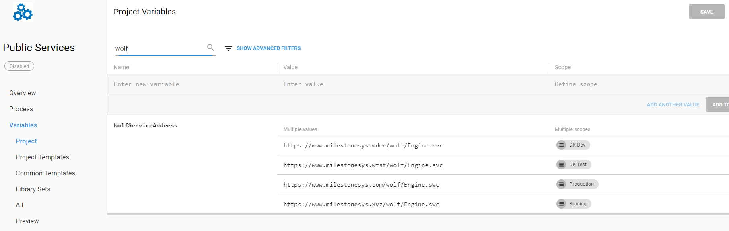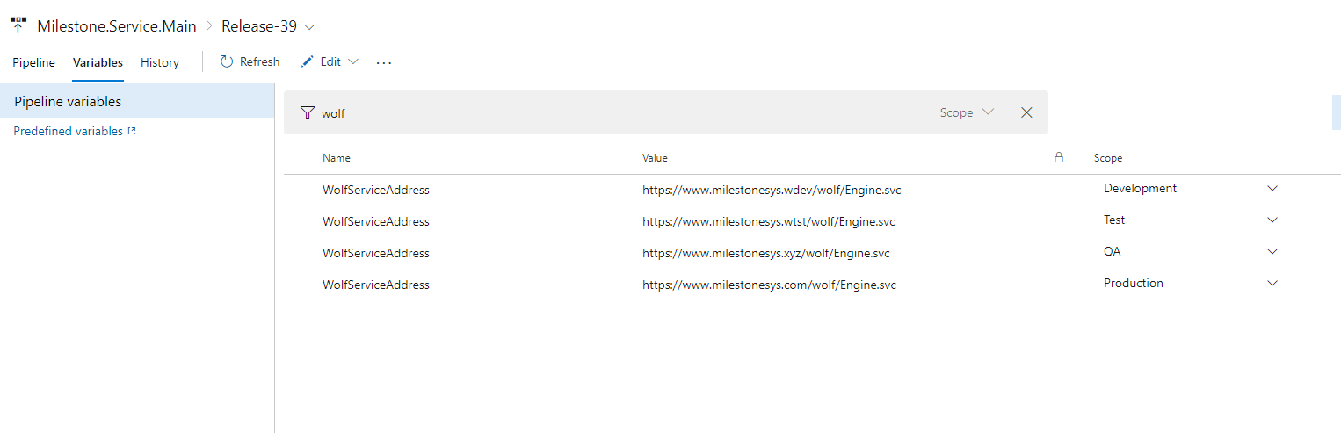

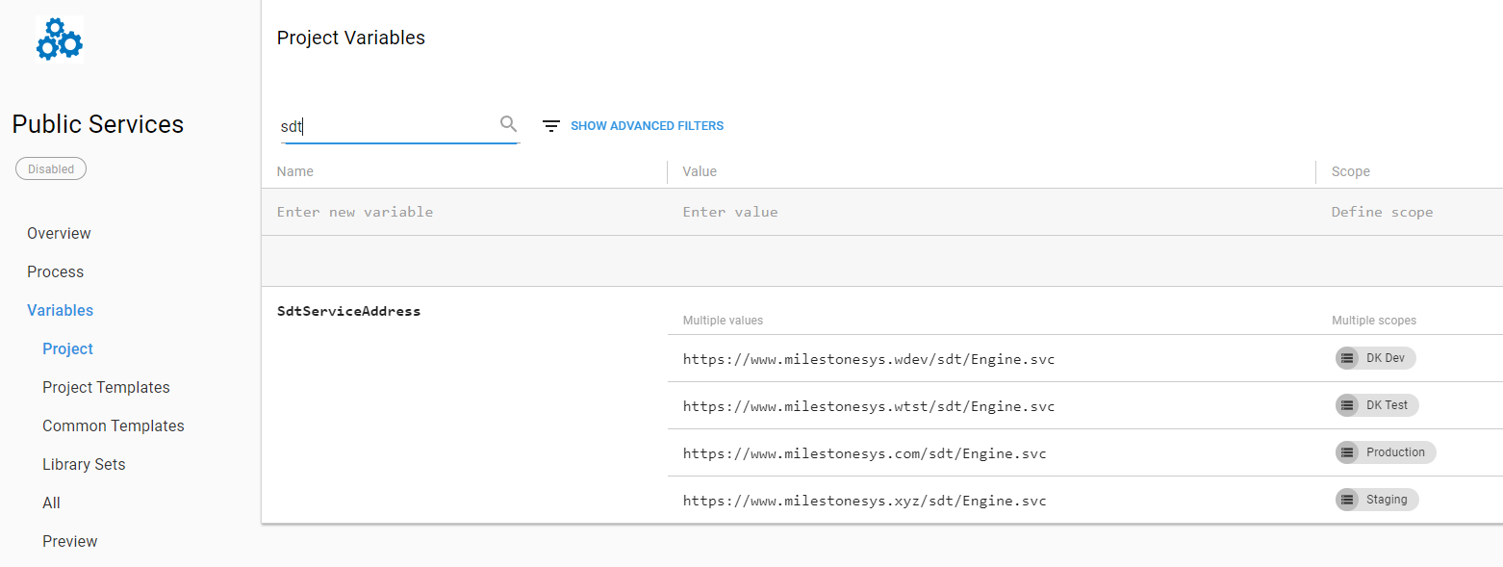

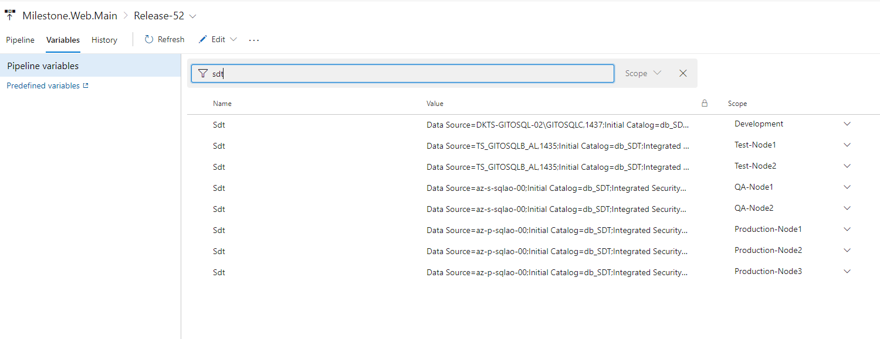

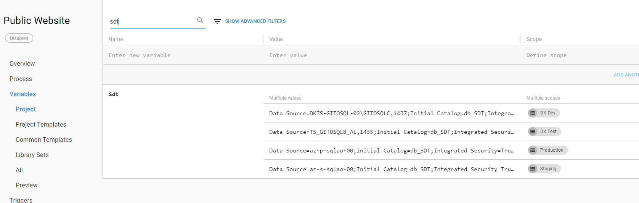

Usability Testing

What is Usability Testing?
- Is User-friendliness check.
- the application flow is tested so that a new user can easily understand use of the application..
What is the purpose or Goal of Usability testing?

The main goal of Usability testing is to establish the ease of use and effectiveness of a product by a new user.
Example Usability Test Cases
- grammatical errors: Web page content should be correct without any spelling.
- Font Consistency: All fonts should be same as per the requirements.
- Alignment: All the text should be properly aligned.
- Error message: All the error messages should be correct without any spelling or grammatical errors and the error message should match with the field label.
- Tool tip: text should be there for every field.
- Form Fields: All the fields should be properly aligned.
- Spacing: Enough space should be provided between field labels, columns, rows, and error messages.
- Button: All the buttons should be in a standard format and size.
- Home link: should be there on every single page.
- Disabled fields: should be grayed out.
- broken links and images check
- Confirmation message: should be displayed for any kind of update and delete operation.
- Different Resolution Check the site on different resolutions (640 x 480, 600×800 etc.?)
- Check the end user can run the system without frustration.
- Tab checking: tab should work properly.
- Scroll bar: should appear only if required.
- error message on submits, the information filled by the user should be there.
- Title: should display on each web page
- All fields (Textbox, dropdown, radio button, etc.) and buttons should be accessible by keyboard shortcuts and the user should be able to perform all operations by using keyboard.
- dropdown data is not truncated due to the field size. Also, check whether the data is hardcoded or managed via administrator.

Functional Testing:
What is Functional Testing?
- features and operational behavior of a product to ensure they correspond to its specifications.
- focuses solely on the outputs generated in response to selected inputs and execution conditions.
What is the purpose or Goal of Functional testing?
- The goal of Functional Testing is to verify whether your product meets the intended functional requirement specified by the stakeholders mentioned on their business documentation.
Example Functional Test Scenarios:
- mandatory fields: Test all the mandatory fields should be validated.
- asterisk sign: Test the asterisk sign should display for all the mandatory fields.
- optional fields: Test the system should not display the error message for.
- Leap year: Test that leap years are validated correctly & do not cause errors/miscalculations.
- Numeric Field: Test the numeric fields should not accept the alphabets and proper error message should display.
- Negative number: Test for negative numbers if allowed for numeric fields.
- Test division by zero: should be handled properly for calculations.
- Test the max length of every field: to ensure the data is not truncated.
- Test the pop up: message (“This field is limited to 500 characters”) should display if the data reaches the maximum size of the field.
- confirmation message: should display for update and delete operations.
- Amount values: should display in currency format.
- special characters: Test all input fields with special characters.
- Timeout: Test the timeout functionality.
- Sorting: Test the Sorting functionality.
- Button Functionality: Test the functionality of the buttons available
- Privacy Policy & FAQ : Test the Privacy Policy & FAQ is clearly defined and should be available for users.
- Custom error page: Test if any functionality fails the user gets redirected to the custom error page.
- uploaded documents: Test all the uploaded documents are opened properly.
- Download functionality: Test the user should be able to download the uploaded files.
- Email Functionality: Test the email functionality of the system.
- Java scripts: Test the Java script is properly working in different browsers (IE, Firefox, Chrome, safari and Opera).
- Delete Cookies: Test to see what happens if a user deletes cookies while in the site and after visiting a site.
- chronological order : Test all the data inside combo/list box is arranged in chronological order.

Compatibility Testing:
What is Compatibility testing?
- Compatibility testing is used to determine if your software is compatible with other elements of a system with which it should operate, e.g. Browsers, Operating Systems, or hardware.The purpose of Compatibility testing is to evaluate how well software performs in a particular browser, Operating Systems, hardware or software.
Sample Compatibility Test Scenarios:
- Different Browsers: Test the website in different browsers (IE, Firefox, Chrome, Safari and Opera) and ensure the website is displaying properly.
- Test the HTML version being used is compatible with appropriate browser versions.
- Image Display: Test the images display correctly in different browsers.
- Fonts: Test the fonts are usable in different browsers.
- Java script : Test the java script code is usable in different browsers.
- Animated GIF: Test the Animated GIF’s across different browsers.
- Video:
- Slider:
- Forms:

Database Testing:
What is Database Testing?
- The data which is displaying in the web application should match with the data stored in the Database.
To perform the Database testing, the tester should be aware of the below mentioned points:
- The tester should understand the functional requirements, business logic, application flow and database design thoroughly.
- The tester should figure out the tables, triggers, store procedures, views and cursors used for the application.
- The tester should understand the logic of the triggers, store procedures, views and cursors created.
- The tester should figure out the tables which get affected when insert update and delete (DML) operations are performed through the web or desktop applications.
With the help of the above mentioned points, the tester can easily write the test scenarios for Database testing.
Example Test Cases for Database Testing:
- Verify the database name: The database name should match with the specifications.
- Verify the Tables, columns, column types and defaults: All things should match with the specifications.
- Verify whether the column allows a null or not.
- Verify the Primary and foreign key of each table.
- Verify the Stored Procedure:
- Test whether the Stored procedure is installed or not.
- Verify the Stored procedure name
- Verify the parameter names, types and number of parameters.
- Test the parameters if they are required or not.
- Test the stored procedure by deleting some parameters
- Test when the output is zero, the zero records should be affected.
- Test the stored procedure by writing simple SQL queries.
- Test whether the stored procedure returns the values
- Test the stored procedure with sample input data.
- Verify the behavior of each flag in the table.
- Verify the data gets properly saved into the database after each page submission.
- Verify the data if the DML (Update, delete and insert) operations are performed.
- Check the length of every field: The field length in the back end and front end must be same.
- Verify the database names of QA, UAT and production. The names should be unique.
- Verify the encrypted data in the database.
- Verify the database size. Also test the response time of each query executed.
- Verify the data displayed on the front end and make sure it is same in the back end.
- Verify the data validity by inserting the invalid data in the database.
- Verify the Triggers.

What is Security Testing?
Security Testing involves the test to identify any flaws and gaps from a security point of view.
Sample Test Scenarios for Security Testing:
- Verify the web page which contains important data like password, credit card numbers, secret answers for security question etc should be submitted via HTTPS (SSL).
- Verify the important information like password, credit card numbers etc should display in encrypted format.
- Verify password rules are implemented on all authentication pages like Registration, forgot password, change password.
- Verify if the password is changed the user should not be able to login with the old password.
- Verify the error messages should not display any important information.
- Verify if the user is logged out from the system or user session was expired, the user should not be able to navigate the site.
- Verify to access the secured and non-secured web pages directly without login.
- Verify the “View Source code” option is disabled and should not be visible to the user.
- Verify the user account gets locked out if the user is entering the wrong password several times.
- Verify the cookies should not store passwords.
- Verify if, any functionality is not working, the system should not display any application, server, or database information. Instead, it should display the custom error page.
- Verify the SQL injection attacks.
- Verify the user roles and their rights. For Example, the requestor should not be able to access the admin page.
- Verify the important operations are written in log files, and that information should be traceable.
- Verify the session values are in an encrypted format in the address bar.
- Verify the cookie information is stored in encrypted format.
- Verify the application for Brute Force Attacks

What is Performance Testing?
Performance Testing is conducted to evaluate the compliance of a system or component with specified performance requirements.
General Test scenarios:
- To determine the performance, stability and scalability of an application under different load conditions.
- To determine if the current architecture can support the application at peak user levels.
- To determine which configuration sizing provides the best performance level.
- To identify application and infrastructure bottlenecks.
- To determine if the new version of the software adversely had an impact on response time.
- To evaluate product and/or hardware to determine if it can handle projected load volumes.
How to do Performance testing? By Manual Testing or by Automation
Practically it is not possible to do the Performance Testing manually because of some drawbacks like:
- More number of resources will be required.
- Simultaneous actions are not possible.
- Proper system monitoring is not available.
- Not easy to perform the repetitive task.
Hence to overcome the above problems we should use Performance Testing tool. Below is the list of some popular testing tools.
- Apache JMeter
- Load Runner
- Borland Silk Performer.
- Rational Performance Tester
- WAPT
- NEO LOAD

You Might Like:
- What is System Testing? Types & Definition with Example
- What is State Transition Testing? Diagram, Technique, Example
- Difference Between Retesting and Regression Testing
- Protocol Testing Tutorial: L2 & L3
- What is Operational Acceptance Testing(OAT)? Example Test Cases

