Milestone Integration Document
Smart Safety Platform

1.0
Contents
Foreword 4
Version History 4
Abbreviations 4
Introduction 6
Common Use Case/Case Study 6
The Scope of Integration 6
What is in scope? 6
What is out of scope? 6
Integration with MXSC Overview 6
Integration with MXSC Architecture 6
High Level Workflow Diagram 7
System Requirements 8
License Requirement 8
Hardware Specification 8
Software Specification 8
External Hardware (If applicable) 9
External Software (If applicable) 9
Installation Pre-requisites 9
Quality Assurance 9
Integration Limitations 9

Table 1 - Version History 4
Table 2 - Abbreviations 4
Table 3 - Quality Assurance 9

Figure 1. High level workflow diagram 7
Figure 2. Data flow diagram 8

Foreword
The purpose of this document is to explain required information for the certification team to prepare for the DEMO of the “Smart Safety Platform”, and, to use as a future reference for the review and certification process.

Version History

Version | Date | Author | Object
1.0 | 2022/07/21 | Vladislav Terekhov | First version
Table 1 - Version History

Abbreviations
Term | Definition
MXSC | Milestone XProtect Smart Client
MXMC | Milestone XProtect Management Client
SSP | Smart Safety Platform by REMARK AI
AI | Artificial Intelligence
ANPR | Automatic Number Plate Recognition
PPE | Personal Protective Equipment
VMS | Video Management System
SDK | System Development Kit
API | Application Programming Interface
GUI | Graphic User Interface
CPU | Central Processing Unit
GPU | Graphic Processing Unit
RAM | Random Access Memory
OS | Operational System
GUI | Graphic User Interface
HDD | Hard Disk Drive
WEB | World Wide Web
Table 2 - Abbreviations
This document is the entire property of Milestone. It may be not copied nor released to any tier, even partially, without expressed approval of Milestone.

Introduction
The SSP provided by the REMARK AI is a solution based on a mixture of software and hardware. The SSP employs the AI processing with purpose to extract an information from the video stream. The SSP can be deployed on the Edge Server or on Edge Server with Cloud Server. The SSP extends the MXSC by providing additional functionality. The functionality allows MXSC users to discover additional information from the video stream. The extracted information will be available for MXSC user as a Bookmark.

Common Use Case/Case Study
The integration allows extending the MXSC by adding features such as Pedestrian Intrusion, Face Recognition, Vehicle Intrusion with ANPR, Unattended Object detection, and PPE detection. The SSP will consume and process the video stream data provided by the MXSC. The result of processing will be transferred to the Milestone product, and this result will be visible as a Bookmark within the MXSC. For example, the vehicle crossing the street will be detected and the license plate will be recognized, and as a result, the Bookmark will arise within MXSC with camera name, source name, event timestamp, with the message provided by SSP (‘vehicle detected with car plate number’, device name, floor number, venue name), and snapshot thumbnail.

The Scope of Integration

What is in scope?
Synchronization of Cameras installed in MXSC to SSP system.
Detected Alerts sent to MXSC system and catalogued accordingly to the event type (unauthorized access, people intrusion, vehicle detection).

What is out of scope?
Alarms, events, and motion generation.
Same applies for direct setup of the analytics and polygons, it can’t be done on MXSC itself.

Integration with MXSC Overview
The SSP is processing video stream and extracting the information from video stream. The extracted information is an event type, timestamp, etc. The event type can be Pedestrian Intrusion, Face Recognition, Vehicle Intrusion with ANPR, Unattended Object detection, and PPE detection. The SSP includes an additional information about VMS name, VMS location. The extracted information and additional information will be transferred to the MXSC by using Milestone SDK/API. The transferred information will be natively recognized by MXSC as a Bookmark.

Integration with MXSC Architecture
Communication with MXSC is done using Milestone API. A service is taking care to periodically download the camera list from MXSC and push records back to MXSC.
This service is run by an additional Hardware to be installed in the same network as MXSC. This Edge AI Server is provided by REMARK AI and it’s also in charge of running the video analytics. Please refer to document 5 ‘Quality Assurance Document’ and paragraph ‘Test plan’.

High Level Workflow Diagram
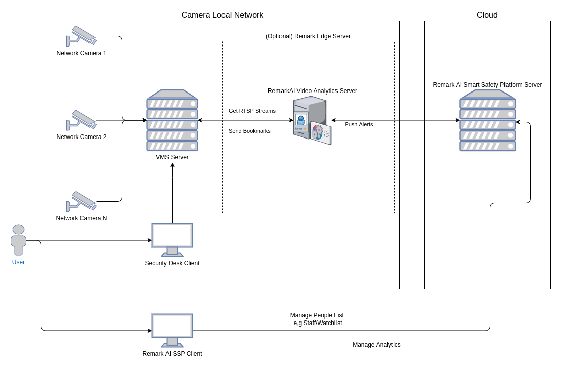
Figure 1. High level workflow diagram
Data Flow Diagram
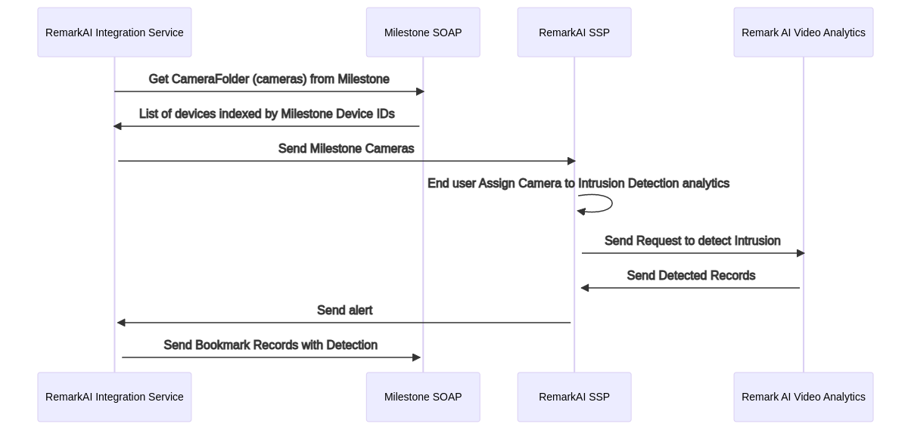
Figure 2. Data flow diagram

System Requirements

License Requirement
No licence required.

Hardware Specification
- CPU: Intel ® Core™ 2 X6800 @ 2.93 GHz
- RAM: 2 GB of RAM or better
- GPU: 256 MB PCI-Express x16 video card
- HDD: 80 GB hard drive for OS and Security Center applications
- Monitor: 1280 x 1024 or higher screen resolution with 96 dpi
- Network: 100 Mbps Ethernet network interface card

Software Specification
- Windows 10 Pro Version 21H1 OS build 19043.1706
- Chrome WEB browser Version 102.0.5005.115
- .Net Framework 4.8.04161
- Milestone XProtect 2022 R1
- Smart Safety Platform 3.0.1

External Hardware (If applicable)
The Remark AI edge server or Remark AI edge server with cloud server together.

External Software (If applicable)
The Smart Safety Platform 3.0.1 installed on the edge server or edge server with cloud server together.

Installation Pre-requisites
The Remark AI edge server must be installed in the same network as MXSC.

Quality Assurance

Test Type | Description | Checkmark  (If Applicable)
Integration Test | Testing the integration of your software solution with Milestone. | yes
Functional Test | Have you tested the functionalities that are part of the integration with MXSC? | yes
System Test | Have you performed system level tests on the integration part of your solution, such as testing on distributed servers? Hosting MXSC and your solution on different servers? | yes
Scalability Test | Has the scalability of your solution been tested with MXSC? In case the clients have large amount of entities, does your solution support that? | yes
Performance Test | Have you tested the performance of your integration with MXSC?  Are there any performance impacts on MXSC processes? | n/a
Robustness Test | Have you tested your integration when there is Server failures, Database connection issues, network issues or any other robustness tests? | yes
Regression Test | How do you make sure if any bug fixes will not impact any other areas that are part of the integration? | n/a
Soak Test | Have you tested your Integration when the system has been running with production like load for at least 5 days? Are there any memory leaks, crash or exceptions? | yes
Table 3 - Quality Assurance

Integration Limitations
The access to SSP is not a part of the MXSC GUI. The SSP GUI must be used for adding connection to the MXSC, adding algorithms for processing, and algorithms configuration.

