Now data goes from VaxLPR MMC (which is running in Axis Q1700-LE) directly to Milestone.

All data is transferred via Vapix/ONVIF. So no XML is needed.

Below you’ll find example search. (New yellow Vehicle search comes with Alpha FW of Optimizer, which I had today)

All info that is seen in Details (right in image) are possible to search.

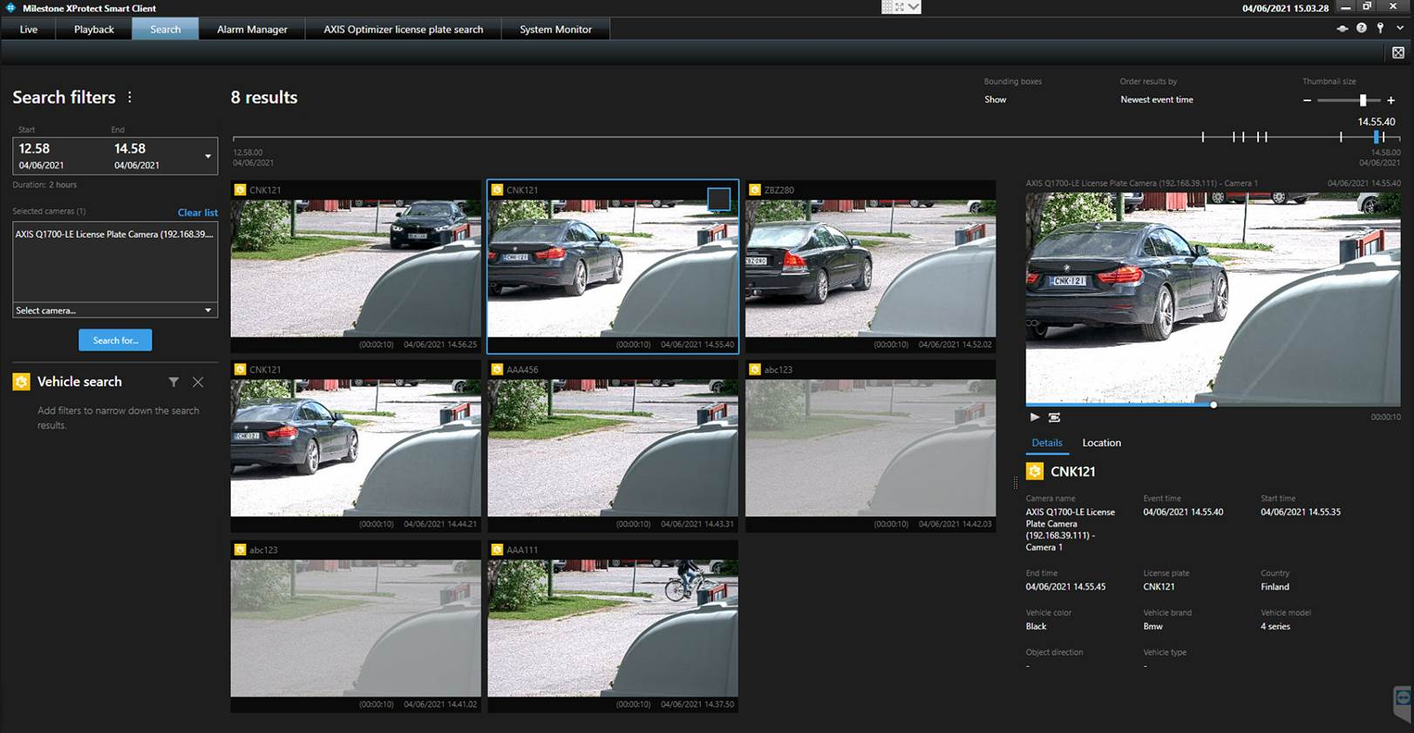

My previous setup had all done correctly, but I guess I had old versions of software. That was the issue.

Previous I had VaxLPR MMC 2.2.15 and Axis Optimizer 4.1.7.0.

Now I have VaxLPR MMC 2.2.16 and Axis Optimizer 4.1.8.0 (this is Alpha version. Not released yet).  
  
Creating a connection is super easy!

Vaxtor protocol and Vapix needs to be active. Host below is Milestone server IP.

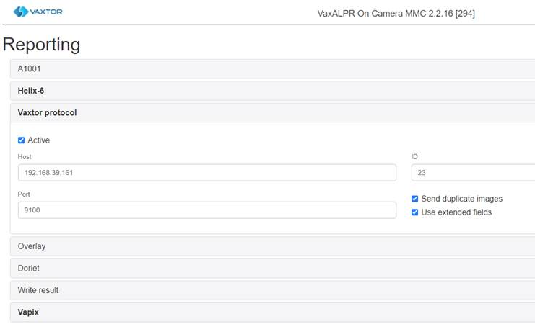

And in Milestone, I think this is only that is needed. I understood that it is critical to record Metadata in Milestone. Number 4 below instructions.

