**Sending MMC data to Milestone**

See full guide. There are several options to send data to Milestone:

1. Directly from Axis cameras using XML reporting and you can use Axis Optimizer plugin for Milestone.
2. Using Helix Connector plugin for Milestone

However, Axis Optimizer has not included the MMC fields yet. Axis need to add these.

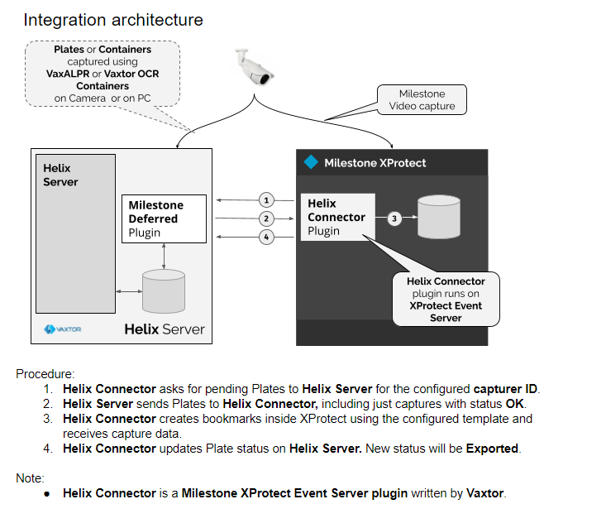

We have a test server: Milestone XProtect Express + test server.

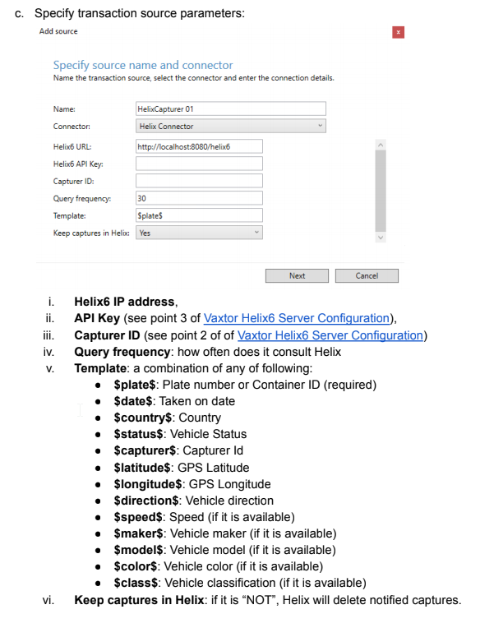

a