**Milestone x W-Access**

The integration of milestone with W-Access takes place in two ways, making it possible to monitor traffic and W-Access events from the integrated Milestone platform, and from w-access to view images from Live IP cameras and recordings on the W-Access.

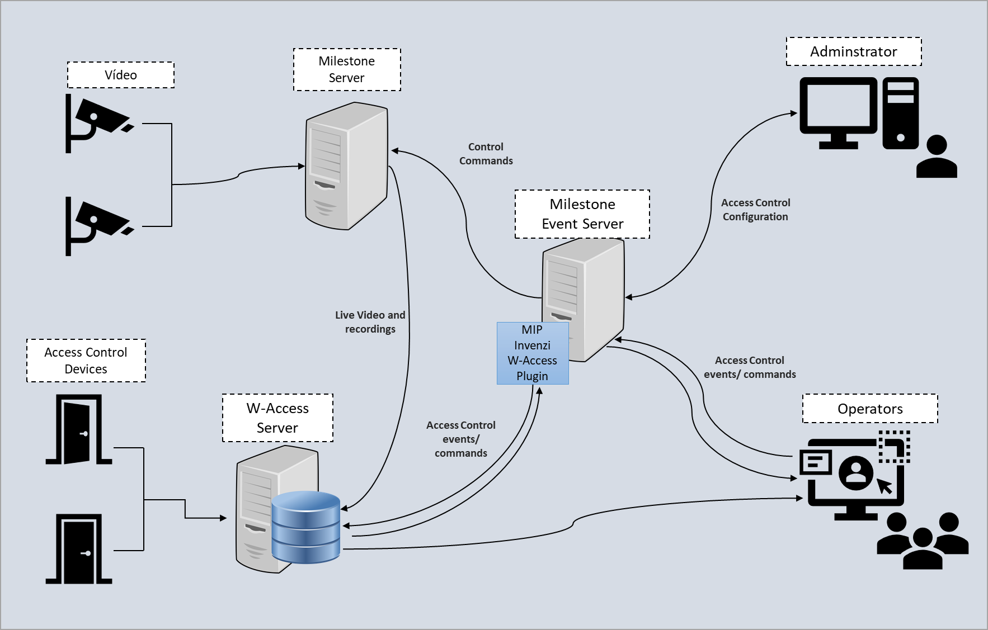

**Viewing IP cameras registered on Milestone through W-Access**

First, it is necessary to configure the access data to the XProtect Web Client in the general settings of W-Access, for this access: System> System Settings> General Settings:

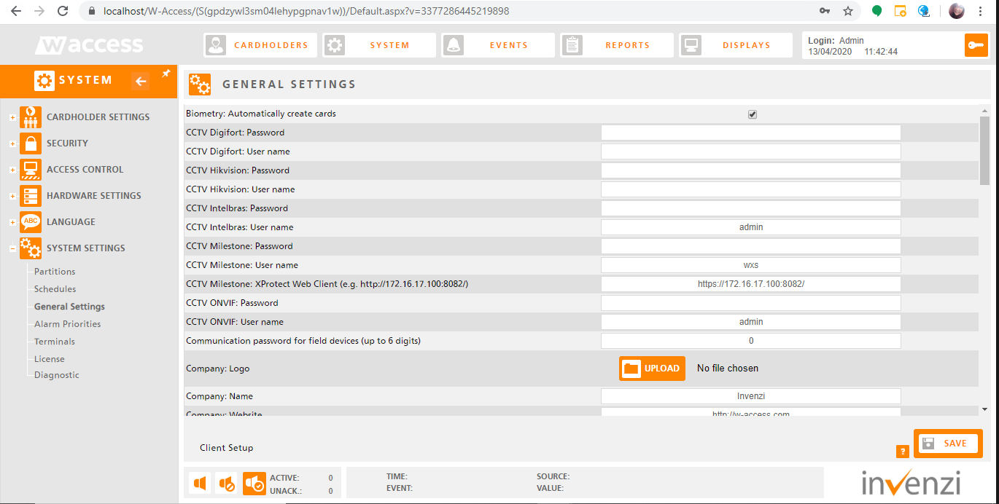

Fill in the fields:

* CFTV Milestone: User Name
* CFTV Milestone: Password
* CFTV Milestone: XProtect Web Client (ex. http://172.16.17.100:8082/)

Remembering that for this a Basic user must be created for this purpose in the XProtect Client Manager settings.

To add new cameras, access the path: System> Hardware Settings> Cameras

Register the identification data of the camera, and in "System" select "Milestone" and click "Save":

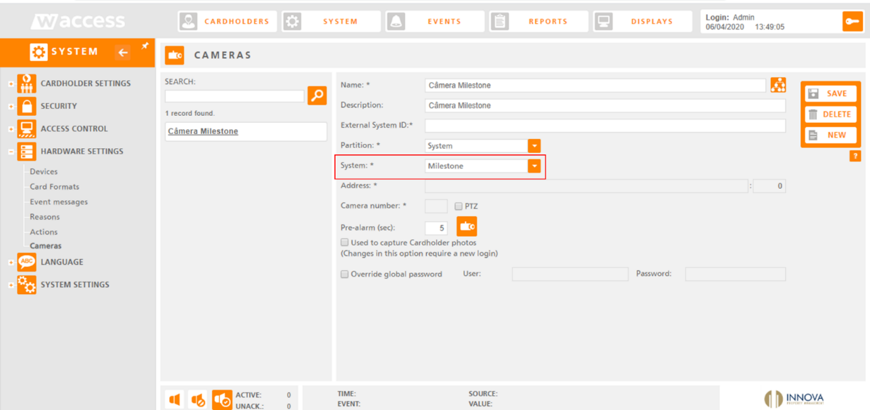

Then from the Milestone platform, find the registration of the camera and pressing the "Ctrl" key on the keyboard click on "Information":

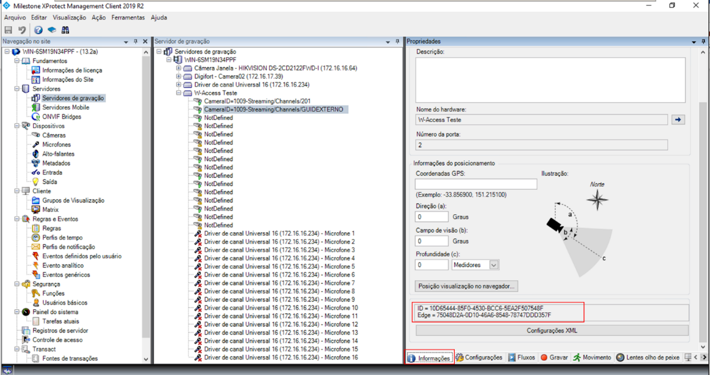

Use the camera ID, in “External System ID” in the registration of the camera in W-Access. And click save, then to test the camera view click on the icon  .

The live view of the camera should appear:

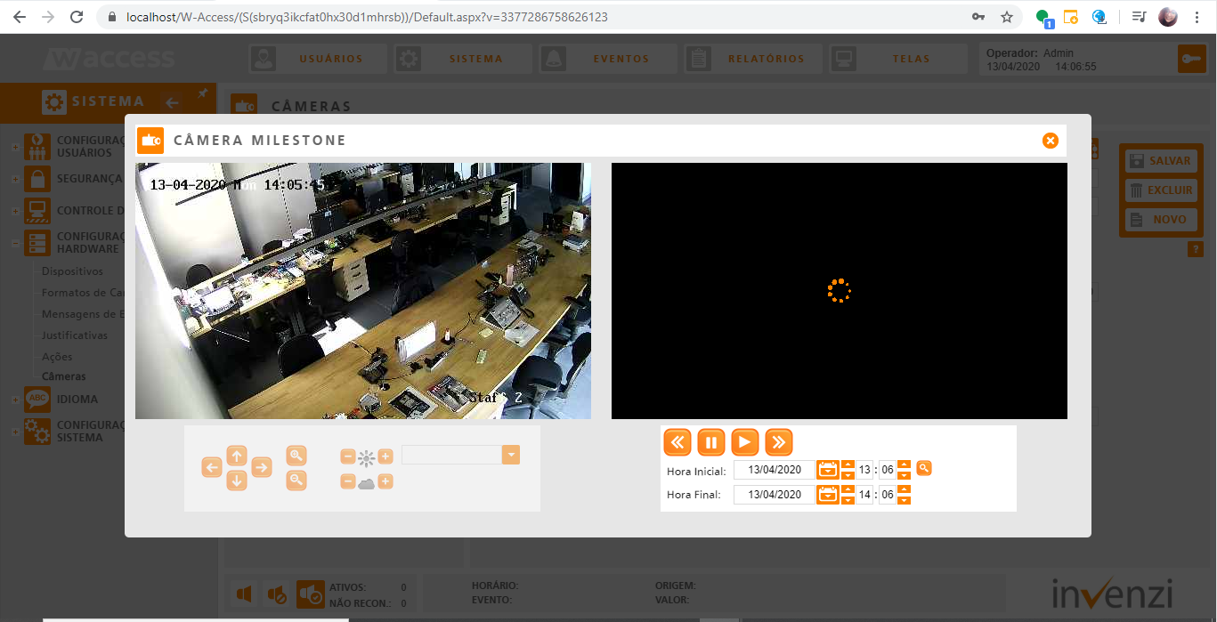

**Viewing W-Access Events on the XProtect interface**

On the Server where Milestone XProtect is installed, it is necessary to add the W-Access plugin. To do this, access the milestone installation folder, if the directory is the default the path is: “C:\Program Files\Milestone\MIPPlugins”

Add the WAccessPlugin folder :

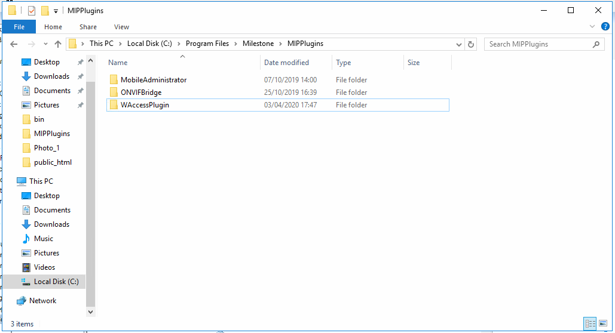

Then access XProtect Client Management Client and in Access control and with the right button select “Create Access Control”:

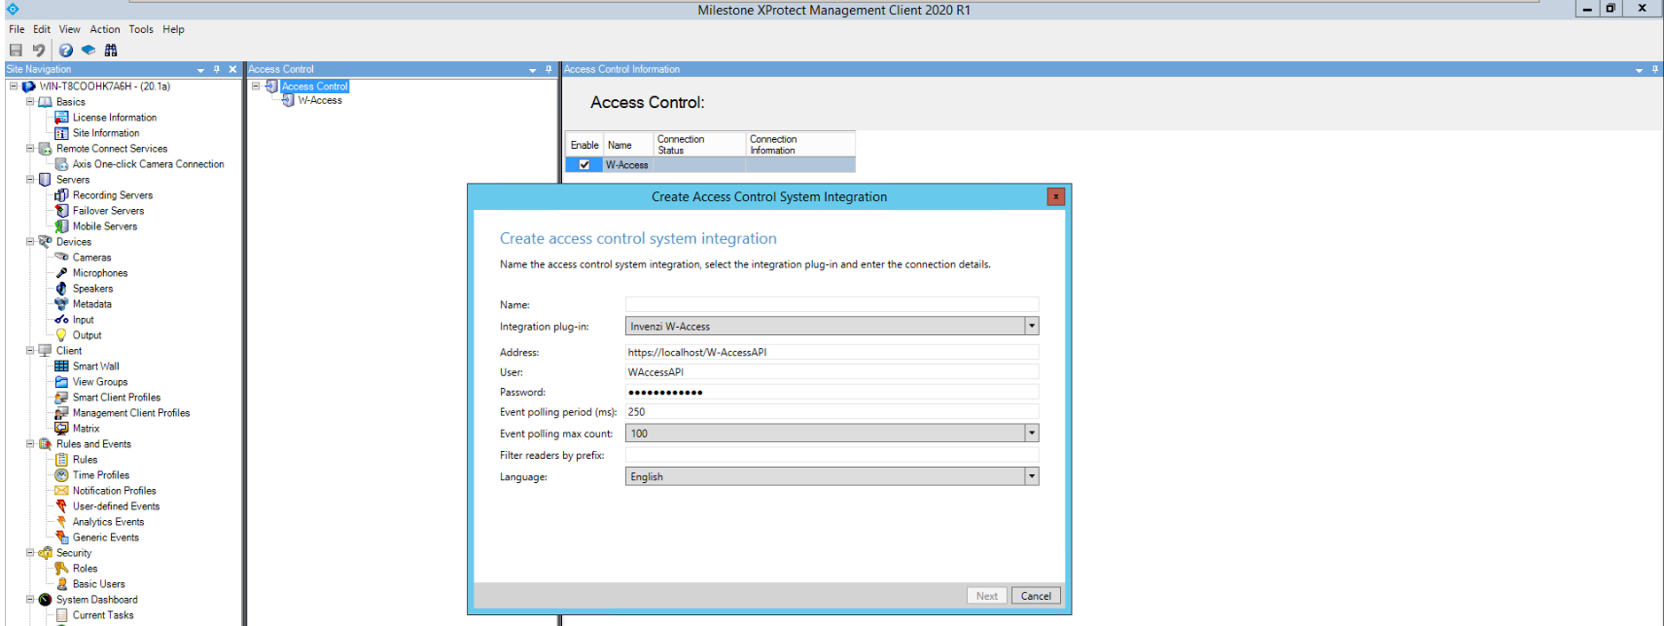

Fill in the W-Access connection information:

* Name: name to identify the connected W-Access server.
* Integration plug-in: select “Invenzi W-Access”.
* Address: W-Access API Address – https://{W-AccessServerIPAddress}/W-AccessAPI.
* User: W-Access operator with API privileges.
* Password: Password of W-Access operator with API privileges.

Click "Next" and continue with the process until the end.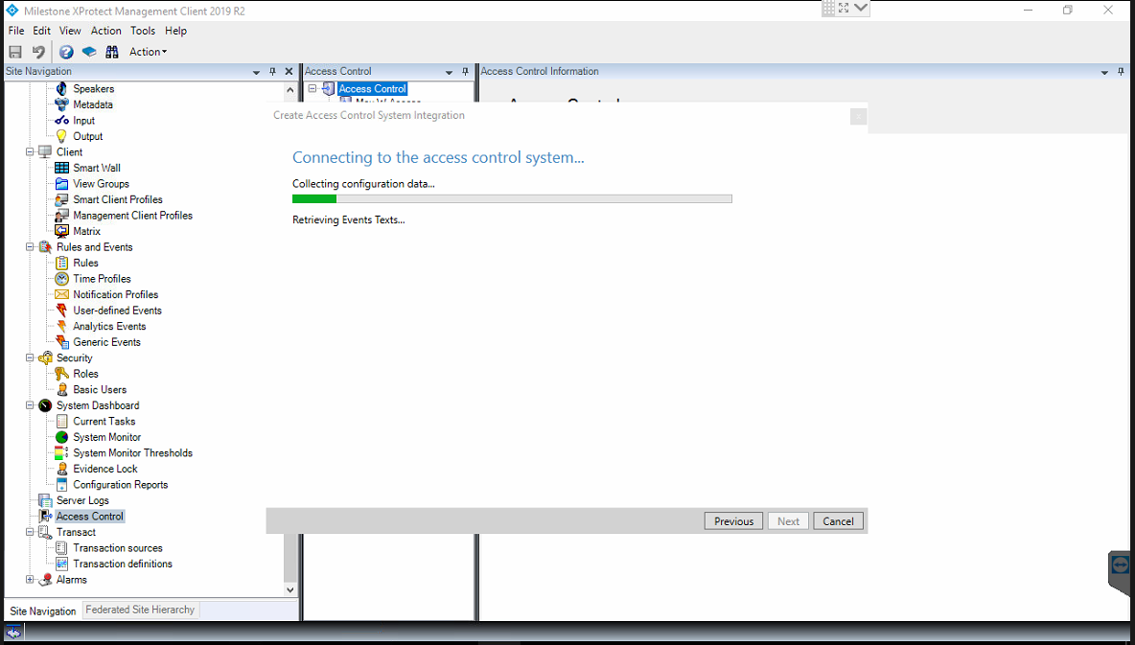

In the general settings screen, in “Filter Readers by prefix:” it is necessary to indicate a reader prefix that will be considered by Milestone, in this case we choose the prefix “MIP”:

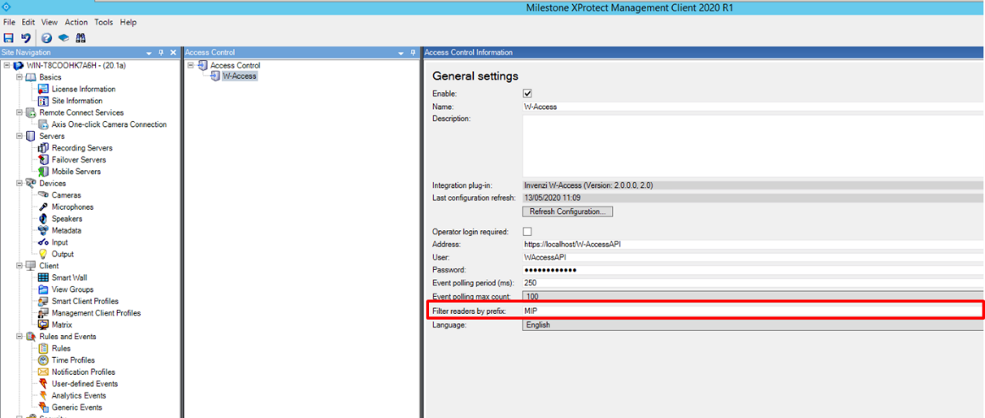

Then it will be possible to view the events from W-access in XProtect Smart Client and configure the access screens to display the events from doors and send commands to Open or Block doors:

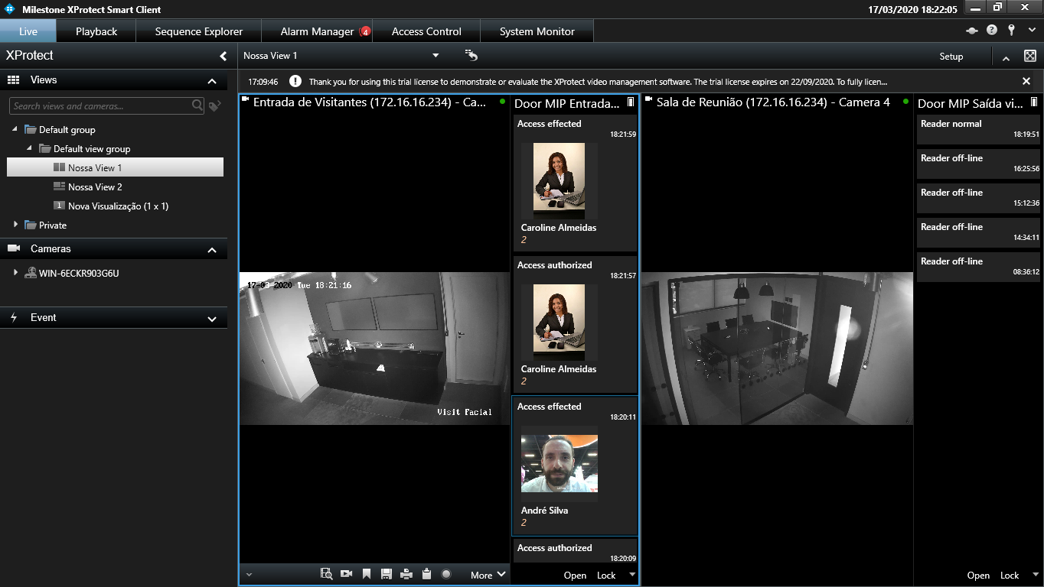

List of integrated Access Events:

|  |  |  |
| --- | --- | --- |
| Access Control Event | Source Type | Event Category |
| Access authorized | Access Point | Access granted |
| Access effected | Access Point | Access granted |
| Anti-passback violation | Access Point | Access denied |
| Anti-passback violation (supervise only) | Access Point | Access denied |
| Card disable | Access Point | Access denied |
| Card not authorized to escort | Access Point | Access denied |
| Door forced | Access Point | Error |
| Door opened (pulse) | Access Point | Warning |
| Door opened (unlock) | Access Point | Warning |
| Door opened for too long | Access Point | Alarm |
| Duress | Access Point | Access granted |
| Entry authorized | Access Point | Access granted |
| Entry effected | Access Point | Access granted |
| Escort required | Access Point | Access denied |
| Exit authorized | Access Point | Access granted |
| Exit effected | Access Point | Access granted |
| Invalid Access Reader | Access Point | Access denied |
| Invalid Access Time | Access Point | Access denied |
| Invalid Card (card doesn't exist) | Access Point | Access denied |
| Invalid Card Validity dates | Access Point | Access denied |
| No Meal credits available | Access Point | Access denied |
| Reader failure | Access Point | Warning |
| Reader locked | Access Point | Warning |
| Reader normal | Access Point | Warning |
| Reader off-line | Access Point | Warning |
| Return to normal - Door forced | Access Point | Warning |
| Return to normal - Door Opened for too long | Access Point | Warning |
| Server Connected | Demo Server |  |
| Server Connection lost | Demo server | Error |