# Hidden Level Milestone VMS User Configuration Guide

## Target Audience

This document is aimed at system users and provides descriptions on how to install, configure and maintain the Hidden Level AMS Milestone VMS integration. The solution is developed as a XProtect® Event Server plug-in which provides events on based on small Unmanned Ariel System (sUAS or “drones”) activity near cameras in the VMS system.

The manual only covers the necessary configuration steps in the XProtect® Management Client.

To benefit from this document, you should have thorough knowledge of:

* Milestone XProtect® Management Client

## Copyright, trademarks and disclaimer

Copyright © 2021 Hidden Level Inc.

### Trademarks

Hidden Level is a registered trademark of Hidden Level Inc.

XProtect is a registered trademark of Milestone Systems A/S.

Microsoft and Windows are registered trademarks of Microsoft Corporation.

All other trademarks mentioned in this document are trademarks of their respective owners.

### Disclaimer

This text is intended for general information purposes only, and due care has been taken in its preparation. Any risk arising from the use of this information rests with the recipient, and nothing herein should be construed as constituting any kind of warranty.

Hidden Level reserves the right to make adjustments without prior notification.

All names of people and organizations used in the examples in this text are fictitious. Any resemblance to any actual organization or person, living or dead, is purely coincidental and unintended.

This product may make use of third-party software for which specific terms and conditions may apply. When that is the case, you can find more information in the file 3rd_party_software_terms_and_conditions.txt located in your Milestone system installation folder.

## General Description

The Hidden Level Airspace Monitoring Service (AMS) Milestone VMS integration enables users to get real-time events based on flight activity of small Unmanned Ariel Systems (sUAS or “drones”) near installed cameras in the system. These events can be used to generate rules in order to take a myriad of actions, such as recording video or cueing other devices on the network.

The Hidden Level AMS plug-in is installed on the machine(s) running the Milestone XProtect® Event Server and Management Client. The plug-in is compatible with the following:

* Milestone XProtect® VMS 2021 R1 or newer

## Installation

### Prerequisites

Before you start, make sure that the following is available:

* Milestone XProtect® video management software (such as Milestone XProtect® Corporate) along with an appropriate version (2021 R1 or later) of a Milestone XProtect® Management Client.
* Event Server server must have outbound internet access (port 443)

### Installation Procedure

The Hidden Level AMS plug-in must be installed on the machine running the Milestone

XProtect® video management software. On a system with multiple machines, the plug-in needs to be installed on the machines that runs Milestone XProtect® Management Client and Event Server.

The following describes how to install the plug-in:

1. Stop the XProtect Event Server and XProtect Management Server processes
2. Install Hidden Level AMS plugin by running the following installer application:  
   HiddenLevel-AMS-Milestone-VMS-plugin-installer.exe
3. When the installation wizard starts, click ‘Next’ to continue.
4. Read the license agreement. If you accept, hit “I Agree” to continue
5. The plugin will be installed to C:\Program Files\Milestone\MIPPlugins\HiddenLevelAms by default. If your installation requires a custom destination, configure as needed. Hit “Install” when ready.
6. When the installation has completed, click “Finish”
7. Restart the XProtect Event Server and XProtect Management Server processes

## Configuration

In order to utilize the Hidden Level AMS data, you must obtain and configure a valid API key. If you have not already been provided with a key, please contact [support@hiddenlevel.com](mailto:support@hiddenlevel.com)

Once your key has been issued, open the XProtect Management Client. Under MIP Plug-ins -> Airspace Monitoring Service -> Config enter your AMS API Key and hit save.

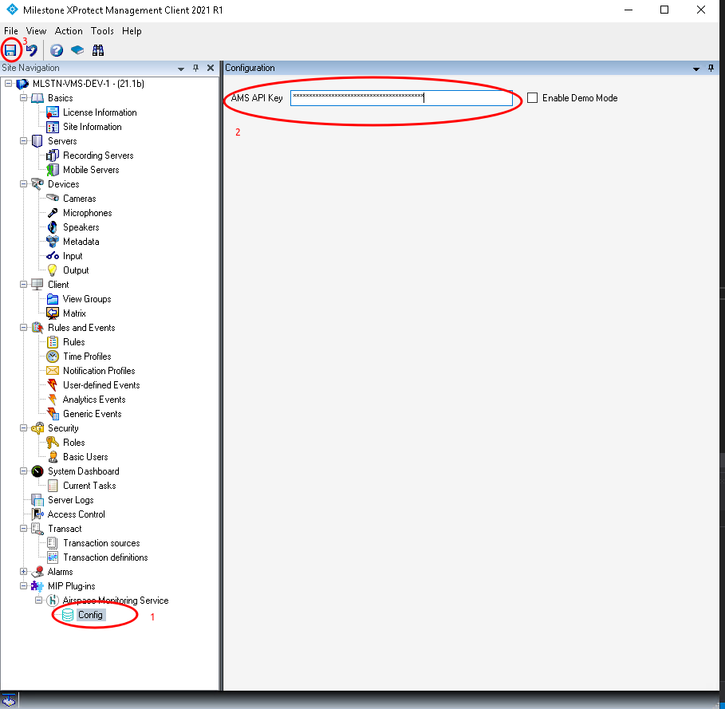

Once configured, the plugin will automatically connect to the AMS service and begin to generate events. Rules can be generated from the events through the Management client rule interface.

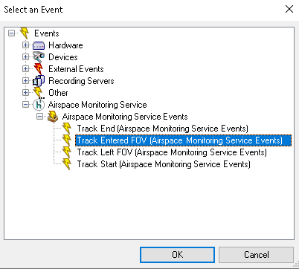

The following events are available:

* **Track Start**
  + Triggered when a new AMS track is created or enters the coverage area
* **Track End**
  + Triggered when an AMS track ends or leaves the coverage area
* **Track Entered FOV**
  + Triggered when an AMS track enters a camera’s field of view for the first time
* **Track Left FOV**
  + Triggered when an AMS track leaves a camera’s field of view for the last time. Note that this event is delayed until track end (in case the track re-enters the FOV)

Please consult the [Milestone documentation](https://doc.milestonesys.com/2020R3/en-US/standard_features/sf_mc/sf_mcnodes/sf_5rulesandevents/mc_rulesandevents.htm?TocPath=XProtect%20VMS%20products%7CXProtect%20VMS%20administrator%20manual%7CConfiguration%7C_____20) for further details on rule configuration.

In order for the FOV events to trigger, each camera must be properly configured with positioning information. Fill out each field of the configuration with the data that is appropriate for your camera installation.

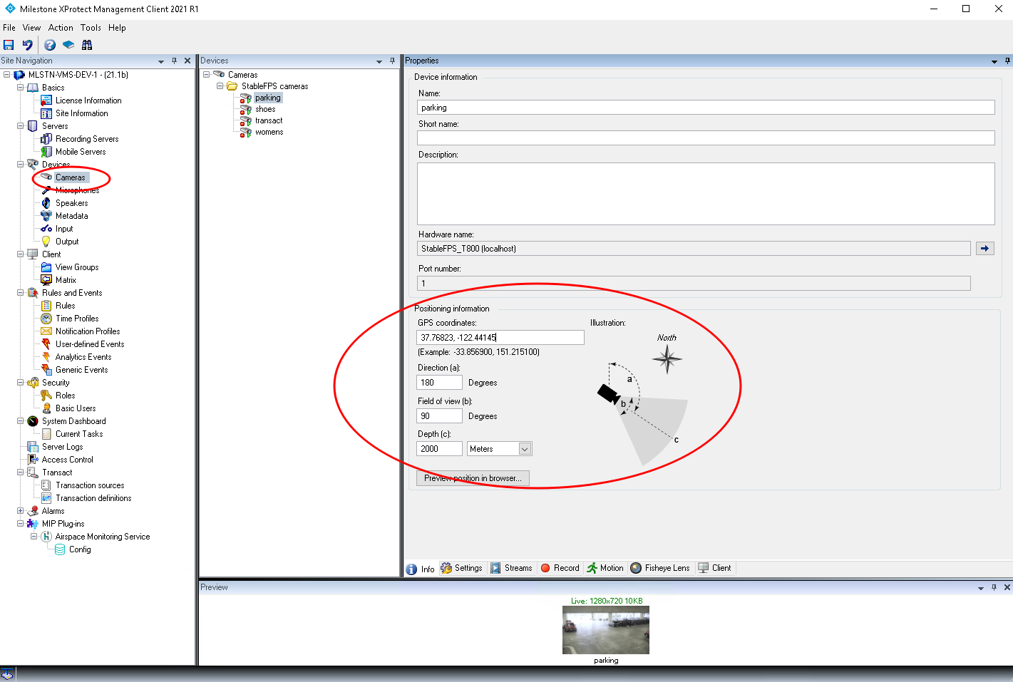

Note that if any field is not filled out, FOV events will not be generated. Also note that the camera angle relative to true north must be appropriately set to generate accurate alarms. Care should be taken if magnetic compass readings are used to correct for declination.

### Demo Mode

If event testing is desired, the AMS connection can be run in demo mode. This connects to a test server which outputs constant air traffic. To enable demo mode, select the option from configuration and save. Note that all existing tracks will have their “Track End” event triggered when demo mode is started.

