**nuPSYS-3D-Plugin for Milestone**

Installation Guide

Please follow the instructions:

1. download and unpack the installer, then run it
2. in File Explorer open the following folder: C:\Program Files\Milestone\XProtect Smart Client\MIPPlugins
3. right click on "nuPSYSPlugin" folder and open Properties
4. open "Security" tab and press "Edit"
5. check that  "Users" and "Trusted installer" have Full control :   
   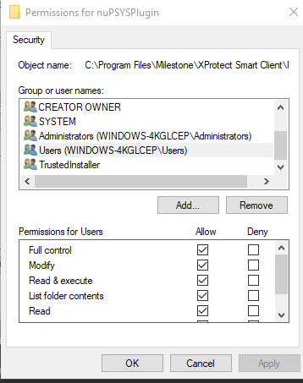
6. Restart Milestone Client and see nuPSYS Plugin is installed