Xprotect setup procedure Guide
for Media Gateway (VMS Plus)

Soliton Systems K.K

table of contents
1 Introduction - 1 -
2 Xprotect installation - 2 -
2.1 Download Xprotect VMS Products - 2 -
2.2 Xprotect installation - 3 -
2.2.1 Choose language - 3 -
2.2.2 License Agreement - 4 -
2.2.3 Select license file - 5 -
2.2.4 Select installation type - 7 -
2.2.5 Components to be installed - 8 -
2.2.6 Specify recording server settings - 9 -
2.2.7 Select file location and product language - 10 -
2.2.8 The installation is complete - 12 -
2.2.9 Enter user names and passwords for hardware - 13 -
2.2.10 Select the hardware to add to the system - 14 -
2.2.11 Add users - 15 -
2.2.12 The configuration is complete - 16 -
3 Register Media Gateway - 17 -
3.1 Start Xprotect Management Client - 17 -
3.2 Add hardware - 18 -
3.2.1 Additional method - 19 -
3.2.2 Specify user name and password - 20 -
3.2.3 Select driver - 21 -
3.2.4 Addition of hardware information - 22 -
3.2.5 Enable device - 24 -
3.2.6 Select default group - 25 -
4 For Viewing on Smart Client - 27 -
4.1 Start Smart Client - 27 -
4.2 Add View - 28 -
4.3 Arrange the Camera - 29 -

Introduction
This document explains the procedure for building Xprotect.
If you already have XProtect connection environment, refer to Chapter 3 "Register Media Gateway" on p.17.
You can check the procedure to distribute video from Media Gateway to XProtect.

Xprotect installation
Download the installer and install Xprotect.
Note: Media Gateway is tested with Xprotect 2018R3

Download Xprotect VMS Products
Access to the following URL to specify the following items and Download Xprotect VMS Products.
https://www.milestonesys.com/support/resources/download-software/
Download location Europe
Product Xprotect Essential +
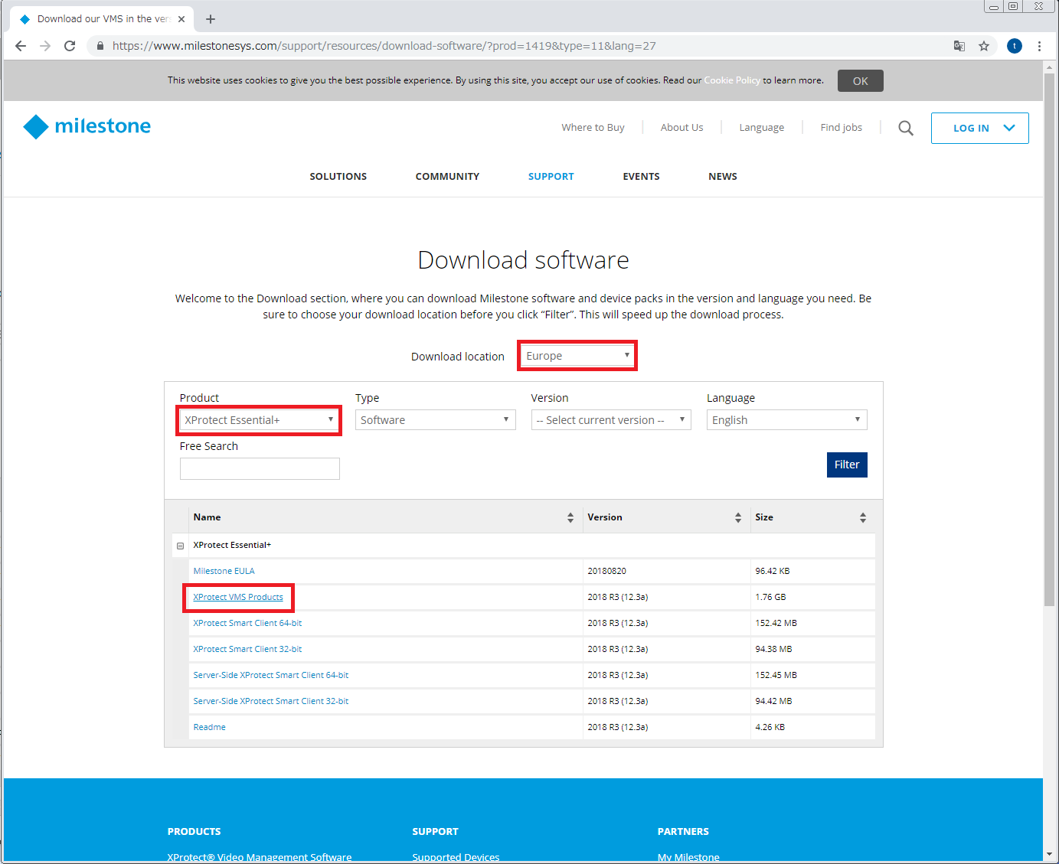

Xprotect installation
Run the downloaded installer.

Choose language
Select the Continue to specify the language you want to install.
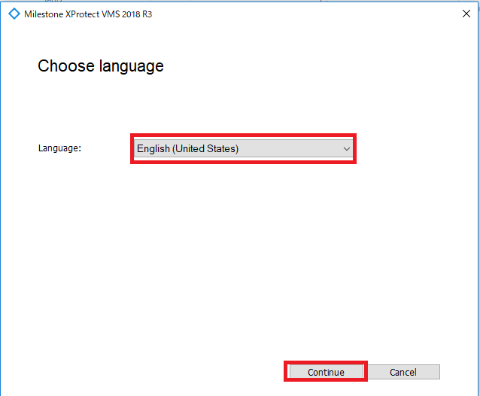

License Agreement
Read the terms of the license agreement, and then select the Continue put a check to agree.
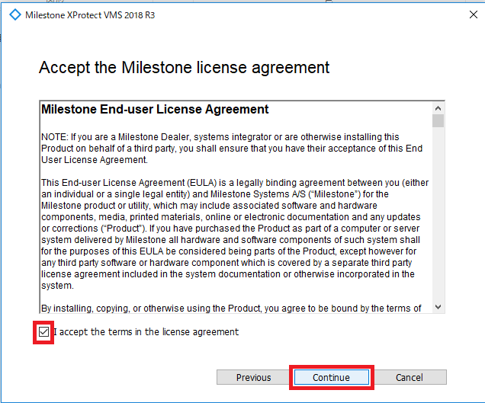

Select license file
Select Download free Xprotect Essential+ license.
Since the download is complete license is automatically selected and choose Continue.
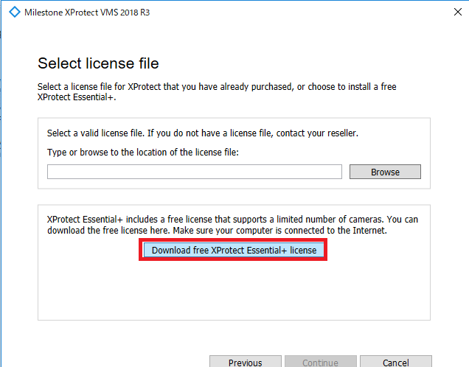
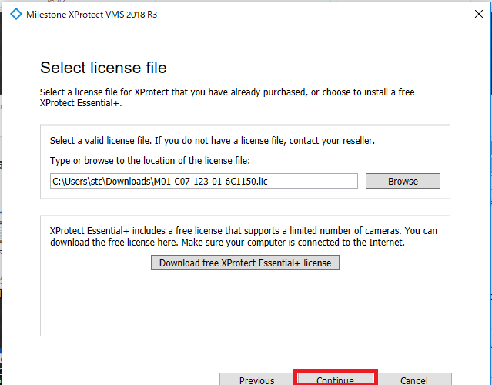

Select installation type
Select Single computer.
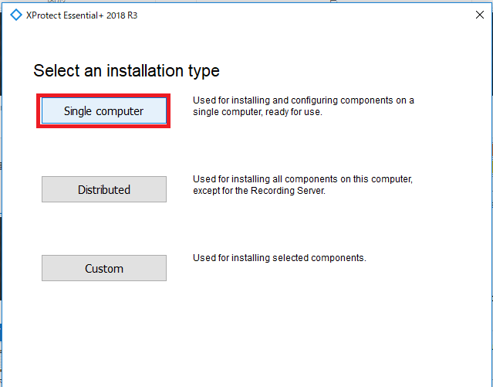

Components to be installed
Leave the default checking and select Continue.
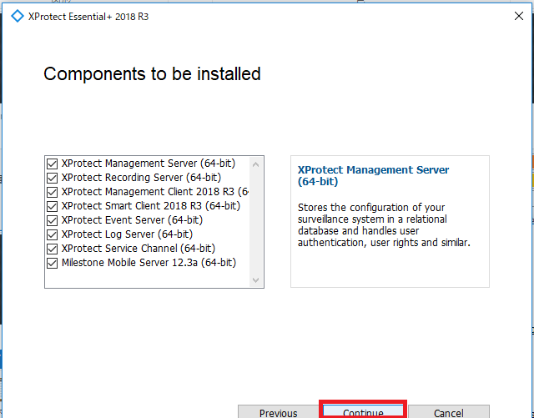

Specify recording server settings
Leave the default and select Continue.
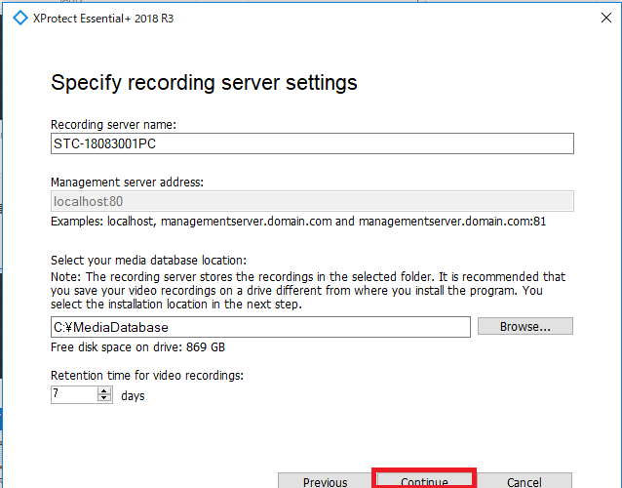

Select file location and product language
Leave the default and select Install.
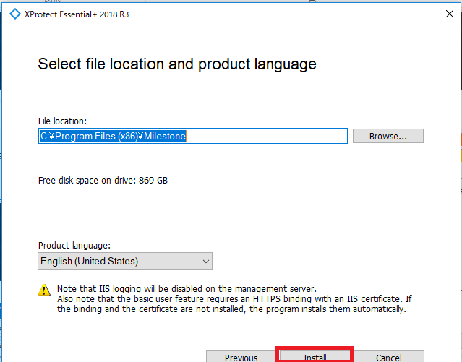

After installation is complete select Restart Computer.
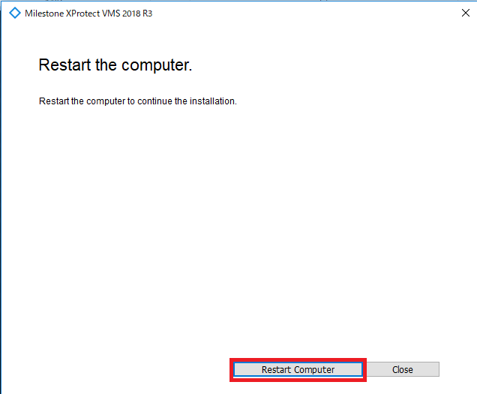

Installation restarts after rebooting.
When installation is over, you will be prompted to restart again so select Restart computer.

The installation is complete
Select Continue.
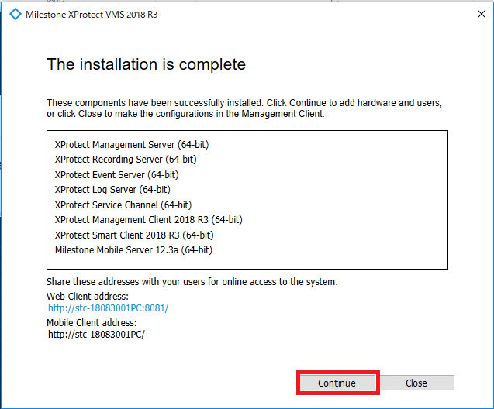

Enter user names and passwords for hardware
Leave blank and select Continue.
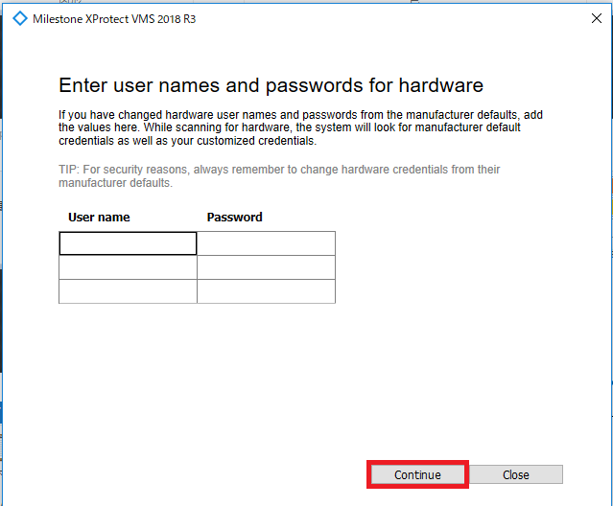

Select the hardware to add to the system
Select Continue.
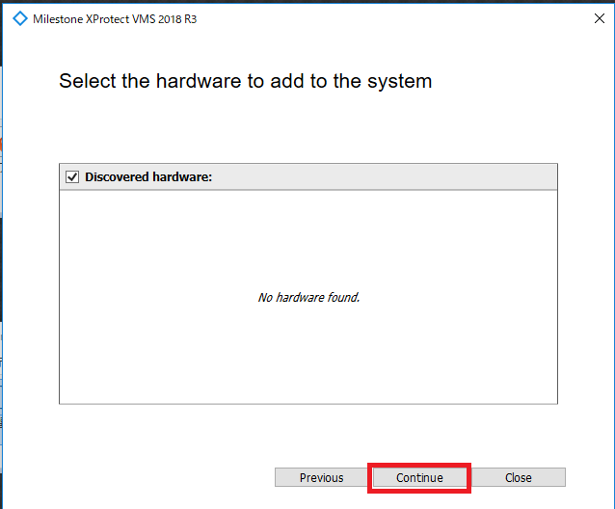

Add users
Leave the default and select Continue.
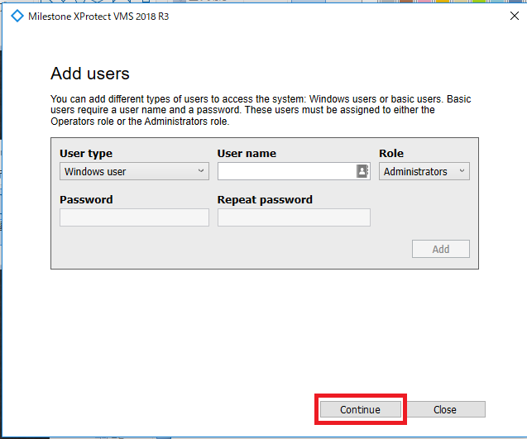

The configuration is complete
Select Close.
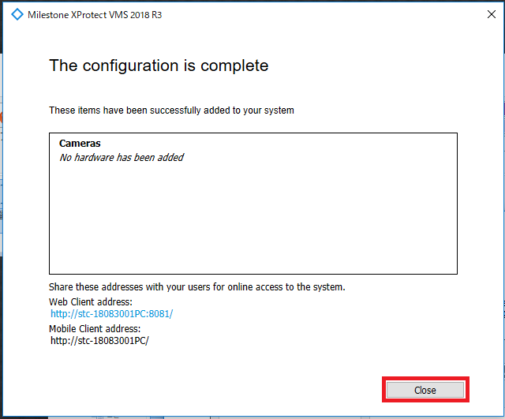

Register Media Gateway
Register the Media Gateway to the Xprotect Management Client.
Note: Media Gateway must be activated for registration.

Start Xprotect Management Client
Click the shortcut Xprotect Management Client 2018 R3 created on the desktop to start the Xprotect Management Client.
Select Connect after startup.
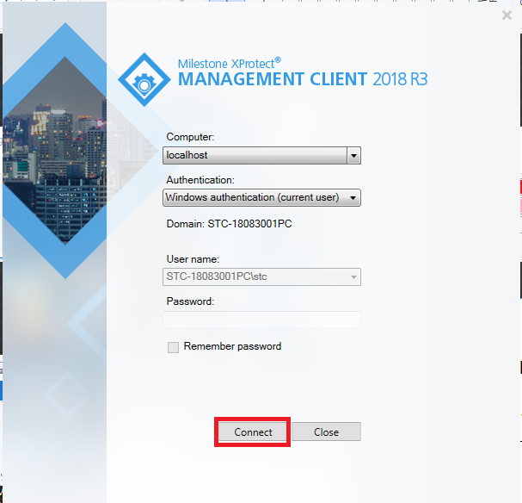

Add hardware
Select Site Navigation-> Servers-> Recording Servers.
Right-click Recording Server - > Recording Servers -> Server and select Add Hardware.
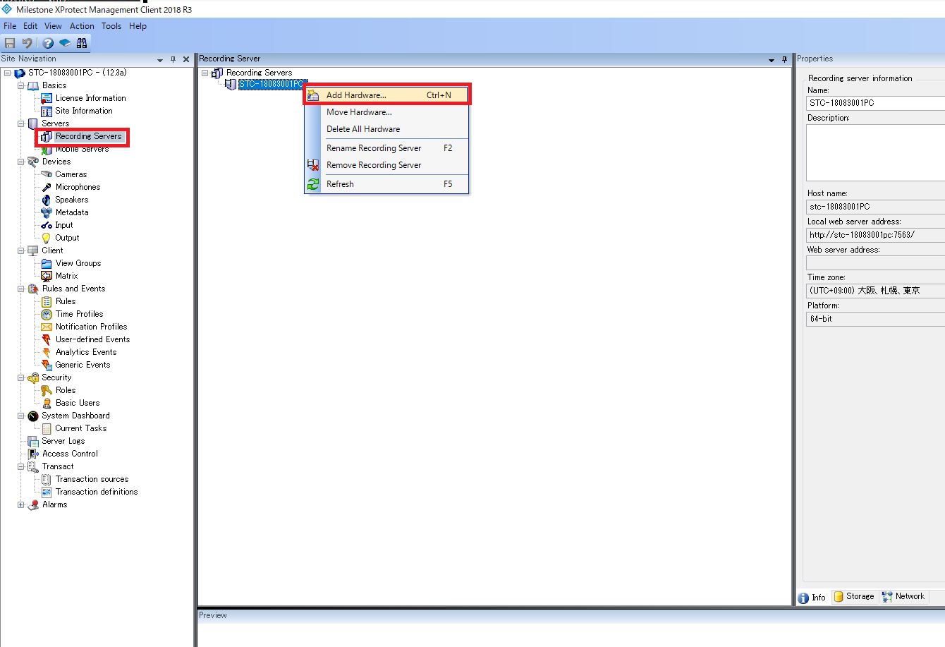

Additional method
Specify Manual and select Next>.
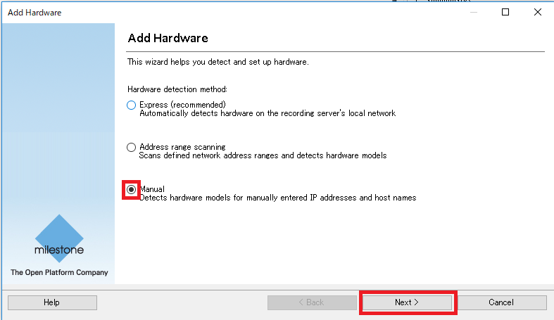

Specify user name and password
Leave the default and select Next>.
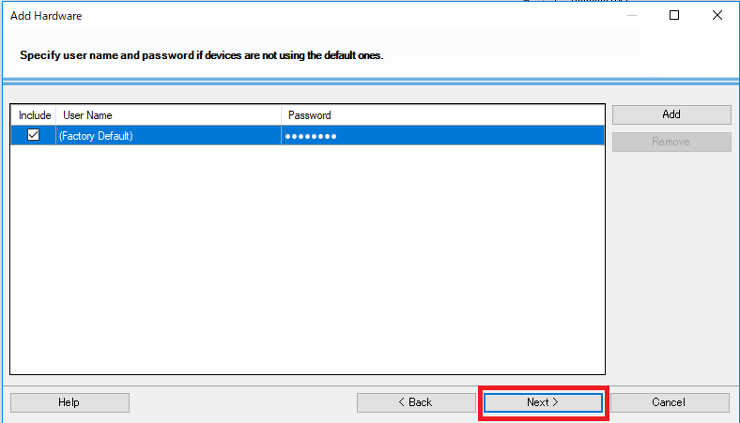

Select driver
Since the default is checked for all the items and remove all of them (Clear All).
Check only ONVIF and select Next>.
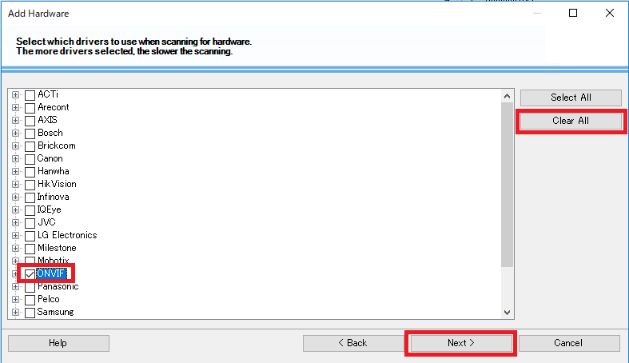

Addition of hardware information
Enter the IP address of the PC running the Media Gateway in the Address field.
In the Port field, specify the port to receive.
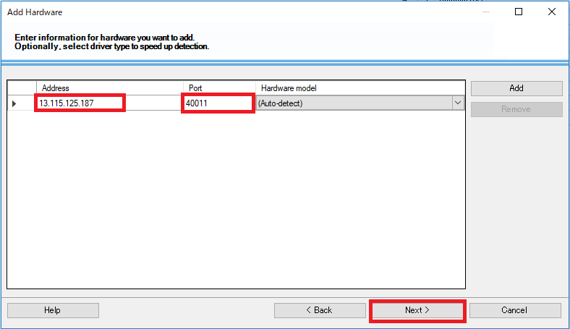
Note: Please specify 40011-40121 as the port.
Each port of 40011-40121 corresponds to the Endpoint Port to be set up in Zao Web Management by the following relationship.
20010→40011
20020→40021
20030→40031
20040→40041
20050→40051
...

Please refer to the Zao Web Management Manual for details about port.
If the registration is successful it will see a Success in Status. Select Next>.

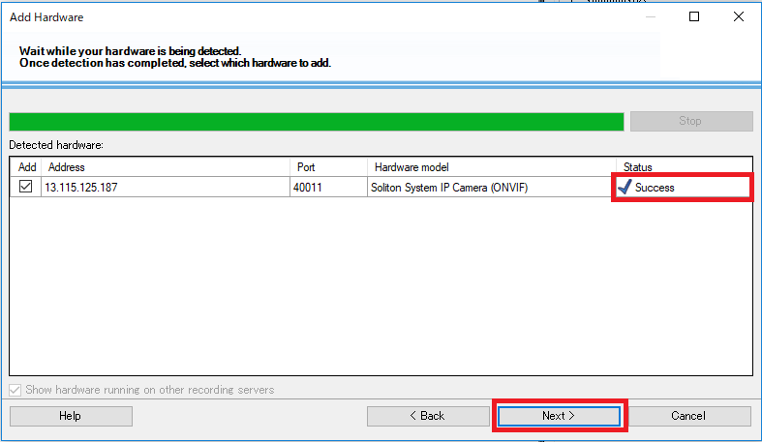

Continue to select the Next>.
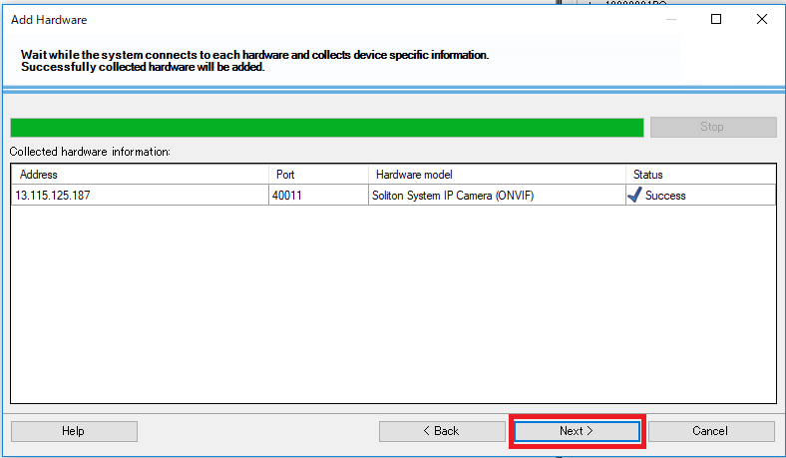

Enable device
Check Hardware, Camera port 1, Microphone port 1, Speaker port 1 and select Next>.
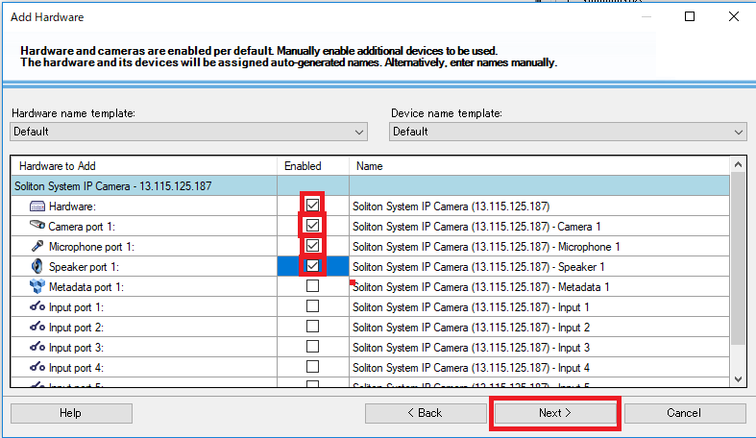

Select default group
Default camera group,
Default microphone group,
Default speaker group.
Create a group by selecting folder icons for each
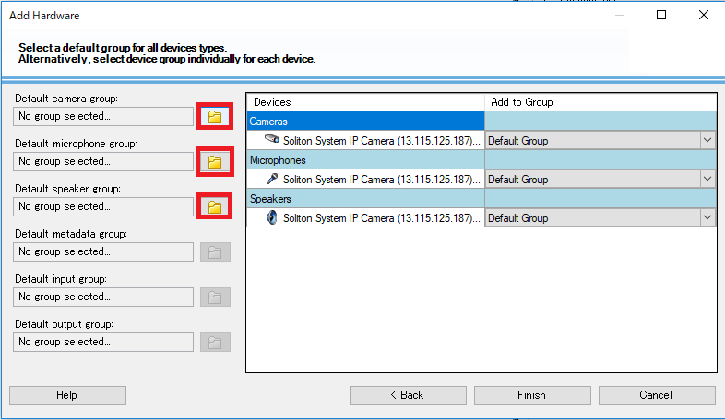
Select Add Group and create a group, then choose OK. after creating groups to camera, microphone, speaker, select Finish.
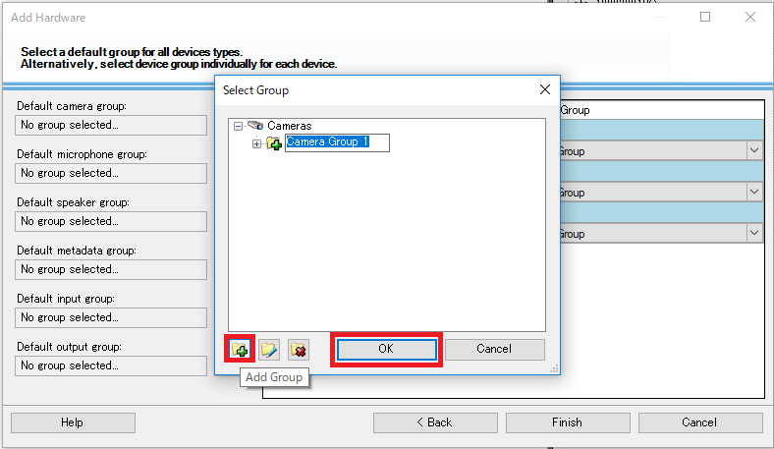
When a green triangle mark is attached to the lower right of the icon, images are being received.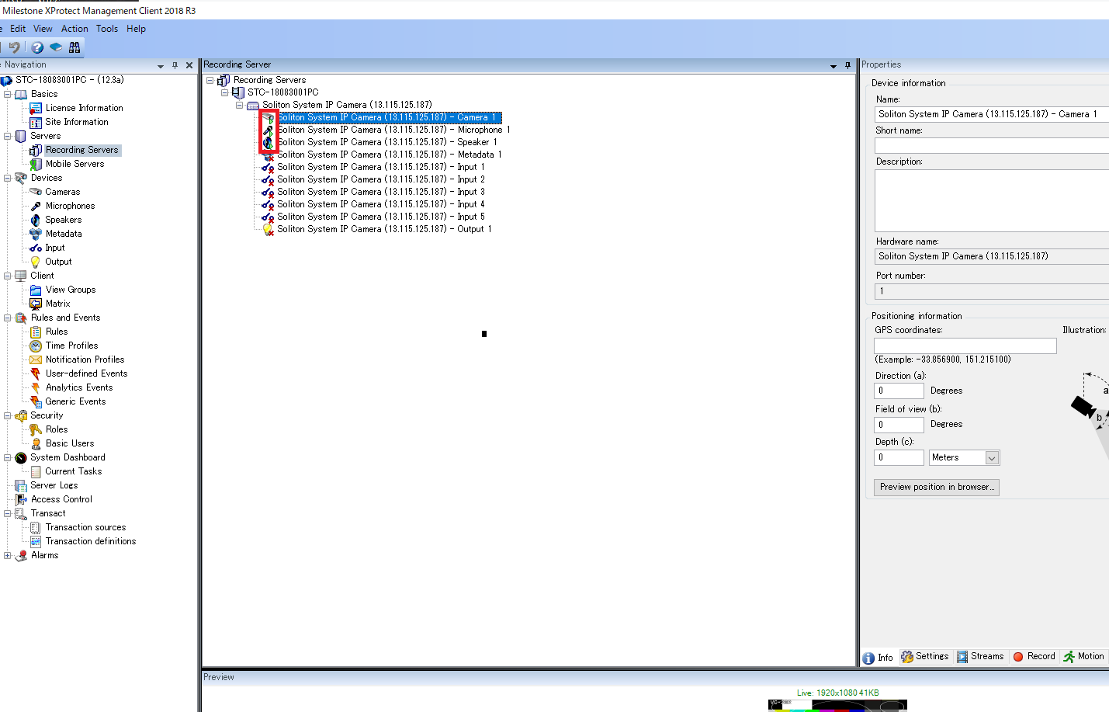

Four Viewing on Smart Client
We will watch the video of Media Gateway on Xprotect Smart Client.

Start Smart Client
Click the shortcut Xprotect Smart Client R3 created on the desktop and start it. Select Connect after startup.
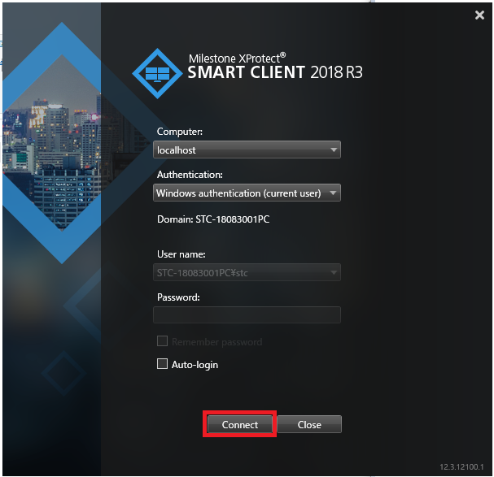

Add View
Select Setup and add View.
Select Views -> Default group - > Default view group -> Add View - > 16:9 -> 1+3 and select Setup to complete adding the View.
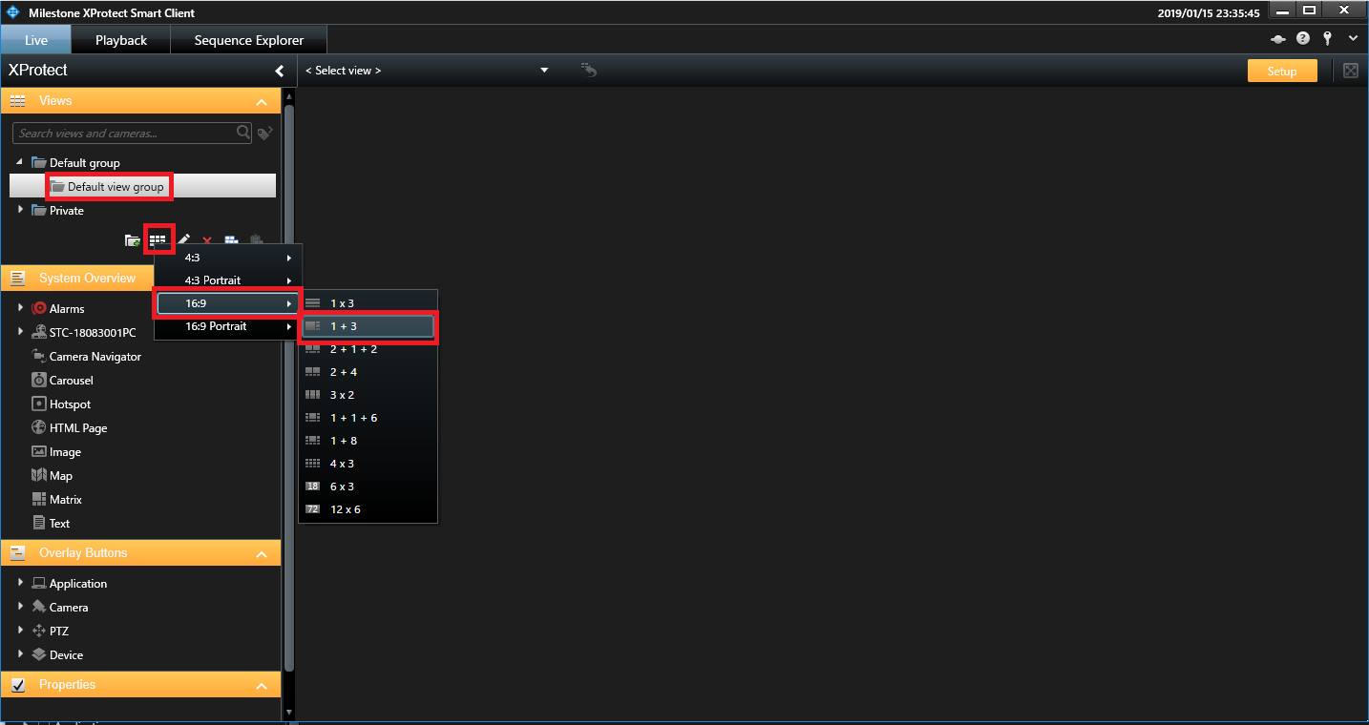

Arrange the Camera
If you drag and drop the Cameras-> Server-> Camera Group 1->camera onto View, video will be displayed.
