

Hexagon (CAD) Integration®  
USER GUIDE

**6SS Table of Contents**

**Table of Contents**

Copyright and Disclaimer 3

Introduction 4

6SS CAD® Main Features 5

Getting Started 6

System Components 6

System Introduction 7

6SS CAD plugin 7

Main Benefits 8

6SS CAD plugin 9

# Copyright and Disclaimer

**Copyright © 2021 6SS L.L.C**.

**Disclaimer**

The information provided in this document is intended for general information purposes only. 6SS believes the information is provided in good faith in this publication and it is accurate.

The information is subject to change without notice.

Any risk arising from the use of this information rests with the recipient, 6SS makes no representations or warranties of any kind with respect to the information in this publication, and speciﬁcally disclaims implied warranties of merchantability or ﬁtness for a particular purpose. Use, copying, and distribution of any 6SS software described in this publication requires an applicable software license.

# Introduction

6SS CAD® is a monitoring application that is fully integrated with Hexagon software, used for showing alarms received from Milestone (Fire, Robbery, etc…) That can be used later by the operator to create an event in the CAD system. Once the CAD system operator dispatch or close any event (Ambulance, police, Fire Extinguisher …) the status will be automatically updated using 6SS API.

6SS CAD combines the power of Milestone and CAD system to ensure a fully secure environment.

# 6SS CAD® Main Features

* Supports all camera types that are compatible with Milestone VMS (more than 10000 IP devices)
* Integrated with Milestone XProtect Corporate, Expert, Professional+, Express+ & Essential+
* Accessed from the Smart Client interface
* Ability to filter by date and by alarm status or message
* Alarms generated by Milestone are shown clearly
* Ability to set the status of an alarm generated by Milestone
* Two-way communication with CAD system using API
* Ability to create an event in CAD system
* Ability to monitor the status of each alarm
* Capability of adding an attachment or remark to any event in CAD System
* Ability to stream out the real time processed video of every event
* Ability to see a live stream of an event camera
* Image related to an alarm is also shown

# Getting Started

## System Components

* Windows OS 8.1 or above
* Microsoft .NET framework 4.5 or newer (for .NET components usage).
* Microsoft SQL Server Express, Standard or Enterprise edition
* Milestone XProtect Corporate, XProtect Expert, Professional+, Express+, or Essential+
* 6SS CAD® client plugin

## System Introduction

### 6SS CAD plugin

New tab in Milestone XProtect Smart Client will be added to show information, snapshots, and statistics about alarms and events, in addition to the ability of creating an event in CAD system directly from CAD plugin.

## Main Benefits

* Cost effective
* Time effective
* Easy to use and configure
* Very fast processing speed
* Seamless integration
* Enhanced security
* Centralized control through the Smart client
* Multiple applications and use cases
* Development team is always available to add Customer-tailored features in case needed

# 6SS CAD plugin

After installing 6SS CAD plugin, a new tab in Milestone XProtect Smart Client will be shown.

In the 6ss CAD Tab, Operator will have an overview of all Alarms created in Milestone where Date Time, Priority level, status, message and source of each alarm are shown. Moreover, Events created in CAD system are shown with their related information also.

Finally, live stream is shown for the camera of each alarm in addition to an image captured at the time of the alarm.

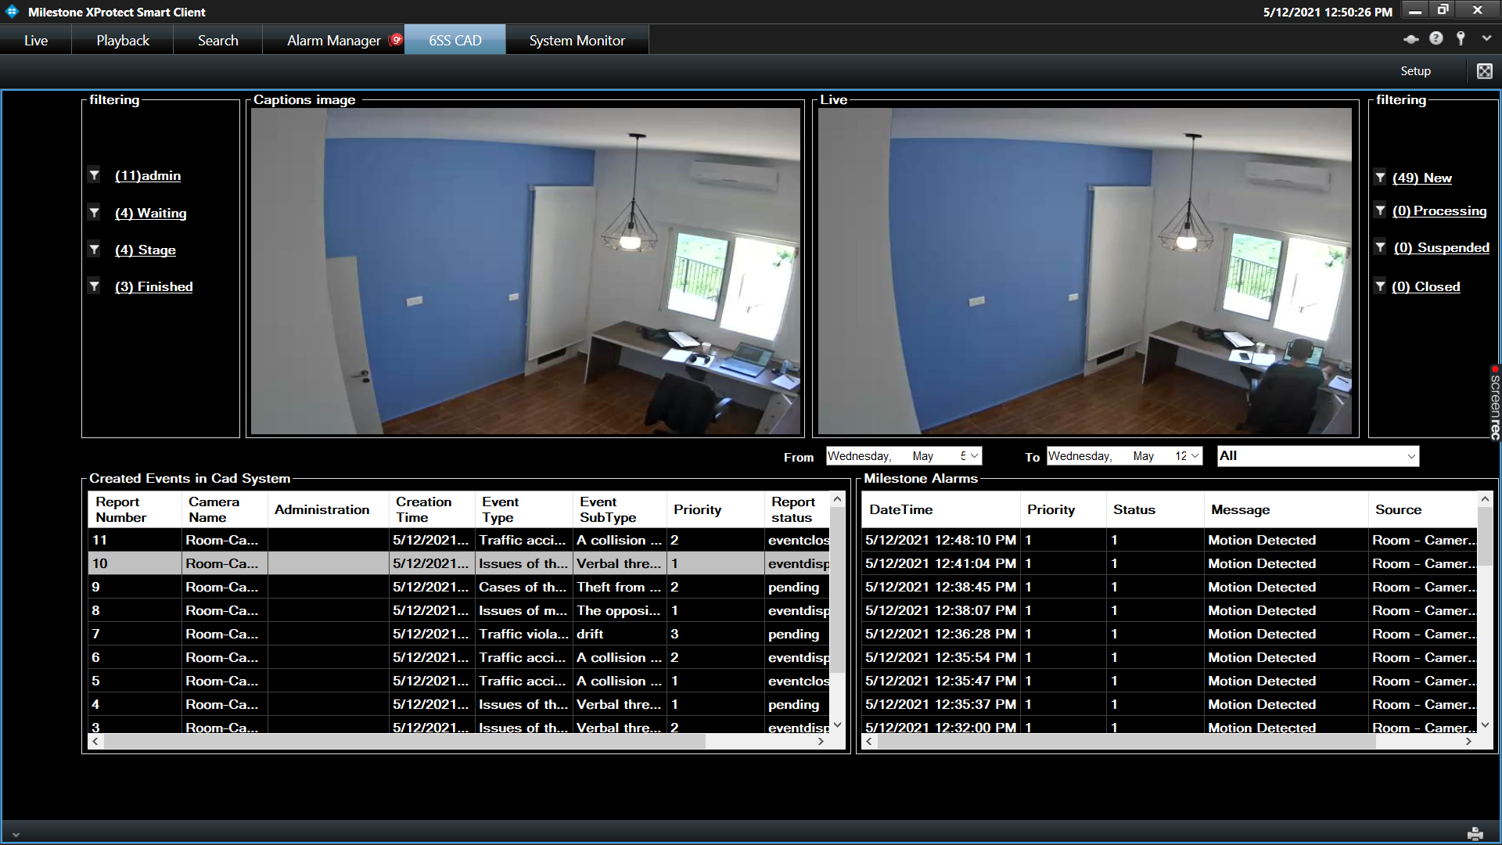

Operator can filter alarms by setting the interval of time he is interested in.

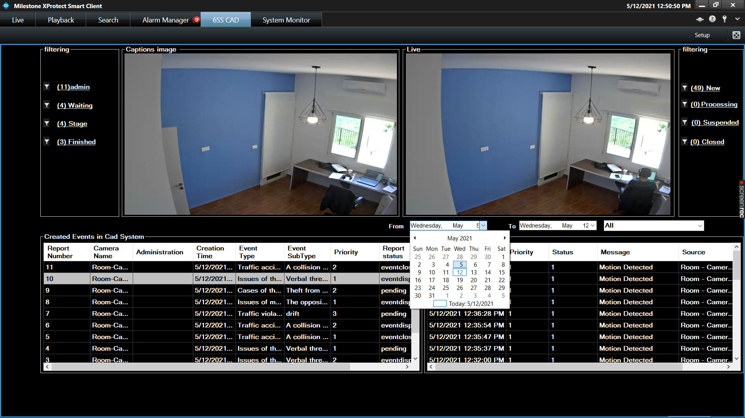

Moreover, operator have the option to choose the type of alarm to be showed in the table.

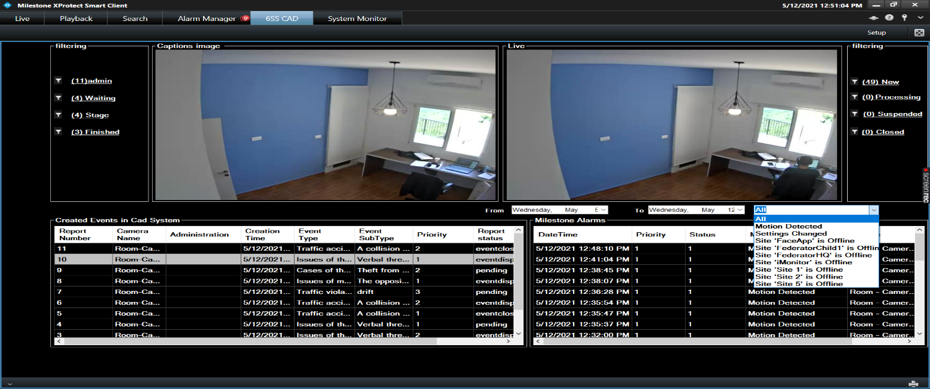

By right clicking on any row in Milestone Alarms, the operator will have the option to set the status of an alarm, or he can create an event in the CAD system.

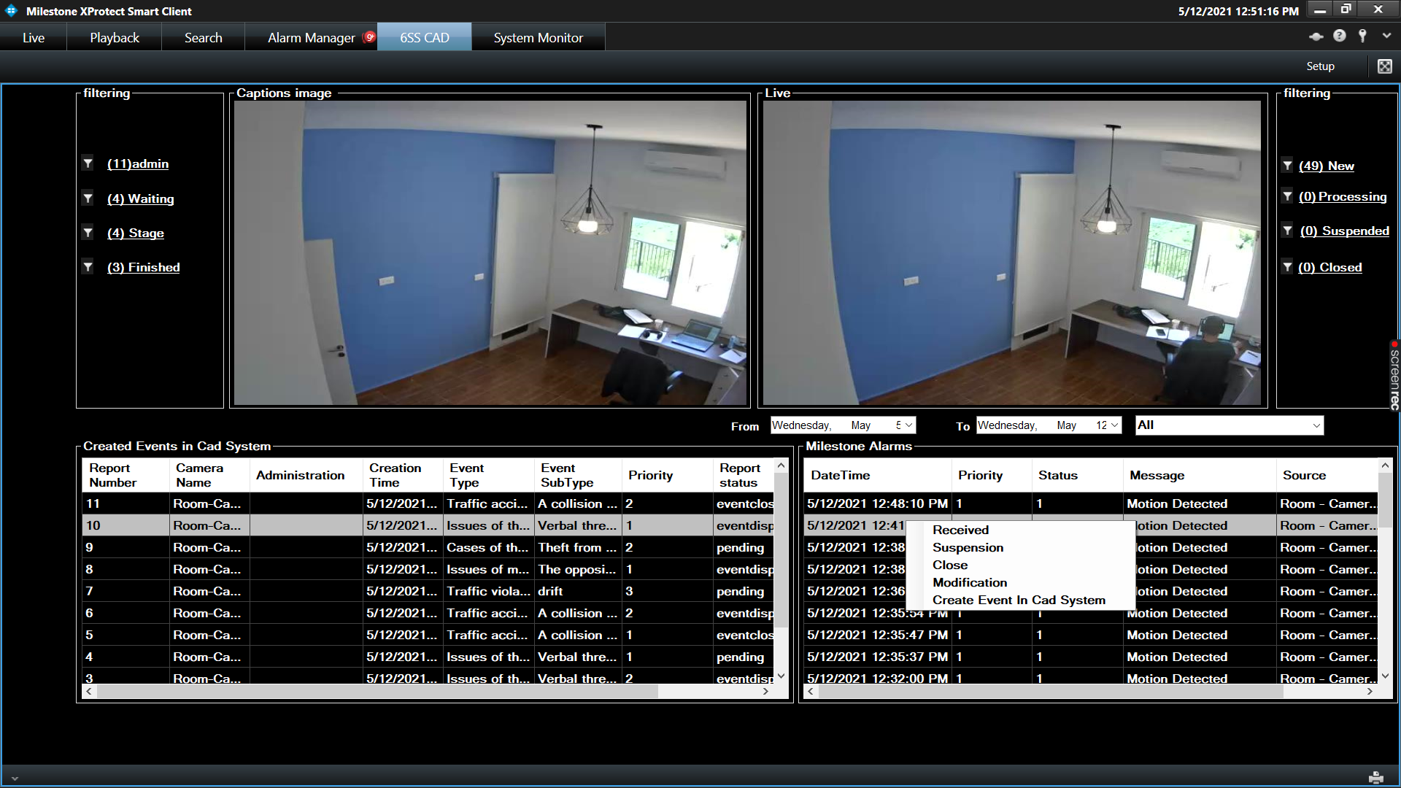

Upon clicking on “Create event in CAD Systems”, a popup window will appear where operator can add description for his event, in addition to specifying the event type, subtype and priority.

Attachment could also be added to an event.

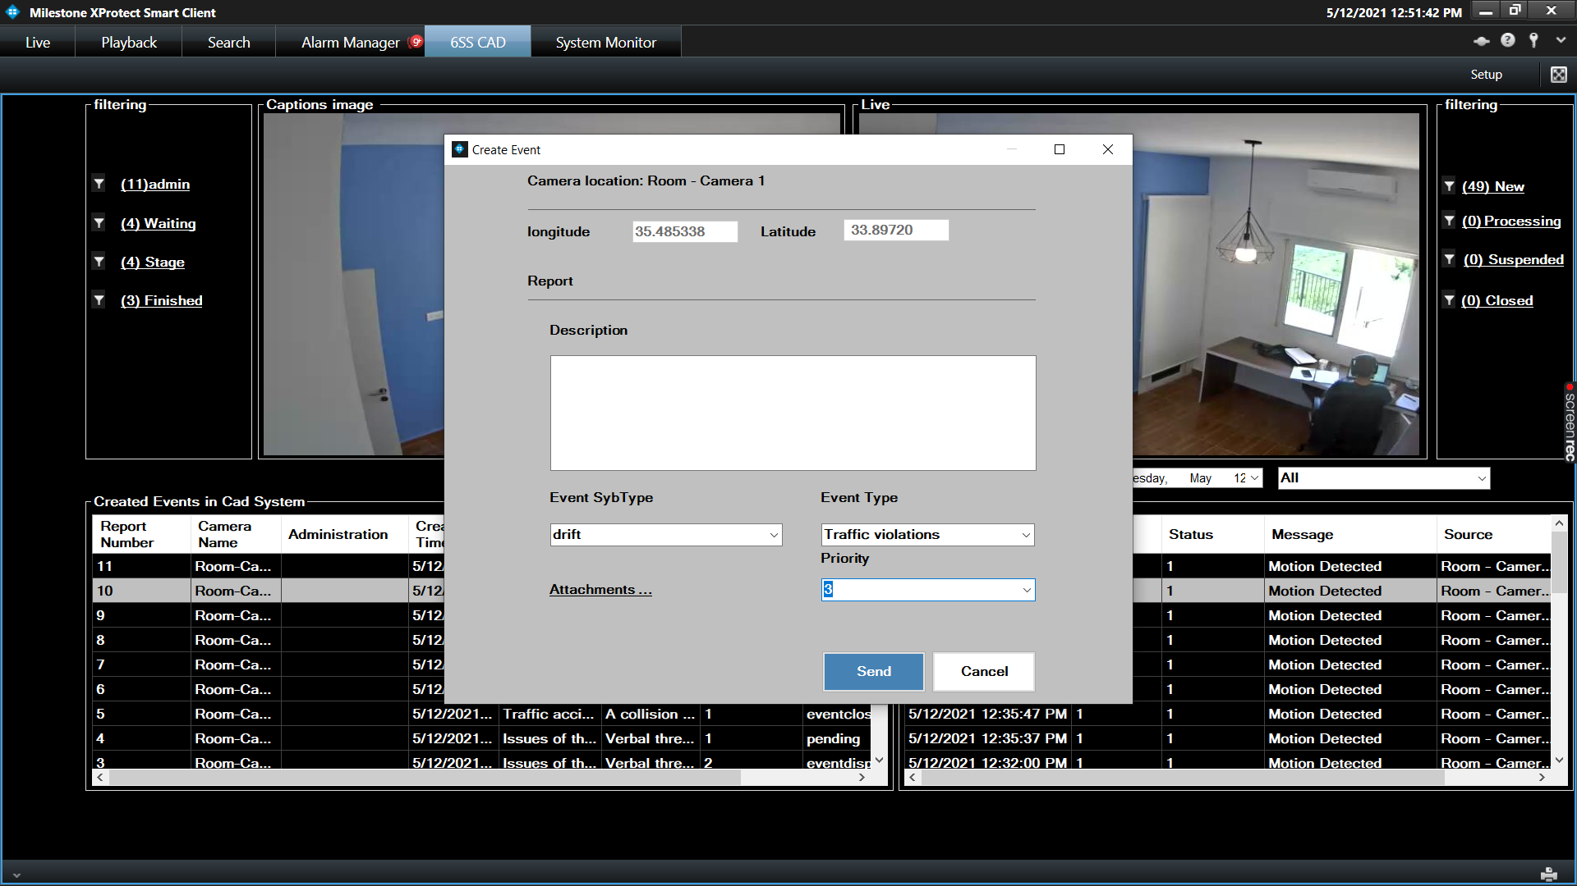

By double clicking on any row in Milestone Alarms, a popup window will appear showing a live feed from the camera, in addition to a playback video where you can retrieve snapshots.

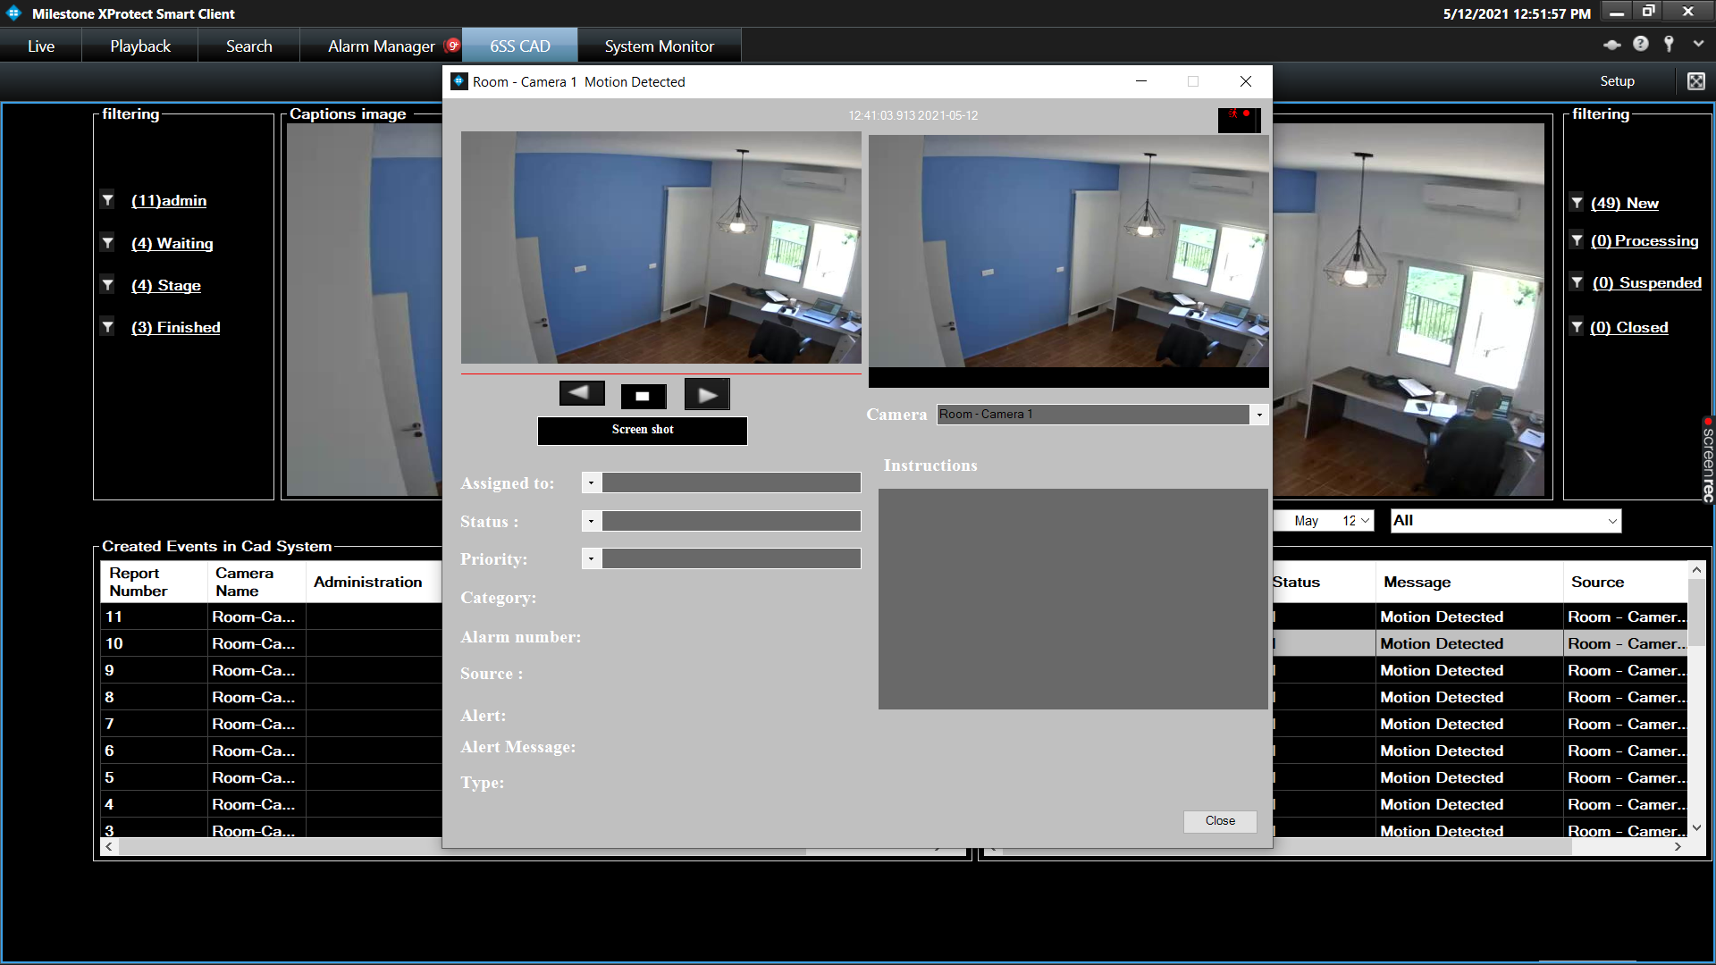

Operator can add attachment or remark to an event created in CAD System by right clicking on the Event row.

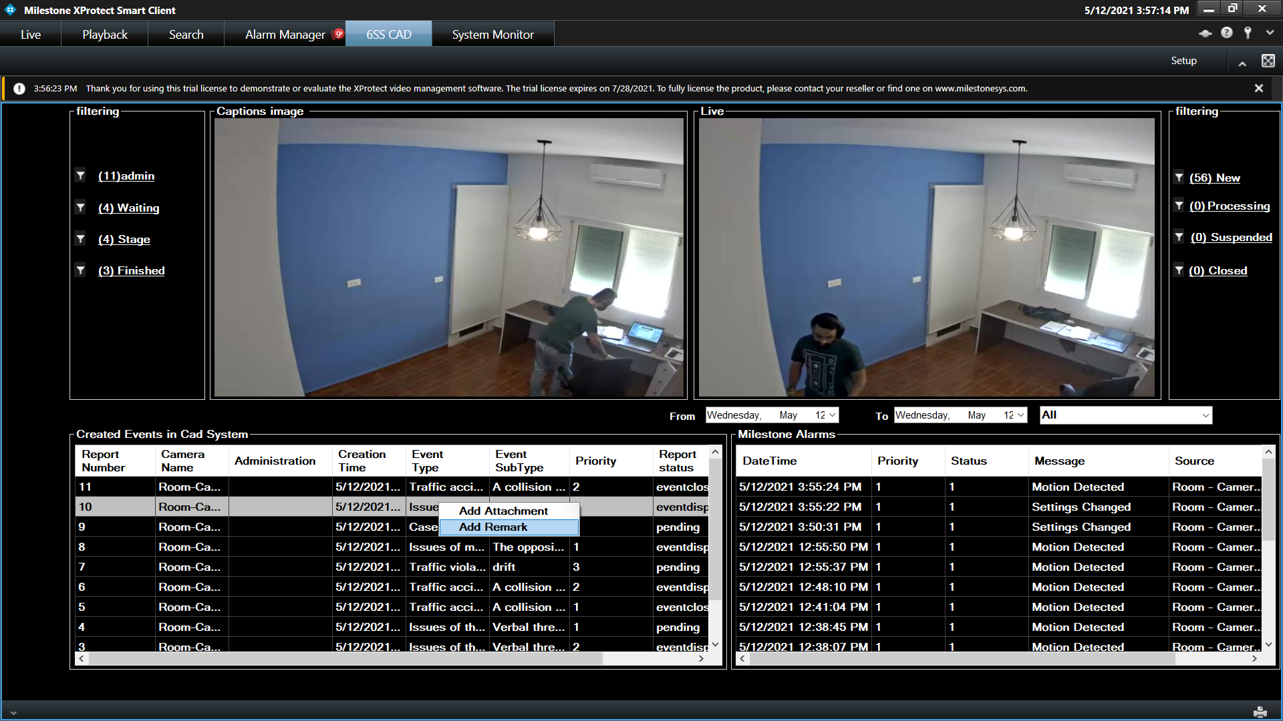

By clicking on add remark option, a popup window will appear where the user can add his own remark to an event in CAD system.

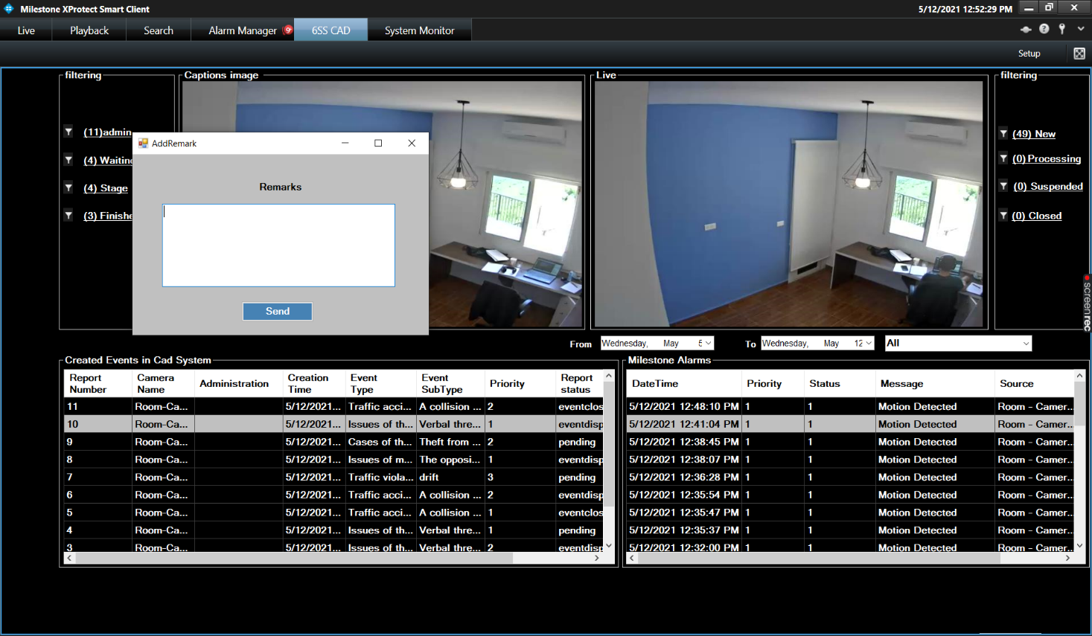

By clicking on the add attachment option, a new form will show up where the user can add his own attachment to an event in CAD System.

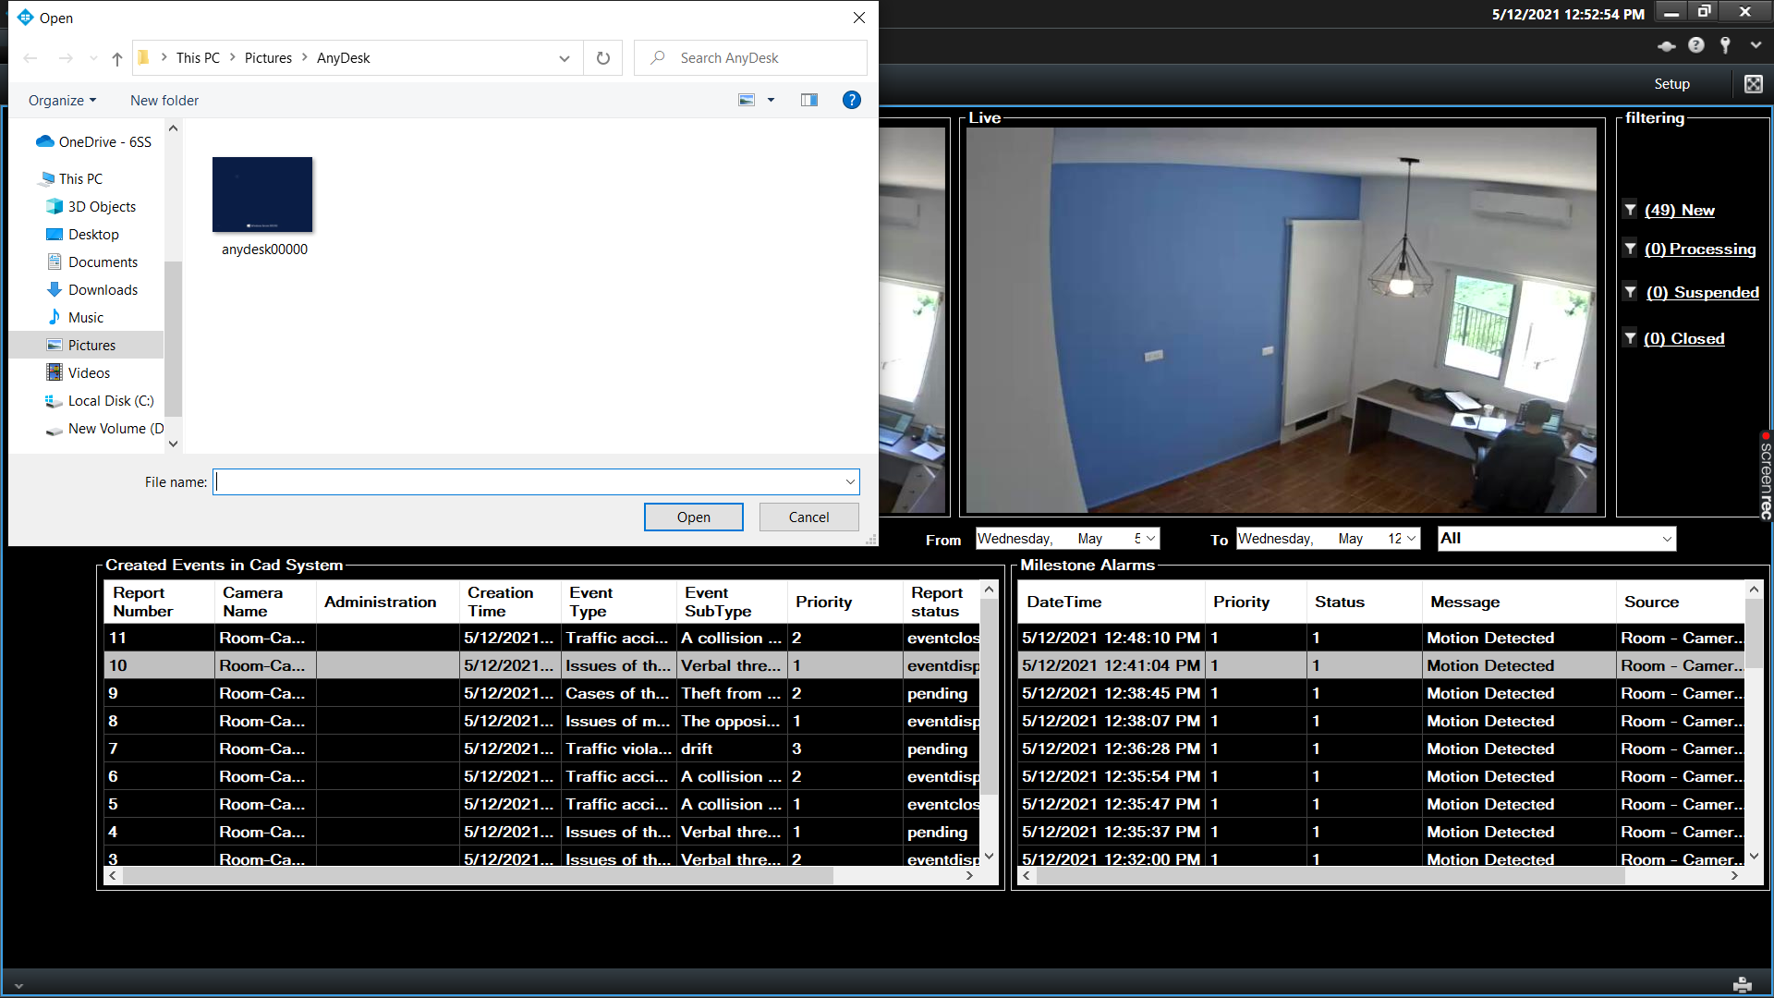

Operator can filter Events by their status. For example, if an operator clicks on the waiting button inside the Left filtering box, CAD system events that are pending will only show in the table. Same option is available for the Milestone Alarms.

