|  |
| --- |
| Installation Guide |
|  |
|  |
| Milestone XProtect® on HPE SimpliVity |
|  |
|  |
| Prepared by: |
| Solutions team, HPE SimpliVity |



Table of Contents

Overview 2

Licensing 2

Design 2

Installation 3

Other Considerations 3

# Overview

This document gives the details/instructions to install and run Milestone XProtect® on HPE SimpliVity

# Licensing

Below are the list of HPE SimpliVity and Milestone versions supported as part of the current release.

|  |  |
| --- | --- |
|  | Versions Supported |
| HPE SimpiVity Omnistack | 4.0.0 |
| Milestone XProtect® | 2020-R1 |

# Design

Based on the hardware and licenses available, follow the standard design as suggested in the Milestone XProtect® installation document.

HPE SimpliVity has verified the Milestone solution for Separate (Management and recording servers on separate hosts) setup.

The following diagram shows the setup used while verifying the hardware but keep in mind that this is just for reference and the setup can be done case to case based on the need.

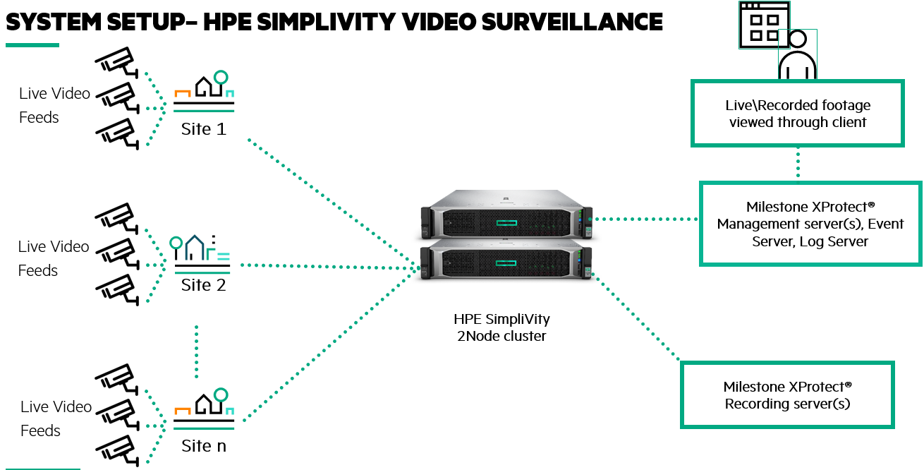

# 

# Installation

Please follow the steps mentioned in the Milestone XProtect® installation guide. There are no changes to be made specific to the HPE SimpliVity environment.

# Other Considerations

HPE SimpliVity does not recommend any other optimizations or considerations to be made to the Milestone XProtect® application other than what is already recommended by Milestone. Please make sure the right set of recommendations from Milestone are applied particular to your use case, in order to find optimal results.

Do visit <https://www.hpe.com/us/en/integrated-systems/simplivity.html> for more information on HPE SimpliVity and reference architecture for Video monitoring based use cases.

|  |  |
| --- | --- |
|  | About HPE Simplivity  At its most basic, hyperconverged infrastructure combines physical servers and storage with data services inside a single chassis or hyperconverged node. Whereas other brands converge only part of the infrastructure, HPE SimpliVity converges the entire IT stack in each node, consolidating as many as 10 devices and apps in a simple, powerful building block for virtualised environments. Architected to empower the VM administrator, HPE SimpliVity improves the management, protection, efficiency and performance of virtualised workloads.  <https://www.hpe.com/us/en/integrated-systems/simplivity.html> |
|  |  |
|  | About Milestone  Milestone Systems is a leading provider of open platform video management software; technology that helps the world see how to ensure safety, protect assets and increase business efficiency. Milestone enables an open platform community that drives collaboration and innovation in the development and use of network video technology, with reliable and scalable solutions that are proven in more than 150,000 sites worldwide. Founded in 1998, Milestone is a stand-alone company in the Canon Group.  [www.milestonesys.com/community/marketplace](http://www.milestonesys.com/community/marketplace) |

