|  |
| --- |
| **TIL Technologies Access control Milestone XProtect Access Integration Installation guide** |



VERSION 1.0 December 2019

Table of Contents

Document revision 3

Introduction 4

Copyright, trademarks & disclaimer 4

Targuet audience 4

Solution overview 4

Prerequisites 4

Installing 6

Associating Cameras with Doors 11

Access Control properties 12

Milestone Xprotect Smart Client configuration 15

Monitoring installation with Xprotect Smart Client 17

APPENDIX 21

|  |  |  |
| --- | --- | --- |
| *Document Revision History* | | |
| **Date** | **Version** | **Description** |
| 16/12/2019 | 1.0 | Initial version |
|  |  |  |
|  |  |  |
|  |  |  |
|  |  |  |
|  |  |  |
|  |  |  |

# Document revision

# Introduction

Integrating TIL Technologies MICRO-SESAME acces control system in Milestone NVRs enables you to associate the camera images provided by Milestone with access control information from MICRO-SESAME in a single client user interface.

The standard display of people information, such as name, department or photos as well as controls like door lock and unlock will help to optimize work processes, improve control over premises and increase the global security level of buildings.

This is an installation and configuration guide showing how to install and configure the integration of a TIL Technologies MICRO-SESAME Access Control system in Milestone XProtect NVRs.

# Copyright, trademarks & disclaimer

**Copyright**

© 2019 TIL Technologies www.til-technologies.fr

**Trademarks**

XProtect is a registered trademark of Milestone Systems.

Microsoft and Windows are registered trademarks of Microsoft Corporation.

All other brands and trademarks mentioned are trademarks registered by their respective owners.

**Disclaimer**

The information in this manual is subject to change without notice.  
The information given in this document as examples, can not in any case commit the  
responsibility of TIL TECHNOLOGIES. The companies, names and data used in the examples are fictitious, unless otherwise notified.  
All the brands mentioned are trademarks registered by their respective owners.  
No part of this document may be altered, reproduced or transmitted in any form and  
any means whatsoever without the express permission of TIL TECHNOLOGIES.

# Targuet audience

This installation guide is aimed at Installers and System Administrators

# Solution overview

This solution is a joined project between TIL Technologies and Milestone System.

# Prerequisites

TIL Technologies Access Control System, MICRO-SESAME MS 2018.4 and over, with Milestone compatible Door model objects description (JSON Milestone Door model available).

Supported Microsoft Windows Operating Systems and Database Management Systems for Micro-Sésame (for Milestone refer to Milestone support documentation)

* Windows 10 Pro or Entreprise 64 bits
* Windows Server 2019 Standard or Essential Edition
* Windows Server 2016 Standard or Essential Edition
* Windows Server 2012 R2 Standard or Foundation Edition

Microsoft SQL Server 2017, 2016, 2014, Oracle 12.1c

Supported Milestone Systems:

Milestone 2018, 2019:

* XProtect Corporate
* XProtect Expert
* XProtect Professional+
* XProtect Express+

A Milestone ‘Access control door’ license corresponding to the number of doors to control, is required.

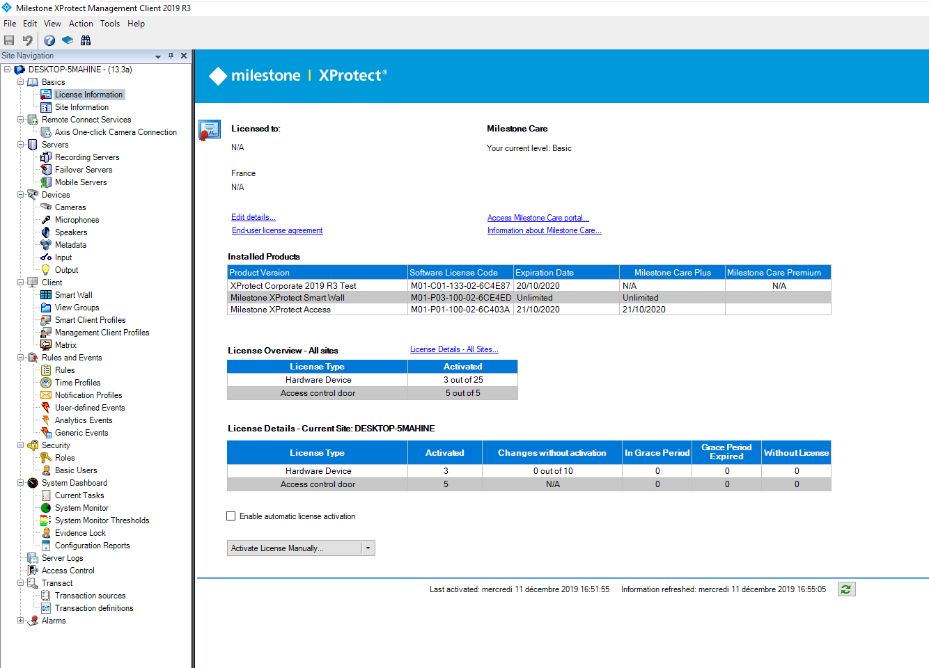

# Installing

Ask TIL Technologies support team [support@til-technologies.fr](mailto:support@til-technologies.fr), for the files needed for Milestone Access Control plugin connectivity.

Connect to Milestone Server :

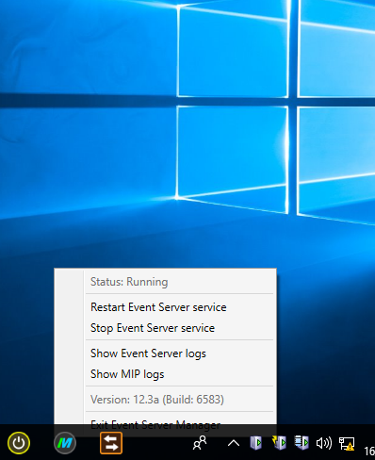

Click to Stop Event Server Service (you must have sufficient rights to do this)

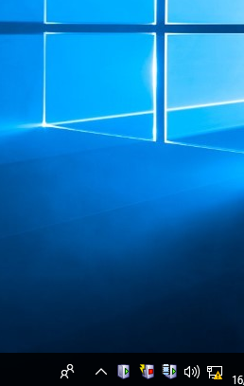

Milestone Event Server Service stopped

Copy files for Milestone Access Control Plugin

Directory path to install files

On the Milestone NVR, directory

C:\Program Files\Milestone\XProtect Event Server\MIPPlugins\_MIPMicroSesameAccessControlPlugin

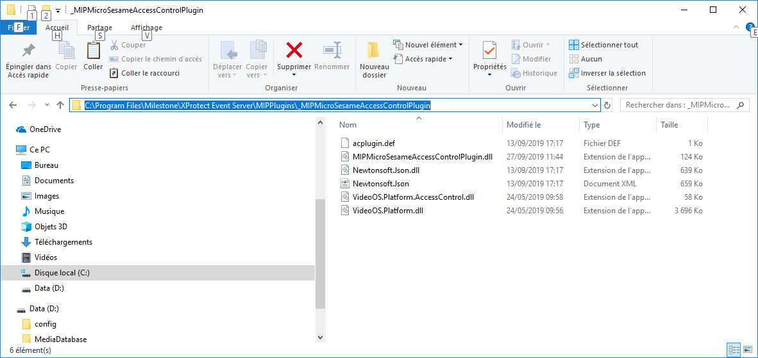

Copy TIL Technologies files here

Re-Start Event Service

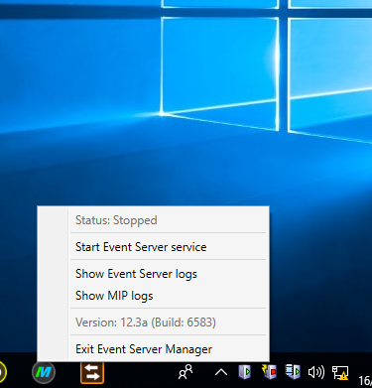

Start Event Server Service



Event Server Service running

Run the Milestone Management Client and create a new Access Control system integration

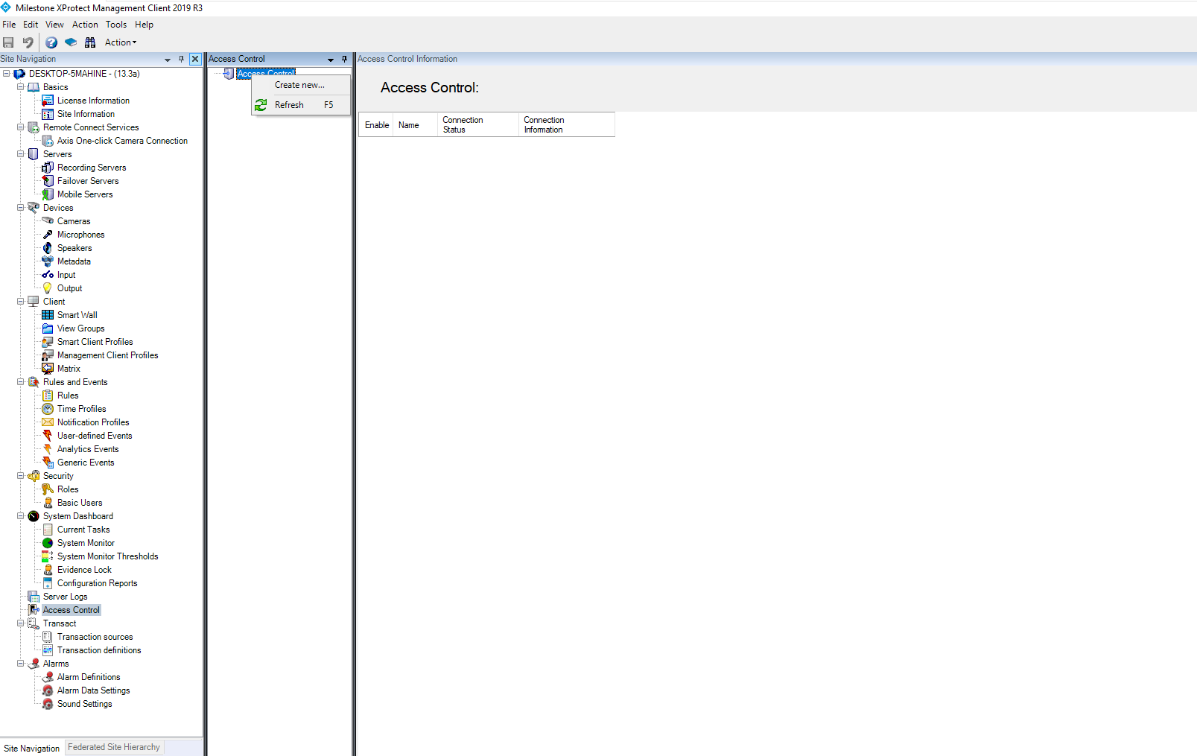

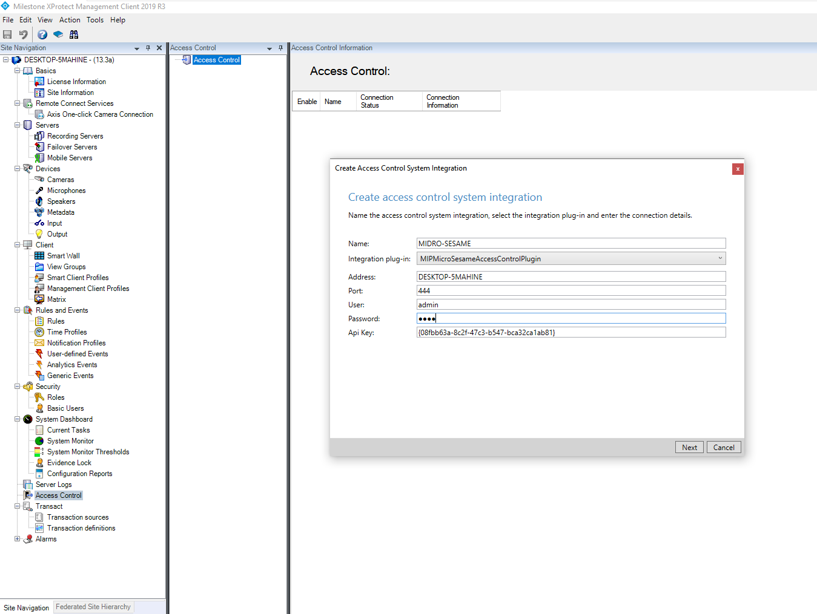

Click next when all information is completed

API Key generated on MICRO-SESAME Server

IP identity of the MICRO-SESAME Server

MICRO-SESAME operateur with access rights to manage MICRO-SESAME data

Name of this connection

* **Name**: The name of the connection
* **Integration Plugin**: Select the TIL Technologies Access integration
* **Address**: MICRO-SESAME Server name or IP address
* **Port**: Port number of the MICRO-SESAME https service (default 443 or other)
* **Username**: MICRO-SESAME operator name with management access rights
* **Password**: MICRO-SESAME operator password
* **Api Key**: API Key generated on MICRO-SESAME, for security purposes (see appendix)

When the connection succeeds , the synchronisation between MICRO-SESAME and Milestone is updated

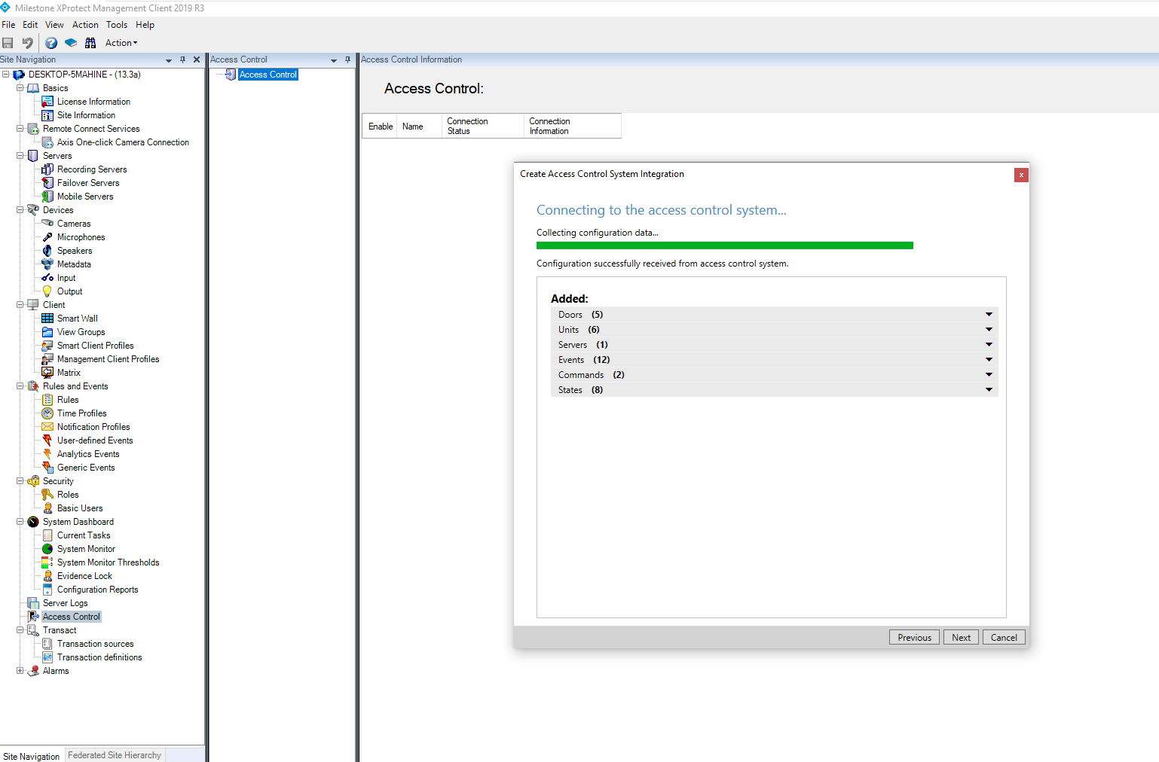

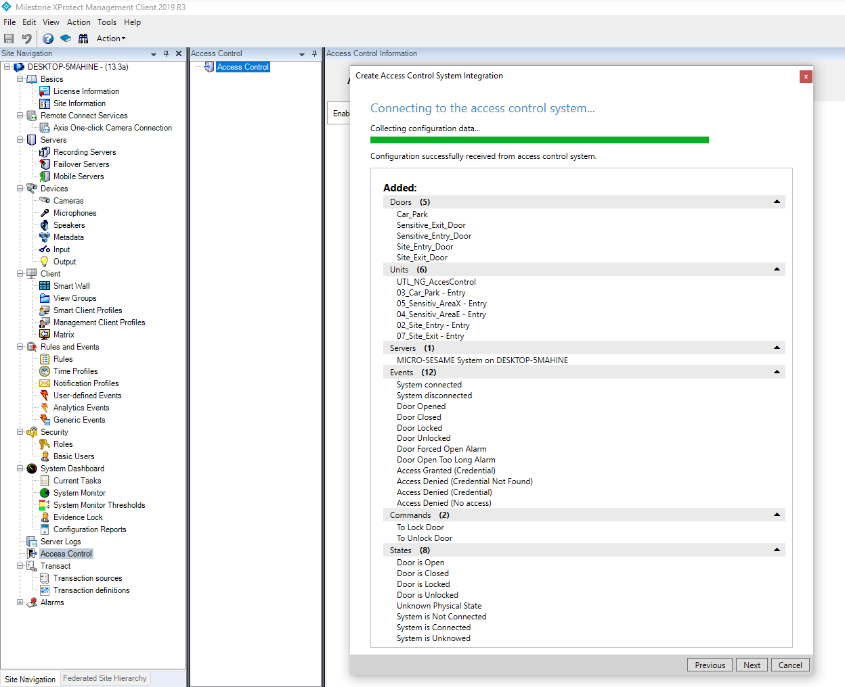

Click next to finish

Details about MICRO-SESAME access control system

If connection fails, see Troubleshooting appendix

# Associating Cameras with Doors

It is possible to associate Cameras and Doors, in order to display images while someone accesses Doors, no, one or more cameras can be associated with each door

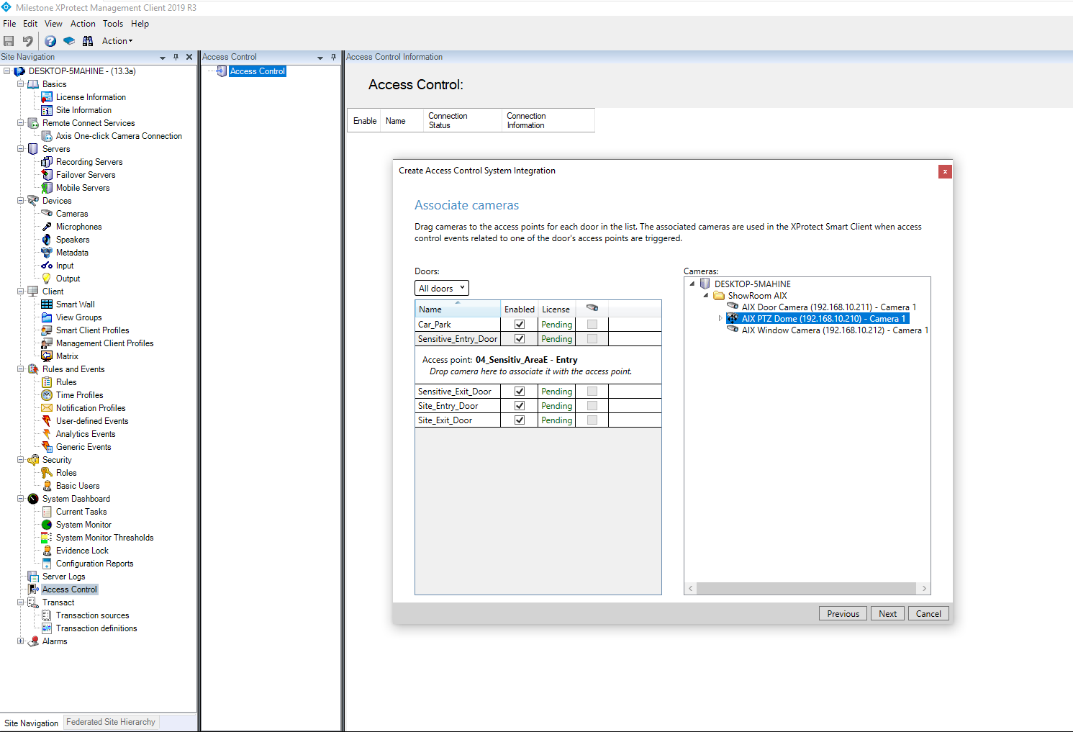

When all cameras have been associated, click next to continue

Click on doors and drag and drop available cameras to associate them to the door

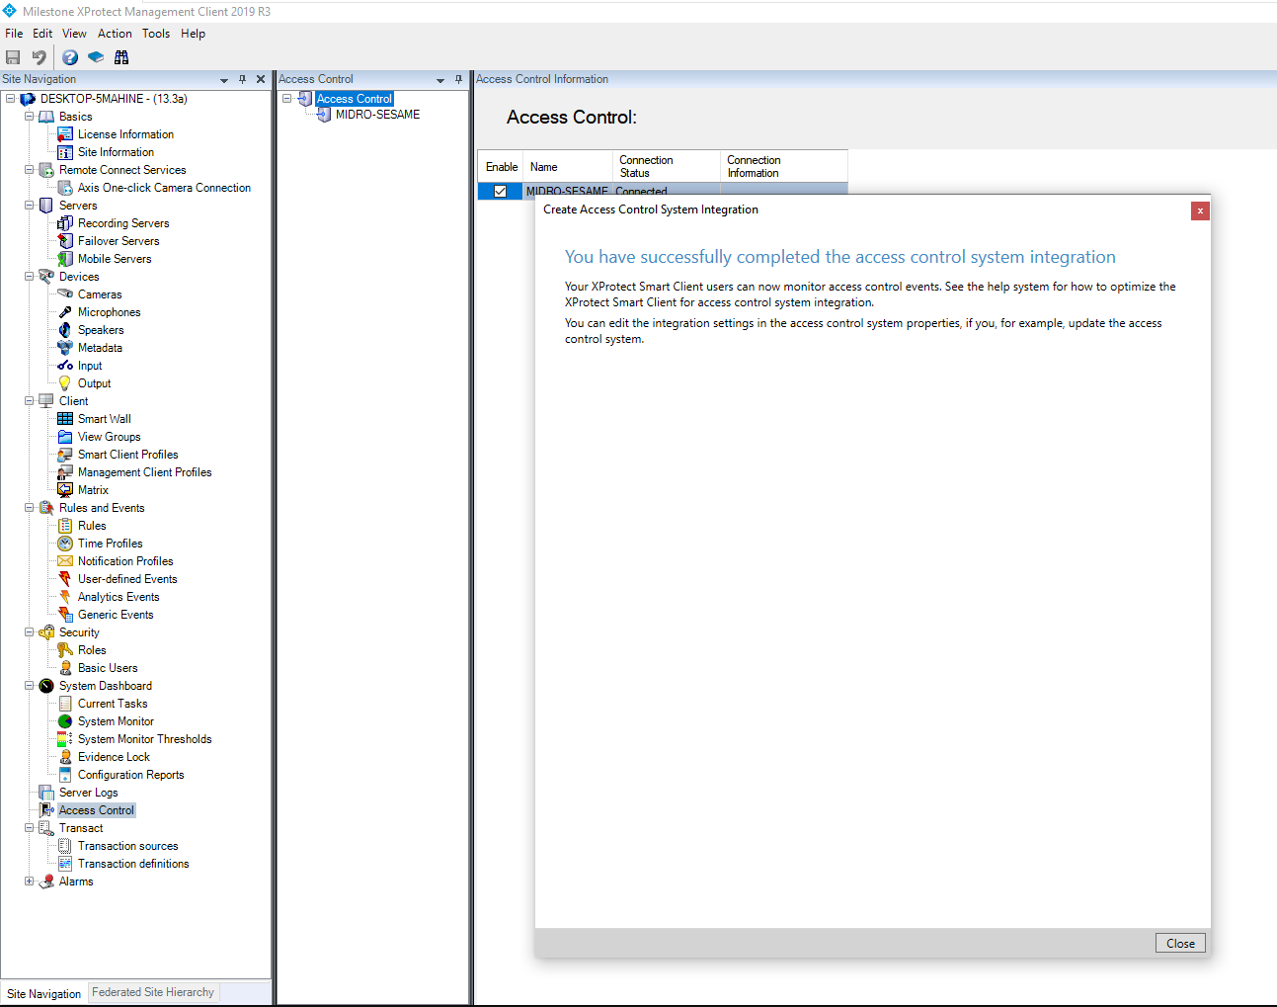

Job done

# Access Control properties

After a successful integration, the access control properties can be accessed by right clicking on the configured access control node, in the Milestone Management Client.

Access control properties are available on 5 panes of the access control node:

* **General Settings**:

The access control name and connection properties can be checked updated here

* **Doors and Associated Cameras:**

Door and camera associations can be checked and modified here. See: Associate Cameras

* **Access Control Events:**

All kinds of available events from MICRO-SESAME, are listed here. These different kinds can be activated or de-activated and assigned to Milestone event categories.

Categories can also be created and assigned to an event kind.

* **Access Request Notifications:**

You can specify access request notifications that appear on the XProtect Smart Client screen when a given event occurs. Refer to Milestone Administration manual.

* **Cardholders:**

Cardholder information can be viewed, and cardholders can be searched for here.

**General Settings**:

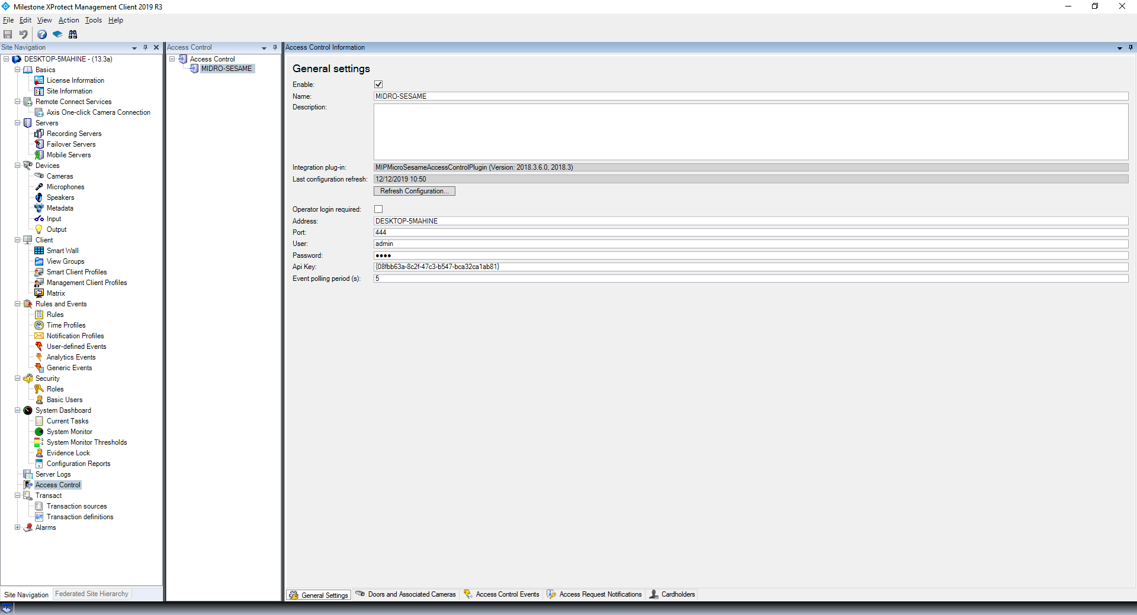

**Doors and Associated Cameras:**

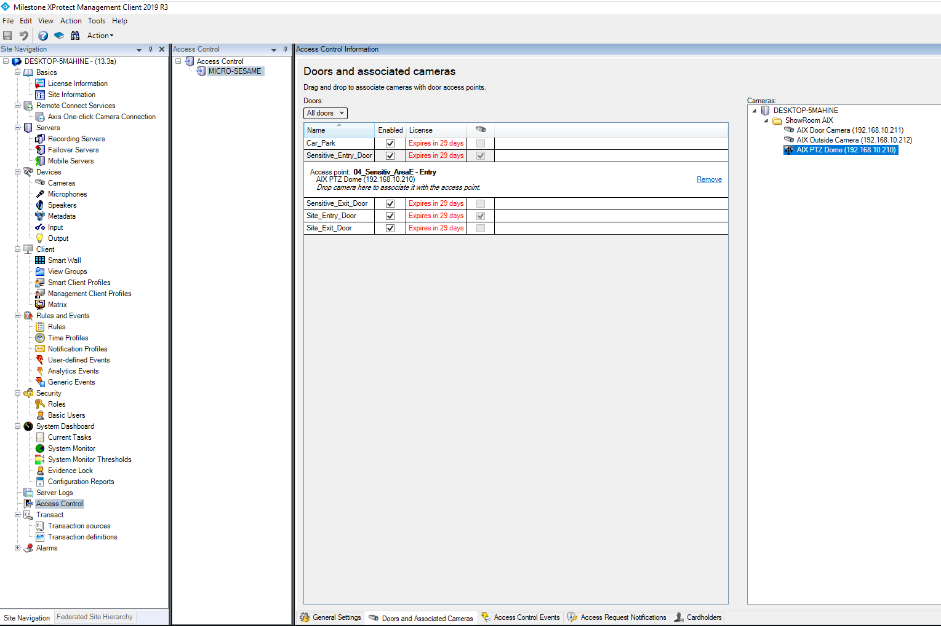

**Access Control Events:**

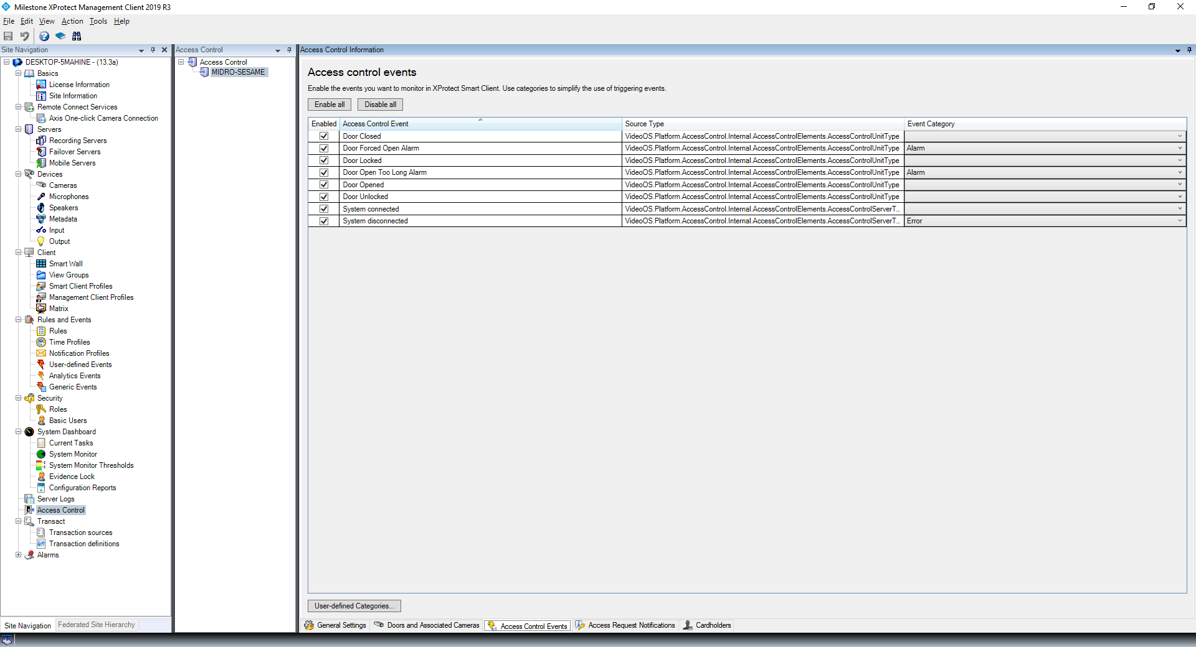

**Access Request Notifications:**

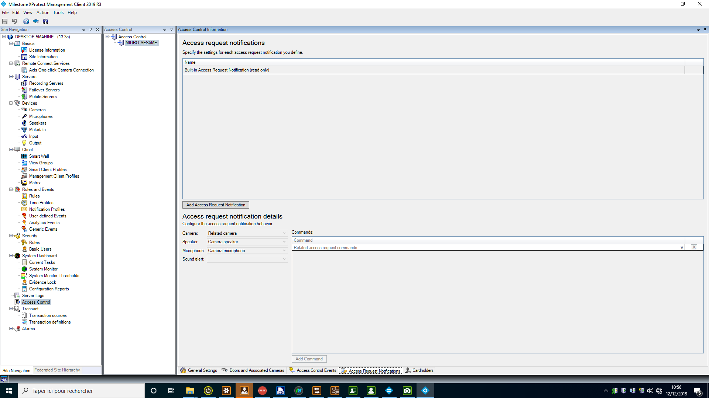

**Cardholders:**

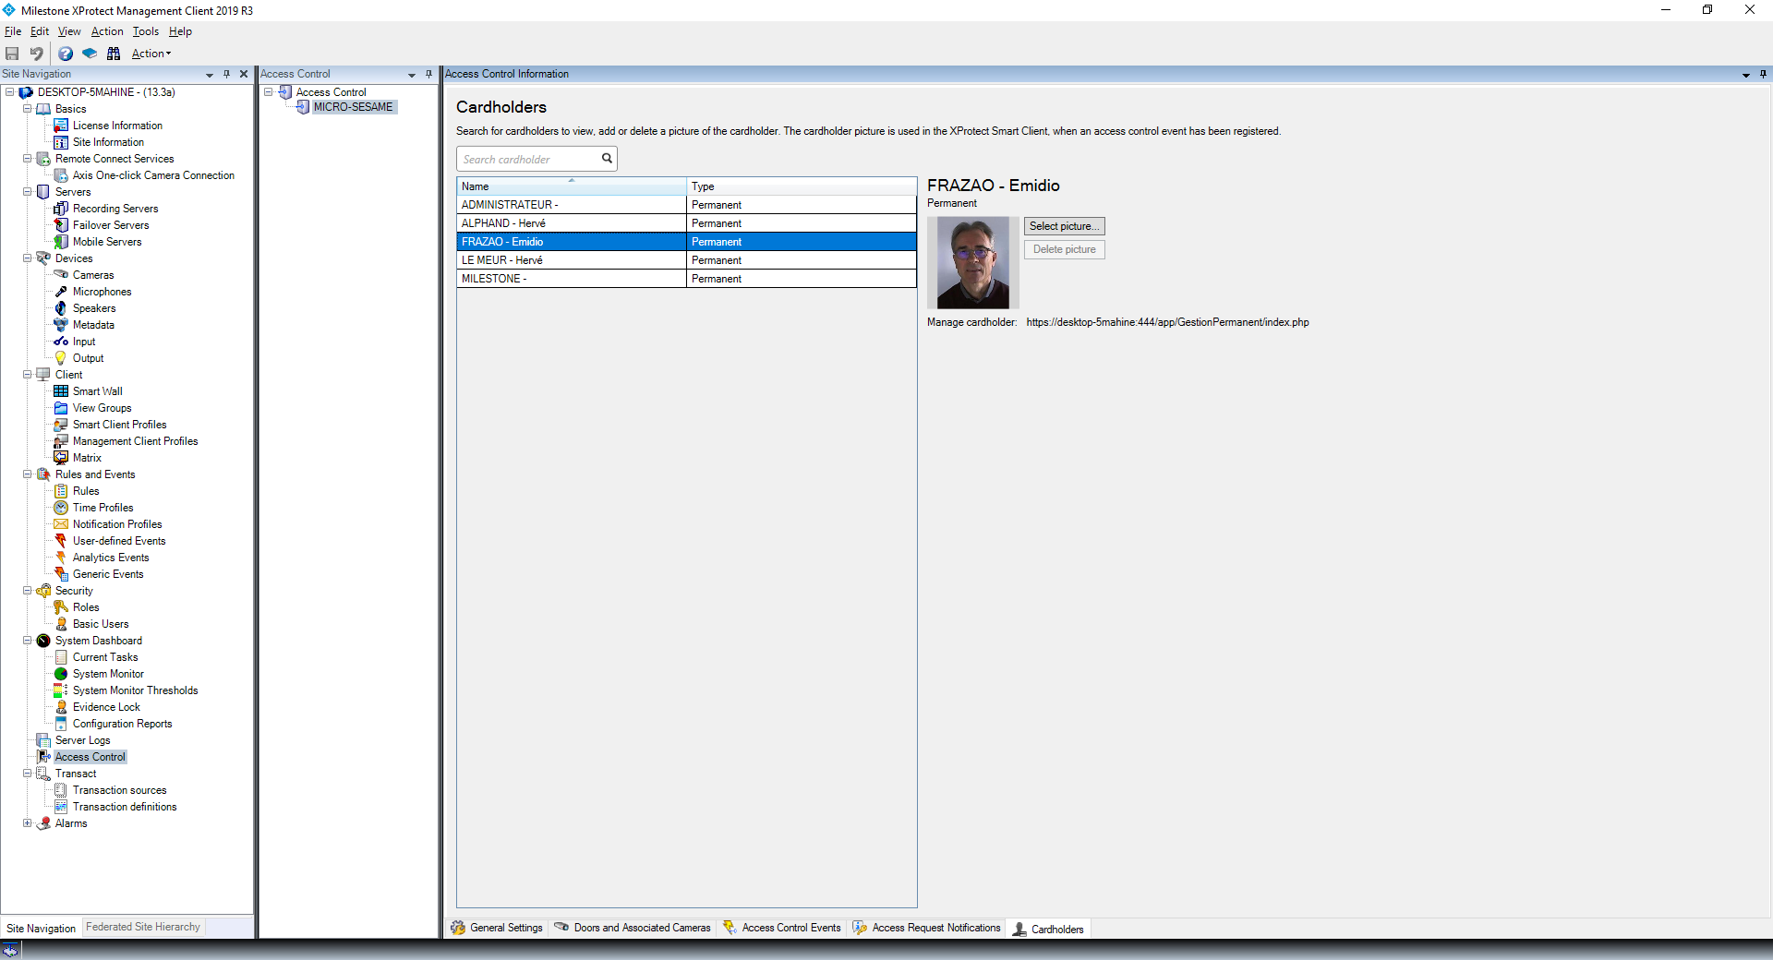

# Milestone Xprotect Smart Client configuration

Start Xprotect Smart Client and click on **Setup** to configure operator’s interface

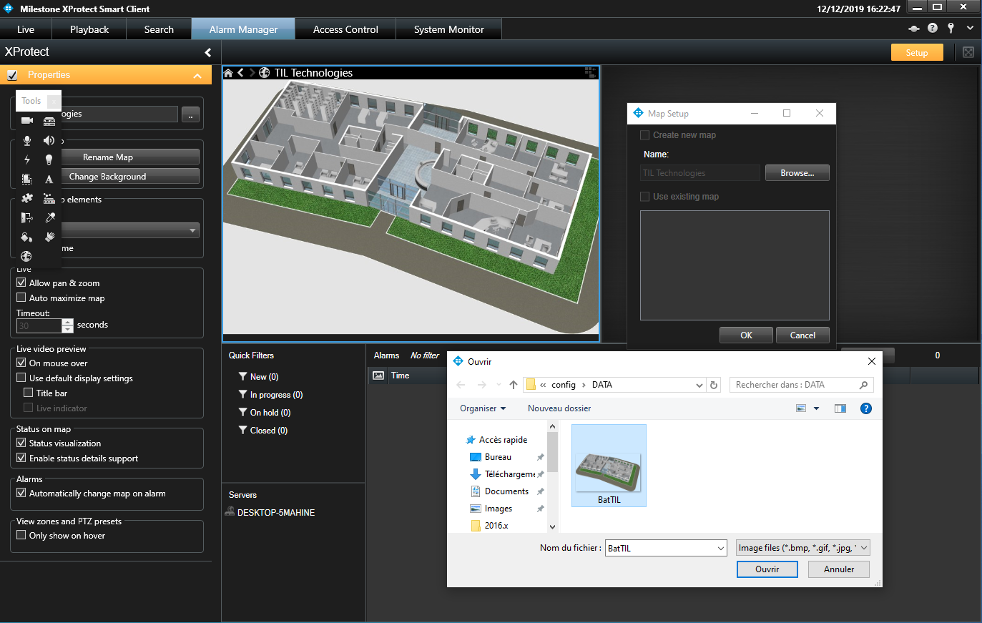

Declare one or several maps

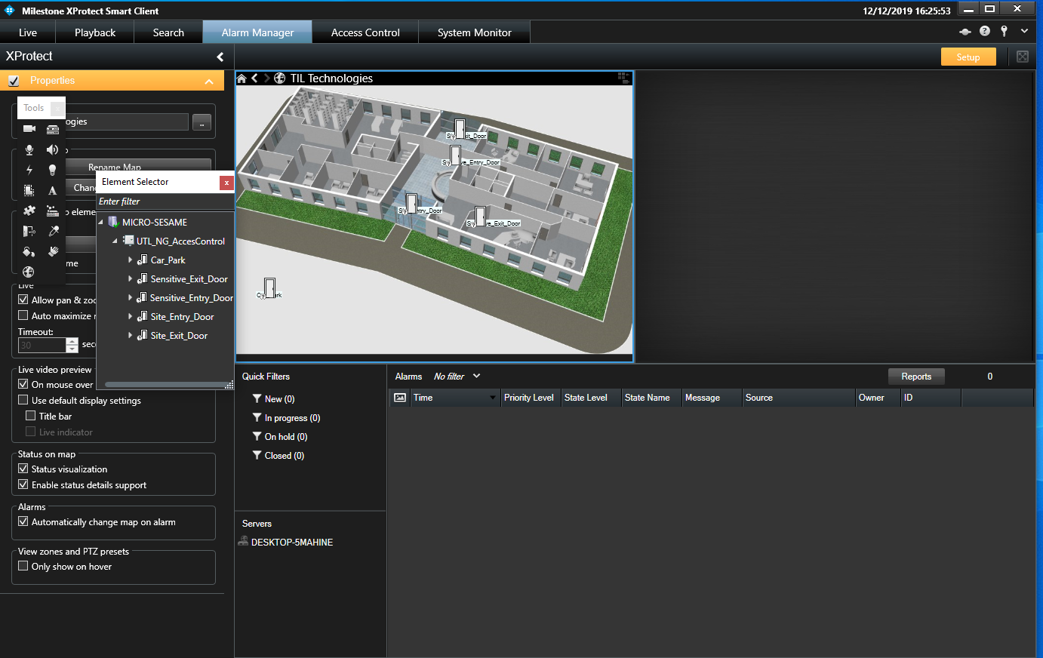

Drag Doors on the maps

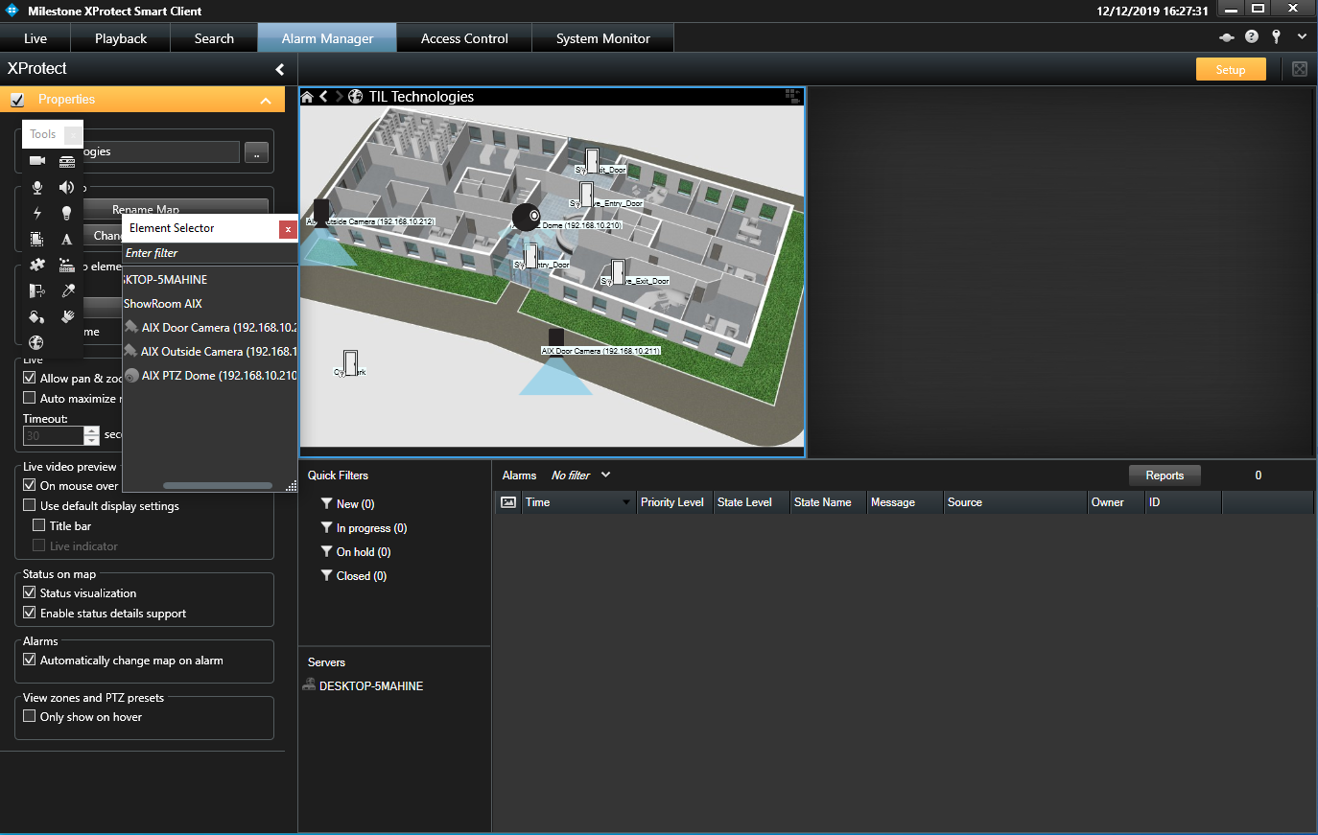

Drag Cameras on the maps

# Monitoring installation with Xprotect Smart Client

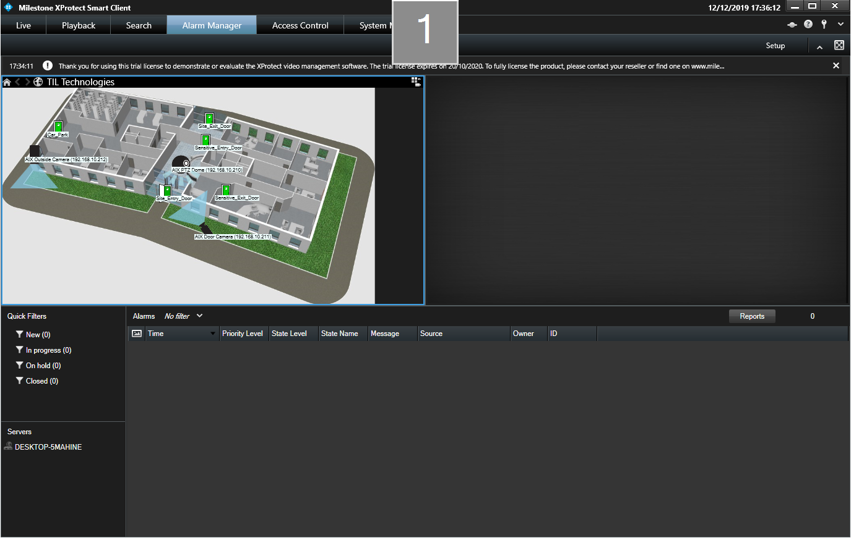

Doors status

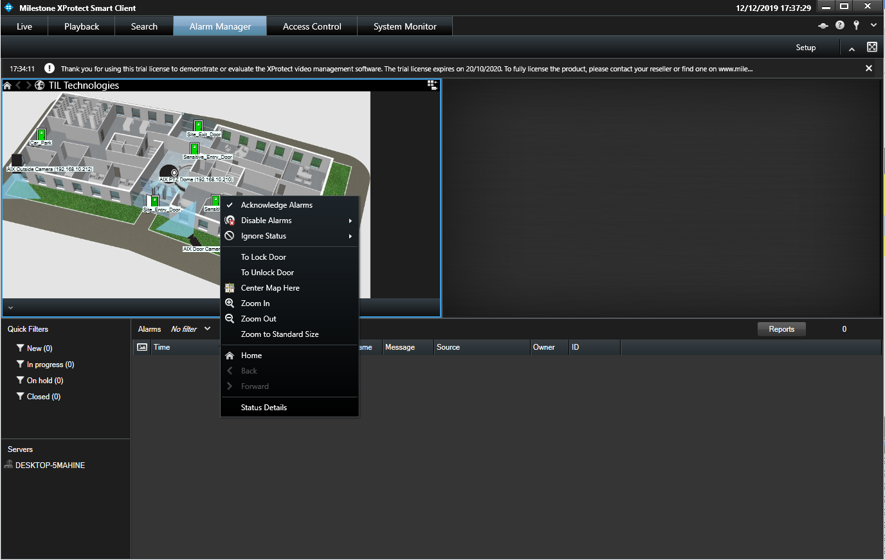

Access control Doors pane

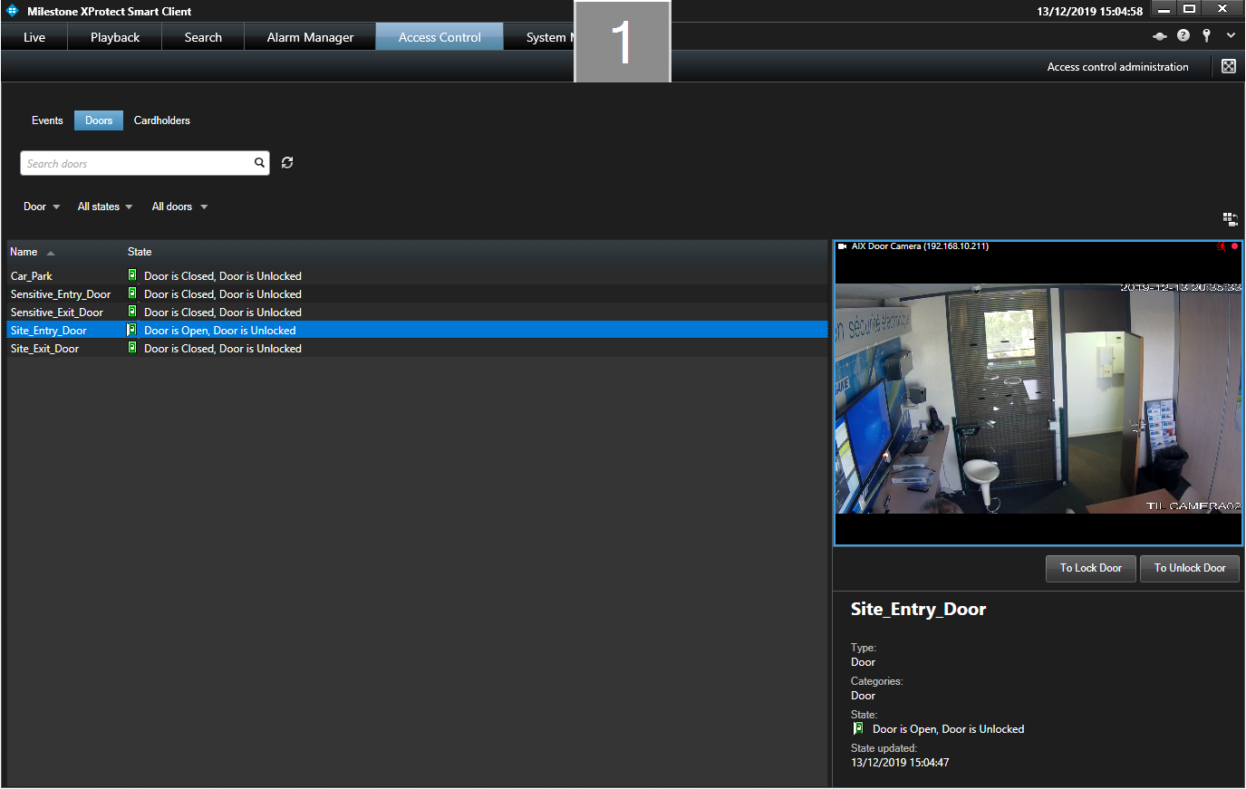

Doors can be Locked or Unlocked from Smart client

Access control Events pane

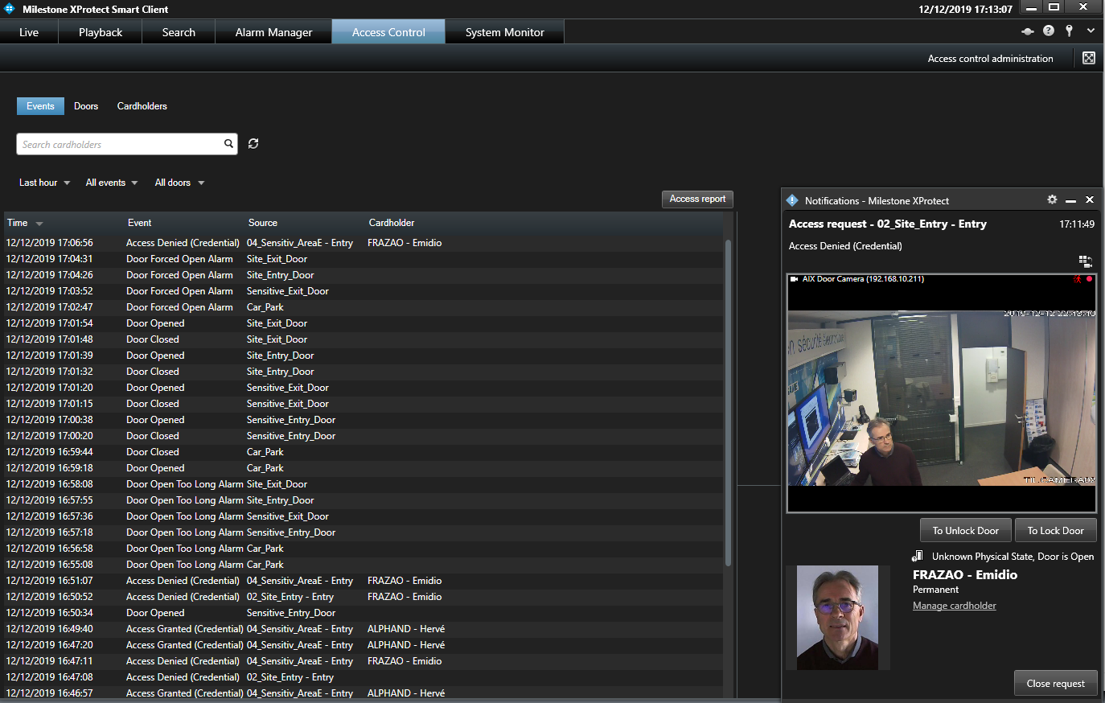

Reports can be printed

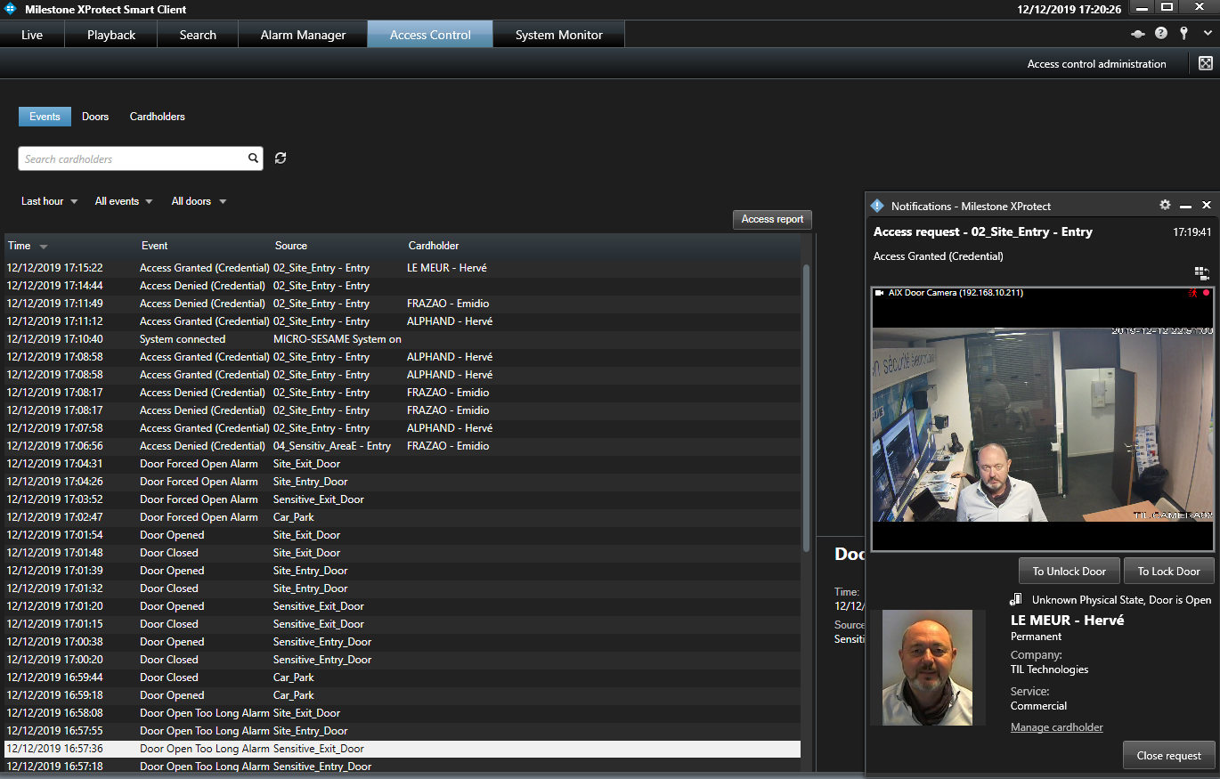

Access control Cardholders pane

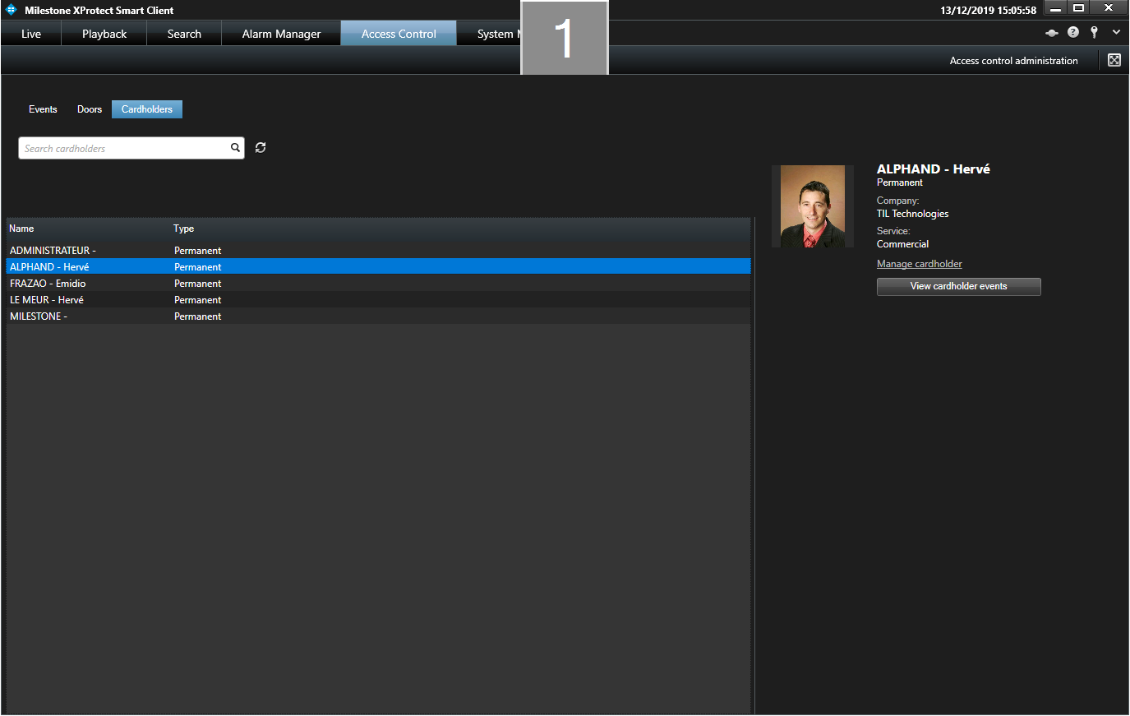

Manage MICRO-SESAME users

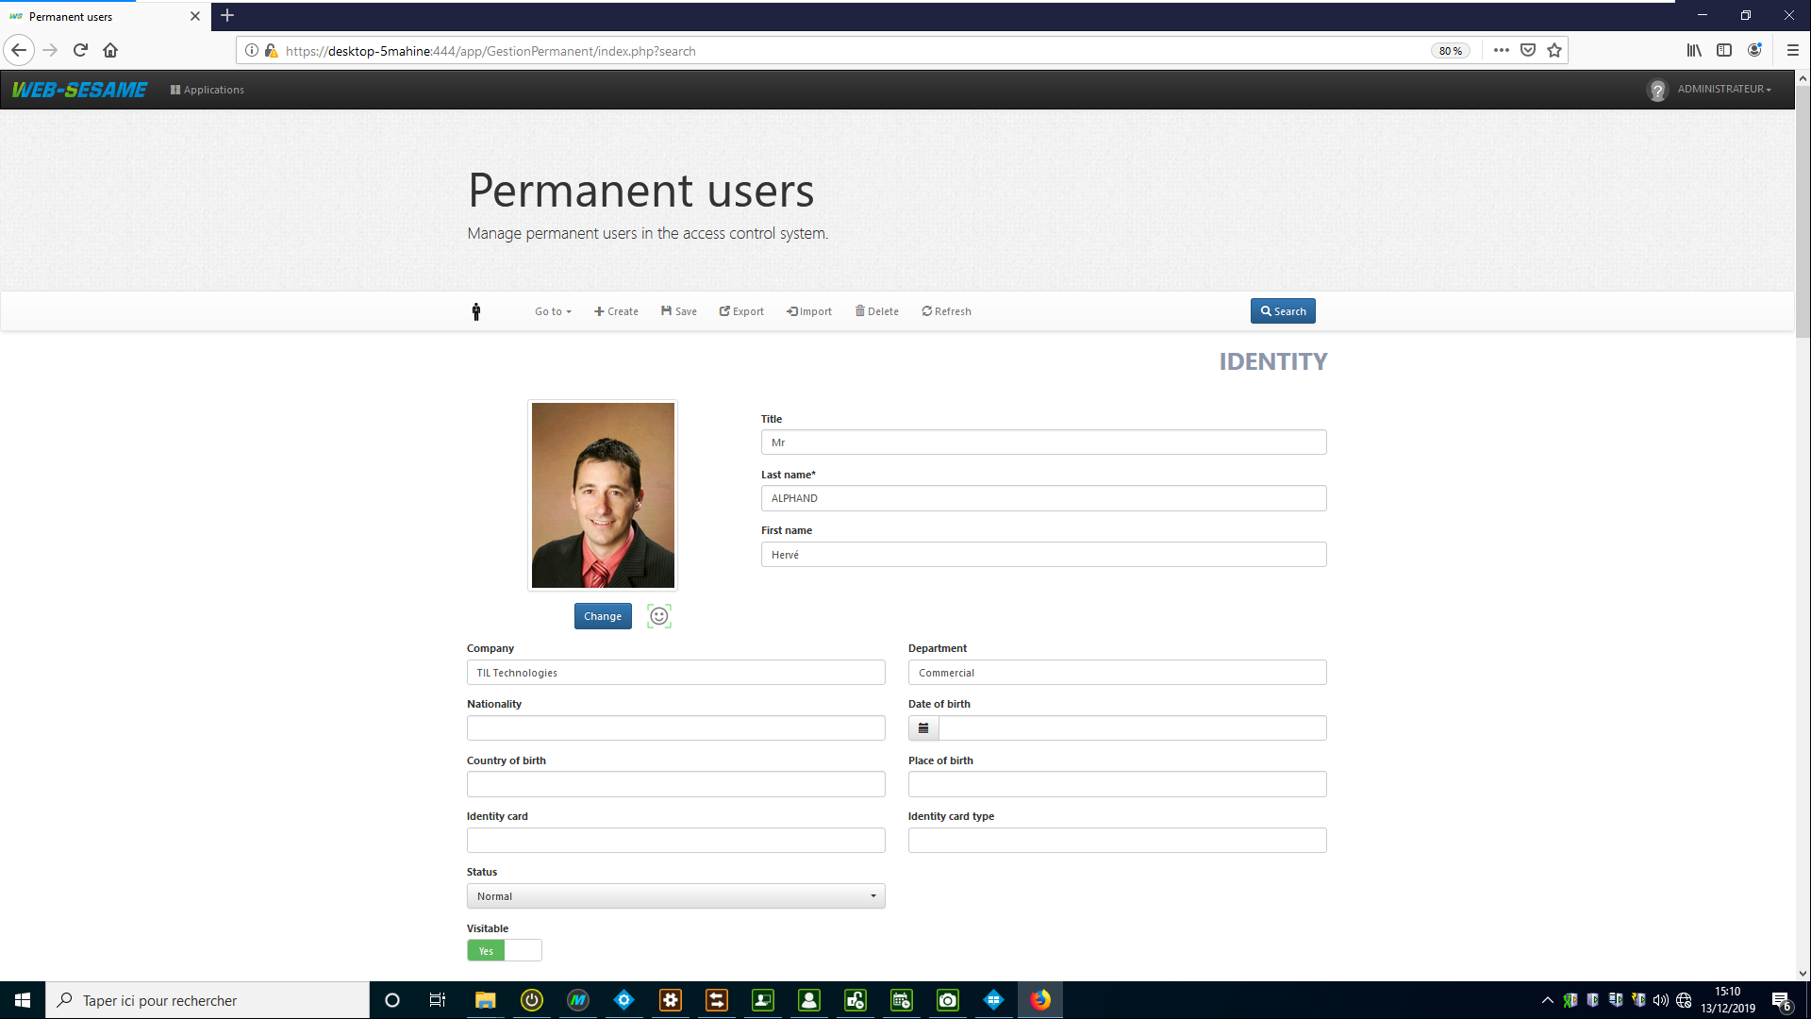

# APPENDIX

**Troubleshooting**

* “No Access Control Plugins Are Available . . .” Message, when attempting to add MICRO-SESAME plugin in the Milestone Management Client.



* If this warning appears, then the Milestone Event Server Service may need to be started for the plugin to be recognised. Starting/Restarting event server can be done from tray icon.
* Check that the MICRO-SESAME plugin package is installed on the Milestone Management Server.

• Connection to MICRO-SESAME server fails while attempting to configure the plugin:

* Ensure that MICRO-SESAME can be reached on the network (use a “Ping” test) and that the local Firewall allows communications.
* Check data consistency, plugin Name**,** MICRO-SESAME Server name / IP address, Https Port number, Username/Password, Api Key.
* Ensure that MICRO-SESAME server is running and that API network services are reachable.

**MICRO-SESAME API Key generation**

This key is necessary to access MICRO-SESAME data from Milestone plugin, in a secured mode.

