Version. 1.05
Last modified on January 02, 2020

Thank you for purchasing NEXX360.
This user manual is designed to keep users safe and to prevent property damage. Please read this carefully before use.
The content of this manual is subject to change without prior notice.

f

01 Summary 4
1. Copyright 4
2. Revision History 5
3. Typographical Convention 6
4. Terms and Definitions 7
02 Safety Precautions 8
1. Product Handling Precautions 8
2. Precautions of radio waves 10
3. Battery Handling Precautions 11
03 About NEXX360 12
1. Product information 12
2. Part names and descriptions 14
3. Product Specifications 18
04 Preparing NEXX360 21
1. Connecting Components 22
2. Power On and Off 24
3. Charging the Main Unit 25
4. Setting up the Viewer Program 26
5. Configuring Product Settings 27
6. Connecting to a Network 38
7. Setting up a Backup Server 47
8. Installing Firmware 49
05 Using NEXX360 53
1. Check Product Status 53
2. Wearing the Product 56
3. Recording 57
4. Transferring Files to the Server 58
06 Viewing Videos 59
1. Viewing Recorded Videos 59
2. Viewing Live Videos 62
3. Controlling Videos 66
07 Troubleshooting 68
1. I want to know my computer IP address. 68
2. My Computer IP Settings 69
3. The time of the video is not correct. 70

08 Warranty 72
1. Warranty terms 72
2. Quality Warranty 73
09 Appendix 74
1. NEXX360 Manager 74
2. Milestone XProtect 90
3. VLC Media Player 99
4. ONVIF Device Manager 100

- Summary
This manual contains information to keep the user safe and to prevent damage to product and property. Be sure to read and understand this manual thoroughly before using the product to ensure proper and safe use.
  - Copyright
The copyright of this manual belongs to Linkflow Inc., the manufacturer of NEXX360 SECURITY. Unauthorized use or reproduction of all or part of this manual without prior permission of Linkflow Inc. is prohibited.
The content of this manual is subject to change without prior notice. If you find an error in this user manual or have any questions, please contact us at the following address:
              - 3F & 4F, InBody Bldg. 54, Nonhyeon-ro 2-gil, Gangnam-gu, Seoul, Republic of Korea
              - Website: linkflow.co.kr
              - Service Center: +82-1833-2526

Ⓒ 2019 All rights reserved by LINKFLOW

  - Revision History
Date | Version | Contents
September 2019 | 1.0 | Initially created
September 2019 | 1.01 | Web settings are added
October 2019 | 1.02 | Manual revision and more information for settings
October 2019 | 1.03 | Changes in Live streaming ID,Password
December 2019 | 1.05 | Modify UI images, revision

  - Typographical Convention
In this manual, the details of the product are described as follows:
Classification | Description
Press the power button. | Indicates the terms that appear on the product or program screen, or selectable menus and buttons.
Go to Help > About to display the program information window. | Displays when you continuously click a menu or button that appears on the program screen.
- Item  - Item  - Item  - Item  - Item | It refers to items that need to be ordered, such as sequential processes or how to use a feature.
- Item  - Item  - Item  - Item  - Item | It refers to items listed in random order.
Caution | Indicates what the user must know when handling the product.
Notice | Indicates the information that users can refer to when handling the product.

  - Terms and Definitions
This document uses the following terms and definitions
Classification | Description
Version | Released number of firmware or client software
Client software | It indicates NEXX360 Manager(NM) in this manual
NEXX360 Manager | Program developed for PC to configure NEXX360 and to play videos,  hereinafter (“NM”).
Cradle | Docking station for Recharging and backup
Device, System, Main System, NEXX360 | It generally indicates NEXX360 device itself on the document
NEXX Streaming Server(NSS) | Server to bypass a firewall(LTE, AP or etc)

- Safety Precautions
Safety precautions describe what users should follow when handling the product, including use, storage and disposal of the product.
Caution | - Please read and understand the safety precautions to ensure user safety and prevent damage to the product.  - Keep this manual in a safe and easily accessible place for everyone.

  - Product Handling Precautions
    - When using the system unit
          - Protect your eyes, ears, or other body parts from damage by the product, and do not put the product in your mouth. There is a risk of serious injury or choking.
          - Be sure to wear clothing to avoid direct contact with the product (NEXX Camera, system unit, external battery, etc.). In particular, the system unit and external battery must be used with the pouch attached. If used in a high temperature environment, or for users with poor blood circulation or with sensory impairment, it may cause a low temperature burn.
          - Be careful not to let the product in use or the AC adapter come into direct contact with your skin. Low temperature burns may occur due to the heat generated when using the product for a long time.
          - If AC adapter and other components get hot, cease use. If not, users may get a low temperature burn or the product may be damaged.
          - Do not use the product where there is a lot of smoke or steam. The product may malfunction or its appearance may be damaged.
          - Use only the original components, batteries and cradles that are approved or provided by Linkflow Inc. Use of unauthorized components may shorten the life of the product or cause damage to the product and personal injury due to overheating, fire, or explosion.
          - We are not responsible for any problems caused by incorrect operation during an update, and this may result in a paid repair.
          - Keep important data separately. We are not responsible for any damage caused by your data loss.
          - Make sure to power off the product before removing Micro SD card. If it is removed while the product is still powered on, it would cause damage to Micro SD card and cause potential malfunction
          - When using the wireless network function, security settings are absolutely important. However, we are not responsible for any security issues that may arise from the network environment and security settings associated with the use of your wireless network.
          - As Micro SD cards are consumable goods, recommend to change Micro SD cards after a certain period (starting from 3 months). Make sure to check the specification of Micro SD cards and use the compatible one. (Micro SD, Max 64GB supported, Class 10)
          - Do not use this product for unauthorized surveillance or confidential purposes or in violation of privacy laws. Such use is often strictly prohibited, which may result in legal liability for the user or administrator.

    - When using the cradle
          - It is recommended to attach the cradle to a glass surface.
          - Do not use any charger other than the dedicated cradle. If you use a different battery charger, there is a risk of explosion and damage to the product.
          - Do not connect the negative and positive terminals of the cradle directly. There is a risk of fire or injury.
          - Be careful not to let conductive foreign objects (liquid, dust, metal powder, pencil lead, etc.) get into the connections of the cradle and neck connectors, and do not poke the connectors with pointed objects or exert force on them. There is a danger of explosion or fire due to corrosion or temporary short circuit of the power terminal.
          - Do not bend, heat, pull or place heavy objects on the power cord. The cord could be damaged, resulting in a fire or electrical shock.
          - Do not charge using a power source other than AC 100V-240V voltage. If so, there is a risk of fire or electric shock.
          - Use the supplied AC power cord, and unplug it from the AC power socket when not using the cradle.
          - When unplugging the AC cord from the power socket, do not pull on the cord. There is a risk of fire or electric shock. Be sure to grasp the plug handle and pull it out of the socket.
          - Do not cover the cradle with clothing or cushions. There is a danger of fire due to overheating or deformation of the product.
          - Do not use a damaged power cord, plug, or loose outlet. If the connection is unstable, there is a danger of fire, electric shock, or injury.

    - When storing and managing the product
          - Do not place the product near heat or fire. It may cause a fire or damage to the product.
          - Do not modify or disassemble the product. There is a risk of fire or electric shock.
          - Be careful not to damage the lens. The lens is made of glass and can be easily broken or damaged.
          - If the ambient temperature is high or the product overheats during charging, charging may be interrupted for your safety.
          - When used in cold areas, the battery life may be reduced even if it is fully charged.

  - Precautions of radio waves
This product uses radio waves in the 2.4 GHz/5 GHz band. When using this product, you do not need a license for radio stations, but be aware of the following:
          - Do not use the product near a car, hospital or medical product that is affected by high frequency (RF) waves. If you have to use a medical device personally, contact the medical product manufacturer to check if it is safe from a high frequency (RF) waves.
          - Use of electronics on an aircraft can affect the aircraft's electronic navigation equipment. Follow the airline's regulations and the crew's instructions on the plane. Even if you are allowed to use electronics during flight, be sure to remove the network dongle.
          - Electronic systems in cars may be affected by the product's high-frequency (RF) waves, which can cause them to malfunction or not function at all. Please contact the automobile manufacturer to check if the car is safe from the product's high frequency (RF) waves.
          - Do not use the product near medical equipment such as a cardiac pacemaker. If the product is used in close proximity to medical devices such as a cardiac pacemaker, radio waves from this product may affect the medical device.
          - Do not use the product near a microwave oven. If you use this product near a microwave oven, radio wave interference may occur, causing a communication failure or a decrease in communication speed.
          - If there is a wall or partition using metal, rebar, concrete, etc. between this product and the wireless device, communications may become unstable or slow. If this happens, change the location of this product or wireless device, or remove the partition.
          - Do not use the product near on-premises stations and certain low-power stations for mobile object identification. The frequency band used for this product is shared with on-premises stations (radio stations that require a license) for mobile object identification, which are used in industrial production, production lines, etc., as well as industrial, scientific and medical equipment such as microwave ovens.
          - Before using this product, check if there are on-premises stations used for mobile object identification, low-power stations and amateur radio stations nearby.
          - If this product is found to be causing harmful interference to an on-premises station for mobile object identification, immediately stop using it, and contact the place of purchase or Linkflow, and ask about measures to avoid interference (such as installation of a partition).
If other problems occur due to the product, such as causing harmful interference to certain low-power stations or amateur radio stations, contact the place of purchase or Linkflow.

  - Battery Handling Precautions
Caution | This information applies to the system unit and external battery, and if you ignore the precautions, serious damage or other dangerous consequences can occur.

If any of the following occurs, immediately stop charging or using the product:
              - If smoke or odor comes out from the battery, or it leaks
              - If the system unit or external battery expands, deforms, or discolors
              - If the system unit or external battery gets abnormally hot
          - If the system unit or external battery and cradle is malfunctioning, move the product immediately to outdoor and place it on a concrete floor away from buildings or combustible materials. Also, do not recycle the battery, be sure to dispose of it immediately following precautions.
          - Keep the battery and the cradle out of reach of infants and toddlers. If you swallowed a battery, call emergency services immediately.
          - Do not use any battery other than authorized batteries. Use of the wrong battery may present a risk of battery explosion, leakage, product damage, and fire.
          - Do not touch the product, power cord, plug, or outlet with wet hands or other body parts. It may cause an electric shock.
          - Never remove the battery pack, short-circuit it, or get it close to fire. There is a risk of battery explosion, leakage and fire.
          - Do not strike or shake the battery. There is a risk of battery explosion, leakage and fire if the battery is subject to strong impact.
          - Do not modify or remove the battery. There is a risk of fire or electric shock.
          - When disposing of batteries, do so in accordance with the local regulations.
          - Do not store batteries with trash or throw them in the trash.

- About NEXX360
NEXX360 SECURITY is the world's first high performance wireless camera capable of 360-degree shooting. NEXX360 SECURITY is designed for a wide range of applications. Capture complete scenes in all directions (360 degrees) while comfortably wearing it around your neck.
  - Product information
    - Certification
          - Korea
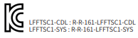 | This product is certified to be suitable for use in business (Class A) environments. It may cause interference if used in a home environment.

          - Japan (Radio Certification)
VCCI-A | This device is a Class A Information Technology Equipment. When used in a home environment, this product may cause radio interference. If such a situation occurs, the user should take appropriate countermeasures.

Caution | This product is manufactured and certified for industrial use by institutions, companies, etc., and is not suitable for personal use.

    - Registered trademark
          - LINKFLOW and NEXX360 are registered trademarks of Linkflow Inc.
          - The Wi-Fi logo is a registered trademark of the Wi-Fi Alliance.
          - All other trademarks are the property of their respective owners.

    - Software License
          - This product includes software licensed under several license terms.
          - This product includes some open source software. See the Linkflow website for more information.

    - Components
The product configuration is as follows:
Notice | - Illustrations of the supplied components in the user manual may differ from the actual items.  - Power cords may be supplied differently depending on national standards.  - Separate components must be purchased separately. If you wish to purchase them, please contact the place of purchase.

          - Basic Components
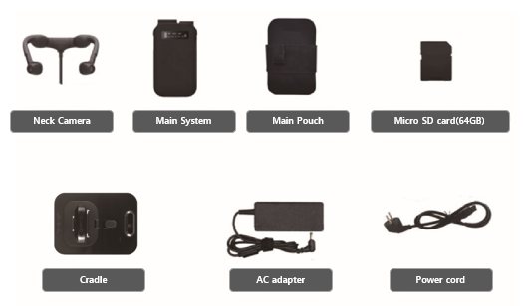
Fig. 1. Basic Components
          - Separate components
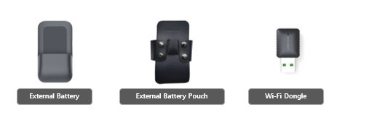
Fig. 2. Separate components

  - Part names and descriptions
    - NEXX camera
Use the camera to shoot a 360 degree video.
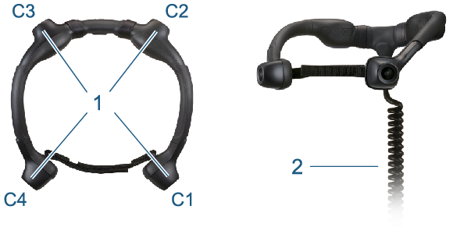
Fig. 3. NEXX Camera Configuration
Classification | Designation | Description
1 | NEXX camera | Shoots images using four cameras.
2 | NEXX Camera Cable | Supplies power on the camera and transfers the images taken by the camera to the system unit.

Notice | - Product specifications are subject to change without notice to the user to improve performance.  - To change the length of the NEXX Camera cable, contact the place of purchase.  - The cable noise filter is attached to the NEXX Camera cable and does not affect the use of the product.

    - System Unit
The video recorded by Neck Camera is compressed with a dedicated codec and saved or transmitted to the viewer.
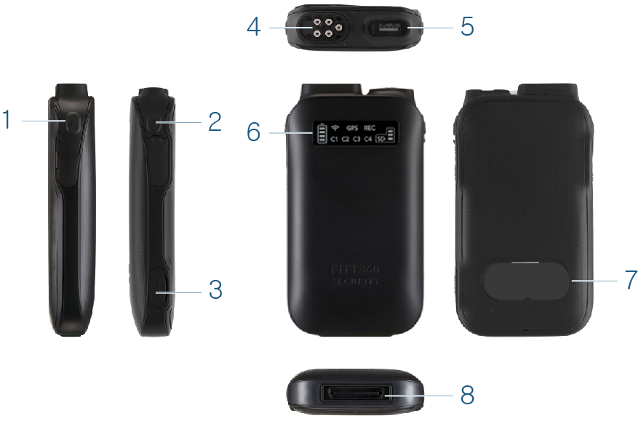
Fig. 4. System Unit Configuration
Classification | Designation | Description
1 | REC Button | - When pressed for less than one second: Starts or stops recording.  - When pressed for more than three seconds: Updates the firmware.
2 | Power Button | - When pressed for less than two seconds: Each time you press the button, the picture quality for live streaming changes in the following order: 480p (default), 720p and 1080p.  - When pressed for more than three seconds: Turns the product on or off.
3 | Micro SD Card Port | Insert a Micro SD card.
4 | Neck Camera Connector | Inserted to the main unit to connect it to the NEXX Camera cable.
5 | Wi-Fi Port | Connects the dongle for Wi-Fi.
6 | LED Display | Show product status.
7 | Label | Label containing product information.
8 | Connector for charging and data transfer | Connects with the cradle's connector. It can charge the system unit or transfer internal data to a PC.

Notice | We recommend that you use the Micro SD card enclosed with the product. Some Micro SD cards may not be compatible with this product depending on the maker and type.

    - Cradle
Charges the system unit or external battery, or transfer data from the body to your PC.
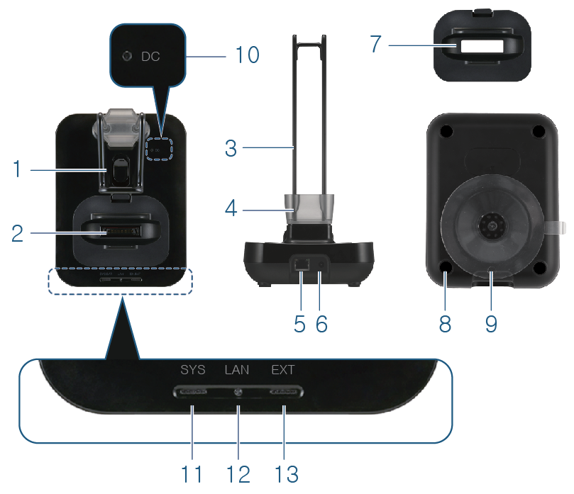
Fig. 5. Cradle Configuration
Classification | Designation | Description
1 | Suction Mount | Secure the rubber suction mount so that it does not fall off. When the lever is pushed up, the inside of the rubber suction mount becomes vacuumed and firmly sealed.
2 | System unit /  External Battery Connector | Charges the system unit or external battery, or transfer data from the body to your PC.
3 | NEXX Camera Holder | NEXX Camera is mounted on it.
4 | Rubber Cap Storage Box | Keeps the rubber cap.
5 | LAN Port | Connects the LAN cable.
6 | Power Port | Connects the power adapter.
7 | System Unit Gender Changer | - When mounting the system unit, holds it in place.  - If you have an external battery installed in your system, you must replace the system gender changer with an external battery gender changer.
8 | Anti-Slip Rubber | Prevents the cradle from slipping.
9 | Suction Rubber | Fixes the cradle to the surface by suction.
10 | Power Indicator LED | Displays the power supply status of the cradle.
11 | System Unit LED | Displays the connection status of the system unit.
12 | LAN Status / Data Transfer LEDs | Displays the connection status of the LAN cable.
13 | External Battery Indicator LED | Displays the connection status of the external battery.

    - External Battery
The external battery is coupled to the console to provide additional power.
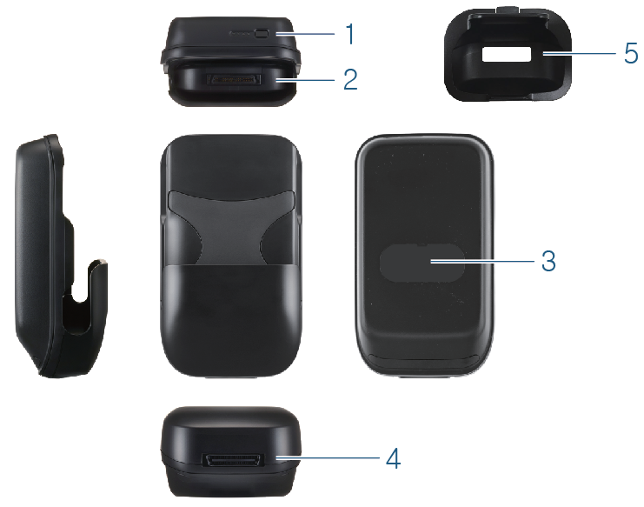
Fig. 6. External Battery Configuration
Classification | Designation | Description
1 | External Battery Level Button | Checks the power remaining in the external battery.
2 | System Connector | Connect the charge / data transfer connector to the system unit.
3 | Label | Label containing product information.
4 | External Battery Charging Connector | It is connected to the cradle's system/external battery connector. You can charge the system unit and an external battery, or transfer data from the body to a PC.
5 | External Battery Gender Changer | Secures the external battery so that it will not shake when mounted to the cradle.

  - Product Specifications
Notice | Product specifications are subject to change without notice to the user to improve performance.

    - Exterior Specifications
Classification | Item | Specifications
NEXX camera | Dimensions | - Normal NEXX: 172.7 mm (W) x 164.7 mm (H) x 90.5 mm (D)  - Big NEXX: 194.7 mm (W) x 166.4 mm (H) x 90.5 mm (D)
 | Weight | - Normal NEXX: 255 g  - Big NEXX: 270 g
Cradle | Dimensions | 133.7 mm (W) x 175.7 mm (H) x 63.1 mm (D)
 | Weight | 375 g
System Unit | Dimensions | 81.5 mm (W) x 142.8 mm (H) x 26.5 mm (D)
 | Weight | 252 g
External Battery | Dimensions | 87.4 mm (W) x 149.9 mm (H) x 56.6 mm (D)
 | Weight | 379 g

    - Body Specifications
Classification | Item | Specifications
General information | Peripherals | External Battery, Wireless Dongle, LTE Dongle and Cradle
 | External storage | - Types: MicroSD, MicroSDHC and MicroSDXC  - Capacity: Max 64 GB
 | Power Supply | Cradle DC 19V / 3.42A (65W)
 | Power | - Battery life: 2 hours (up to 8 hours with an external battery)  - Charge time: Less than 3 hours for full charge
 | Operating Temperature | -10 to 40℃ degrees
Camera | Image Sensor | 1/2.9" Sony Exmor CMOS
 | Lens Shape | Fixed lens x 4
 | Angle of View | 133° x 4
 | Focal Length | 3.0 m
 | Maximum Aperture | F2.0 ± 5%
 | Minimum Illumination | 1.0 Lux (color), F2.0 ± 5%
Video | Compression | H.264
 | Frame Rate | - Live streaming: Max 15 fps @ 1920 x 1080  - MicroSD storage: Max 15 fps @ 1280 x 720 Lens x 4
 | Bandwidth | Primary 512 Kbps-8 Mbps
 | Video Stream | Primary H.264
 | Resolution | - Live streaming: 720 x 480, 1280 x 720, 1920 x 1080  - MicroSD storage: 1280 x 720 Lens x 4
 | MicroSD Video Storage Mode | AVI (H.264)
Audio | Compression | G.711
 | Sampling Rate | G.711 (16 KHz)
 | Bandwidth | 128 kbps
External interface | USB | USB 2.0 Type A
 | Built-In Microphone | Built in MIC
 | External Speaker | TBA (currently beep speaker)
 | Wireless | Available (when purchasing a wireless version)
 | LTE | Available (when purchasing a wireless version)
 | 5G | Available (when purchasing a wireless version)
Certification | Certificate | - Flame retardant class: Main system (V0), NEXX Camera rubber (HB)  - External battery: KC, PSE  - Wireless module: KC, TELEC, FCC, CE  - IP Class: IPX5

Notice | Compatible with Wireless and LTE external dongle (802.11 a / b / g / n / ac)

    - Power Supply (AC Adapter) Specifications
Classification | Specifications
Model name | A12-065N2A
Manufacturer | Chicony
Rated input | AC 100-240V 1.7A 50-60Hz Class Ⅰ
Rated output | DC 19V 3.42A 65W
CONNECT ONLY TO A GROUNDED OUTLET

    - System Requirements
      - PC Specifications
This is required to use the live streaming function.
Classification | Specifications
HW | Desktop or laptop computer with USB port
CPU | Intel i5 or higher
OS | Windows 7 or higher
RAM | 8 GB RAM or more
HDD | 10 GB or more disk space

      - Server Specifications
This is required for sending files to the server.
Classification | Specifications
H/W | FTP server or server storage
S/W | FTP server and client programs

- Preparing NEXX360
Describes how to connect each component, and set up the product and network before using the product.
  - Connecting Components
    - Connecting the Power and LAN Cable
Connect the AC adapter's power connector and the LAN cable from the router to the ports on the back of the cradle.
When the power is supplied, the DC LED lights up in green ().
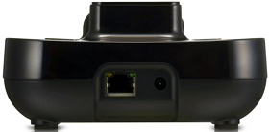
Fig. 7. Connecting Power and Network
    - Connecting to NEXX Camera
Connect the to the NEXX Camera connector on the system unit.
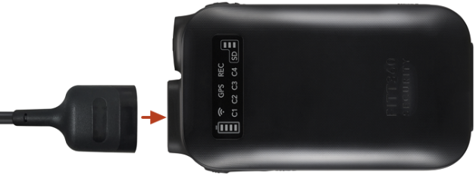
Fig. 8. Connecting to NEXX Camera

    - Connecting the Dongle
Connect the Wi-Fi dongle or the LTE dongle to a port on the system unit.
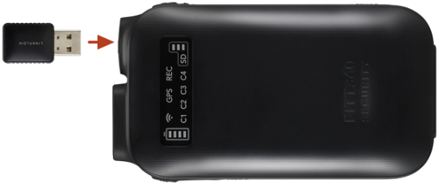
Fig. 9. Connecting the Dongle
    - Inserting a Micro SD Card
Check the orientation of the Micro SD card and insert it into the Micro SD card slot on the system.
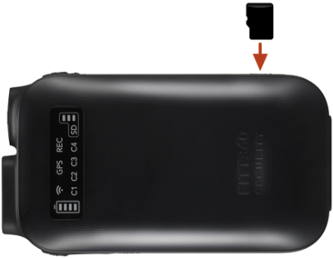
Fig. 10. Inserting a Micro SD Card

    - Mounting an External Battery
Connect the system unit to the connector on the external battery.
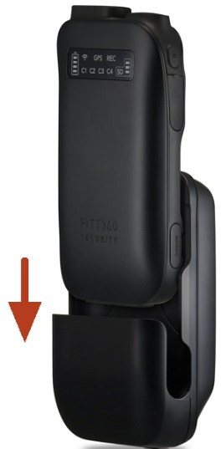
Fig. 11. Mounting an External Battery

  - Power On and Off
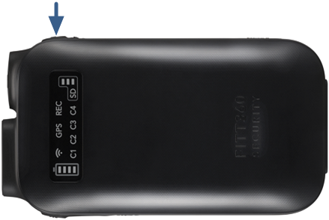
Fig. 12. Power On and Off
            - Make sure that the NEXX Camera cable is connected.
            - Make sure the Micro SD card is inserted.
            - Press the Power button on the system unit for about 3 seconds.
              - When the power is turned on, you will hear two beeps and the LED indicator will light up.
              - If the Power button is pressed for about 3 seconds while the power is on, you will hear two beeps and then the power is turned off.
Caution | If the Micro SD card is not inserted and the NEXX Camera cable is not connected, the main unit will not turn on.

Notice | When the power is turned on, you can check the status of the system unit on the LED display. See “Using the NEXX360 > Checking the Product Status” for how to check the status of the LED indicator on the system unit.

  - Charging the Main Unit
Charging starts when the system unit is inserted into the cradle's system connector.
When charging starts, the SYS LED on the front of the cradle lights up red (), and when charging is complete, green ().
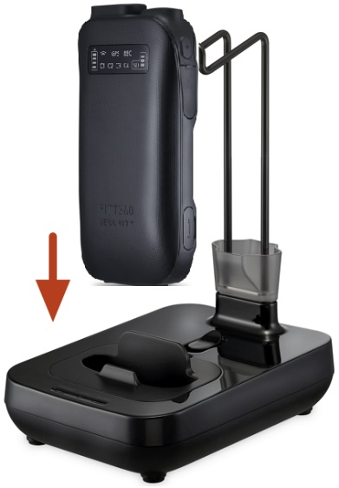
Fig. 13. Charging the Main Unit of the Product
Notice | See “Using NEXX360 > Checking Product Status” for how to check the status of the cradle.

  - Setting up the Viewer Program
    - NEXX360 Manager
The NEXX360 Manager is a program to configure the user environment, and check the images taken with the product. If you connect to a wireless network, you can also check the video in real time.
Notice | To configure your product settings, you need to install the NEXX360 Manager on your PC.

You can configure the Viewer settings in the Setting menu of the NEXX360 Manager.
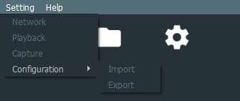
Fig. 14. Viewer Settings Menu
Classification | Description
Network | Configures the network settings.
Playback | Configures the playback settings for the recorded video.
Capture | Sets the save path of captured images.
Configuration | Exports the current settings to a file or imports the settings stored in a file.  - Import: Imports your existing settings.  - Export: Exports the current settings to a file.

Notice | Detailed information about each setting item can be found in “NEXX360 Manager > Menu Bar > Setting”.

  - Configuring Product Settings
    - NEXX360 setting
Notice | To configure your product settings, you need to install the NEXX360 Manager on your PC.

            - Remove the Micro SD card from the device.
            - Insert the Micro SD card to a PC with the NEXX360 Manager installed.
            - Run the NEXX360 Manager.
            - Click the Settings () tab on the Function tab of the main screen.
Fig. 15. Main page tab
            - Double-click the Device ID of the inserted Micro SD card.
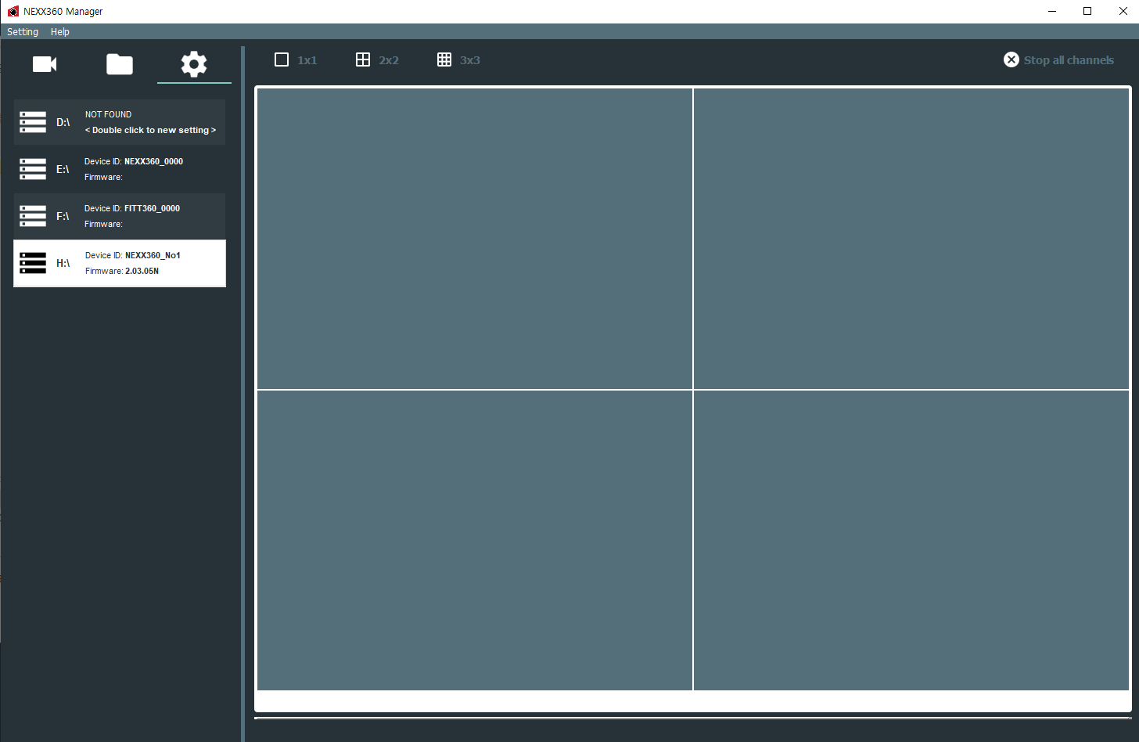
Fig. 16. Micro SD information

            - When the Settings window appears, click each setting tab to configure the product settings.
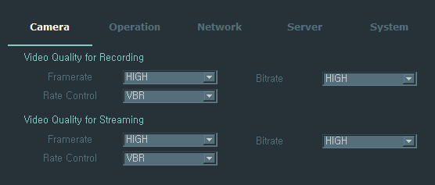
Fig. 17. Micro SD settings
Classification | Description
Camera | Sets the quality of recording and streaming video.
Operation | Configures the recording settings.
Network | Configures the network settings.
Server | Configures the server settings.
System | Checks the product information and sets the device ID.

Notice | For detailed information about each setting item, go to NEXX360 Manager > Function tab > Settings.

            - Click the OK button when setup is complete.
            - Remove the Micro SD card from your PC and insert it into the system unit.
              - The settings you made are automatically applied when you turn on the power.

    - Web
You can access the product settings site and configure your product settings.
Notice | - Web Settings are equal to Settings of NEXX360 Manager  - Refer to more details from the following directory ‘NEXX360 Manager > Menu bar > Setting’  - Any changes made from Web settings will be applied after rebooting the system. Able to restart the system by pressing Apply(Restart) from the web menu  - If the following popup message continuously appears, disable a checkbox. If the checkbox is already clicked, close the browser and access it again.  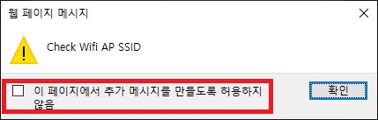

            - Enter IP address in browser address bar.
Default IP address is 192.168.1.252.(If IP address is not correct, refer to [My Computer IP settings] and enter the IP address properly for access)
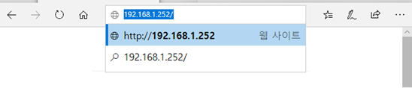
Fig 18. Browser address bar
            - After entering IP address, popup login will appear (Default ID/PASS : admin/admin)

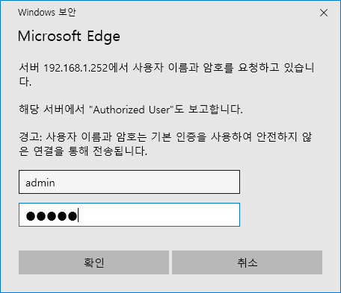
Fig 19. Page to authenticate user

            - When you enter the wrong ID/PW, popup message will appear as below

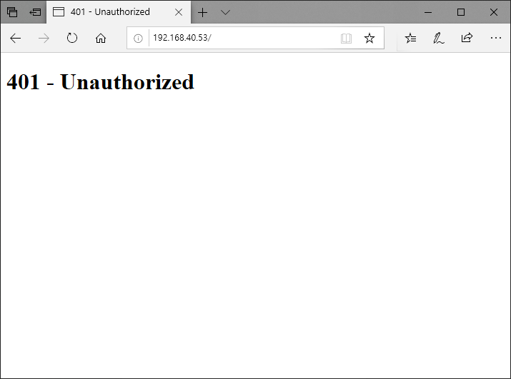
Fig 20. Authentication failure

            - Change password upon first login
            - Enter new password as shown below

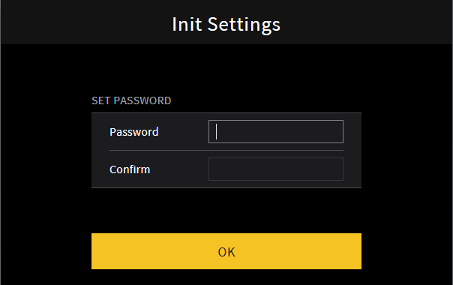
Fig 21. Image for changing password

6. Login popup will appear after changing password
7. Access to setting page with new password
Caution | - Manufacturer is not able to recover new password  - You can reset password via NEXX360 manager in case you have forgotten it

8. Refer to main page settings as below
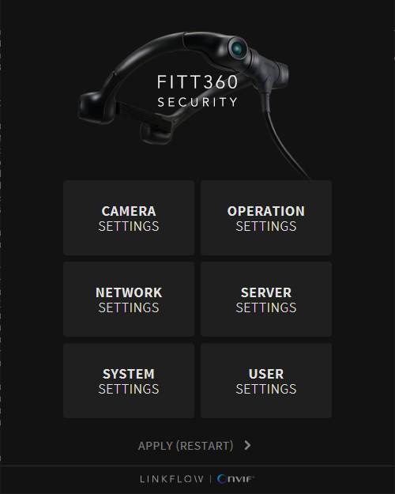
Fig 22. Main page settings

9. Click individual menus in order to change settings

10. Images for each Settings
- Camera Settings
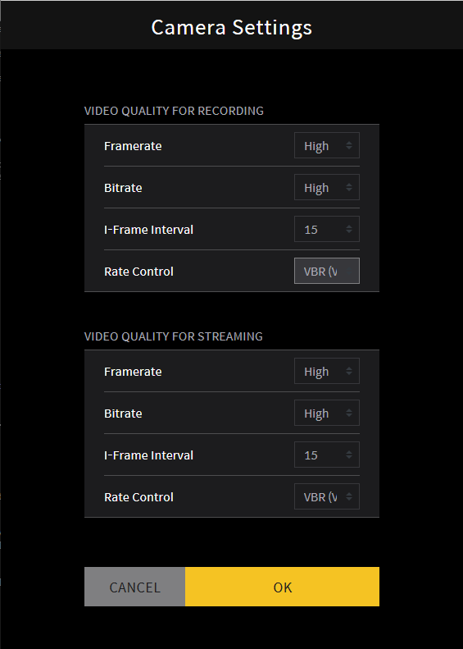
Fig 23. Camera settings
- Operation Settings
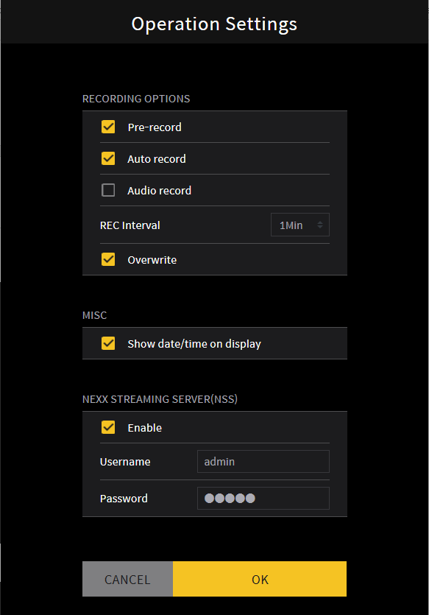
Fig 24. Operation settings

- Network Settings
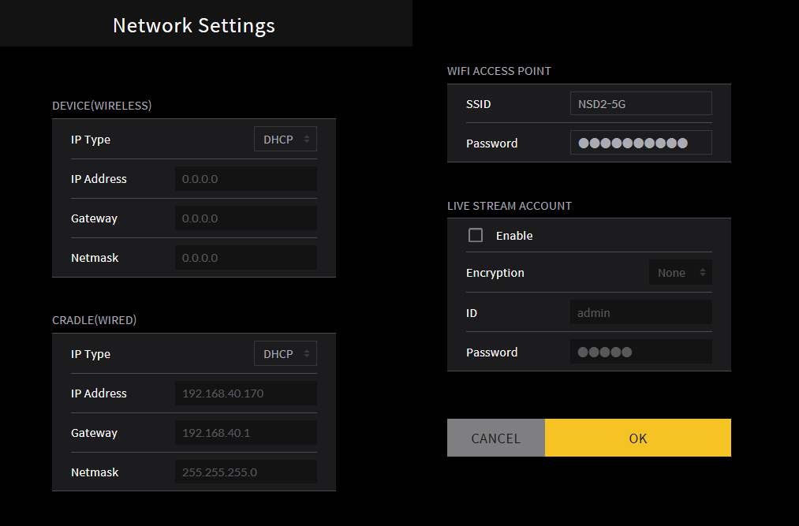
Fig 25. Network settings
- Servers settings
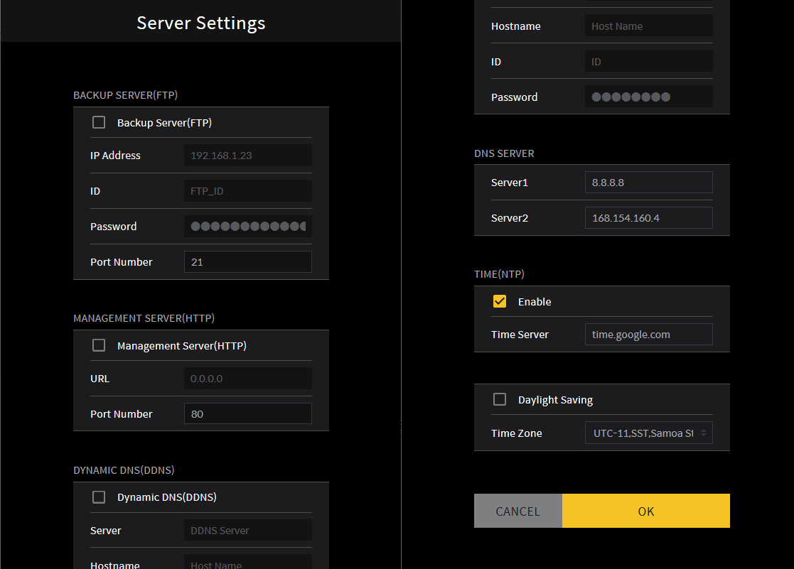
Fig 26. Servers settings
- System Settings
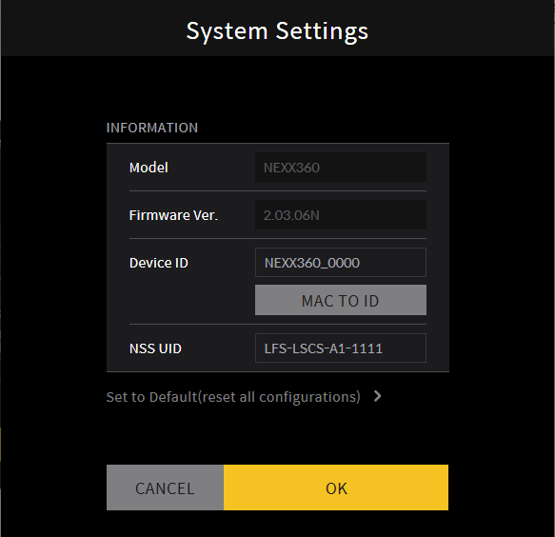
Fig 27. System settings
- User Settings: Change Web user password
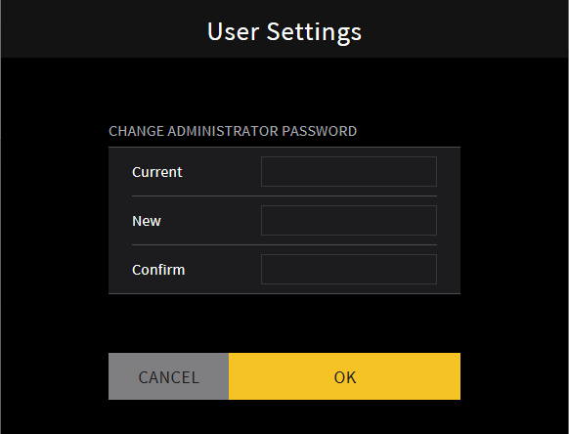
Fig 28. User settings

- Apply(Restart): Popup message will appear
-Message for retarting device
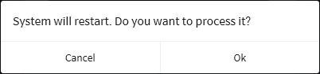
Fig 29-1. Popup message for restart
-The following popup message will appear after clicking “Ok”
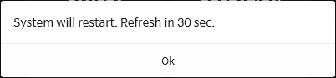
Fig 29-2. Restart popup message
-The popup message for rebooting
Fig 29-3. Restarting message

  - Connecting to a Network
Notice | - Before connecting to a network, make sure the Wi-Fi dongle or the LTE dongle is properly connected.  - For information on network configuration and preferences setting, contact a network expert at the place of use.

    - Default Mode
NEXX360 saves the recorded video to a Micro SD card. Play back it on a PC that has NEXX360 Manager installed
Through the wired network environment shown as Fig.30., the recorded videos taken by NEXX360 which is attached to Cradle are played with NEXX360 Manager in real time. 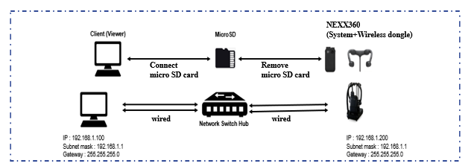
Fig.30. Default Mode Diagram
The video shooting and confirmation process when using the default mode is as follows:
            - Take pictures using the NEXX Camera.
            - The recorded image is saved on the Micro SD card of the system unit.
            - After shooting, remove the Micro SD card from the system unit.
            - View images stored on the Micro SD card through the dedicated viewer installed on the PC.
              - Use images stored in a Micro SD (one file with 4 video tracks)
            - Check the IP address assigned according to the internal (local) IP allocation policy
            - Check live streaming from NEXX360 manager on PC which is connected to the same local network
Caution | The PC with the NEXX360 Manager should be connected to the same network (same AP) as the NEXX360.
            - Configure network settings via NEXX360 Manager

Classification | Setting items | Description | Default
Cradle (Wired) | IP Type | Set IP type of Ethernet connected to Cradle | STATIC(Fixed)
 | IP Address | Set IP address details of Ethernet connected to Cradle | 192.168.1.200
 | Gateway | Set Gateway details of Ethernet connected to Cradle | 192.168.1.1
 | Netmask | Set Subnet details of Ethernet which is connected to Cradle | 255.255.255.0
Live Stream Account | Live Stream Account | Enables or disables a live streaming account. | Disable
 | Use Encryption | ID and Password will be encrypted.  *When it is activated, live streaming videos will be played from specific viewer only | Able/disable
 | ID | Sets your account ID. | linkflow
 | Password | Sets a password. | 12345678

    - Wi-Fi mode
After connecting the system to PC through the local IP inside the wireless router, check the recorded video in real time with the dedicated viewer.
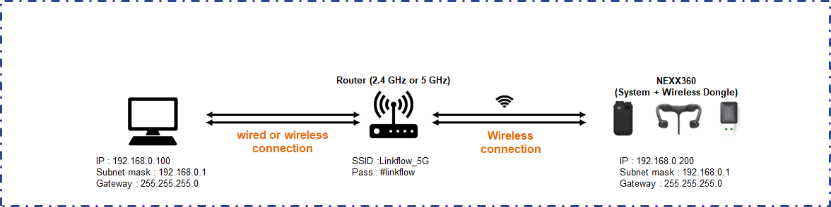
Fig. 31. Wi-Fi Mode Diagram
Connect to the wireless streaming server through the internal (local) Wi-Fi network. How to connect to a network in Wi-Fi mode:
            - Check the IP address assigned according to the internal (local) IP allocation policy.
Caution | The PC with the NEXX360 Manager should be connected to the same network (same AP) as the NEXX360.

            - Configure your network settings using NEXX360 Manager.
Classification | Setting items | Description | Default
NEXX360 Device (Wireless) | IP Type | Sets the wireless IP type. | STATIC(fixed)
 | IP Address | Sets the wireless IP address. | 192.168.0.200
 | Gateway | Sets the gateway address. | 192.168.0.1
 | Netmask | Sets the netmask address. | 255.255.255.0
Cradle (Wired) | IP Type | Sets the IP type of Ethernet connected to the cradle. | STATIC(fixed)
 | IP Address | Sets the IP address of the Ethernet connected to the cradle. | 192.168.1.252
 | Gateway | Sets the gateway address of the Ethernet connected to the cradle. | 192.168.1.1
 | Netmask | Sets the netmask address of the Ethernet connected to the cradle. | 255.255.255.0
Wi-Fi Access Point | SSID | Sets the SSID of the Wi-Fi AP to connect to. | AP_SSID
 | Password | Sets a password for the Wi-Fi access point. | Entered by the user
Live Stream Account | Live Stream Account | Enables or disables a live streaming account. | Disable
 | ID | Sets your account ID. | linkflow
 | Password | Sets a password. | 12345678

Caution | - The IP address is set by the user to any number. Be careful not to duplicate the IP of other products or other NEXX360 devices on the same network.

Notice | - For information on how to configure your network settings, refer to 'Configuring Product Settings'.  - The Wi-Fi Access Point is the router name and password configured on the network. Please contact your network manager for relevant information.

    - LTE SIM Wireless Dongle Mode
After connecting the system to a PC through an external communication network (fixed public IP LTE dongle), you can check the recorded video in real time with the dedicated viewer.
Notice | - To use the LTE SIM wireless dongle mode, you must subscribe to your carrier's static public IP service and receive an LTE SIM and an LTE dongle.  - The compatible LTE dongle is as follows:  - Pixela PIX MT-100  - Hucomwireless HE-211S/K  - Please check with your place of purchase for compatibility with other LTE dongle products.

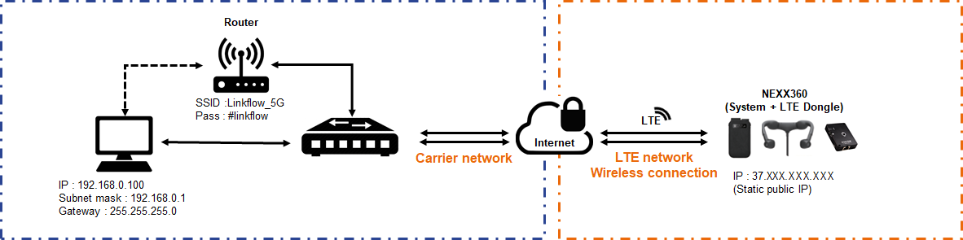
Fig. 32. Diagram of LTE SIM Wireless Dongle Mode
Connect to a network (wireless streaming) using an external network (static public IP LTE dongle). Configure the network for the LTE SIM wireless dongle mode as follows:
            - Insert the LTE SIM card purchased from the carrier into the LTE dongle and connect the LTE dongle to the system unit.
            - Configure your network settings using NEXX360 Manager.
Classification | Setting items | Description | Default
NEXX360 Device (Wireless) | IP Type | Sets the wireless IP type. | STATIC(Fixed)
 | IP Address | Sets the wireless IP address. | 192.168.0.252
 | Gateway | Sets the gateway address. | 192.168.0.1
 | Netmask | Sets the netmask address. | 255.255.255.0
Cradle (Wired) | IP Type | Sets the IP type of Ethernet connected to the cradle. | STATIC
 | IP Address | Sets the IP address of the Ethernet connected to the cradle. | 192.168.1.252
 | Gateway | Sets the gateway address of the Ethernet connected to the cradle. | 192.168.1.1
 | Netmask | Sets the netmask address of the Ethernet connected to the cradle. | 255.255.255.0
Wi-Fi Access Point | SSID | Sets the SSID of the Wi-Fi AP to connect to. | AP_SSID
 | Password | Sets a password for the Wi-Fi access point. | Entered by the user
Live Stream Account | Live Stream Account | Enables or disables a live streaming account. | Disable
 | ID | Sets your account ID. | linkflow
 | Password | Sets a password. | 12345678

Caution | - The IP address is set by the user to any number. Be careful not to duplicate the IP of other products or other NEXX360 devices on the same network.

Notice | - For information on how to configure your network settings, refer to 'Configuring Product Settings'.

            - In case of live streaming through NEXX360 manager, configure DDNS settings if you prefer to use domain name instead of IP address
Notice | Configuring DDNS Settings you need to prepare a separate DDNS service. This section explains how to set up a DDNS environment using No-IP.

            - Go to NEXX360 Manager > Settings > Server > Dynamic DNS (DDNS). Enable the Dynamic DNS (DDNS) by selecting the checkbox

            - Set the DDNS details
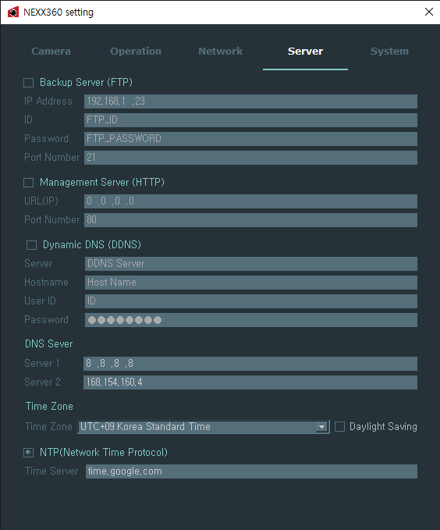
Fig. 33. DDNS settings

Classification | Setting items | Description | Default
Dynamic DNS (DDNS) | Server | Sets URL of DDNS Server | http://dynupdate.no-ip.com/nic/update
 | Hostname | Sets hostname | Entered by the user
 | User ID | Sets User ID | Entered by the user
 | Password | Sets a password | Entered by the user
DNS Server | Server 1 | Sets IP address of DNS1 server | -
 | Server 2 | Sets IP address of DNS2 server | -

    - NEXX Streaming Mode
After connecting the system to a PC through an external communication network (shared public IP LTE dongle or smartphone tethering), you can check the recorded video in real time with the dedicated viewer.
Notice | - To use a floating public IP LTE dongle, you must subscribe to a carrier's floating public IP service and receive a LTE SIM and a LTE dongle.  - The compatible LTE dongle is as follows:  - Pixela PIX MT-100  - Hucomwireless HE-211S/K  - Please check with your place of purchase for compatibility with other LTE dongle products.

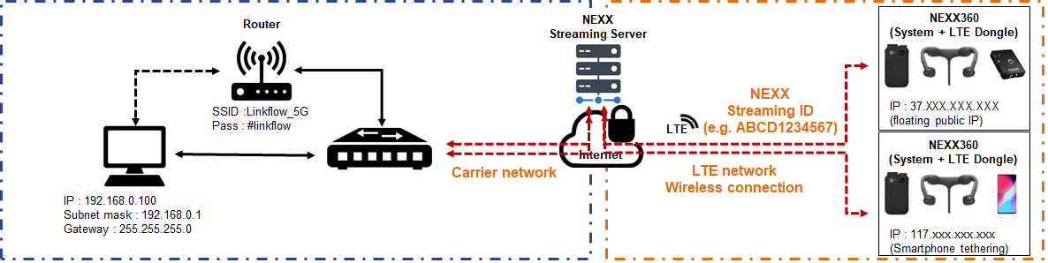
Fig.34. Diagram of NEXX Streaming Mode
Connect to a network (wireless streaming) through an external network (floating public IP LTE dongle or smartphone tethering). The following explains how to set the network for NEXX streaming mode:
            - Insert the LTE SIM card purchased from the carrier into the LTE dongle and connect the LTE dongle to the system unit.
Notice | - When using smartphone tethering, connect the Wi-Fi dongle to the system unit.  - For how to activate the tethering function of your smartphone, refer to the user manual of the device.

            - Configure your network settings using NEXX360 Manager.
Classification | Setting items | Description | Default
NEXX360 Device (Wireless) | IP Type | Sets the wireless IP type. | DHCP
 | IP Address | Sets the wireless IP address. | Sets automatically
 | Gateway | Sets the gateway address. | Sets automatically
 | Netmask | Sets the netmask address. | Sets automatically
Cradle (Wired) | IP Type | Sets the IP type of Ethernet connected to the cradle. | STATIC
 | IP Address | Sets the IP address of the Ethernet connected to the cradle. | 192.168.1.252
 | Gateway | Sets the gateway address of the Ethernet connected to the cradle. | 192.168.1.1
 | Netmask | Sets the netmask address of the Ethernet connected to the cradle. | 255.255.255.0
Wi-Fi Access Point | SSID | Sets the SSID of the AP to connect to. | AP_SSID
 | Password | Sets the password of the AP to connect to. | Entered by the user
Live Stream Account | Live Stream Account | Enables or disables a live streaming account. | Disable
 | ID | Sets your account ID. | linkflow
 | Password | Sets a password. | 12345678

Caution | - The IP address is set by the user to any number. Be careful not to duplicate the IP of other products or other NEXX360 devices on the same network.

Notice | - For information on how to configure your network settings, refer to 'Configuring Product Settings'.  - When tethering your smartphone, you can check the SSID and Password of the Wi-Fi Access Point in the tethering settings of your smartphone.

            - Configure your NEXX Streaming Server(NSS) settings
Notice | To configure a NSS environment, enable NSS by selecting the checkbox.  Product settings > Operation > NSS  Enter UID settings provided when purchasing the product. Product settings > System > Device ID>UID settings
  - Setting up a Backup Server
Once you set up a backup server (FTP server), you can transfer the images stored on the Micro SD card to the backup server for storage.
    - Setting up a Server Network
Notice | - The LAN line of the AP must be connected to the cradle.  - The AP on the backup server must be connected to the same AP as the cradle.  - Actual operation may differ depending on the usage environment. Contact the place of purchase for details.

            - Turn off the device and remove the Micro SD card from the device
            - Insert Micro SD card to PC and run NEXX360 Manager.
            - Configure backup server network settings
Fig.35. Backup server section

Classification | Setting items | Description | Default
Backup Server (FTP) | IP Address | Sets the IP address of the backup server. | 192.168.1.23
 | ID | Sets the user ID registered in the viewer program. | FTP_ID
 | Password | Sets a password for the ID. | FTP_PASSWORD
 | Port Number | Sets the port number for the backup server. | 21 (recommended value)

Caution | The AP on the backup server must be connected to the same AP as the cradle.

Notice | For information on how to configure your network settings, refer to 'Configuring Product Settings'.

    - Setting up a FTP program
Configures the network after installing the FTP server and client program to back up the recorded images.
Notice | - This product does not provide any software required to use the server. Therefore, please purchase the suitable software according to your requirements.  - This manual describes how to set up a backup server using Filzilla.  - Filezilla is distributed under a free software license.  - Contact the manufacturer for detailed installation

  - Installing Firmware
    - Checking Current Version
            - Turn off the device.
            - remove the Micro SD card from the device.
            - Connect the Micro SD card to a PC that has NEXX360 Manager installed.
            - Run the NEXX360 Manager.
            - On the Function tab, click the Recording Settings () tab.
            - the firmware version will appear once Micro SD card is properly inserted.
Fig.36. Firmware version-1

            - The Firmware version is also indicated on system menu.
-Double click “Device id” (marked in red rectangular)>Settings popup will appear>click system

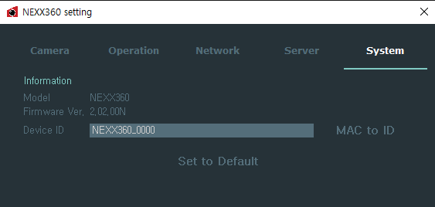
Fig.37. Firmware version -2

            - You can check the program version. Go to Help > About to display the program information.
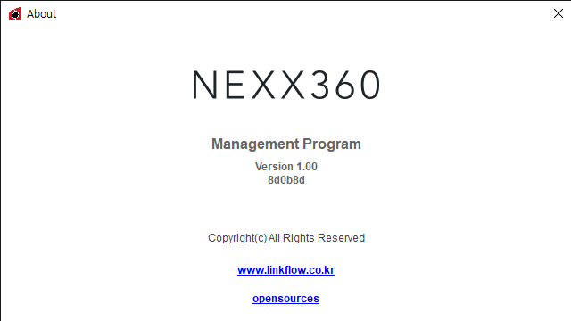

Fig.38. NEXX360 Manager version

    - Firmware Updates

Notice | - The firmware version may be modified to improve functionality. Contact the place of purchase for a firmware file.  - Installation and updates take about 30 seconds to 1 minute.  - We recommend you to proceed with installation and updates with the help of a professional.

Caution | - Never operate or shut down the system during a firmware update. An error may occur in the system unit.  - Make sure that backup server is disable prior to firmware update  - Make sure you have enough battery capacity left during installation and updates. Low battery during an update can cause the product to fail.  - Manufacturer is not responsible for any damage if the product is updated in an improper way

            - Turn off the device.
            - Remove the Micro SD card from the system unit that you want to update the firmware.
            - Connect the Micro SD card to your PC.
            - Contact the manufacturer to get the right firmware. Save the new firmware file (updated version) to the formatted Micro SD card.
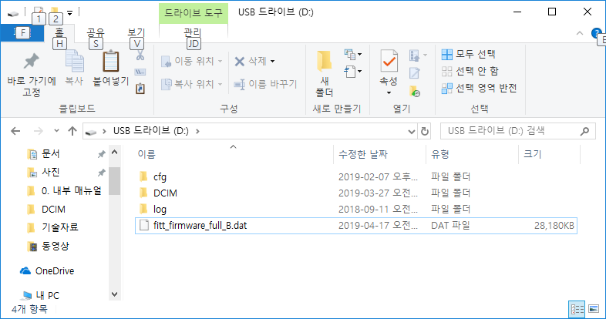
Fig.39. NEXX360 Manager

            - Remove the Micro SD card from your PC and insert it into the system unit.
            - Press the Power button to turn on the product.
            - Press the REC button for about 3 seconds. Firmware installation and update will proceed.
              - When the update starts, you will hear three beeps and the LED display will flash.
              - When the update has completed normally, the power automatically turns off.
            - Press the Power button to turn the power back on.
            - Click the System tab in the Settings window to check the firmware version.
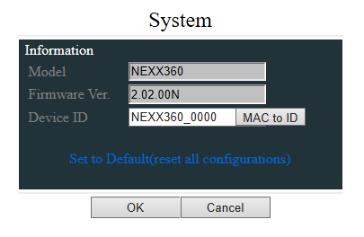
Fig.40. Check Firmware version from the web
            - Using New Micro SD card or Formatted Micro SD card.
1)After formatting the Micro SD card, Insert it into the system unit
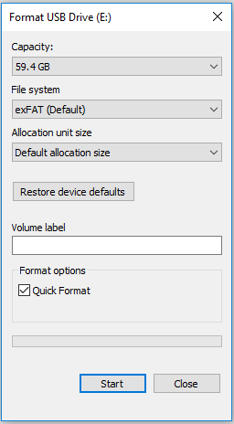
Fig.41. How to format the Micro SD card
2) Turn on the device
Caution | - The data on the Micro SD card will be deleted, please back it up before formatting.  - Configure the File System to exFAT when formatting. (Based on 64GB Micro SD card)

- Using NEXX360
This section describes how to mount the product, take a video, and check and manage the recorded videos.
  - Check Product Status
    - System Unit
Fig.42. LED Display on the System Unit

Classification | LED Display | LED Status | Description
System | 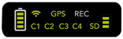 | On | Power is supplied normally.
 | 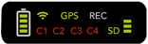 | - Green: On  - Red: Flashing | Firmware update is in progress.
Battery | 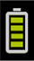 | On | The remaining battery capacity is displayed.
Network | 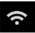 | Off | The dongle is not connected.
 |  | On | Wireless network (WI-FI or LTE) is connected normally.
GPS |  | Off | The dongle is not connected.
 |  | On | GPS is connected normally.
 |  | On | The dongle is connected, but the GPS is not connected properly.
Recording |  | Flashing | Recording is in progress.
 |  | On | An error has occurred while recording.

Classification | LED Display | LED Status | Description
Micro SD Card Storage |  | On | Micro SD card is inserted correctly.
 |  | Flashing | Micro SD card is missing or inserted incorrectly.
 | 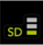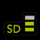 | On | The remaining storage space on the Micro SD card is displayed.
 |  | On | Recording has stopped because there is no remaining storage space on the Micro SD card.
 | 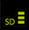 | Flashing | Recording is in overwrite mode as there is no storage space left on the Micro SD card.
Camera |  | On | Each camera is operating normally.
 |  | On | The camera has a problem.

Notice | - Camera LEDs display status by camera.  - For network, GPS, and Micro SD card storage spaces, the preview may look different depending on the remaining space and whether the dongle is attached or not.

    - Cradle
Fig. 43. Cradle LED

Classification | LED Display | LED Status | Description
Power | DC | Off | The cradle is not powered on.
 | DC | On | The cradle is powered on.
System Unit | SYS | On | The system unit is being charged.
 | SYS | On | The system unit is fully charged.
External Battery | EXT | On | The external battery is being charged.
 | EXT | On | The external battery is fully charged.
Data Transfer | LAN | Off | - Micro SD card is empty.  - All data on the Micro SD card has been transferred.
 | LAN | - Green: Flashing  - Red: On | Data is being transferred.
 | LAN | Flashing | There was an error during data transfer.
 | LAN | On | There is data remaining on the Micro SD card.

  - Wearing the Product
Describes how to wear the product.
Caution | - Be sure to wear clothing to avoid direct contact with the product (NEXX Camera, system unit, external battery, etc.).  - Be sure to keep the system unit and external battery in the pouch while in use. If used in a high temperature environment, or for users with poor blood circulation or with sensory impairment, it may cause a low temperature burn.

            - Place the system unit in the body pouch.
            - Put the Neck Camera behind your neck and fasten the velcro.
            - Fix the body pouch to a belt or pants.
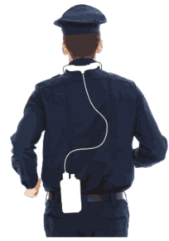

  - Recording
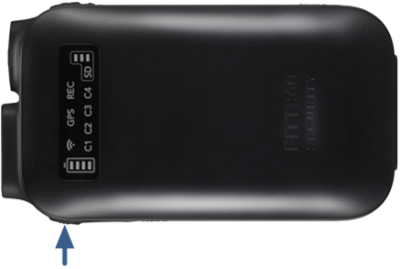
Fig. 44. Recording
            - Put on the product.
            - Press the Power button to turn on the product.
            - Press the REC button for about 1 second.
              - When recording begins, you hear one beep and the Record () LED blinks red on the display of the system unit.
              - You can stop recording by pressing REC button during recording. When recording stops, you hear two beeps and the Record () LED on the system unit's display turns off.

Notice | - The Recording function is available only when the Auto-Record function is turned off. When the Auto-Record function is turned on, recording starts automatically when the power of the main unit is turned on.  - Recorded video is saved in DCIM folder of the Micro SD card.  - You can check the recording environment in the 'NEXX360 Manager > Function Tab> Recording Settings'.

Caution | If the Overwrite function in Operation > Recording Options is turned on, the existing video is overwritten if there is no storage space on the Micro SD card.

  - Transferring Files to the Server
When the system is turned on and the system is plugged into the cradle's system/external battery connector, the images stored on the Micro SD card will be automatically transferred to the backup server.
When transfer starts, the cradle's LAN LED turns red, and () flashes green. When the file transfer is complete, the LAN LED turns off automatically.
Notice | - You need to set up a backup server to automatically transfer files to the server. See “Preparing NEXX360 > Setting Up a Backup Server” for details on setting up a backup server.  - See “Using NEXX360 > Checking Product Status > Cradle” for LED indications during the transfer process.

- Viewing Videos
  - Viewing Recorded Videos
Notice | - Recorded videos can be checked using a dedicated viewer program (NEXX360 Security) or a regular viewer program. However, a regular viewer program may not work depending on the program version.  - Contact the place of purchase for a viewer program dedicated to NEXX360 Security.

            - Turn off the device and Remove the Micro SD card from the device.
            - Connect the Micro SD card to a PC that has NEXX360 Manager installed.
            - Run the NEXX360 Manager.
            - Click the Recorded Video () tab in the Function tab of the main screen.
Fig. 45. Viewing Recorded Videos
            - Click the Add Folder () button.
Fig. 46. Viewing Recorded Videos
            - Select the DCIM folder on the Micro SD card, and click the Select Folder button.
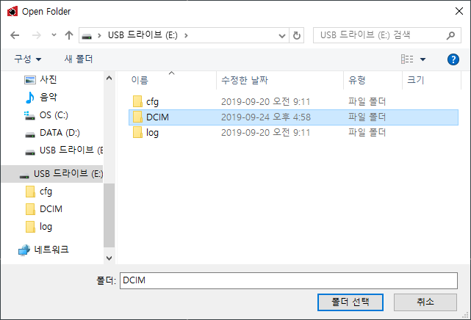
Fig. 47. Selecting recorded video folder

            - From the Recorded Video Folder List, select a folder to check the videos.
Fig. 48. Selecting recorded video folder

Notice | - If you have a lot of recorded videos, use the recording date filter and text filter to find the video you want easily.  - See “NEXX360 Manager > Function tab > Recorded Video Tab” for details on the filters.

            - Select a video to play back from the recorded video list. The video is displayed in the Video Screen Area.
Fig. 49. Selecting recorded video folder

Notice | - Video stitching cannot be used for recorded videos.  - Recorded file can be checked (saved by the rule of R_YYYYMMDD_HHMMSS_Device ID_4ch)  - An example of a recorded video on the Test_Device at 15:29, on September 4, 2019:  R20190904_152930_TEST_Device_4ch

  - Viewing Live Videos
    - Registering Your Profile
            - Connect the PC that has NEXX360 Manager installed to same network as the AP.
Fig. 50. PC network configuration
Notice | The AP selected on the network can be checked in the Settings window.

            - Run NEXX360 Manager on your PC.
            - In the Streaming Video tab, click the Add Profile () button.
            - When the device registration window appears, enter the device you want to register.

              - When Live Stream Account setting (refer to 09. Appendix – 1.NEXX360 Manager - 1.2.3 Settings – Network tap) is not used
              - When NEXX Streaming Server(NSS) (refer to 09. Appendix – 1.NEXX360 Manager - 1.2.3 Settings – Operation tap) is not used

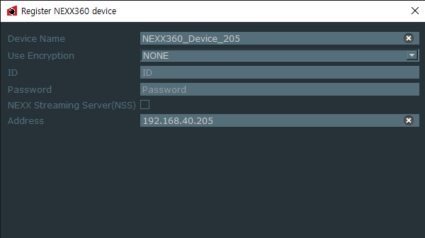
Fig. 51. Profile Registration

              - When Live Stream Account setting (refer to 09. Appendix – 1.NEXX360 Manager - 1.2.3 Settings – Network tap) is used
              - When NEXX Streaming Server(NSS) (refer to 09. Appendix – 1.NEXX360 Manager - 1.2.3 Settings – Operation tap) is not used
              - When “Use Encryption” is selected as “NONE”, enter same ID and PW which are already entered
(refer to ID/PW from 09. Appendix – 1.NEXX360 Manager - 1.2.3 Settings – Operation tap)
              - -Able to live stream videos via NEXX360 Manager, Milestone, IDIS, VLC and etc

              - When “Use Encryption” is selected as “AES”, enter same ID and PW which are already entered
              - (refer to ID/PW from 09. Appendix – 1.NEXX360 Manager - 1.2.3 Settings – Operation tap)
              - -Able to live stream videos via NEXX360 Manager only.
              - *Milestone, IDIS, VLC are not supported
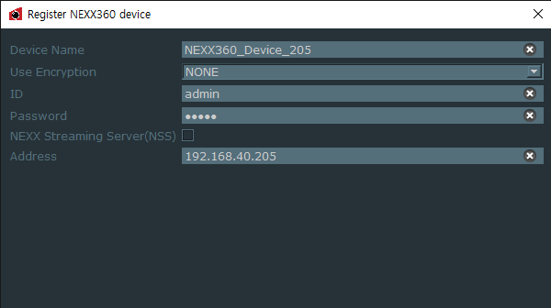
Fig. 52. Profile registration
              - When Live Stream Account setting (refer to 09. Appendix – 1.NEXX360 Manager - 1.2.3 Settings – Network tap) is not used
              - When NEXX Streaming Server(NSS) (refer to 09. Appendix – 1.NEXX360 Manager - 1.2.3 Settings – Operation tap) is used
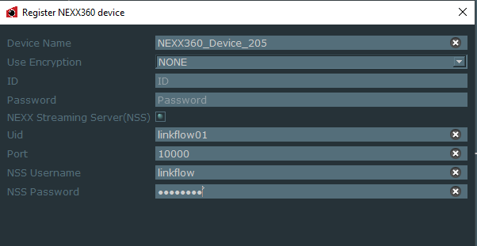
Fig. 53. Profile registration

              - When Live Stream Account setting (refer to 09. Appendix – 1.NEXX360 Manager - 1.2.3 Settings – Network tap) is used
              - When NEXX Streaming Server(NSS) (refer to 09. Appendix – 1.NEXX360 Manager - 1.2.3 Settings – Operation tap) is used
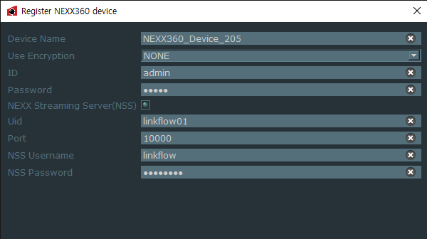
Fig. 54. Profile registration
              - When NEXX Streaming Server(NSS) is used, instead of entering IP address, it requires UID, NSS ID and NSS PASSWORD which are provided when products are purchased. Default of NSS ID and PASSWORD is (linkflow/12345678)
              - In a case when many devices are connected to NEXX Streaming Server(NSS), each port shall be entered with different configuration(ex 10000,10001,10002…)

Classification | Default Mode | Wi-Fi mode | LTE (Static IP/Floating IP) | NEXX Streaming mode
Device ID | Device ID of the device to view videos
ID | Do Not use/linkflow | Do Not use/linkflow | Do Not use/linkflow | Do Not use/linkflow
Password | Do Not use/12345678 | Do Not use/12345678 | Do Not use/12345678 | Do Not use/12345678
Address | xxx.xxx.xxx.xxx | xxx.xxx.xxx.xxx | xxx.xxx.xxx.xxx/ddns settings domain | Use UID, Port, NssID, NssPasswd

            - Click the OK button. The device's profile has been created.
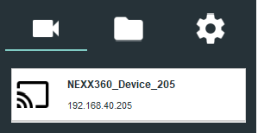
Fig. 55. Profile registration

    - Viewing Videos
In the Streaming Video tab, double-click the profile you want to view or drag it to the Video Screen Area to display it on the screen.
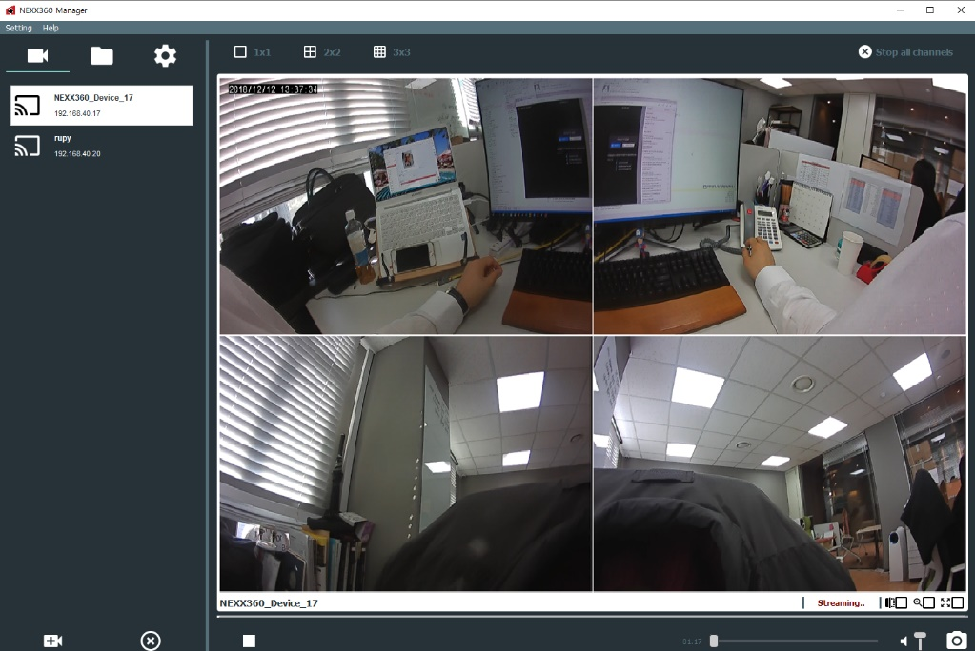
Fig. 56. Profile registration
Notice | - Check if the time at the top left of the Video Screen is correct. If the external internet is not connected, the correct time is not displayed.  - To change the picture quality when shooting, press the Power button on the system unit. (SD → HD → FHD → SD → HD → FHD)  - Footage may be distorted once the network bandwidth is not good enough for neither Live streaming resolution nor image quality.

    - Recording Live streaming
In the streaming Video tab, right click on a mouse on the live streaming screen > Select start recording to save videos. Directory for saved videos: Directory where it is configured from NEXX360 Manager (Main menu – Settings – Capture)

    - Viewing recorded videos
Click the Recorded Video () tab in the Function tab of the main screen
Click the Add Folder () button
Select the folder where recorded videos are saved and click the Select Folder button
Select a video to play back from the recorded video list

  - Controlling Videos
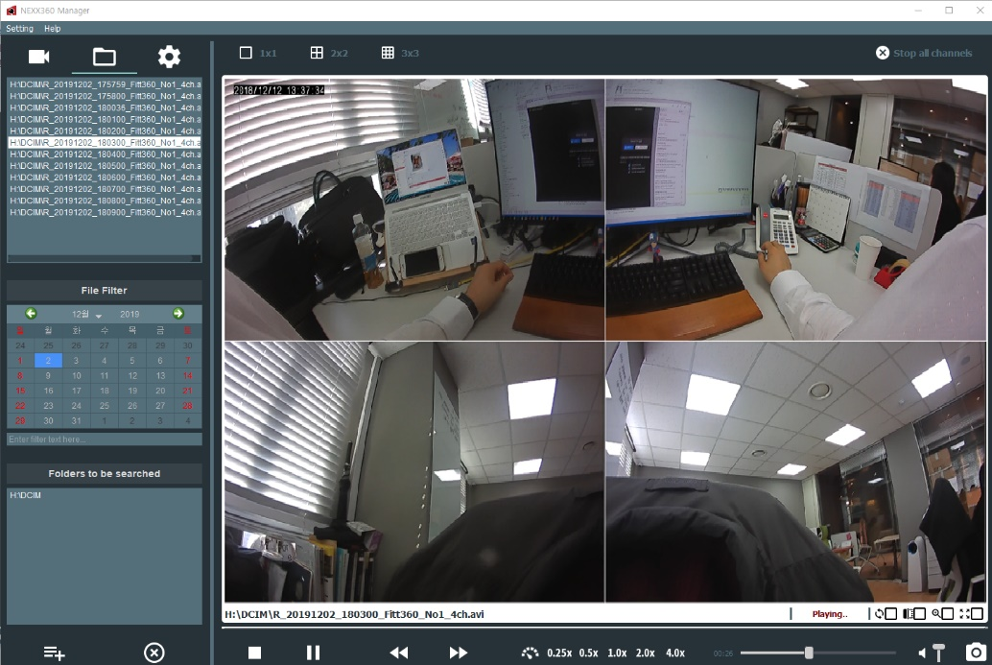
Fig.57. Recorded video playing screen

Classification | Designation | Description
 | Play/Pause | Plays or pauses the video.
 | Stop | Stops video playback.
 | Forward | Moves the video backward to an earlier time.
 | Backward | Moves the video forward to a later time.
 | Playback Speed | Sets the playback speed.  - -2: Plays back at 1/4 of normal speed.  - -1: Plays back at 1/2 of normal speed.  - 0: Plays back at normal speed.  - +1: Plays back at 2x normal speed.  - +2: Plays back at 4x normal speed.
 | Play Time Control | Checks and adjusts the current playback time.
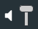 | Volume Control | Adjusts the audio volume of the video.
 | Screen Capture | Captures the current footage.

Notice | - The screenshot is saved in the My Documents folder. You can change the save path of screenshots in the Settings window.  - See “NEXX360 Security Manager > Function tab > Recorded Video Tab” for details on the filters.

- Troubleshooting
  - I want to know my computer IP address.
            - Click the Search () icon on the taskbar.
Or Press Window icon key + R key and then enter “cmd”
            - Enter CMD and press the Enter key.
Fig. 58. Checking PC IP Address
            - When the command prompt window appears, type ipconfig and press the Enter key.
Fig. 59. Checking PC IP Address

            - If network information appears, check Wireless LAN Adapter Wi-Fi.
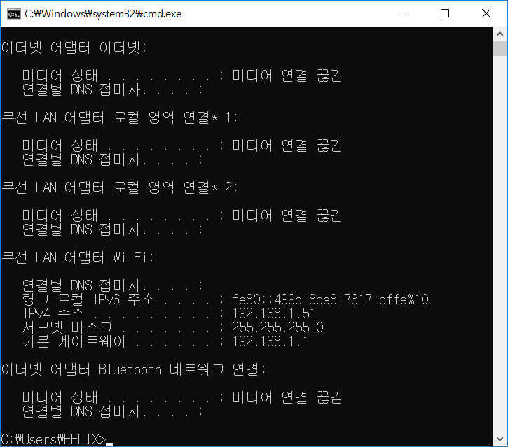
Fig. 60. Checking PC IP Address
Network information of the example screen is as follows:
              - Gateway: 192.168.1.1
              - Net Mask: 255.255.255.0

  - My Computer IP Settings
            - Click Window icon key() from task bar
            - Click Setting icon key()
            - Click Network & Internet from Windows Settings
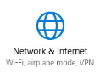
            - Select the current connected network (ethernet or Wi-Fi)
Click icons in order as below
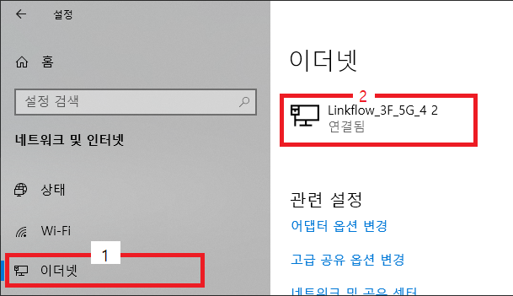
            - Ethernet information will be displayed with saved IP address.
Click Edit to change IP address
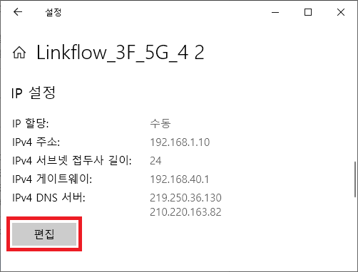

            - Enter new IP address and press save
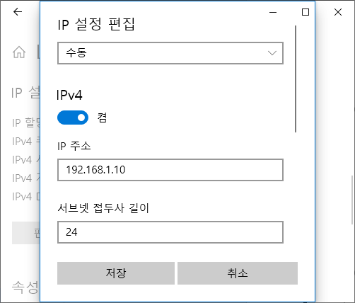

  - The time of the video is not correct.
If you insert the system unit into the cradle's system connector while the Internet (LAN cable) is connected, the time is automatically set to the Korea Standard Time (GMT + 09).
If the Coordinated Universal Time (UTC) offset is not set for your location, the time is not set automatically. UTC can be set in the Function tab > Settings tab > Server tab in the NEXX360 Manager.
Fig. 61. Time settings

- Warranty
  - Warranty terms
This product has been manufactured under strict quality control and inspection. However, there is a possibility that the product may not work properly due to design or manufacturing issues. The warranty period will last for one year from the date of shipment.
However, we do not guarantee compensation for any damage to product or property caused by misuse by the user.
          - Technical Support Inquiries: + 82-1833-2526

Linkflow Inc. is not responsible for any personal injury and/or damage to product or property caused by the following:
          - Use of unauthorized parts or separate components
          - If the user or a third party disassembles, modifies or repairs the product
          - If product is damaged or data is lost due to force majeure, such as natural disasters, etc.
          - If the product is damaged or data is lost due to incorrect use
          - If the product is damaged or data is lost due to incorrect operation during an update
          - If there is a security problem in the network

  - Quality Warranty
If a problem occurs with the product, fill in the following form and contact our service center.
This warranty must be presented if any repairs are required. So please keep it in a safe place.
Classification | Item | Contents
Product information | Product name | NEXX360 SECURITY
 | Model name | LFFTSC1
Purchase Information | Name
 | Address
 | Contact | Phone number: | E-mail:
 | Date Purchased | Date/Month/Year
 | Place of Purchase

- Appendix
  - NEXX360 Manager
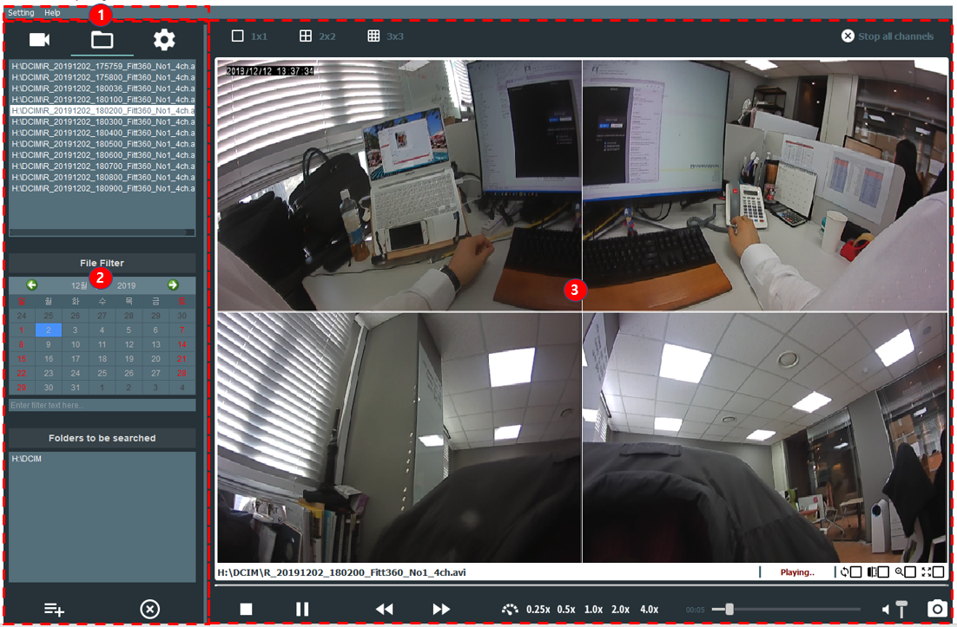
Appx Fig. 1. Main Screen
Classification | Designation | Description
1 | Menu Bar | The main menu of the program is displayed.
2 | Function Tab | Select the live streaming or video function.
3 | Video Area | Live streaming or recorded video is displayed.

    - Menu Bar
The main menu of the program is displayed.
Appx Fig. 2. Menu Bar
Classification | Description
Settings | Configures the product settings.
Help | Check the version of the program.

      - Settings
Configures the settings for the viewer program.
Appx Fig. 3. Settings Menu
Classification | Description
Network | Configures the network settings.
Playback | Configures the playback settings for the recorded video.
Capture | Sets the save path of captured images.
Configuration | Exports the current settings to a file or imports the settings stored in a file.  - Import: Imports your existing settings.  - Export: Exports the current settings to a file.

Configuring Network Settings
Configures the network settings.
Appx Fig. 4. Network Settings Menu

Classification | Setting items | Description
Connection Strategy | Auto Reconnect | Select this to allow automatic reconnection when a session is disconnected.

Playback Settings
Configures the playback settings for the recorded video.
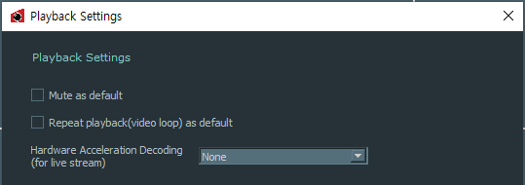
Appx Fig. 5. Playback Menu

Classification | Setting items | Description
Default Settings of File Playback | Mute as default | Select this to play videos with the sound turned off
 | Repeat playback | Playback recorded videos automatically
 | Hardware Acceleration | Settings of live streaming display acceleration  - None: Do not use hardware acceleration  - Auto: Use acceleration function based on PC performance  - NDirect3D 11: Use DirectX acceleration  - DXVA 2.0: Use DXVA acceleration

Notice | Able to configure Hardware Acceleration while live streaming only. Default setting of playback is Auto.

Capture Settings
This allows you to set the save path of captured screen shots.
Appx Fig. 6. Capture Menu
          - Save files to: Select a directory for captured videos
          - Max record duration: Set recording duration such as 1, 3, 5, 10minutes

Configuration settings for Import / Export
Import previously saved settings or export current settings to a file.
          - Import: Imports your existing settings.
          - Export: Exports the current settings to a file.

      - Help (Program Information)
You can check the program version. Go to Help > About to display the program information window.
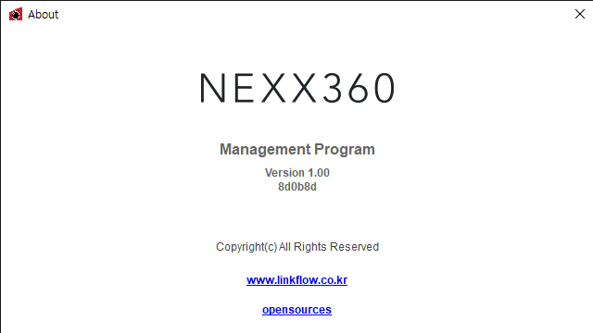
Appx Fig. 7. About Program
Notice | The firmware version may be modified to improve functionality.

    - Function Tab
Go to the main functions.
Appx Fig.8. Function Tab
Classification | Designation | Description
 | Streaming video | You can check, select, add, and delete profiles registered in the program.
 | Recorded Video | You can load and playback images recorded on the Micro SD card.
 | Settings | Configures the product settings.

      - Streaming Video Tab
You can check, select, add, and delete profiles registered in the program.
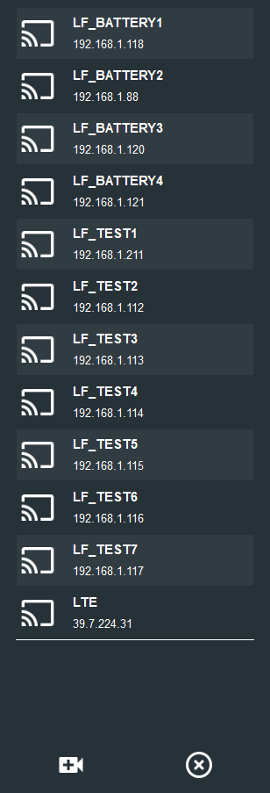
Appx Fig.9. Streaming Video Tab
Classification | Designation | Description
 | Profile | Profile name and IP address of the registered device.  Click to display a video of the device.
 | Add Profile | Add a new device profile
 | Delete Profile | Delete a registered profile.

      - Recorded video tab
You can load and playback images recorded on the Micro SD card.
1
2
3
4
Appx Fig.10. Recorded video tab
Classification | Designation | Description
1 | Recorded Video List | A Recorded Video List is displayed.
2 | Recorded Date Filter | Select a recorded date. The video files of the selected date are displayed in the Recorded Video List.
3 | Character Filter | Applies a character filter to the Recorded Video List. This displays only the video files with their name containing the characters entered in the character filter.
4 | Recorded Video Folder List | The Recorded Video Folder List is displayed.  - Add Folder (): Add a new folder.  - Delete Folder (): Deletes a folder from the Recorded Video Folder List. The videos in that folder will not be deleted.

      - Settings Tab
Configures the product settings. To check the Settings screen, click the Function tab at the top of the screen.
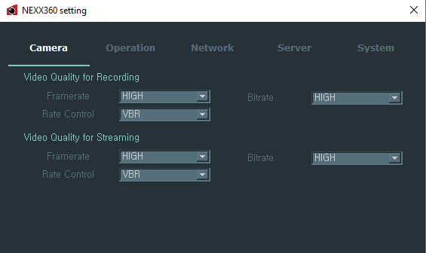
Appx Fig.11. Settings Tab
Classification | Description
Camera | Sets the quality of recording and streaming video.
Operation | Configures the recording settings.
Network | Configures the network settings.
Server | Configures the server settings.
System | Check and set the product information.

Camera Tab
Sets the quality of recording and streaming video.
Appx Fig.12. Camera Tab
Classification | Setting items | Description | Set Point
Video Quality for Recording | Frame Rate | Sets the frame rate of recorded videos. | High/Medium/Low  (Default: 15/10/5)
 | Bitrate | Sets the bitrate of recorded videos. | High/Medium/Low
 | Frame Interval | Sets the frame period. | 15 (fixed value)
 | Rate Control | Sets the variable/fixed bitrate. | VBR/CBR
Video Quality for Live Streaming | Frame Rate | Sets the frame rate of live streaming video. | High/Medium/Low (default: 15/10/5)
 | Bitrate | Sets the bitrate of live streaming video. | High/Medium/Low
 | Frame Interval | Sets the frame period. | 15 (fixed value)
 | Rate Control | Sets the variable/fixed bitrate. | VBR/CBR

Operation Tab
Configures the recording settings.
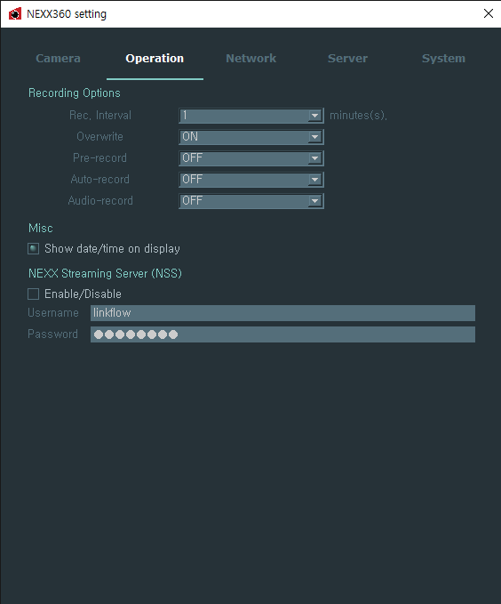
Appx Fig.13. Operation Tab
Classification | Setting items | Description | Set Point
Recording Options | Rec. Interval | Sets the saving interval of recorded files. | 1 minute/5 minutes
 | Overwrite | Sets whether or not to overwrite when the storage space is full. | ON/OFF
 | Pre-record | Sets whether to start recording before the system is powered on. | ON/OFF
 | Auto-record | Set whether to start recording automatically when you turn on the system. | ON/OFF
 | Audio-record | Sets whether to record sound simultaneously when video recording begins. | ON/OFF
Mics | Show Date/Time on Display | Sets whether to display the date and time on the recording/streaming screen. | Entered by the user
P2P Server | Enable/Disable | Enables or disables P2P server. | Entered by the user
 | Username | Enter your user ID. | Entered by the user
 | Password | Enter your password. | Entered by the user

Network
Configure your network.
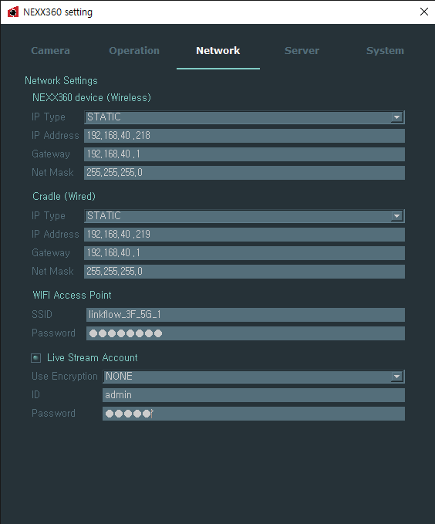
Appx Fig. 14. Network Tab

Classification | Setting items | Description | Set Point
NEXX360 Device (Wireless) | IP Type | When connecting via Wi-Fi, sets the wireless IP type. | STATIC/DHCP
 | IP Address | When connecting via Wi-Fi, sets the wireless IP address. | Entered by the user
 | Gateway | When connecting via Wi-Fi, sets the gateway address. | Entered by the user
 | Netmask | When connecting to Wi-Fi, sets the netmask address. | Entered by the user
Cradle (Wired) | IP Type | Sets the IP type of Ethernet connected to the cradle. | STATIC/DHCP
 | IP Address | Sets the IP address of the Ethernet connected to the cradle. | Entered by the user
 | Gateway | Sets the gateway address of the Ethernet connected to the cradle. | Entered by the user
 | Netmask | Sets the netmask address of the Ethernet connected to the cradle. | Entered by the user
Wi-Fi Access Point | SSID | Sets the SSID of the Wi-Fi AP to connect to. | Entered by the user
 | Password | Sets a password for the Wi-Fi access point. | Entered by the user
Live Stream Account | Live Stream Account | Enables or disables a live streaming account. | Entered by the user
 | ID | Sets your account ID. | Entered by the user
 | Password | Sets a password. | Entered by the user

Server
Configures the server settings.
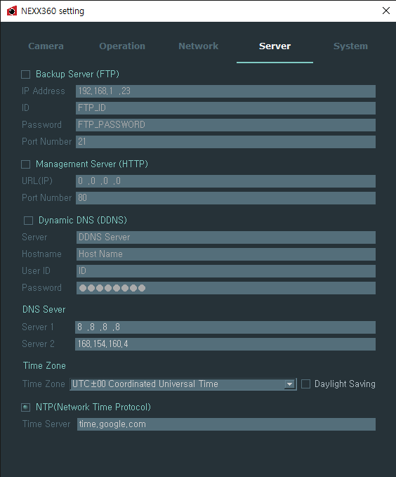
Appx Fig. 15. Server Tab
Classification | Setting items | Description | Set Point
Backup Server (FTP) | IP Address | Sets the IP address of the backup server. | Entered by the user
 | ID | Sets the ID of the backup server. | Entered by the user
 | Password | Sets a password for the backup server. | Entered by the user
 | Port Number | Sets the port number for the backup server. | Entered by the user
Management Server (HTTP) | URL (IP) | Sets the IP address of the device information collecting server. | Entered by the user
 | Port Number | Sets the port number for the device information collecting server. | Entered by the user
Dynamic DNS (DDNS) | Server | Sets the DDNS server URL. | Entered by the user
 | Host Name | Sets the host name. | Entered by the user
 | User ID | Sets user ID. | Entered by the user
 | Password | Sets a password. | Entered by the user
DNS Server | Server 1 | Sets the IP address of the DNS1 server. | Entered by the user
 | Server 2 | Sets the IP address of the DNS2 server. | Entered by the user
Time Zone | Time Zone | Set your time zone. | Entered by the user
 | Daylight Savings | Set whether to use daylight savings time. | Entered by the user
NTP (Network Time Protocol) | NTP (Network Time Protocol) | Enable or disable network time control. | Entered by the user
 | Time Server | Sets the URL address of the server to synchronize time. | Entered by the user

System
Check the product information.
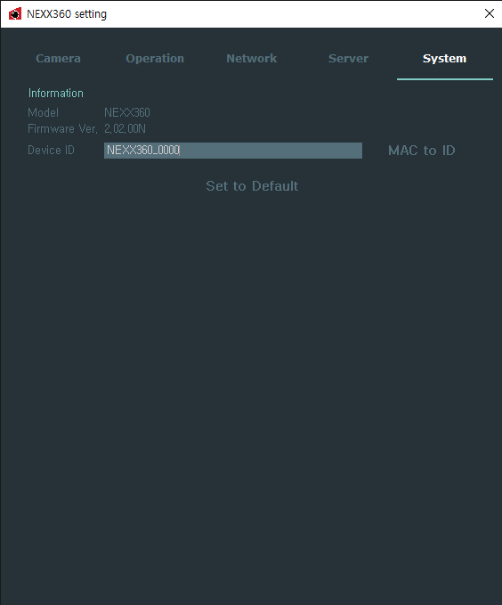
Appx Fig.16. System Tab

Classification | Setting items | Description | Set Point
Information | Model | The model name is displayed. | -
 | Firmware Ver. | The firmware version is displayed. | -
 | Device ID | Sets the device ID.  - Mac to ID: Changes the device ID in the form of MAC address. | Entered by the user
Set to Default | - | Resets all settings. | -

Notice | Device ID is useful when operating multiple cameras at the same time.

    - Video Screen Area
This is the area where recorded video and streaming video are displayed.
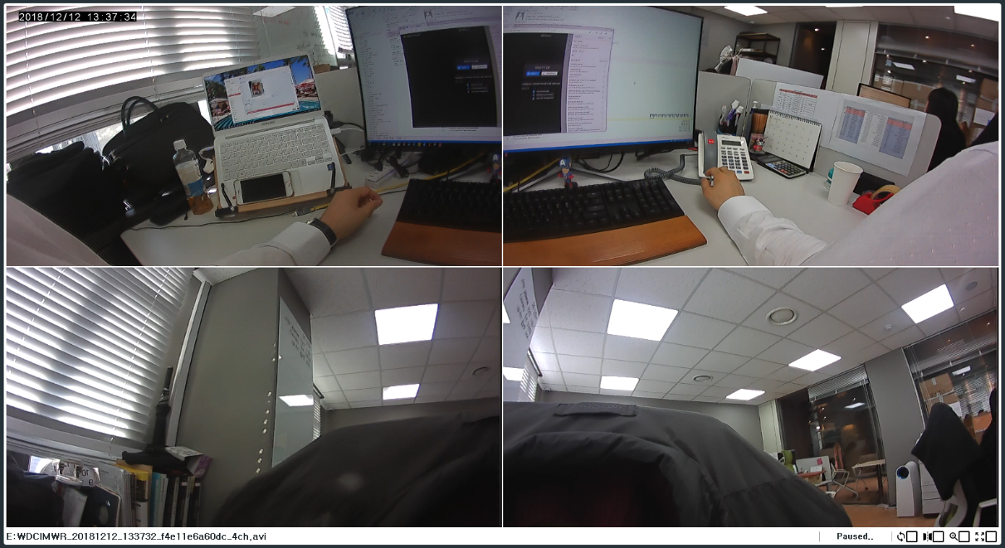
Appx Fig. 17. Video Screen Area
      - View Screen
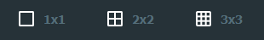
Appx Fig. 18. View Screen
Classification | Designation | Description
 | Default Screen | Plays back only the video transmitted from one NEXX Camera.
 | 2x2 Screen | Plays back videos from four NEXX Cameras at the same time.
 | 3x3 Screen | Plays back videos from nine NEXX Cameras at the same time.
Notice | - 3x3 screens are supported for live streaming only

      - Control Screen View
Appx Fig. 19. Live Streaming Control Screen View
Appx Fig. 20. Recorded Video Control Screen View

Classification | Designation | Description
 | Reverse Screen | Reverses the camera screens (cameras 2 and 3) on the back of the NEXX Camera.
 | Zoom In/Zoom Out | Zoom in or out images.
 | Switch to Full Screen | Switch the current video to full screen view. To return to normal screen view, press ESC key on your keyboard while in full screen.
 | Repeat videos | Replay recorded videos once more
 | Operation | In operation

  - Milestone XProtect
    - Milestone XProtect Management Client
Notice | Before setting up the program, you need to configure the network first. See “Preparing NEXX360 > Configuring a Network” for details on how to configure your network.

            - Run the XProtect Client program.
            - Click the Connect button.
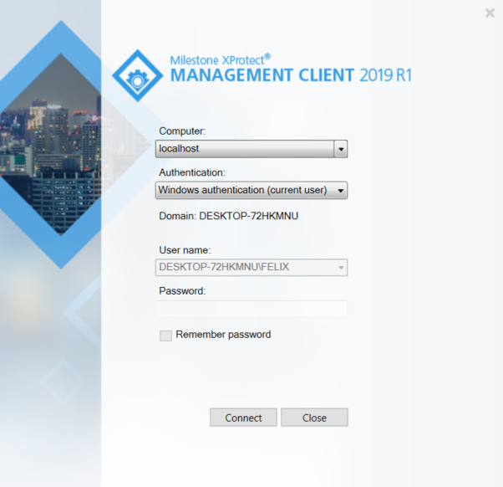
Appx Fig. 21. Milestone XProtect Client

            - Right-click the Recording server and select Add Hardware… .
Appx Fig. 22. Milestone XProtect Client
            - Select Address range scanning and click the Next button.
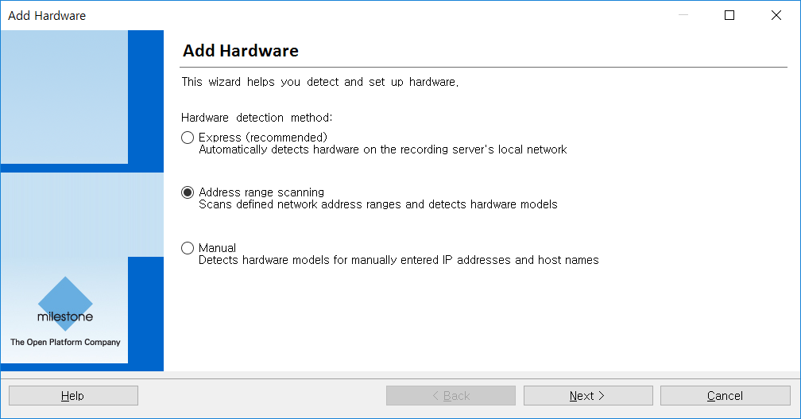
Appx Fig. 23. Milestone XProtect Client

            - After setting the User Name and Password , click the Next button.
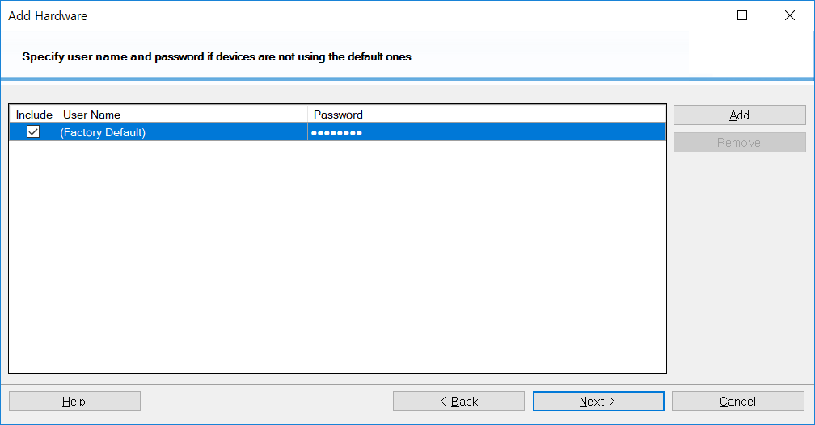
Appx Fig. 24. Milestone XProtect Client

            - Click the Clear All button and select ONVIF.
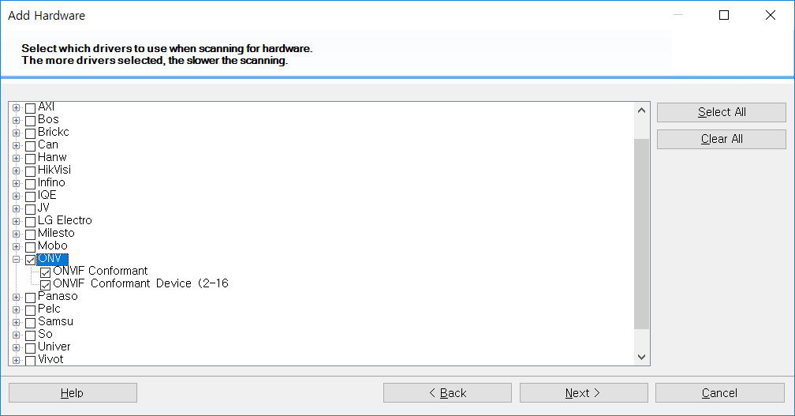
Appx Fig. 25. Milestone XProtect Client

Notice | Selecting these items allows you to quickly search for your device. You can also install a device without selecting them.

            - Set Scan IP and Port.

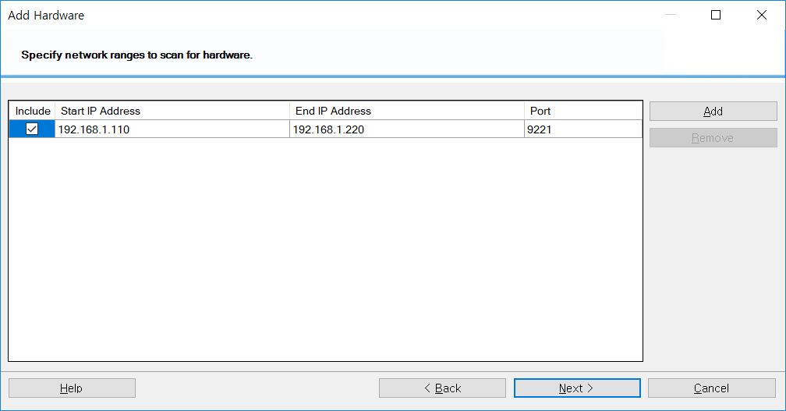
Appx Fig. 26. Milestone XProtect Client

Notice | - If you select this item, you can search for all NEXX360 products set within a certain range.  - It is recommended to set the Port to 9221.

            - When scanning is complete, check the list of devices found and click the Next button.
Example) Scanning found one device with the IP address 192.168.1.213.
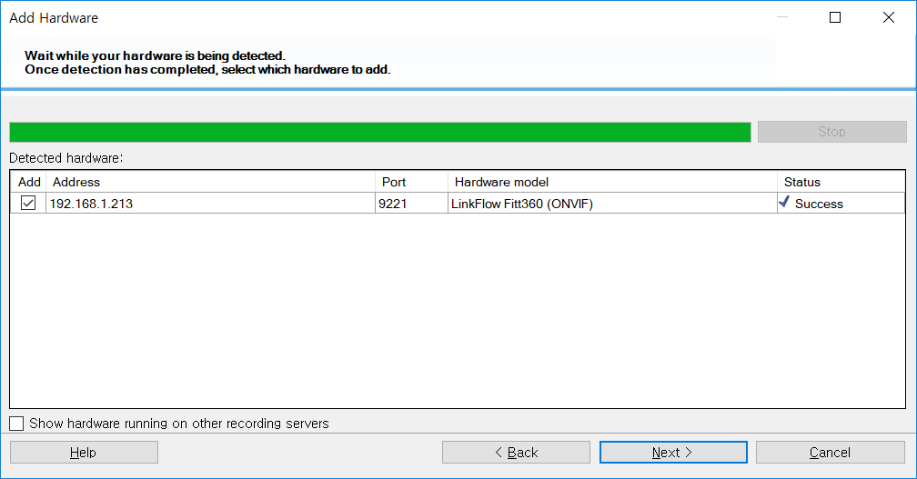
Appx Fig. 27. Milestone XProtect Client

            - Select Enabled in Hardware and Camera Port 1 and click the Next button.
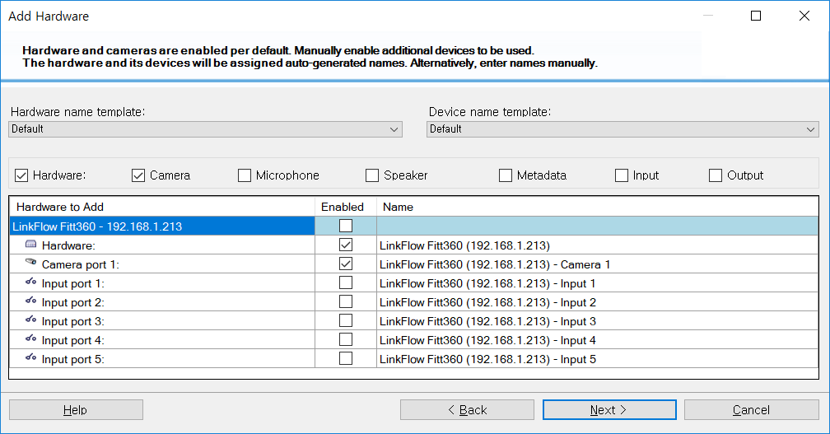
Appx Fig. 28. Milestone XProtect Client

            - After specifying the group, click the Finish button. Device registration is complete.
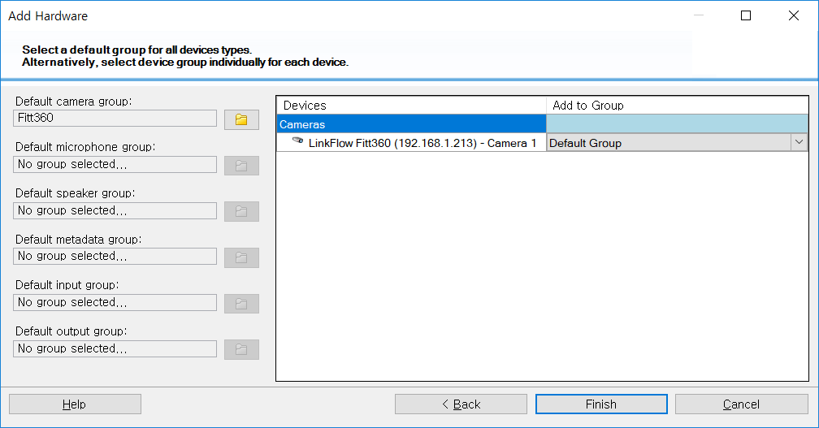
Appx Fig. 29. Milestone XProtect Client

            - Check if the machine has been registered properly.
              - Confirm device registration.
              - Check Preview and resolution notations.
              - Check Hardware information.
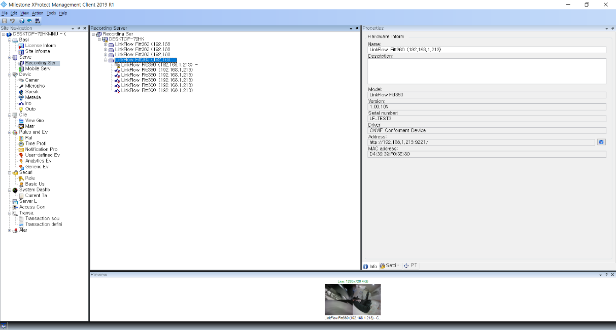
Appx Fig. 30. Milestone XProtect Client

    - Smart Client
Notice | The device must be registered with the Milestone XProtect Management Client before using the program.

            - Run the Smart Client program.
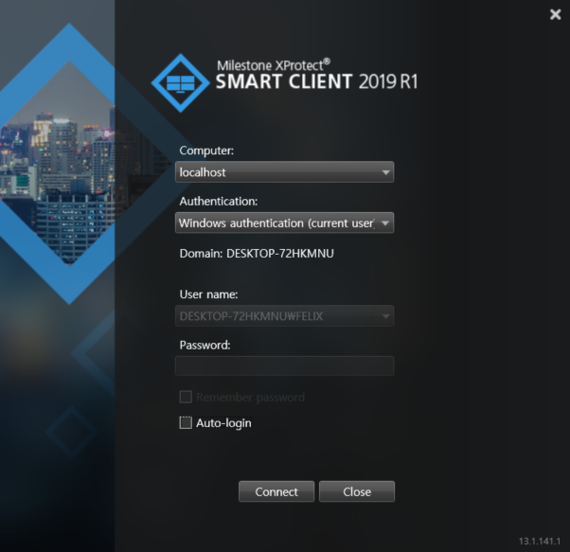
Appx Fig. 31. Smart Client

            - Run the Milestone XProtect Smart Client program.
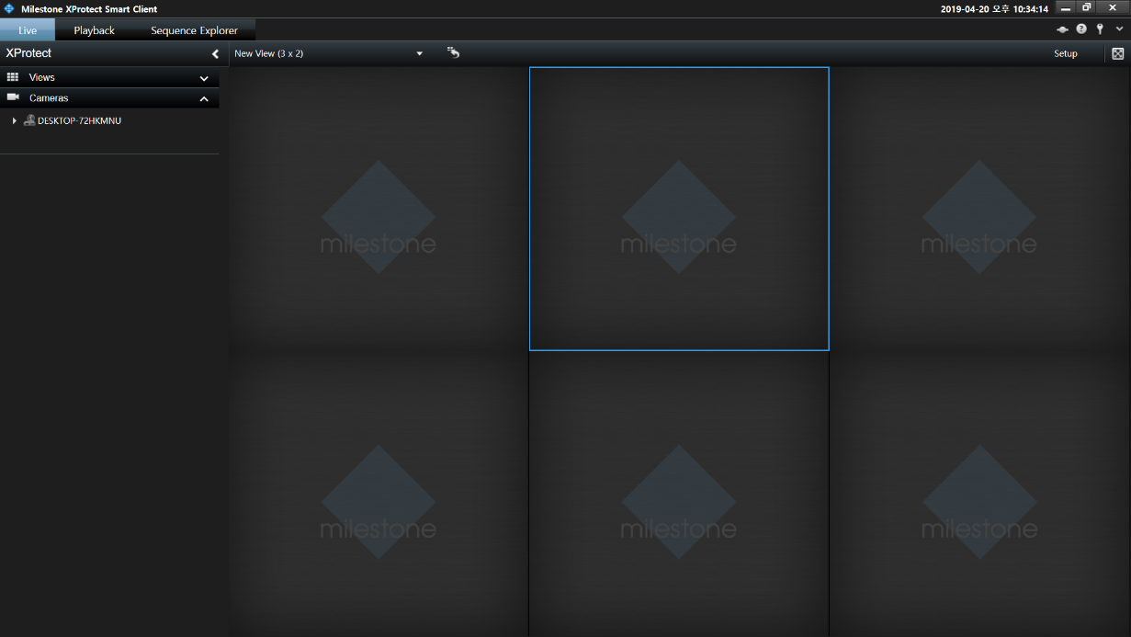
Appx Fig. 32. Smart Client

            - On the Live tab, right-click the device to view the video in the list of Cameras.
Appx Fig. 33. Smart Client

            - Select Send Camera > Main Window – New View, and click the desired location.
Example) In case of 3 X 2 View, select Standard 1
Appx Fig. 34. Smart Client

            - Check the streaming video.
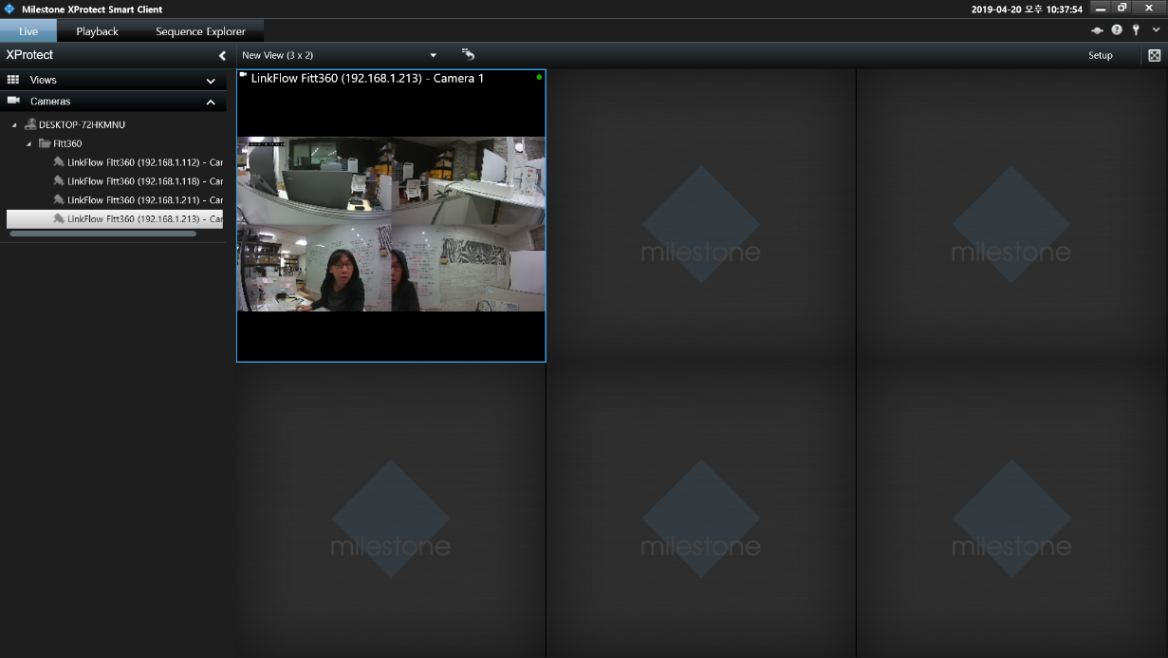
Appx Fig. 35. Smart Client

Notice | When multiple devices are linked, you can double-click a specific screen to check it.  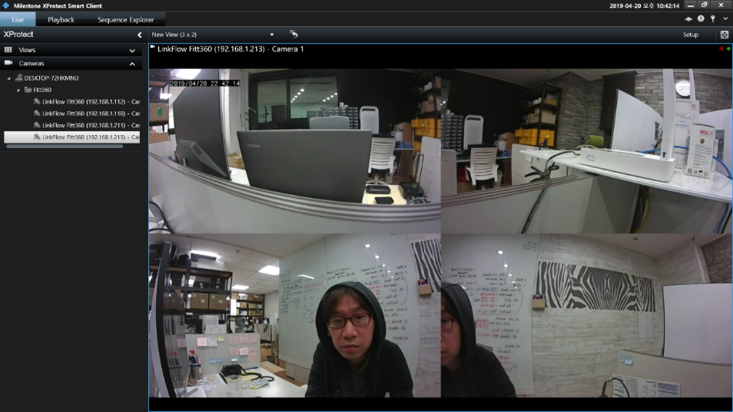  Appx Fig. 36. Smart Client

  - VLC Media Player
Notice | It is recommended to use VLC media player version 2.2.6 or lower.

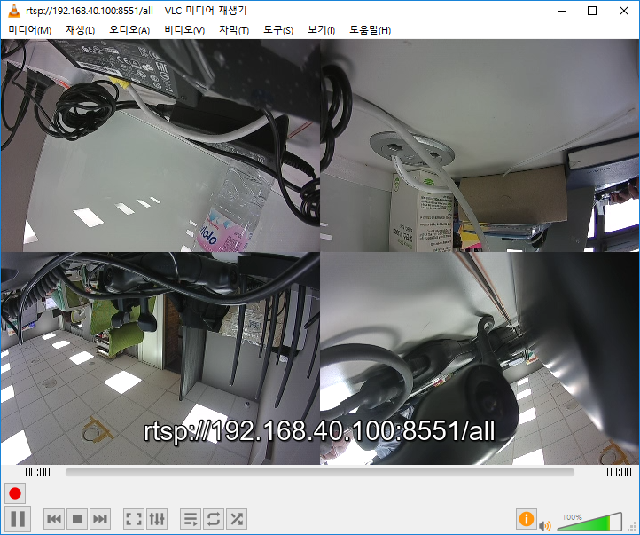
Appx Fig. 37. VLC Media Player
            - Download and install the VLC media player program.
            - Configure your wireless network.
Notice | See “Preparing NEXX360 > Network Configuration” for wireless network configuration.  When NEXX360 Manager Setting >Network>Live Stream Account is enabled, Live streaming is not supported via VLC Player.

            - Network streaming playback.
              - URL: rtsp://<IP address>: 8551/all
(URL example) rtsp://192.168.40.100:8551/all

  - ONVIF Device Manager
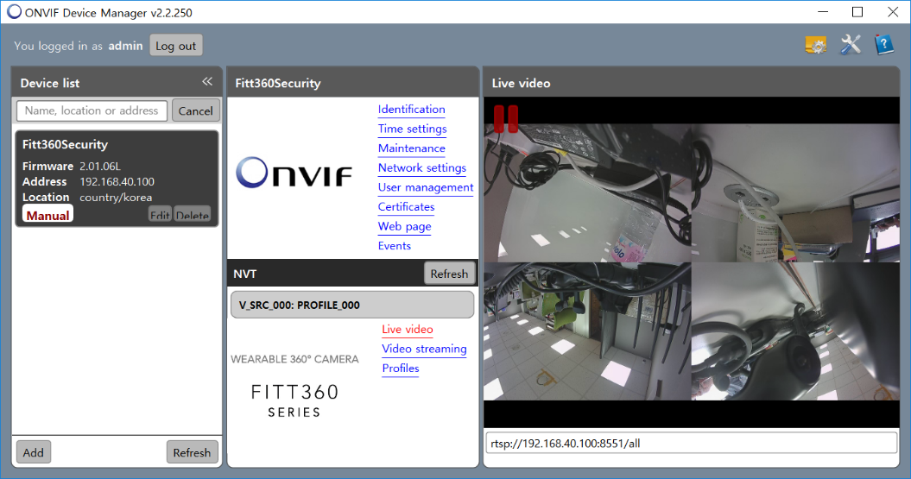
Appx Fig. 38. ONVIF Device Manager
            - Download and install the ODM (Onvif Device Manager) program.
            - Configure your wireless network.
Notice | See “Preparing NEXX360 > Network Configuration” for wireless network configuration.  When NEXX360 Manager Setting >Network>Live Stream Account is enabled, Live streaming is not supported via ONVIF Device Manager.

            - Network streaming playback.
              - ID/PW: admin/admin
              - URL: http://<IP address>/onvif/device_service/
(URL example) http://192.168.40.100:9221/onvif/device_service

