VisionLabs Face Recognition Plug-in
User Manual
VisionLabs B.V.
Keizersgracht 311, 1016 EE, Amsterdam, the Netherlands

+31 20 369 04 93
info@visionlabs.ai
www.visionlabs.ai

v.1.1
Table of contents

Introduction 3
Face Recognition Events Preview Panel 4
Appendix: Version History 6

Introduction
The document describes matching events parameters displayed in XProtect Smart Client.

Face Recognition Events Preview Panel
The plugin adds the following preview panel (Fig. 1) alongside the video display on the Alarm Manager tab.
The panel displays facial recognition results. The event of recognition is already exported by LUNA PLATFORM and stored in the XProtect Event Server database as an Analytics event. Since events are internal entity, not directly visible to users, this plugin shows corresponding event data for Alarms triggered by those events instead.
Note. Alarm rules (definitions) should be configured prior using this plugin in order to receive and view alarms.
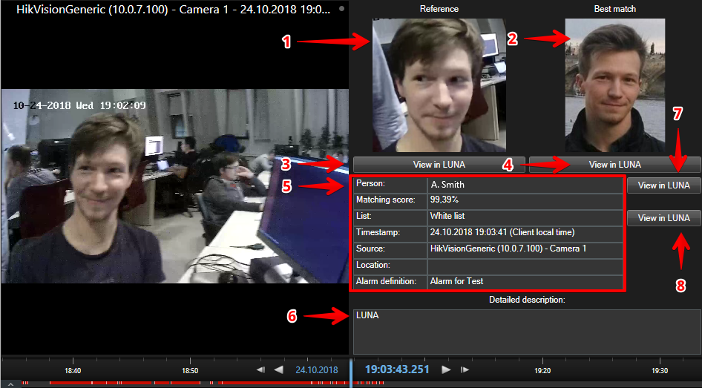
Figure 1 – Facial recognition results
Displayed on the figure 1:
- The reference image (one corresponding to the face detection that was selected by VisionLabs video processing software, e.g. FaceStream);
- The best match image (one from the database, typically stored during enrollment procedure);
- Shows the LUNA PLATFORM User Interface face view page (opens browser) for the reference image;
- Shows the LUNA PLATFORM User Interface face view page (opens browser) for the best match image;
- Data fields:
Person. Recognized person data (if available). The data is customizable via LUNA PLATFORM User Interface.
Matching Score. Confidence score of the recognition.
List. List data. This is the list we were looking for a match to the reference photo in. The data is customizable via LUNA PLATFORM User Interface.
Timestamp. Timestamp of the event (displayed in client machine local time).
Note. It is required that the data for LUNA PLATFORM servers and XProtect servers is synchronized, for example, using Network Time Protocol.
Source. Event source. Typically, is the name of the camera that took the reference image.
Location. Camera location (if available).
Alarm Definition. Rule that has triggered the alarm.
- Alarm detailed description. This is typically configured on server side;
- Shows the LUNA PLATFORM User Interface person view page in browser for the recognized person (if available);
- Shows the LUNA PLATFORM User Interface list view page in browser.

Appendix: Version History
Date | Version | Notes
25.10.18 | 1 | Initial release

