VisionLabs Face Recognition Plug-in
System Overview
VisionLabs B.V.
Keizersgracht 311, 1016 EE, Amsterdam, the Netherlands

+31 20 369 04 93
info@visionlabs.ai
www.visionlabs.ai

v.1.1
Table of contents

Introduction 3
1 Integration Structure 4
2 General Plug-in Description 6
3 Event Content 7
Appendix: Version History 9

Introduction
VisionLabs Face Recognition plug-in adds functionality for face recognition to Milestone XProtect.
VisionLabs Face Recognition plug-in designed to work in conjunction with VisionLabs LUNA PLATFORM facial recognition system. The plug-in adds preview support for Alarms triggered from LUNA PLATFORM matching events.
General workflow of integrated systems is shown in Fig. 1.
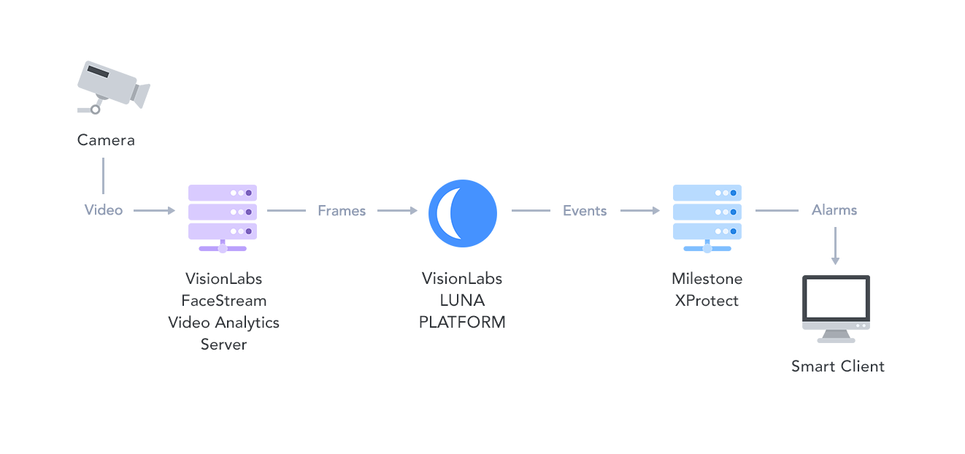
Figure 1 – General workflow
VisionLabs FaceStream finds faces on video frames and sends the frames to VisionLabs LUNA PLATFORM.
VisionLabs LUNA PLATFORM matches received faces with the existing faces in the database and sends matching events to the Milestone XProtect Event Server.
Milestone XProtect shows all the events on the Alarm tab in Smart Client.
Note: More information about FaceStream and LUNA PLATFORM can be found in the corresponding manuals in the distribution packages.

- Integration Structure
Systems integration in general is shown in Fig. 2.
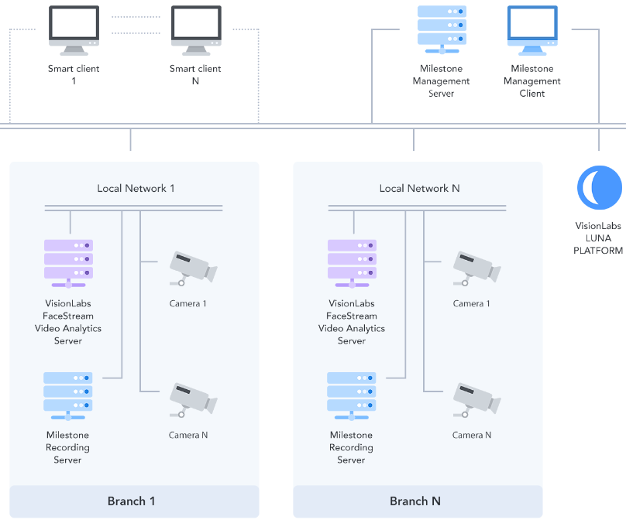
Figure 2 – System components
VisionLabs FaceStream is located on local network server and receives video from cameras. FaceStream receives and processes video stream in parallel with Milestone Recording Server.
VisionLabs LUNA PLATFORM is located on a separate server.
Since the delivery happens on the server side, a network connection is required between LUNA API servers and XProtect Event servers. Moreover, analytics must be enabled in XProtect and network access should be appropriately configured.
The advantages of such approach are significant:
- All the HTTP communication is done by LUNA PLATFORM high performant asynchronous HTTP stack, so it is fast;
- The event export routines scale horizontally automatically with the API scaling; so, the more service workers are used to consume data from LUNA PLATFORM clients (and to spawn more events as the result of their work) the more workers are transparently added to transmit those events to XProtect without delays;
- No additional software and on-site configuration are required; all integration is just a single server-side installation and just a handful lines of configuration;
- Event source identification data as well as identities for facial recognitions and identity lists are all created and managed by means of LUNA PLATFORM web-based User Interface.
- General Plug-in Description
VisionLabs Face Recognition plug-in translates facial recognition events from LUNA PLATFORM to Analytics Events that Milestone XProtect services understand. The translated events are then delivered to XProtect by means of protocol integration.
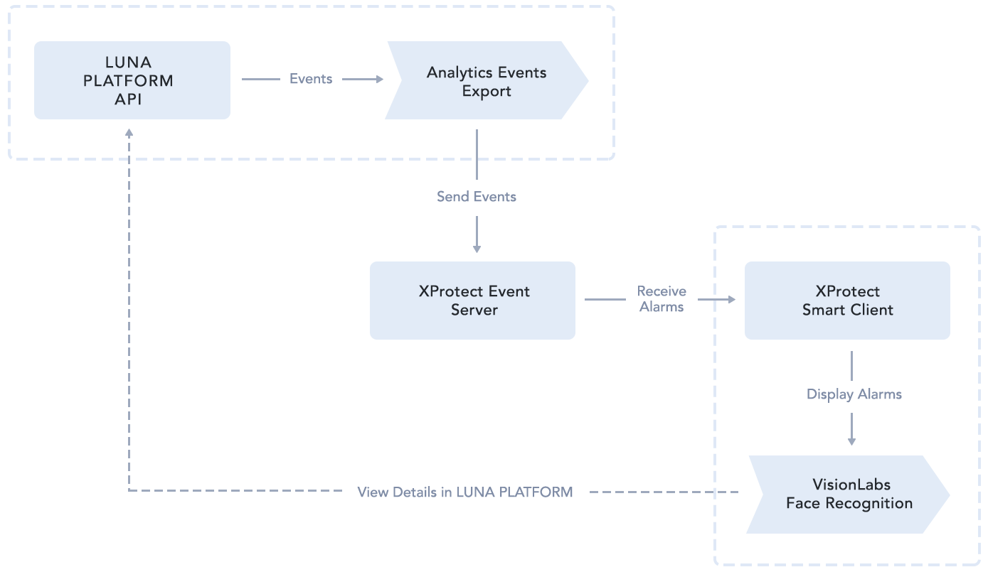
Figure 3 – Workflow of events translation
Events translation is performed with the help of two entities (Fig. 3):
- Analytics Event Export module is a part of LUNA PLATFORM. It allows to export matching events to Milestone XProtect Event Server;
- VisionLabs Face Recognition plug-in is installed for Milestone XProtect. It adds additional preview panel with information about received matching events into XProtect Smart Client.
- Event Content
VisionLabs Face Recognition plug-in allows you to receive all required information about face recognition events.
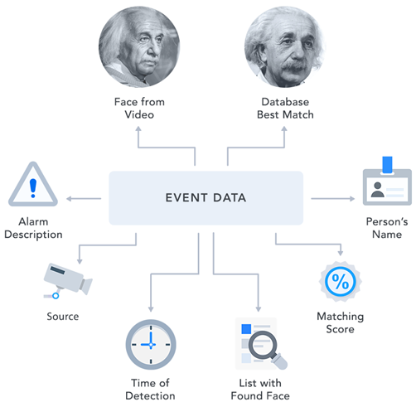
Figure 4 – Event content
The received events include the following information (Fig. 4):
- Person’s face image from video stream;
- Best match of face image from database;
- Person’s name;
- Matching score. The higher the score is, the more similar the faces are. The score is displayed in percent;
- List in LUNA PLATFORM database, where the person was found;
- Time of the face detection in the video;
- ID of the camera that detected the person;
- Alarm description.
Note. User can also view events data in LUNA PLATFORM.
Configurable entities:
- IP address and port for event data XML submission (should match XProtect installation);
- Event message - users can specify a convenient name for LUNA-generated events;
- Similarity score threshold – a recognition threshold to filter out low-probability events and suppress false alarms.
Immutable entities:
- Event type is always reported as VL_LUNA_Event.
Users can define their own rules in the XProtect VMS to trigger various alarms based on Analytics Events using common workflows.

Appendix: Version History
Date | Version | Notes
01.11.18 | 1 | Initial release

