VisionLabs Face Recognition Plug-in
Services Installation Manual
VisionLabs B.V.
Keizersgracht 311, 1016 EE, Amsterdam, the Netherlands

+31 20 369 04 93
info@visionlabs.ai
www.visionlabs.ai

Table of contents

Introduction 3
1 Analytics Event Export Installation 4
1.1 Installation 4
1.2 Analytics Event Export Activation 4
1.3 Configuration of Analytics Event Export Module 4
1.4 Restart LUNA API 5
1.5 Analytics Event Export Module Specification 6
2 FaceStream 3 Installation 7
2.1 Installation on Linux 7
2.1.1 Detection of Third-Party Dependencies 7
2.1.2 Sentinel HASP Installation 7
3 Milestone XProtect Installation and Configuration 8
4 Add Data to LUNA PLATFORM 13
4.1 Requirements 13
4.2 Registration in LUNA PLATFORM 13
4.3 Setting up LUNA PLATFORM 14
4.3.1 Add Photos 14
4.3.2 Create Person 15
4.3.3 Create List of Persons 17
4.4 Create Token for Camera 18
5 Add Cameras 20
5.1 Add Cameras Manually 20
5.2 Add Cameras using Camera configuration window 21
6 Troubleshooting 25
7 Face Recognition Events Preview Panel 26
Appendix: Version History 28

Introduction
The document describes installation of Analytics Event Export, FaceStream 3 and Milestone XProtect and configuration of the products for working with VisionLabs Face Recognition Plug-in.
- Analytics Event Export Installation
The first step for VisionLabs Face Recognition Plug-in installation is activation of Analytics Event Export in LUNA PLATFORM.
- Installation
# Install Unzip
sudo yum install unzip

# Copy plugin archive to LUNA PLATFORM directory
cp <vl_milestone_event_export_archive_path> /var/lib/luna/current/luna-api/luna_api/plugins/
# Go to the folder
cd /var/lib/luna/current/luna-api/luna_api/plugins/
# Unzip the archive
unzip vl_milestone_event_export_*.zip
# Go to the api directry
cd /var/lib/luna/current/luna-api

# Activate virtual environment
source venv/bin/activate

# Go to the plug-in directory
cd /var/lib/luna/current/luna-api/luna_api/plugins/vl_milestone_event_export_*

# Install Python requirements
pip3.6 install -r requirements.txt

# Deactivate virtual environment
deactivate
- Analytics Event Export Activation
Append the module to the enabled plug-ins list by modifying list_enable_plugins.py, for example:
ENABLE_PLUGINS = ["milestone_event_export"]
Make sure plugins are enabled in LUNA API by inspecting luna-api/luna_api/configs/config.conf and setting:
ENABLE_PLUGINS = 1
The module does not require additional dependencies other than LUNA API already implies. Still, external packages with tested versions are listed in requirements.txt.
- Configuration of Analytics Event Export Module
Configurable parameters are defined in the folder of Milestone Analytics Event Export module in the file milestone/config.json. Example configuration with comments is given below.
Example configuration:
{
"url": "http://10.0.6.76:9090",
"event": "Test",
"threshold": 0.75,

"endpoints": {
"api": "http://10.0.4.144:5000/",
"ui": "http://10.0.4.144/"
},

"policies" : {
"event_source": "auto"
}
}
Top-level parameters:
- “url”: the XProtect URL.
- “event”: analytics event name in XProtect.
- “threshold”: matching score threshold.
- “endpoints”: public LUNA PLATFORM endpoints.
- “policies”: various policies that control module logic.
Endpoints section includes the addresses, that should be used by the VisionLabs Face recognition plug-in to access required APIs of this LUNA PLATFORM installation.
Endpoint parameters:
- “api”: LUNA API address with protocol and port.
Note. Do not include API version here, the VisionLabs Face Recognition plug-in will use the API it supports.
- “ui”: LUNA UI address with protocol and optional port.
Policies allow to alter the module behavior.
Policy parameters:
- event_source: controls how token data is parsed to become event source. Possible values:
- "auto": tries to detect if token data represents an ObjectId of the camera or an IP address and builds event XML accordingly,
- "raw": inserts token data into <Name></Name> tag without modifications.
- Restart LUNA API
Restart LUNA API
systemctl restart luna-api.service
- Analytics Event Export Module Specification
The Analytics Event Export module only processes events produced with requests to /matching/search API (i.e. event source is set to search). In other words, it bypasses common events triggered by UI.
The module implements the Analytics Events specification given in “Analytics Events 2.0 Developer’s Manual” and defines the following data:
- Timestamp;
- Type (always set to VL_LUNA_Event);
- Message (configurable);
- Source (assigned with LUNA UI);
- Vendor information and CustomData.

Event ID is also provided, but explicitly set to 00000000-0000-0000-0000-000000000000 which means, that the actual ID is to be assigned by XProtect.
Event source may be specified either as camera ObjectId or IP address (including comma-separated channel specification).
At the moment, only IP v4 addresses are supported.
The ObjectId or IP address must be assigned to token data field of the authentication token used to authorize the device access to LUNA API.
Note. More information can be found in the “Add cameras” section.
The module will parse token data and determine the event source format automatically.
The module will ignore events whose source it cannot identify.
The Vendor CustomData contains additional details on the occurred event and may be viewed in XProtect Smart Client UI via VisionLabs Face recognition plug-in.

- FaceStream 3 Installation
- Installation on Linux
# Unpack the archive
unzip facestream_linux_v.X.X.X.zip
    - Detection of Third-Party Dependencies
# Run the following command
sudo yum install SDL2 gtk3 boost

# Install the tbb version, included in the distribution kit (folder /extras)
cd extras
rpm -Uvh tbb-X.X-xxxxxxxxx.centos.x86_64.rpm

    - Sentinel HASP Installation
# To install HASP on Linux CentOS, use .rmp package (named haspd -X.XX-vlabs.i386.rpm), distributed by VisionLabs (folder /extras)
sudo yum install haspd-X.XX-vlabs.i386.rpm

# Start the service and add license file
# Add service to the autostart and start it
sudo systemctl start aksusbd
sudo systemctl enable aksusbd

# Add the license file to the system
hasp_update u ~/filename.v2c

# Restart service
systemctl restart aksusbd
# Check that the service works
systemctl status aksusbd

To run FaceStream on Linux CentOS, go to the directory with the executable file and run it:
Copy file fs3.service from the FaceStream3/extras folder to the /etc/systemd/system folder
cp <path_to_fs3.service> /etc/systemd/system/
systemctl start fs3.service
systemctl enable fs3.service
Note. The default port for the service is 34569.
- Milestone XProtect Installation and Configuration
To install Milestone XProtect you should go to the
https://www.milestonesys.com/support/resources/download-software/
and download required XProtect product version starting with XProtect Express+.
Note. The plug-in was tested on Milestone XProtect VMS Products 2018 R3 version Corporate license.
Note. The plugin requires Alarm Manager tab in Smart Client. Alarm management is available starting with XProtect Express+ product.
Note. XProtect should be installed on Windows 10 Pro or Windows Server 2012 or higher.
After downloading, run installation and follow its instructions.

Open XProtect Management Client after installation.
Go to the Tools > Options and enable Enabled flag in the Analytics events section on the Analytics Events tab (Fig. 1).
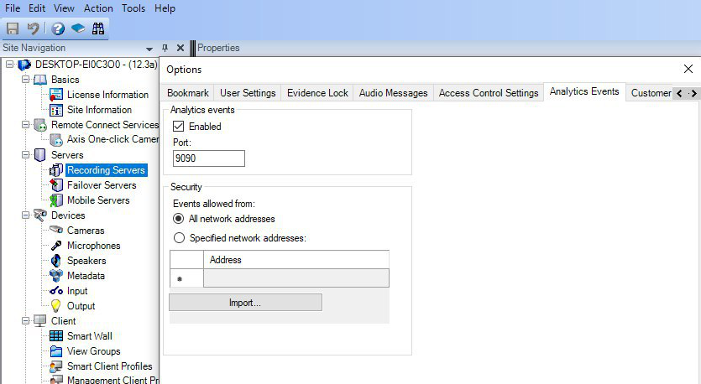
Figure 1 – Enable analytics events
Go to Site Navigation tree in the left site of the window. Select Servers > Recording servers.
Click on your server using right button and in the appeared menu select Add Hardware (Fig. 2).
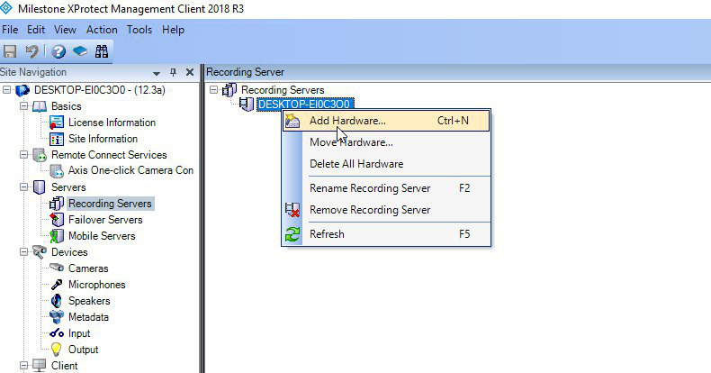
Figure 2 – Add hardware
Add your device to XProtect Server (Fig. 3).
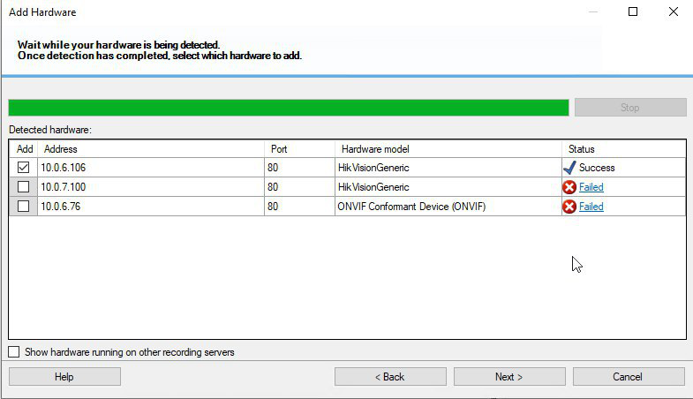
Figure 3 – Device selection
You may group one or several of your devices (Fig. 4).
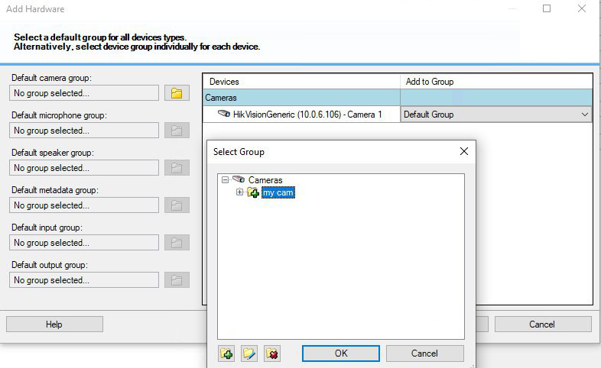
Figure 4 – Devices grouping
If it is not required to record video stream, then disable Recording flag for your device (Fig. 5).
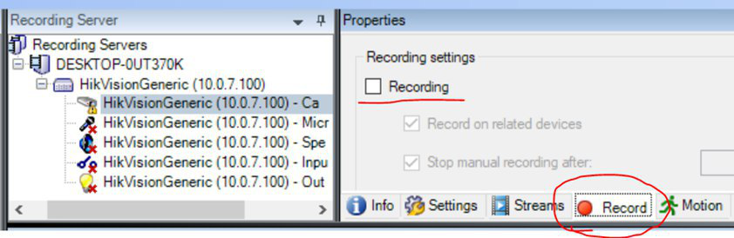
Figure 5 – Disable recording
Add analytics events to XProtect.
Go to Site Navigation tree and select Rules and events > Analytic Events.
Right click and add a new analytic event using Add new (Fig. 6).
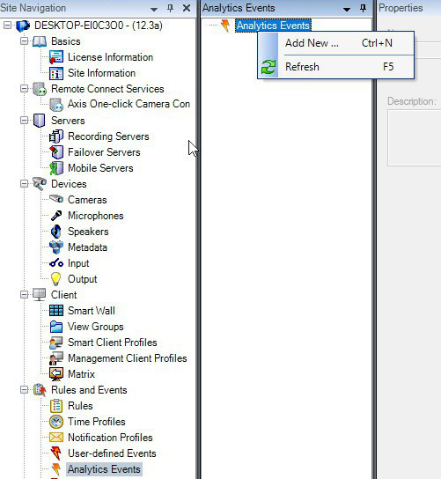
Figure 6 – Add new event
Create an alarm trigger.
Go to Site navigation tree Alarms > Alarms Definition and press Add new (Fig. 7).

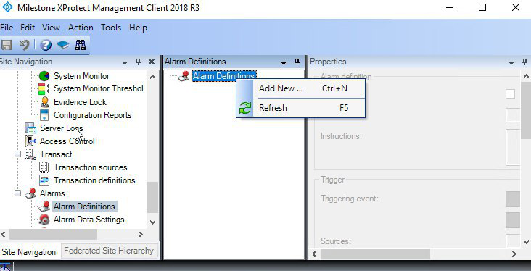
Figure 7 – Add new alarm
Then specify the alarm parameters (Fig. 8).
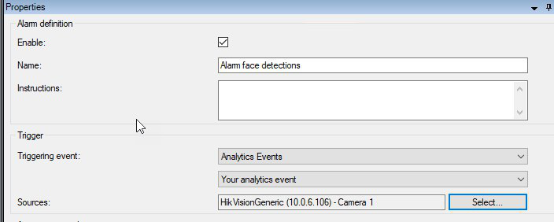
Figure 8 – Alarm parameters
- Add Data to LUNA PLATFORM
- Requirements
Make sure Analytics Events are enabled in XProtect. To do so, open Management Client, go to Tools/Options, scroll to the Analytics Events tab and check Enabled under Analytics events frame.
Events are not displayed in Milestone XProtect Smart Client. Alarms are displayed instead. The alarms are triggered by events according to some rules. The rules are to be defined via Management Client. Expand Rules and events tree node, then click on Analytics events to bring up the rule editor.
- Registration in LUNA PLATFORM
VisionLabs LUNA PLATFORM User Interface is the easiest way to add photos and create lists and tokens in LUNA PLATFORM. Open User Interface in your browser. The service uses port 80 by default.
You should create an account in LUNA PLATFORM User Interface on the Sign up tab (Fig. 9). Fill in all the fields to create an account.
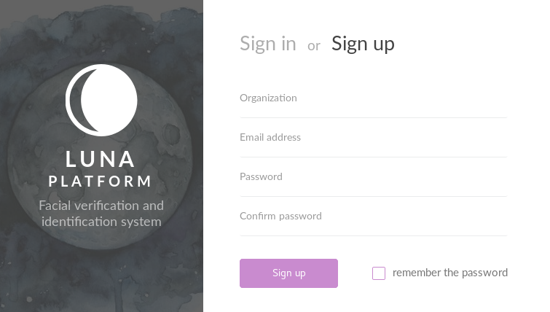
Figure 9 – Sign up tab
You should log in on the Sign in tab (Fig. 10)
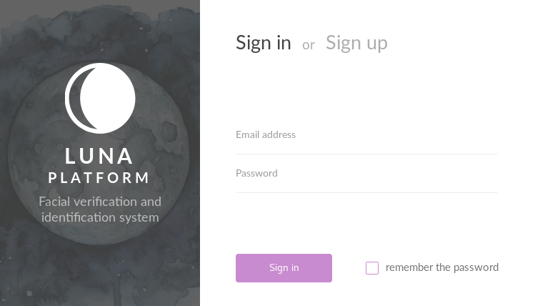
Figure 10 – Sign in tab
- Setting up LUNA PLATFORM
    - Add Photos
Go to Faces page by clicking icon (Fig. 11) on the left toolbar.
Figure 11 – Faces page icon
Press Add face button (Fig. 12) and select photo that should be uploaded to LUNA PLATFORM database.
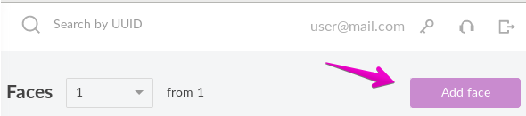
Figure 12 – Add face
    - Create Person
Go to Persons page by clicking icon (Fig. 13) on the left toolbar.
Figure 13 – Persons page icon
Add a new person using Add person button (Fig. 14).
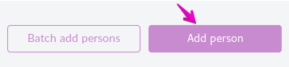
Figure 14 – Add person button
You may upload large number of images and create a separate person for each of the found faces using Batch add persons button (Fig. 15).
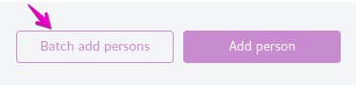
Figure 15 – Batch add of persons
A new person(s) is created and showed in the list of persons (Fig. 16).
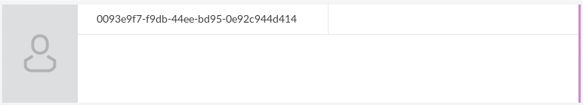
Figure 16 – New person
Parameters of the person are shown to the right in a special dialog (Fig. 17).
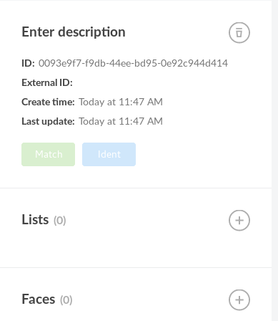
Figure 17 – Person parameters
You can add a person to the list here and add new faces to the person using icons near the corresponding fields.
    - Create List of Persons
Go to Lists page by clicking the corresponding icon (Fig. 18) on the left toolbar.
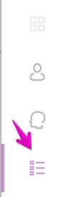
Figure 18 – Lists page icon
Press Add persons list to create a new list for persons (Fig. 19).
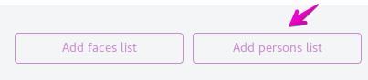
Figure 19 – Add persons list button
When a list is created, it is shown on the page (Fig. 20).
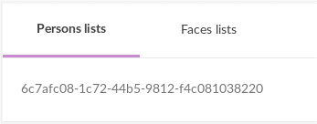
Figure 20 – New list
When you select a list, its parameters dialog appears to the right (Fig. 21).
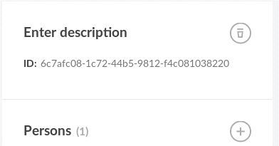
Figure 21 – List parameters
To add a person to the list press icon.
You may also create a list of faces, using the corresponding button (Fig. 22).
Figure 22 – Add faces list button
- Create Token for Camera
You should create a token for your camera so FaceStream could receive video from it.
To create a token, select special icon (Fig. 23) in the upper right corner of UI window.
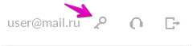
Figure 23 – Create token
On the Tokens page press Add token button (Fig. 24).
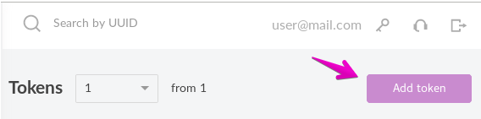
Figure 24 – Add token button
A new token appears. You should enter your camera IP or the ObjectID part of camera FQID into the Enter description field (Fig. 25).
Note. Only ObjectID allows you to add camera using Camera configuration window. More details can be found in “Add Cameras using Camera configuration window” section.
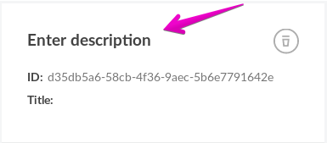
Figure 25 – Enter Description
You should copy the token ID to add it into FaceStream manually (Fig. 26).
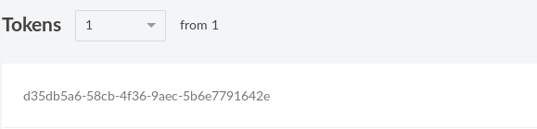
Figure 26 – Token ID
- Add Cameras
There are two ways to add cameras for working with FaceStream. You may fill in FaceStream configuration file manually or you may use Camera configuration window to add cameras.
- Add Cameras Manually
You can manually add cameras using LUNA PLATFORM User Interface by creating a new token for each camera and setting either camera ID (the ObjectID part of camera FQID, if you have it) or IP address (only IP v4 addresses are supported at the moment!).
To add a new camera to FaceStream you should open input.json file located in <facestream_folder>/bin/data/.
Note. FaceStream should be launched in a standard mode.
IP cameras connection parameters are set in "stream-sources" section. In the section you should add data to the following fields:
“source” – an address of your camera.
"source" : {
"value" : "rtsp://<address>"
},
“destination” – an address of LUNA PLATFORM server. You should specify server address, port and list for searching.
"destination”:
{
"value" : "https://127.0.0.1:5000/4/matching/search?list_id=3e64f6319-ede8-4c61-b63b-85fdfa207c18"
}
"login" – a login for authorization on LUNA PLATFORM server.
"login”:
{
"value": "user@mail.com"
}
“password” - a password for the authorization on the LUNA PLATFORM server.
"password”:
{
"value": "12345678"
{
“token” – a token for authorization on the LUNA PLATFORM server. You should paste the received token ID here.
"token" : {
"value" : "d35db5a6-58cb-4f36-9aec-5b6e7791642e"
}
- Add Cameras using Camera configuration window
VisionLabs Face Recognition plug-in provides additional window in XProtect Management Client – Camera configuration window. This window allows to register IP cameras in LUNA PLATFORM as external clients. This is necessary to determine the source of each recognition event. Each camera should have a unique authentication token, which is assigned upon registration.
It is preferred to use Camera configuration window when you use ObjectID to add a camera.
Note. Camera configuration window does not display tokens bound by IP. You should add cameras by IP manually.
Note. FaceStream version 3.2 and higher is required to use Camera configuration window. FaceStream should be launched in a server mode.
The plug-in adds a new site navigation tree node under MIP Plug-ins category (Fig. 27).
Figure 27 – New tree node
After selecting “Camera configuration” sub node, a special window appears. There are two tabs available: LUNA and ONVIF Bridge (Fig. 28).
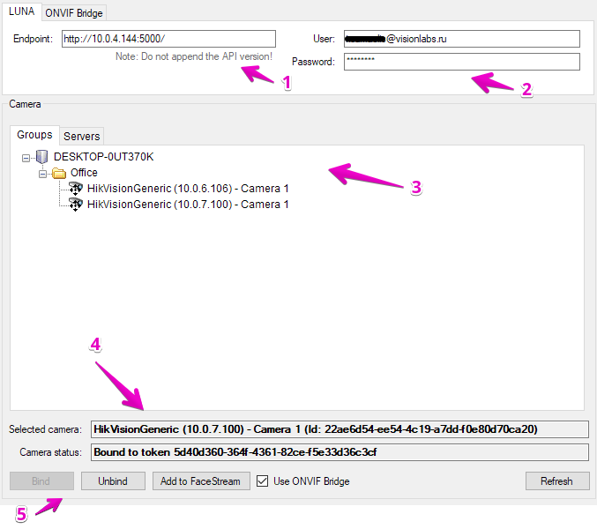
Figure 28 – UI for cameras registration
Displayed in the figure 28:
- Address of LUNA API installation you wish to access, including protocol and port (do not include API version here);
- LUNA PLATFORM user credentials. They are received upon registration in LUNA PLATFORM;
- Camera browser per Milestone server;
- Camera information panel, displaying:
- selected camera name and ID (this is the ObjectID part of camera FQID),
- camera status: either Unbound (meaning, there's no token with appropriate identification data in the selected LUNA PLATFORM instance) or Bound (in this case the bound token ID is also displayed);
- Camera control panel, allowing to:
- bind or unbind token for the camera,
- add the camera as a new input stream to VisionLabs FaceStream (see details below),
- enable ONVIF Bridge. More information about it can be found in the end of the section;
- The refresh button, that triggers manual synchronization of the data cached in the plugin with LUNA PLATFORM server.
Note. Normally you should never have need to refresh manually. Only do so if you know that other administrators alter camera configuration at the same time as you and you receive error response from LUNA PLATFORM when trying to bind or unbind a camera.
The Add to FaceStream button triggers the following dialog (Fig. 29):
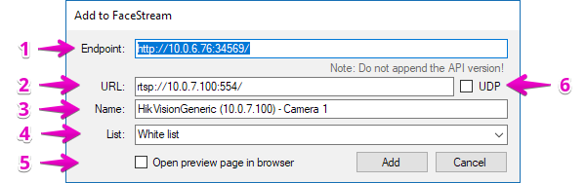
Figure 29 – Add to FaceStream dialog
Note. In order to enable the "Add to FaceStream" functionality, you should bind the selected camera with a token first.

Displayed in the figure 29:
- Address of FaceStream you wish to access, including protocol and port
(do not include API version here);
- Camera RTSP stream URL (filled automatically from camera configuration). The pug-in will guess the base RTSP stream URL from camera IP and default port. You should modify it to your needs depending on actual camera configuration, authorization settings and desired stream path.
If you enable the Use ONVIF Bridge flag, the plug-in will receive correct URL of the camera;
- Stream name (filled automatically and defaults to camera display name);
- List in LUNA PLATFORM to match all the detected faces against;
- Open browser to display FaceStream-generated preview of the newly added stream upon success. If unchecked, will display a simple message box instead;
- Whether should FaceStream prefer UDP transport for the video stream instead of TCP (which is the default).

Milestone ONVIF Bridge allows to securely transmit video streams from cameras.
We recommend you use it when working with plug-in. To do so you should specify credentials for Milestone ONVIF Bridge user and IP address and port on the ONVIF Bridge tab (Fig. 31). FaceStream will receive data from camera from the specified user. You should also enable “Use ONVIF Bridge” flag.
Make sure, that you have already created a user for ONVIF Bridge (Fig. 30).
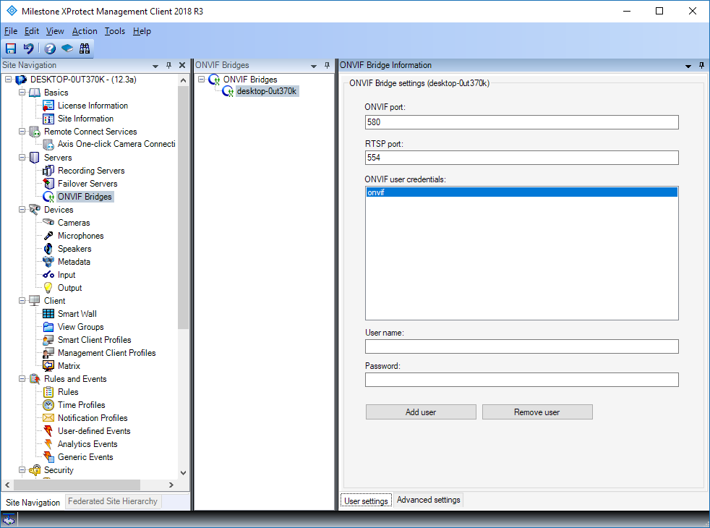
Figure 30 – ONVIF Bridge information
Note. See Milestone ONVIF Bridge documentation to find out about user creation.
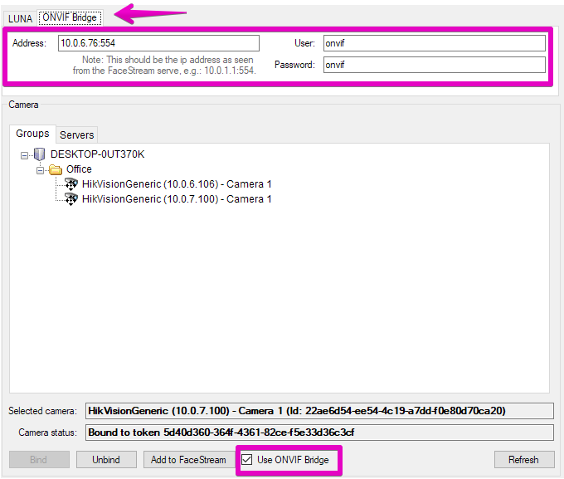
Figure 31 – User credentials on ONVIF Bridge tab
ONVIF user will be specified for FaceStream (Fig. 32). RTSP URL differs for ONVIF user.
Note. ONVIF user password is shown in the RTSP reference.
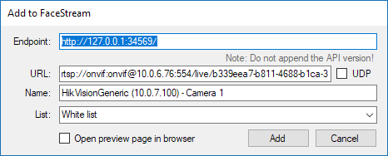
Figure 32 – Add camera to FaceStream with enabled ONVIF Bridge
Note. If you do not use ONVIF Bridge, the URL of camera will be guessed by the system, so you might have to edit it manually.
- Troubleshooting
Q: I see the following warning (Fig. 33). What should I do?
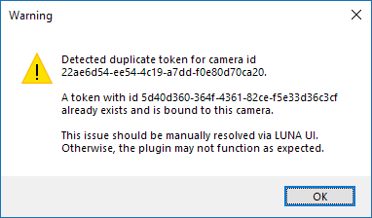
Figure 33
A: You should go to LUNA PLATFORM User Interface and delete all duplicated tokens. Tokens creation is described in “Create Token for Camera” section.

Q: Camera configuration window does not display camera bound by IP.
A: Camera configuration window displays only cameras bound by ID (the ObjectID part of camera FQID). See “Add Cameras using Camera configuration window” section.

- Face Recognition Events Preview Panel
The plugin adds the following preview panel (Fig. 34) alongside the video display on the Alarm Manager tab.
The panel displays facial recognition results. The event of recognition is already exported by LUNA PLATFORM and stored in the XProtect Event Server database as an Analytics event. Since events are internal entity, not directly visible to users, this plugin shows corresponding event data for Alarms triggered by those events instead.
Note. Alarm rules (definitions) should be configured prior using this plugin in order to receive and view alarms.
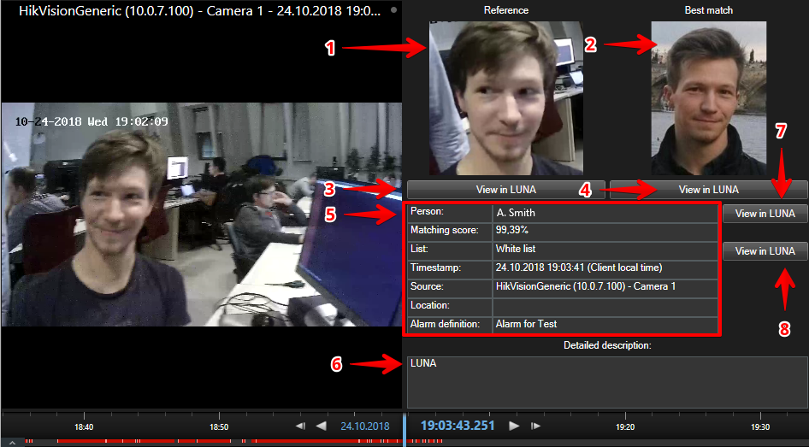
Figure 34 – Facial recognition results
Displayed on the figure 34:
- The reference image (one corresponding to the face detection that was selected by VisionLabs video processing software, e.g. FaceStream);
- The best match image (one from the database, typically stored during enrollment procedure);
- Shows the LUNA PLATFORM User Interface face view page (opens browser) for the reference image;
- Shows the LUNA PLATFORM User Interface face view page (opens browser) for the best match image;
- Data fields:
Person. Recognized person data (if available). The data is customizable via LUNA PLATFORM User Interface.
Matching Score. Confidence score of the recognition.
List. List data. This is the list we were looking for a match to the reference photo in. The data is customizable via LUNA PLATFORM User Interface.
Timestamp. Timestamp of the event (displayed in client machine local time).
Note. It is required that the data for LUNA PLATFORM servers and XProtect servers is synchronized, for example, using Network Time Protocol.
Source. Event source. Typically, is the name of the camera that took the reference image.
Location. Camera location (if available).
Alarm Definition. Rule that has triggered the alarm.
- Alarm detailed description. This is typically configured on server side;
- Shows the LUNA PLATFORM User Interface person view page in browser for the recognized person (if available);
- Shows the LUNA PLATFORM User Interface list view page in browser.

Appendix: Version History
Date | Version | Notes
12.28.18 | 1 | Initial release

