VisionLabs Face Recognition Plug-in
Administrator Manual
VisionLabs B.V.
Keizersgracht 311, 1016 EE, Amsterdam, the Netherlands

+31 20 369 04 93
info@visionlabs.ai
www.visionlabs.ai

v.1.1
Table of contents

Introduction 3
1 Requirements 4
2 Registration in LUNA PLATFORM 5
3 Setting up LUNA PLATFORM 6
3.1 Add Photos 6
3.2 Create Person 7
3.3 Create List of Persons 9
4 Create Token for Camera 11
5 Add Cameras 13
5.1 Add Cameras Manually 13
5.2 Add Cameras using Camera configuration window 14
Troubleshooting 18
Appendix: Version History 19

Introduction
The document gives general approach for configuration of VisionLabs Face Recognition plug-in.
The following actions should be performed to start the plug-in usage:
- add photos to VisionLabs LUNA PLATFORM,
- create a list of persons in VisionLabs LUNA PLATFORM,
- create tokens for your cameras in VisionLabs LUNA PLATFORM,
- add your camera to FaceStream. There are two ways to add a camera:
- using FaceStream configurations file,
- using special Camera configuration window.
- Requirements
Make sure Analytics Events are enabled in XProtect. To do so, open Management Client, go to Tools/Options, scroll to the Analytics Events tab and check Enabled under Analytics events frame.
Events are not displayed in Milestone XProtect Smart Client. Alarms are displayed instead. The alarms are triggered by events according to some rules. The rules are to be defined via Management Client. Expand Rules and events tree node, then click on Analytics events to bring up the rule editor.
- Registration in LUNA PLATFORM
VisionLabs LUNA PLATFORM User Interface is the easiest way to add photos and create lists and tokens in LUNA PLATFORM. Open User Interface in your browser. The service uses port 80 by default.
You should create an account in LUNA PLATFORM User Interface on the Sign up tab (Fig. 1). Fill in all the fields to create an account.
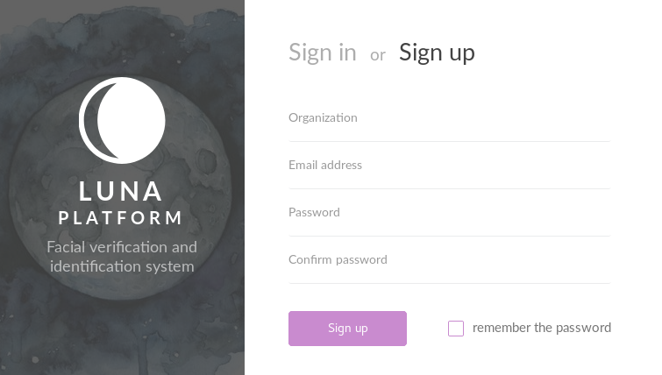
Figure 1 – Sign up tab
You should log in on the Sign in tab (Fig. 2)
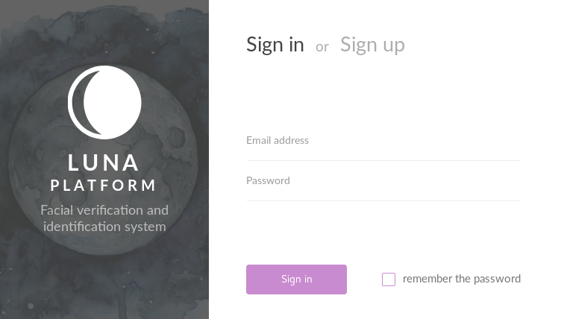
Figure 2 – Sign in tab
- Setting up LUNA PLATFORM
- Add Photos
Go to Faces page by clicking icon (Fig. 3) on the left toolbar.
Figure 3 – Faces page icon
Press Add face button (Fig. 4) and select photo that should be uploaded to LUNA PLATFORM database.
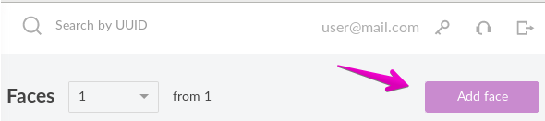
Figure 4 – Add face
- Create Person
Go to Persons page by clicking icon (Fig. 5) on the left toolbar.
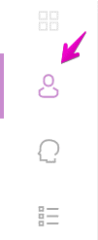
Figure 5 – Persons page icon
Add a new person using Add person button (Fig. 6).
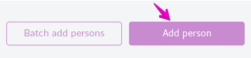
Figure 6 – Add person button
You may upload large number of images and create a separate person for each of the found faces using Batch add persons button (Fig. 7).
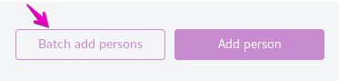
Figure 7 – Batch add of persons
A new person(s) is created and showed in the list of persons (Fig. 8).
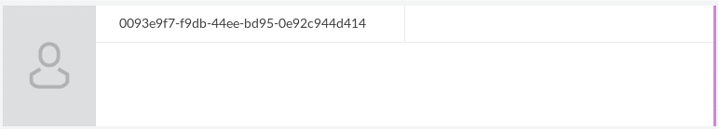
Figure 8 – New person
Parameters of the person are shown to the right in a special dialog (Fig. 9).
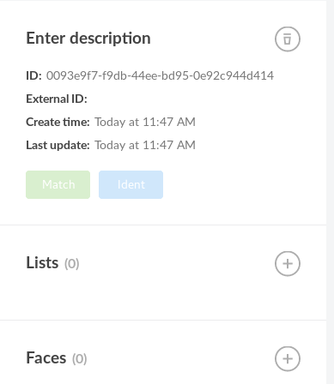
Figure 9 – Person parameters
You can add a person to the list here and add new faces to the person using icons near the corresponding fields.
- Create List of Persons
Go to Lists page by clicking the corresponding icon (Fig. 10) on the left toolbar.
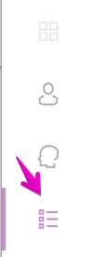
Figure 10 – Lists page icon
Press Add persons list to create a new list for persons (Fig. 11).
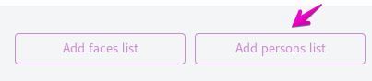
Figure 11 – Add persons list button
When a list is created, it is shown on the page (Fig. 12).
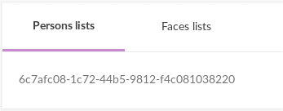
Figure 12 – New list
When you select a list, its parameters dialog appears to the right (Fig. 13).
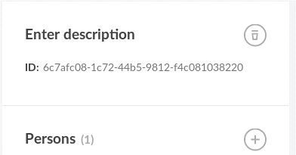
Figure 13 – List parameters
To add a person to the list press icon.
You may also create a list of faces, using the corresponding button (Fig. 14).
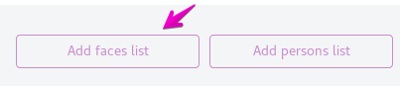
Figure 14 – Add faces list button
- Create Token for Camera
You should create a token for your camera so FaceStream could receive video from it.
To create a token, select special icon (Fig. 15) in the upper right corner of UI window.
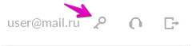
Figure 15 – Create token
On the Tokens page press Add token button (Fig. 16).
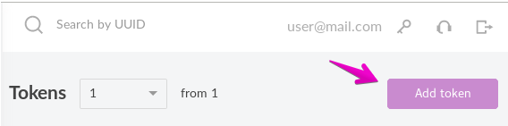
Figure 16 – Add token button
A new token appears. You should enter your camera IP or the ObjectID part of camera FQID into the Enter description field (Fig. 17).
Note. Only ObjectID allows you to add camera using Camera configuration window. More details can be found in “Add Cameras using Camera configuration window” section.
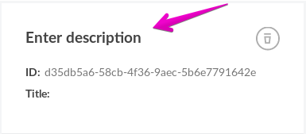
Figure 17 – Enter description
You should copy the token ID to add it into FaceStream manually (Fig. 18).
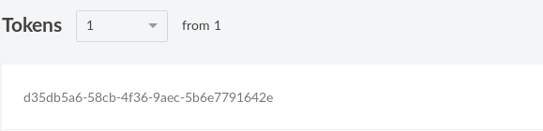
Figure 18 – Token ID
- Add Cameras
There are two ways to add cameras for working with FaceStream. You may fill in FaceStream configuration file manually or you may use Camera configuration window to add cameras.
- Add Cameras Manually
You can manually add cameras using LUNA PLATFORM User Interface by creating a new token for each camera and setting either camera ID (the ObjectID part of camera FQID, if you have it) or IP address (only IP v4 addresses are supported at the moment!).
To add a new camera to FaceStream you should open input.json file located in <facestream_folder>/bin/data/.
Note. FaceStream should be launched in a standard mode.
IP cameras connection parameters are set in "stream-sources" section. In the section you should add data to the following fields:
“source” – an address of your camera.
"source" : {
"value" : "rtsp://<address>"
},
“destination” – an address of LUNA PLATFORM server. You should specify server address, port and list for searching.
"destination”:
{
"value" : "https://127.0.0.1:5000/4/matching/search?list_id=3e64f6319-ede8-4c61-b63b-85fdfa207c18"
}
"login" – a login for authorization on LUNA PLATFORM server.
"login”:
{
"value": "user@mail.com"
}
“password” - a password for the authorization on the LUNA PLATFORM server.
"password”:
{
"value": "12345678"
{
“token” – a token for authorization on the LUNA PLATFORM server. You should paste the received token ID here.
"token" : {
"value" : "d35db5a6-58cb-4f36-9aec-5b6e7791642e"
}
- Add Cameras using Camera configuration window
VisionLabs Face Recognition plug-in provides additional window in XProtect Management Client – Camera configuration window. This window allows to register IP cameras in LUNA PLATFORM as external clients. This is necessary to determine the source of each recognition event. Each camera should have a unique authentication token, which is assigned upon registration.
It is preferred to use Camera configuration window when you use ObjectID to add a camera.
Note. Camera configuration window does not display tokens bound by IP. You should add cameras by IP manually.
Note. FaceStream version 3.2 and higher is required to use Camera configuration window. FaceStream should be launched in a server mode.
The plug-in adds a new site navigation tree node under MIP Plug-ins category (Fig. 19).
Figure 19 – New tree node
After selecting “Camera configuration” sub node, a special window appears. There are two tabs available: LUNA and ONVIF Bridge (Fig. 20).
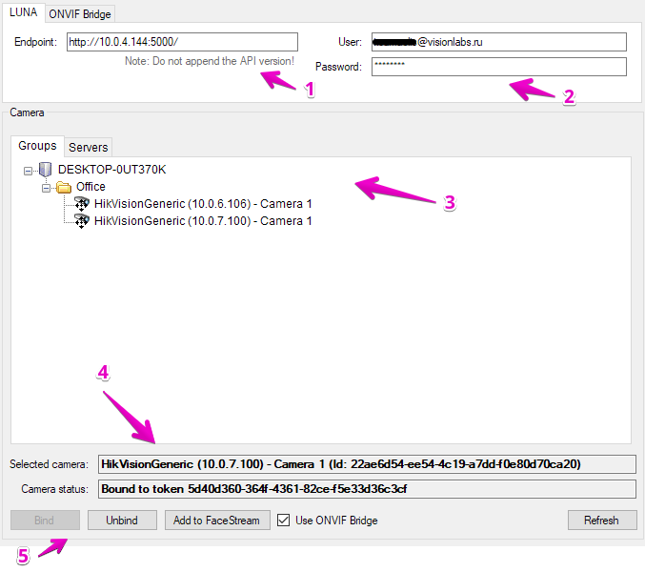
Figure 20 – UI for cameras registration
Displayed in the figure 20:
- Address of LUNA API installation you wish to access, including protocol and port (do not include API version here);
- LUNA PLATFORM user credentials. They are received upon registration in LUNA PLATFORM;
- Camera browser per Milestone server;
- Camera information panel, displaying:
- selected camera name and ID (this is the ObjectID part of camera FQID),
- camera status: either Unbound (meaning, there's no token with appropriate identification data in the selected LUNA PLATFORM instance) or Bound (in this case the bound token ID is also displayed);
- Camera control panel, allowing to:
- bind or unbind token for the camera,
- add the camera as a new input stream to VisionLabs FaceStream (see details below),
- enable ONVIF Bridge. More information about it can be found in the end of the section;
- The refresh button, that triggers manual synchronization of the data cached in the plugin with LUNA PLATFORM server.
Note. Normally you should never have need to refresh manually. Only do so if you know that other administrators alter camera configuration at the same time as you and you receive error response from LUNA PLATFORM when trying to bind or unbind a camera.
The Add to FaceStream button triggers the following dialog (Fig. 21):
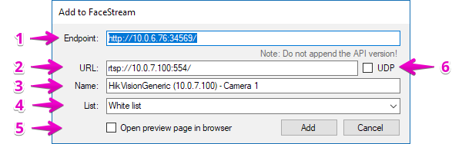
Figure 21 – Add to FaceStream dialog
Note. In order to enable the "Add to FaceStream" functionality, you should bind the selected camera with a token first.

Displayed in the figure 21:
- Address of FaceStream you wish to access, including protocol and port
(do not include API version here);
- Camera RTSP stream URL (filled automatically from camera configuration). The pug-in will guess the base RTSP stream URL from camera IP and default port. You should modify it to your needs depending on actual camera configuration, authorization settings and desired stream path.
If you enable the Use ONVIF Bridge flag, the plug-in will receive correct URL of the camera;
- Stream name (filled automatically and defaults to camera display name);
- List in LUNA PLATFORM to match all the detected faces against;
- Open browser to display FaceStream-generated preview of the newly added stream upon success. If unchecked, will display a simple message box instead;
- Whether should FaceStream prefer UDP transport for the video stream instead of TCP (which is the default).

Milestone ONVIF Bridge allows to securely transmit video streams from cameras.
We recommend you use it when working with plug-in. To do so you should specify credentials for Milestone ONVIF Bridge user and IP address and port on the ONVIF Bridge tab (Fig. 23). FaceStream will receive data from camera from the specified user. You should also enable “Use ONVIF Bridge” flag.
Make sure, that you have already created a user for ONVIF Bridge (Fig. 22).
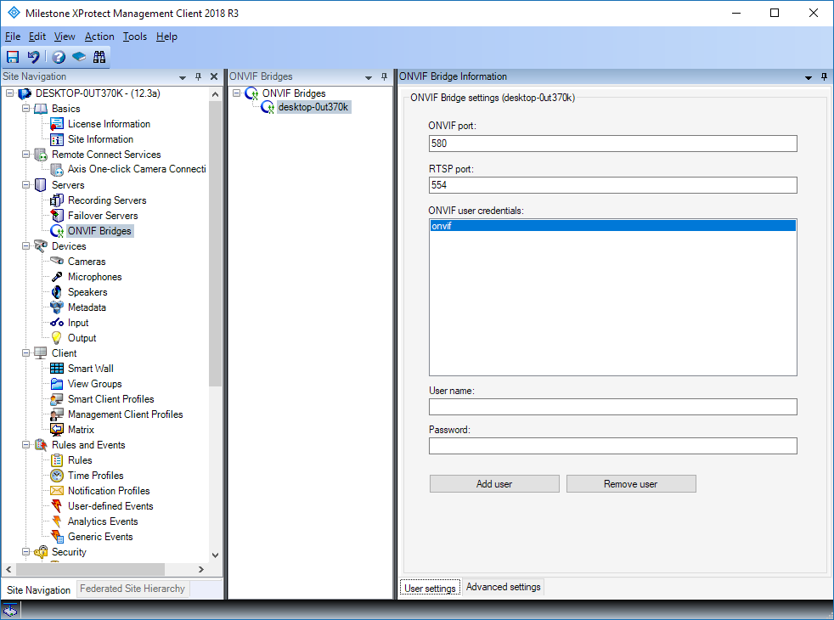
Figure 22 – ONVIF Bridge information
Note. See Milestone ONVIF Bridge documentation to find out about user creation.
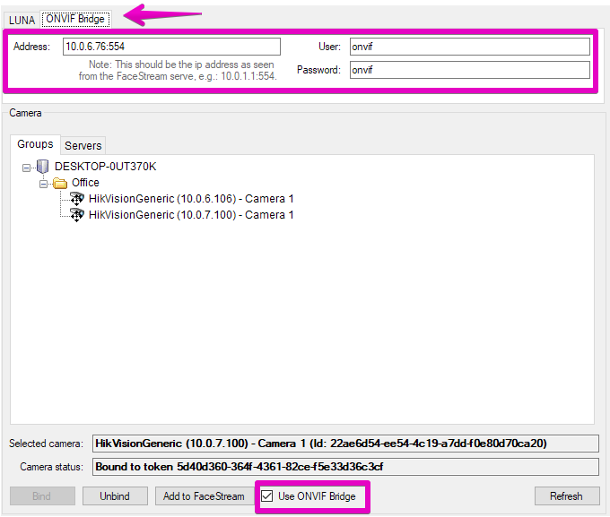
Figure 23 – User credentials on ONVIF Bridge tab
ONVIF user will be specified for FaceStream (Fig. 24). RTSP URL differs for ONVIF user.
Note. ONVIF user password is shown in the RTSP reference.
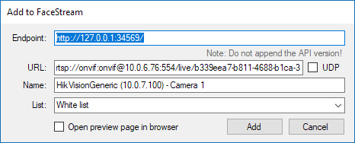
Figure 24 – Add camera to FaceStream with enabled ONVIF Bridge
Note. If you do not use ONVIF Bridge, the URL of camera will be guessed by the system, so you might have to edit it manually.

Troubleshooting
Q: I see the following warning (Fig. 25). What should I do?
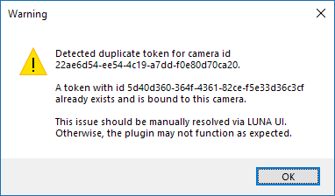
Figure 25
A: You should go to LUNA PLATFORM User Interface and delete all duplicated tokens. Tokens creation is described in “Create Token for Camera” section.

Q: Camera configuration window does not display camera bound by IP.
A: Camera configuration window displays only cameras bound by ID (the ObjectID part of camera FQID). See “Add Cameras using Camera configuration window” section.

Appendix: Version History
Date | Version | Notes
01.11.18 | 1 | Initial release

