



Milestone XProtect Integration

Introduction

ACT offers three different ways to integrate ACTEnterprise with the Milestone XProtect system:
- Via XProtect SmartClient Plug-in – this is the simplest way and allows access control events to be viewed from within the XProtect SmartClient
- Via the XProtect Access Control Module (ACM) plug-in – this will operate on XProtect systems that support Access Control (Express, Professional and Enterprise). To use the plug-in you must purchase an access control door license from Milestone for each door you want to control from XProtect Smart Client.
- Via XProtect SDK plug-in - this will operate on XProtect systems that support Access Control (Express, Professional and Enterprise).

XProtect SmartClient Plug-in
The XProtect SmartClient plug-in allows the SmartClient to have the same functionality as ACTMonitor. Log events may be viewed and doors may be locked, unlocked etc from SmartClient.
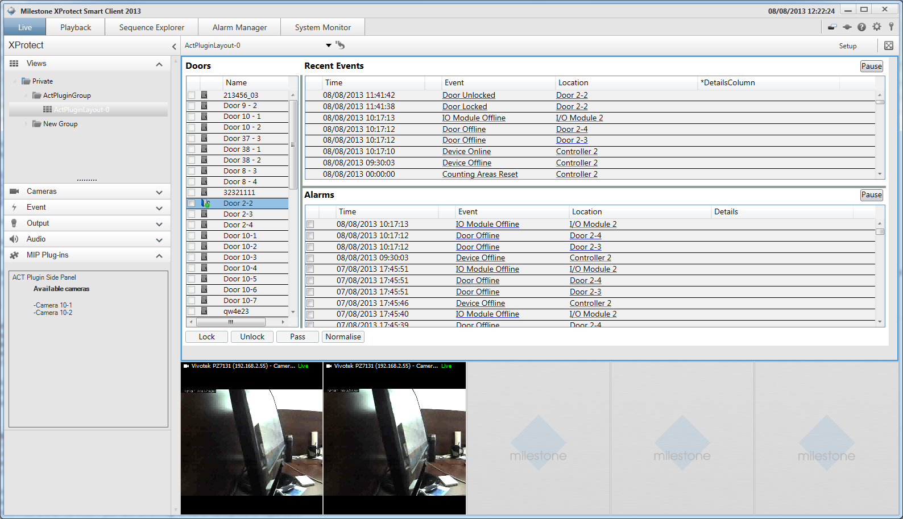

Installation
- Create folder for ACTPlugin at c:\Program Files\Milestone\XProtect Smart Client\MIPPlugins\
- Copy files from binaries.zip to newly created folder
- Add ACT connection options to Smart Client config file. See screenshot below for more details
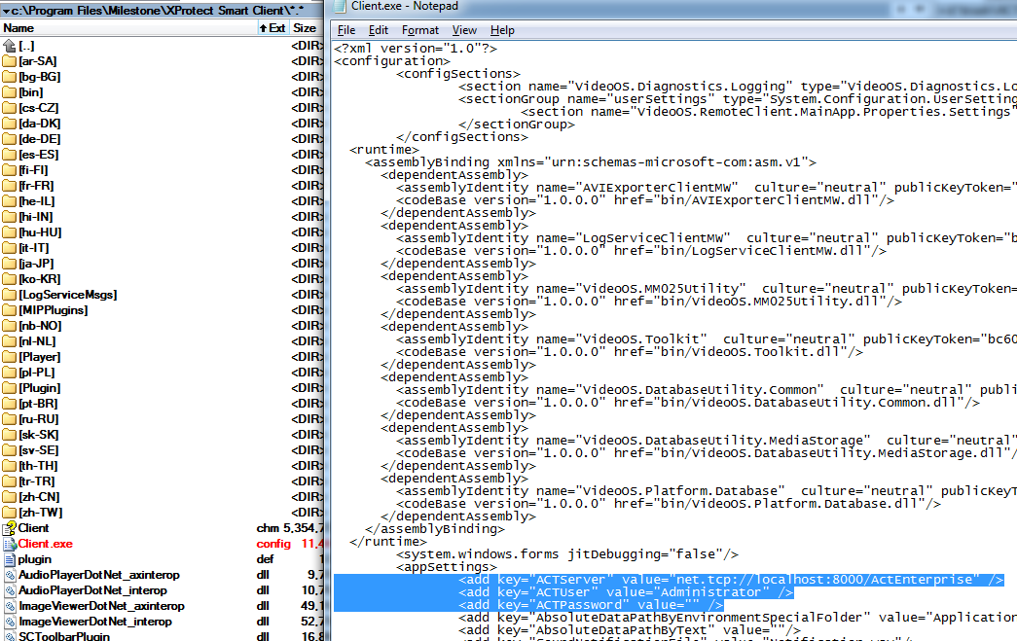
- Run Smart Client, Expand MIP Plug-ins/ACT Plugin side panel and click Refresh button. ACT screen will appear
- Change selection in Doors grid to see relevant cameras.

XProtect ACM Plug-in
The ACM allows you to manage the ACT access control system from the XProtect Smart Client. The operator can view events from ACTEnterprise, control doors and view cardholder information. Rules may also be configured in the XProtect Management Client to trigger recording, PTZ etc. in response to access control events.

Installation

- The ACM must be installed on the server running the XProtect Event Server. Run the installer program and follow the wizard.
- Run XProtect Management Client. Go to Access Control section and add new ACT integration.

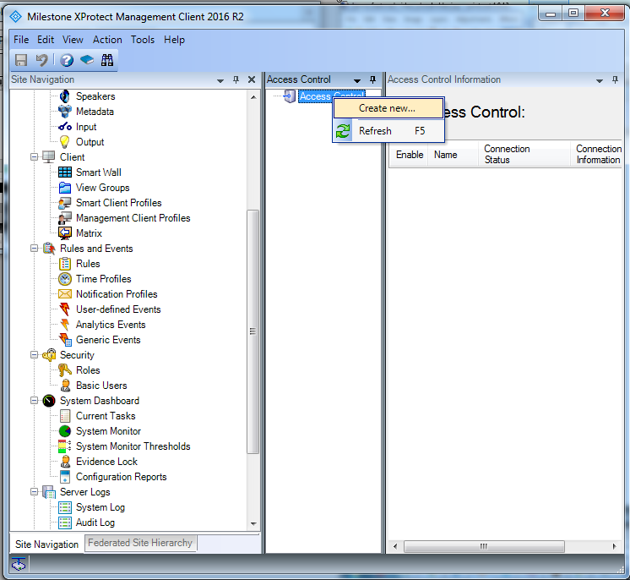

- If the plug-in was installed correctly and was loaded by XProtect Event Server, then ‘ACT Access Control” option should be available in “Integration plug-in” dropdown. Follow the wizard to complete integration with ACT.
- Initially, the plug-in will connect to ACT using provided server address and credentials, load controllers and doors data from ACT, map those to internal Milestone Access Module entities and maintain 2-way communication between Milestone and ACT.

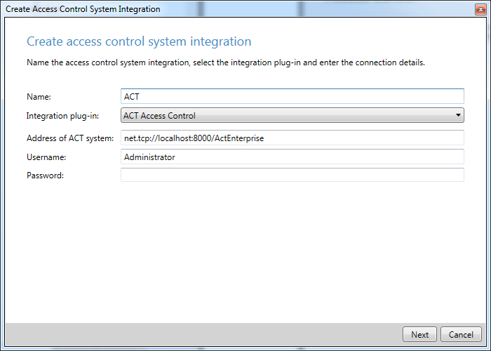

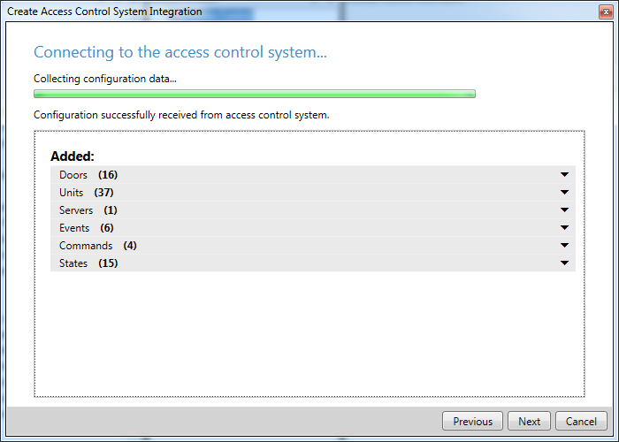

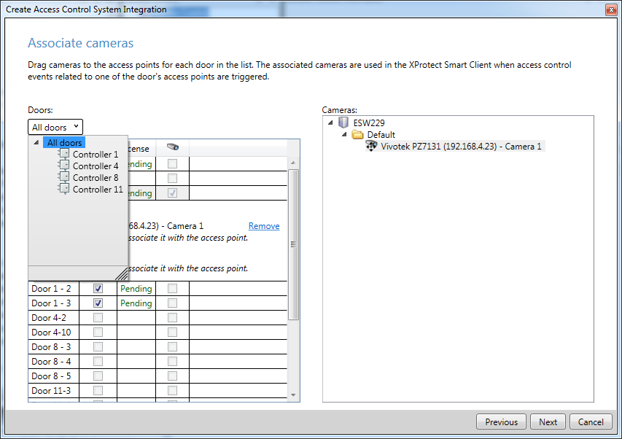

- After completing wizard you should be able to locate newly created integration with ACT at Milestone Access Control pane.

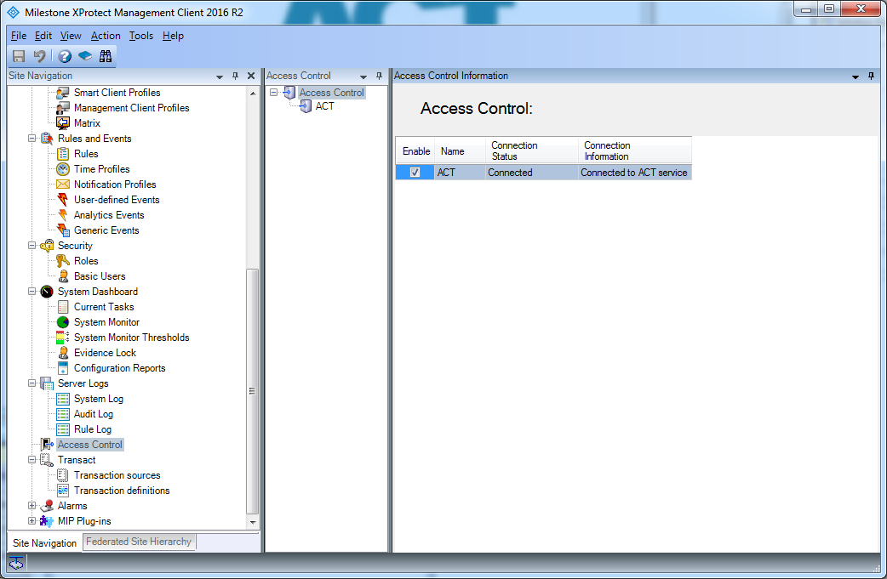

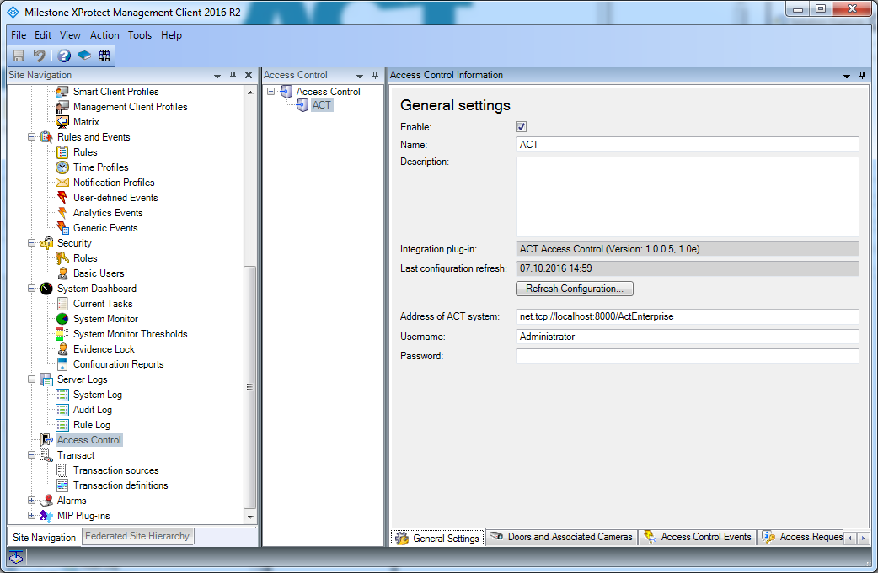

- Troubleshooting: When trying to create new integration, you may get the following error message instead.
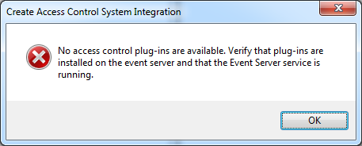

Please verify that ACT plug-in was loaded by Event Server by checking XProtect Event Server log files. You can check those by clicking “Show Event Server logs” option from Milestone XProtect Event Server system tray icon. You can also review the log files, that are located at C:\ProgramData\Milestone\XProtect Event Server\logs
After restarting XProtect Event Server you should be able to find the following line inside the latest log file:

2016-10-07 11:05:21 UTC+03:00 Info ESEnvironmentManager Access Control plugin loaded: ACT Access Control v1.0e - Access Control Technology
- Run the SmartClient. Under the Access Control tab you can view events, control doors and view cardholders.
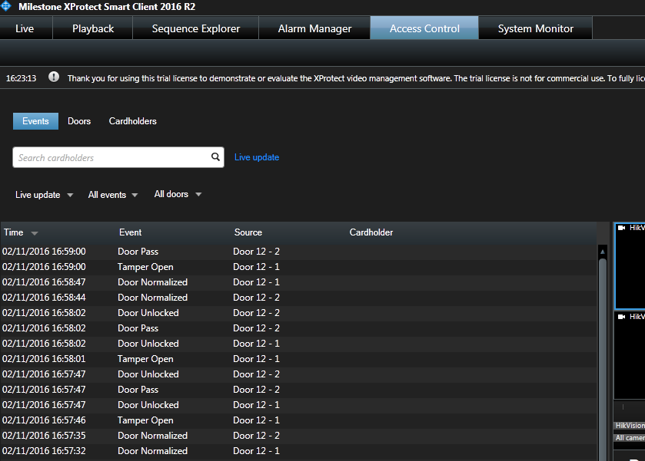

XProtect SDK Plug-in
The XProtect SDK Plug-in allows additional functionality to be performed from with XProtect. Access Control events from ACTenterprise may be used to trigger cameras to record, PTZ etc from within XProtect.

Installation

- Run the installation program on the Milestone XProtect Event Server and follow the instructions.
- To verify plug-in installation open XProtect Management Client, go to MIP Plug-ins:

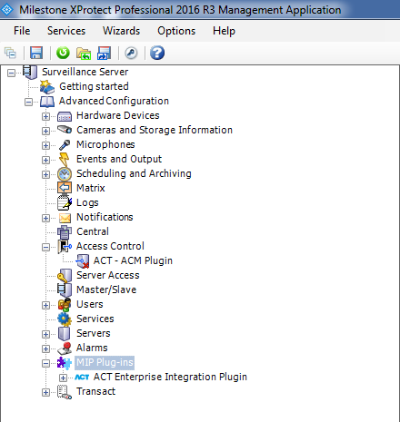

- Initially, the plug-in will connect to ACT using provided server address and credentials, load controllers and doors data from ACT, map those to internal Milestone Access Module entities and maintain 2-way communication between Milestone and ACT
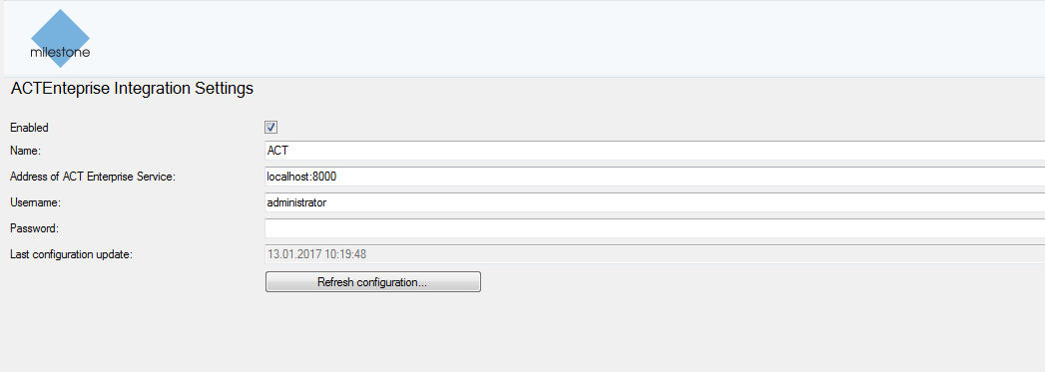

- All information displayed in Milestone is taken directly from ACTEnterprise
- The SDK Plugin provides the User the ability to view Doors and Events from ACTEnterprise with Live and Recorded Video. All of this needs to be setup in ACTEnterprise.
- When trying to create new integration you may get the following error message instead:

Please verify that the ACT plug-in was loaded by Event Server by checking XProtect Event Server log files. You can check those by clicking “Show Event Server logs” option from Milestone XProtect Event Server system tray icon. Alternatively, check the log files located at C:\ProgramData\Milestone\XProtect Event Server\logs
After restarting XProtect Event Server you should be able to find the following line inside the latest log file:

2016-10-07 11:05:21 UTC+03:00 Info ESEnvironmentManager Access Control plugin loaded: ACT Access Control v1.0e - Access Control Technology
- Run the SmartClient. Under the ACTEnterprise Integration Plugin tab you can view events, control doors and view live and recorded video associated with events.
