Operating Instructions for Face Search Plugin for XProtect Management Server / XProtect Smart Client

Face Search Plugin for XProtect Management Server / XProtect Smart Client

- Please read this file carefully and use this product properly. After reading the file, keep it at hand for future use. Operations flow

Features

The face search function will become available if Face Search Plugin for XProtect Management Server / XProtect Smart Client (hereafter "this software") is installed to XProtect Management Server and XProtect Smart Client and required setup is performed.

Terms in use
This document provides explanations using the following terms.

- Registered face detection mode
It is an operation mode that in which an alarm will be issued when a person registered by the face search monitor is detected by a camera. Users with ASF950 V1.0x will be used in registered face detection mode.
(Selectable with WV-ASF950 version 2.00 or later)

- Registered face/unregistered face detection mode

It is an operation mode that enables selecting per area whether to issue an alarm when a registered person is detected or when an unregistered person is detected by a camera.

(Selectable with WV-ASF950 version 2.00 or later)

Trademarks and registered trademarks

- Microsoft Windows Server is a trademark or a registered trademark of Microsoft Corporation in the United States and other countries.
- Intel, Intel Core and Xeon are trademarks or registered trademarks of Intel Corporation in the United States and other countries.
- Adobe, the Adobe logo, Acrobat, and Reader are either registered trademarks or trademarks of Adobe Systems Incorporated in the United States and/or other countries.
- All other trademarks identified herein are the property of their respective owners.

Copyright

Distributing, copying, disassembling, reverse compiling and reverse engineering of the software provided with this product are all expressly prohibited. In addition, exporting any software provided with this product violating export laws is prohibited.

Before using this software

Outline of functions

The following functions will become available if cameras are operated using XProtect Smart Client where this software is installed.

(1) Alarm function: If a network camera captures a person whose face has features of a face image registered in this software, an alarm will be issued. In the registered face/unregistered face detection mode, alarm notification is available for cases when an unregistered person is detected.

(2) Alarm search function: Searches and displays alarm that meet the search conditions in the accumulated alarms in WV-ASF950.

(3) Face search function: Searches and displays face images that meet the search condition in the accumulated face images in WV-ASF950.

(4) Age and gender statistical report function: Displays the number of people detected in the specified period after sorting by age or gender.

Refer to "Operating Instructions for Face Search Plugin for XProtect Management Server / XProtect Smart Client" for details of operation.

System device configuration

The system consists of XProtect Management Server / XProtect Smart Client where this software is installed, WV-ASF950, and network cameras (hereafter "camera").

The cameras will send captured face images to WV-ASF950.

WV-ASF950 will store the face images sent from cameras, and perform face search according to the request from XProtect Smart Client.

Basically WV-ASF950 consists of one master server. However, slave servers according to the number of connected cameras can be added.

Refer to the help files of WV-ASF950 for further information.

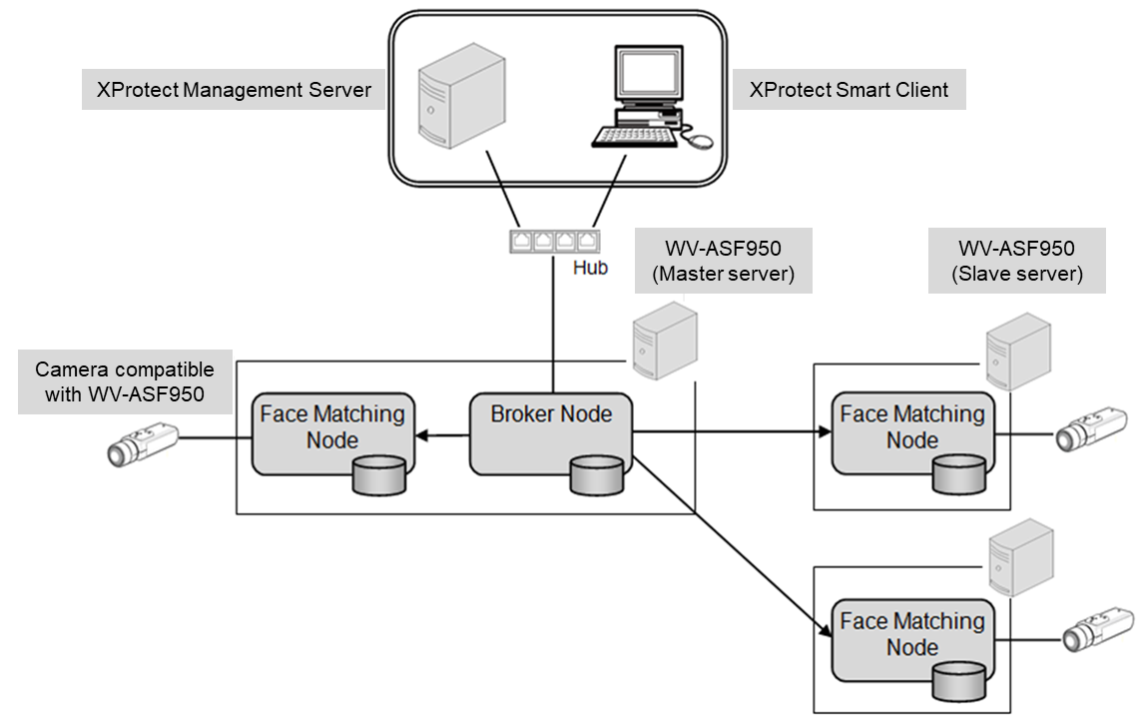

Note) The above described system configuration is just an example, and it varies depending on how to use this software.

Recommended operating environment

Software version | XProtect Corporate 2019 R2

XProtect Management Server
OS: | Microsoft Windows 10 Professional RS5 (64bit)
OS: | Microsoft Windows Server 2016 Standard Edition
OS: | Microsoft Windows Server 2019 Standard Edition
CPU: | Intel ® CoreTM i3-6100 3.7GHz or better*
Memory: | 16GB or more*
HDD: | 256GB SSD for OS/VMS storage (Add additional storage depending on the number of days you want to save data) *
Graphic | Intel® HD Graphics 530 (If Hardware Acceleration is required add graphics card fitting the requirements) *
Interface | 2 x 1 Gigabit Ethernet*

*Note: Refer to the manual of Milestone XProtect system requirements.

XProtect Smart Client
OS: | Microsoft Windows 10 Professional RS5 (64bit)*
OS: | Microsoft Windows Server 2016 Standard Edition
OS: | Microsoft Windows Server 2019 Standard Edition
CPU: | Intel ® CoreTM i7-3770 or better
Memory: | 8GB or more
Graphic | Hardware acceleration is required.**
Interface | 100 / 1000Mbps

*Note: Need to use Windows 10 patched with KB4022725. Turn off Cortana's setting.

**Note: Refer to the manual of Milestone XProtect system requirements.

Operations flow

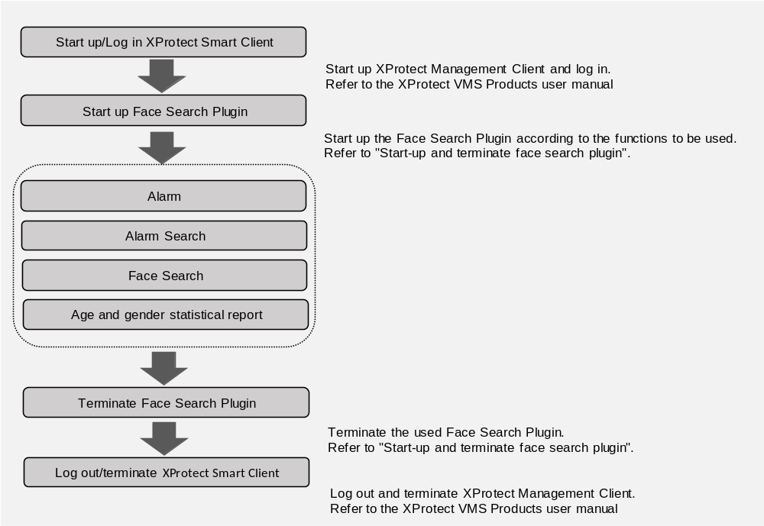

-------------------------------------------------------------------------------

Note:
- The logo displayed on the face search monitor is displayed as follows according to the version and operation mode of the face search server.

< In the case of WV-ASF950 version 1.0x >


< In the case of WV-ASF950 version 2.00 or later (registered face detection mode)>


< In the case of WV-ASF950 version 2.00 or later (registered face/unregistered face detection mode)>


-------------------------------------------------------------------------------

Start-up and terminate face search plugin

Start-up face search plugin

Step 1

Select and start up the plugin to be used in XProtect Smart Client.

(1) Alarm function

- Click the “Alarm" tab.

(2) Alarm search function

- Click the "Alarm Search" tab.

(3) Face search function

- Click the "Face Search" tab.

(4) Age and gender statistical report function

- Click the "Age and gender statistical report" tab.

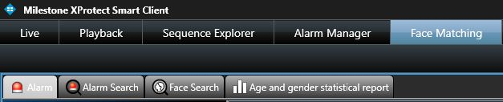

Terminate face search plugin

Close the XProtect Smart Client window.

Alarm

Display alarm notification

When a face image similar to any of the registered images is detected, an alarm will be displayed in the list.

In addition, the face matching pop-up window will be displayed

Step 1

Click the [Alarm] tab.

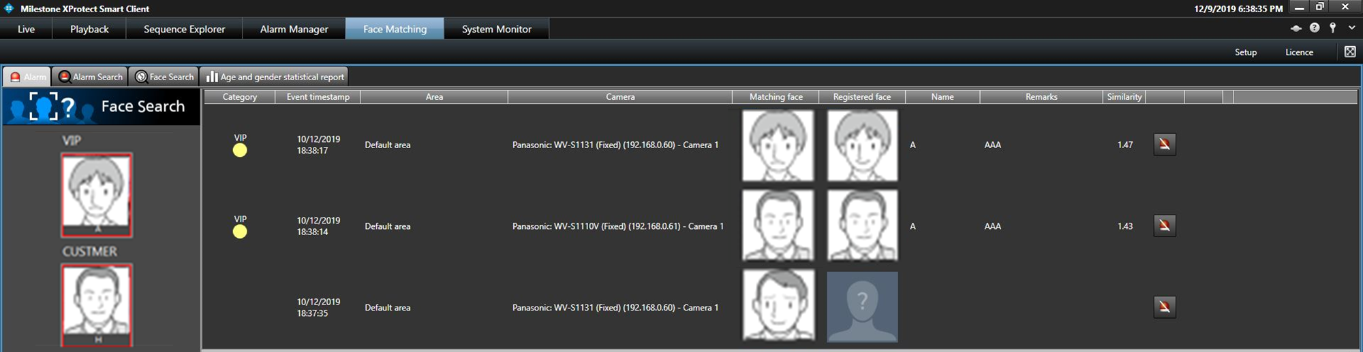

The details are as follows.

- Display the face image to be registered

the representative face image for which "Constant display" is set will be displayed per category.

If alarm is constantly displayed, it is enclosed with a red frame. The red frame will be canceled if it is clicked.

■ Category

Name of the category and category color.

-------------------------------------------------------------------------------

Note:
- When received an unregistered face detection alarm notification, it will be blank.

-------------------------------------------------------------------------------

■ Event timestamp

Time and date when the face search alarm or the unregistered face detection alarm is occurred.

■ Cameras

Name of the camera that notified of the face search alarm or the unregistered face detection alarm.

■ Matching face

Face image sent from the camera checked by Face Server.

■ Registered face

Face image similar to the "Matching face" preliminary registered to Face Server.

-------------------------------------------------------------------------------

Note:
- The following image will be displayed as a registered face image on the unregistered face detection alarm notification message window.



-------------------------------------------------------------------------------

■ Name

Name of the registered person.

-------------------------------------------------------------------------------

Note:
- When received an unregistered face detection alarm notification, it will be blank.

-------------------------------------------------------------------------------

■ Remarks

Remarks of the registered person.

-------------------------------------------------------------------------------

Note:
- When received an unregistered face detection alarm notification, it will be blank.

-------------------------------------------------------------------------------

■ Similarity

Similarity between the registered face and the detected face.

-------------------------------------------------------------------------------

Note:
- When received an unregistered face detection alarm notification, it will be blank.

-------------------------------------------------------------------------------

Face matching pop-up window:

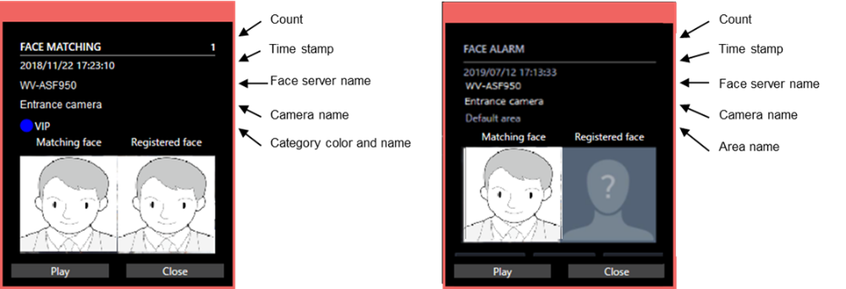

When placing the mouse cursor on the pop-up, the content of the remarks is displayed in the balloon.

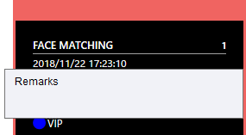

Count is reset to zero when the pop-up window is closed.

■ Play button
When it is pressed, the playback control window appears and the video will be played automatically from 5 seconds before the face matching.

■ Close button

Close the pop-up window.

-------------------------------------------------------------------------------

Note:
- When [Face Search Plugin Setup / General / Getting the latest alarm when starting] is set to ON (Default: OFF),
the latest 100 alarms will be displayed when the [Alarm] tab is displayed.
- The unregistered face detection alarm notification message window will be popped up when using WV-ASF950 version 2.00 or later.
- The following image will be displayed as a registered face image on the unregistered face detection alarm notification message window.

-------------------------------------------------------------------------------

Alarm search

Search by designating a time and date

Perform an alarm notification search by designating time and date.

Step 1

Click the [Alarm Search] tab.

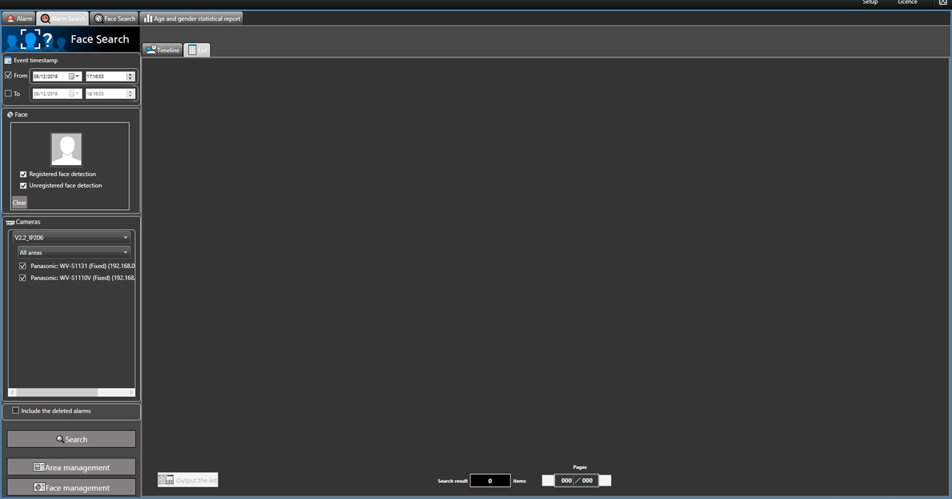

Step 2

Select the start time and the end time of “Event timestamp”.

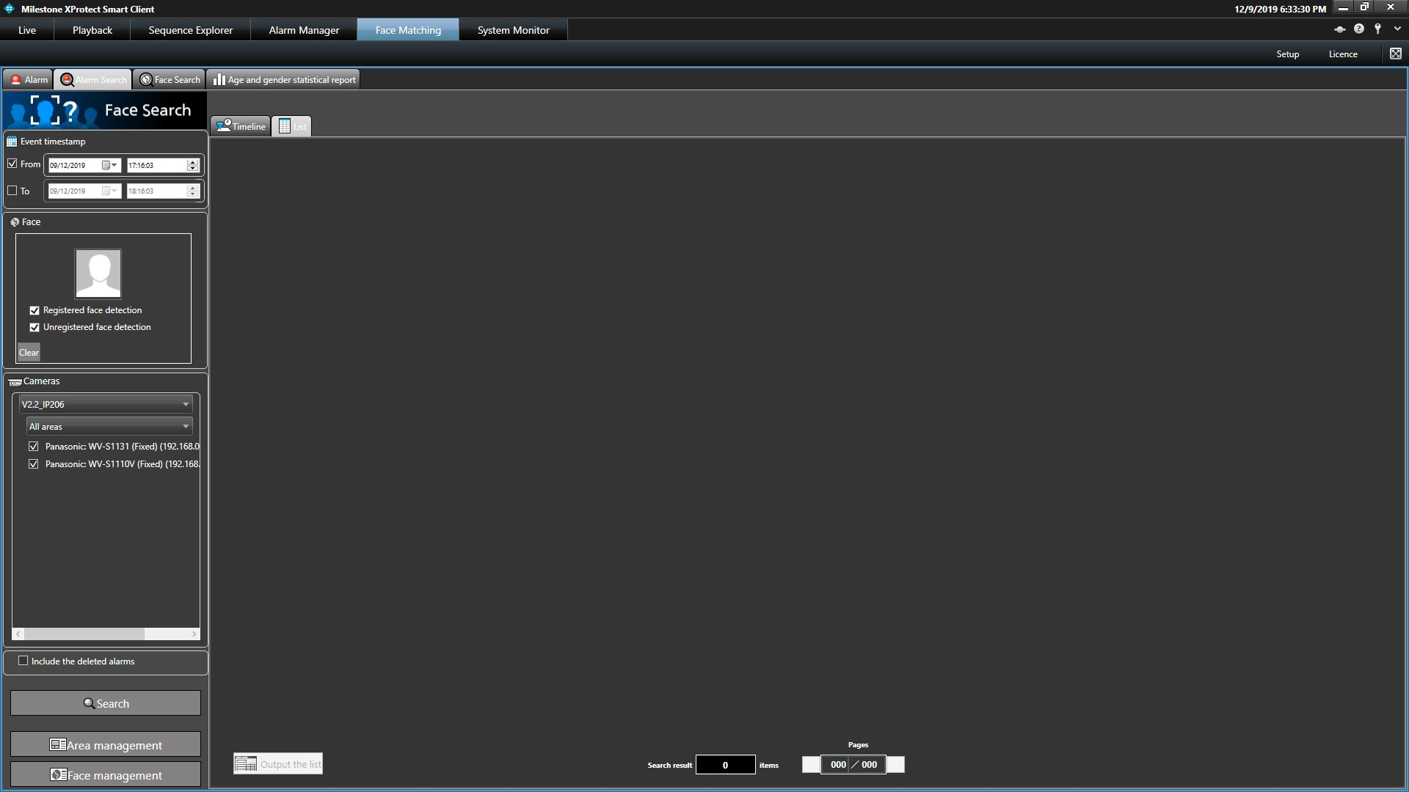

The details are as follows.

■ From

Select the start time of the period to be searched.

Select from "2005/1/1" to "2034/12/31".

■ To

Select the end time of the period to be searched.

Select from "2005/1/1" to "2034/12/31".

Step 3

Click the [Search] button.

→ The search result will be displayed.

Search by designating a face image

Perform the alarm notification search by designating a face image.

Step 1

Click the [Alarm Search] tab.

Step 2

Designate a face image.

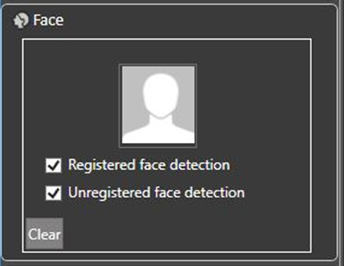

The details are as follows.

■ Person icon

The face image can be configured as follows.

- Display the "List of registered faces" window by left-clicking the person icon, and then select a face image.

- Right-click the person icon, and then click the [Select from list of registered faces] button.

- Drag and drop the face image from the search result onto the person icon.

■ Alarm search condition (In the case of WV-ASF950 version 2.00 or later (registered face/unregistered face detection mode))

Select the alarm to search for.

- Registered face detection: Search for the face matching alarm notifying that the person registered was detected by the camera.

- Unregistered face detection: Search for the unregistered face detection alarm notifying that the person unregistered was detected by the camera.

Default: Select both

-------------------------------------------------------------------------------

Note:
- When the face image is set to the person icon while both are selected, the selection of unregistered face detection alarm will be cleared automatically.
- When face image is set to the person icon, registered face detection alarm is selected automatically.

In this state, when deselecting the registered face detection alarm, the face image will be cleared automatically.
- When a face image is set for the person icon and an unregistered face detection alarm is selected, the face image will be cleared automatically.

-------------------------------------------------------------------------------

■ [Clear] button

Click the selected face image.

Designate the face image to be searched

- Select from the registered images

Right-click the person icon of “Faces” on the “Alarm Search” page and select [Select from list of registered faces] from the menu.

→ The "List of registered faces" window will be displayed.

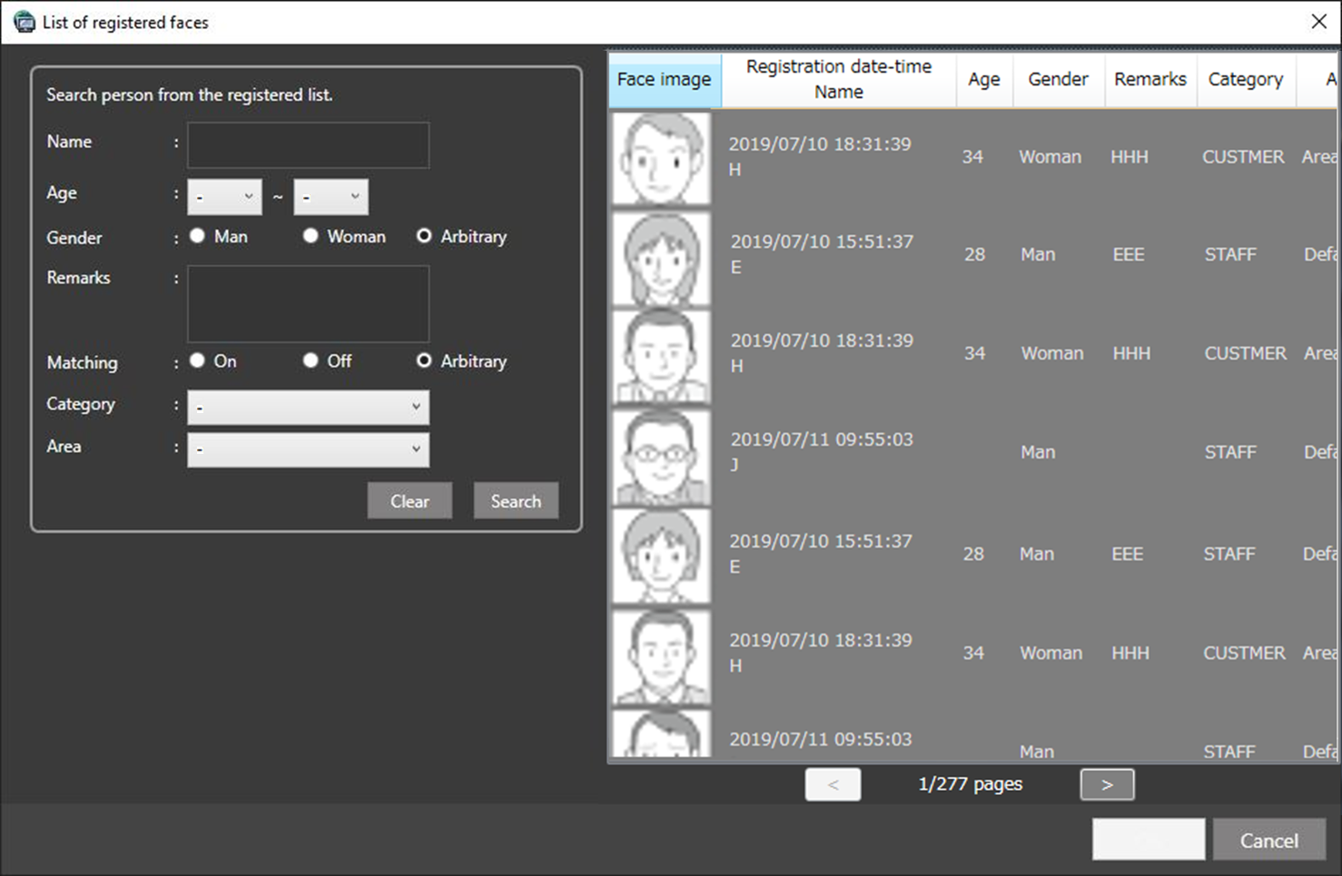

■ List item

Select a person to be searched from the "List of registered faces" displayed on the right side.

■ [OK] button

Close the "List of registered faces" window applying the setting to the search condition.

■ [Cancel] button

Close the "List of registered faces" window without applying the setting to the search condition.

Step 3

Click the [Search] button.

→ The search result will be displayed.

Search by designating a camera

Perform the alarm notification search by designating a camera.

Step 1

Click the [Alarm Search] tab.

Step 2

Check the checkbox of the camera to be searched.

< In the case of WV-ASF950 (version 1.0x) or WV-ASF950 [version 2.00 or later (registered face detection mode)]>

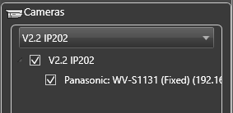

-------------------------------------------------------------------------------

Note:
- The cameras obtained by "Face search - server registration" of the setup window will be displayed in the tree.
- When the checkbox of "Parent node (server)" is checked, the checkboxes of all the child nodes will be checked automatically.
- When the checkbox of "Parent node (server)" is unchecked, the checkboxes of all the child nodes will be unchecked automatically.

-------------------------------------------------------------------------------

<In the case of WV-ASF950 [version 2.00 or later (registered face/unregistered face detection mode)]>

-------------------------------------------------------------------------------

Note:
- The area set in the “Area management” window and the cameras registered in the area (camera registered in the selected server) will be displayed in the tree.

-------------------------------------------------------------------------------

Step 3

Click the [Search] button.

→ The search result will be displayed.

Display/operation of search result

Display search result

There are two ways of displaying the search result; "Timeline" and "List".

<When displaying in "Timeline">

Click the [Timeline] tab.

The search result will be displayed with mapped face images on a two-axis plane with "time" and "place".

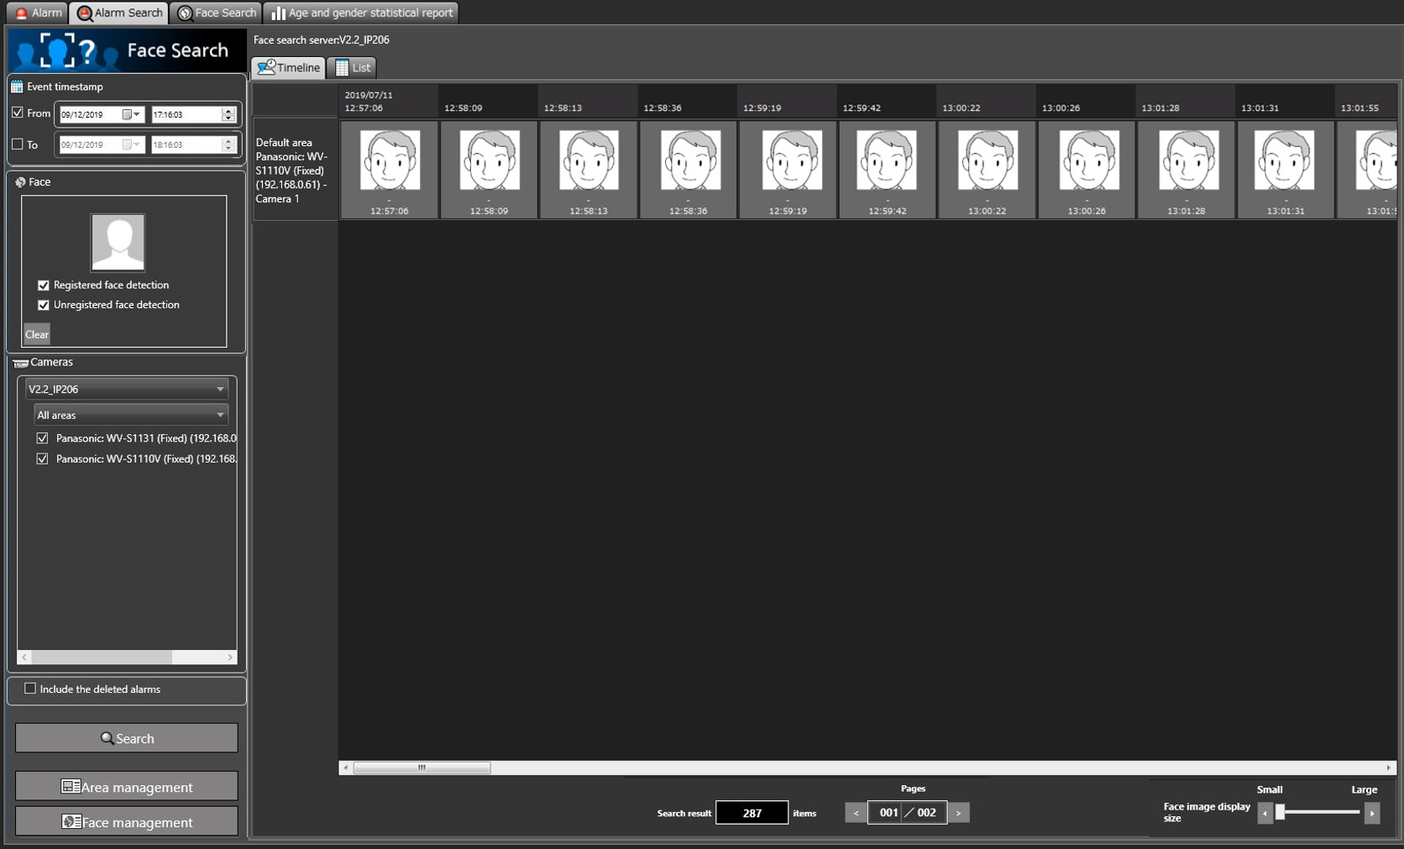

<When displaying in "List">

Click the [List] tab.

The search result will be displayed in a list from the latest date of alarm notification.

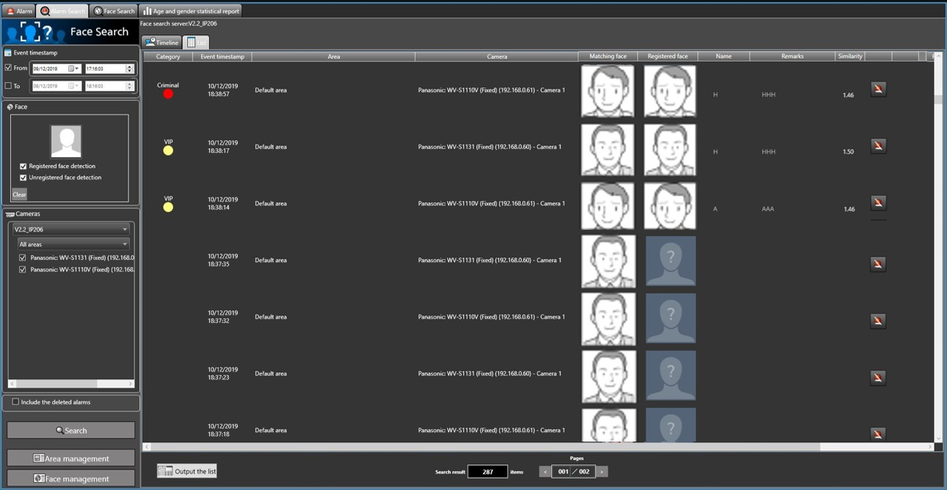

-------------------------------------------------------------------------------

Note:
- When received an unregistered face detection alarm notification, the following image will be displayed as a registered face image.

-------------------------------------------------------------------------------

■ Number of the search results, page information

Displays the total number of search results and the number of currently displayed pages.

The page will be turned when the page button is pressed.

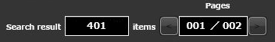

Operation using face image in search result

The following are available by operation using a face image in the search result.

■Apply to filter of the [Face Search] tab

Right-click on a face image and select [Set to Face Search 1] or [Set to Face Search 2] from the menu.

→ The selected image will be displayed in the "Faces" section of the [Face Search] tab.

■Apply to filter of [Alarm Search] tab

Right-click on the face image and select "Set to Alarm Search" from the menu.

→ The selected image will be displayed in the "Faces" section of the [Alarm Search] tab.

-------------------------------------------------------------------------------

Note:
- In the case of the unregistered face detection alarm, it could not be a search condition.

-------------------------------------------------------------------------------

■Register as a target person (face) for alarm notification

Right-click on the face image and select "Newly register this face image" or "Additionally register this face image" from the menu.

■Playback the recorded images

Right-click on the image and select "Play the video" from the menu, or double-click the face image.

→ Image recorded at the alarm occurrence time will be played.

■Display the image in the original size

Right-click on the image and select "Display this image in the original size" from the menu.

→ The original size face image will be displayed in a newly opened window.

Output search result

The alarm search result can be output in a HTML file.

Step 1

Click the [List] tab of the [Alarm Search] tab, and then click the [Output the list] button.

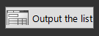

→ The window for specifying the destination folder of the saving file will be displayed.

Step 2

Specify the destination folder of the saving file, name the file, and then click the [OK] button.

→ The window to show the output progress will be displayed.

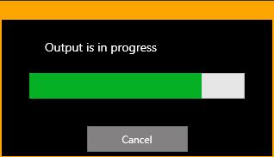

A dated folder will be automatically created in the specified folder, and a file will be saved there with the specified name.

Step 3

When the file saving process is complete, confirmation window for displaying the result will be displayed.

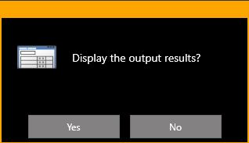

Click [Yes] button to open the output HTML file in the browser.

Face Search

Search by designating a time and date

Perform an alarm notification search by designating time and date.

Step 1

Click the [Face Search] tab.

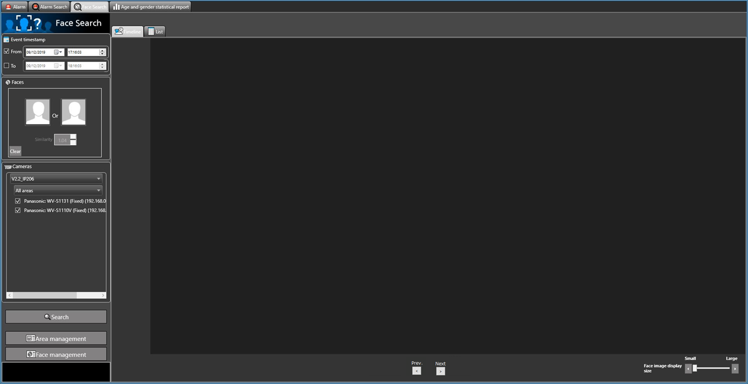

Step 2

Select the start time and the end time of [Date/time].

The details are as follows.

■ From

Select the start time of the period to be searched.

Select from "2005/1/1" to "2034/12/31".

■ To

Select the end time of the period to be searched.

Select from "2005/1/1" to "2034/12/31".

Step 3

Click the [Search] button.

→ The search result will be displayed.

Search by designating a face image

Perform the alarm notification search by designating a face image.

Step 1

Click the [Face Search] tab.

Step 2

Designate a face image.

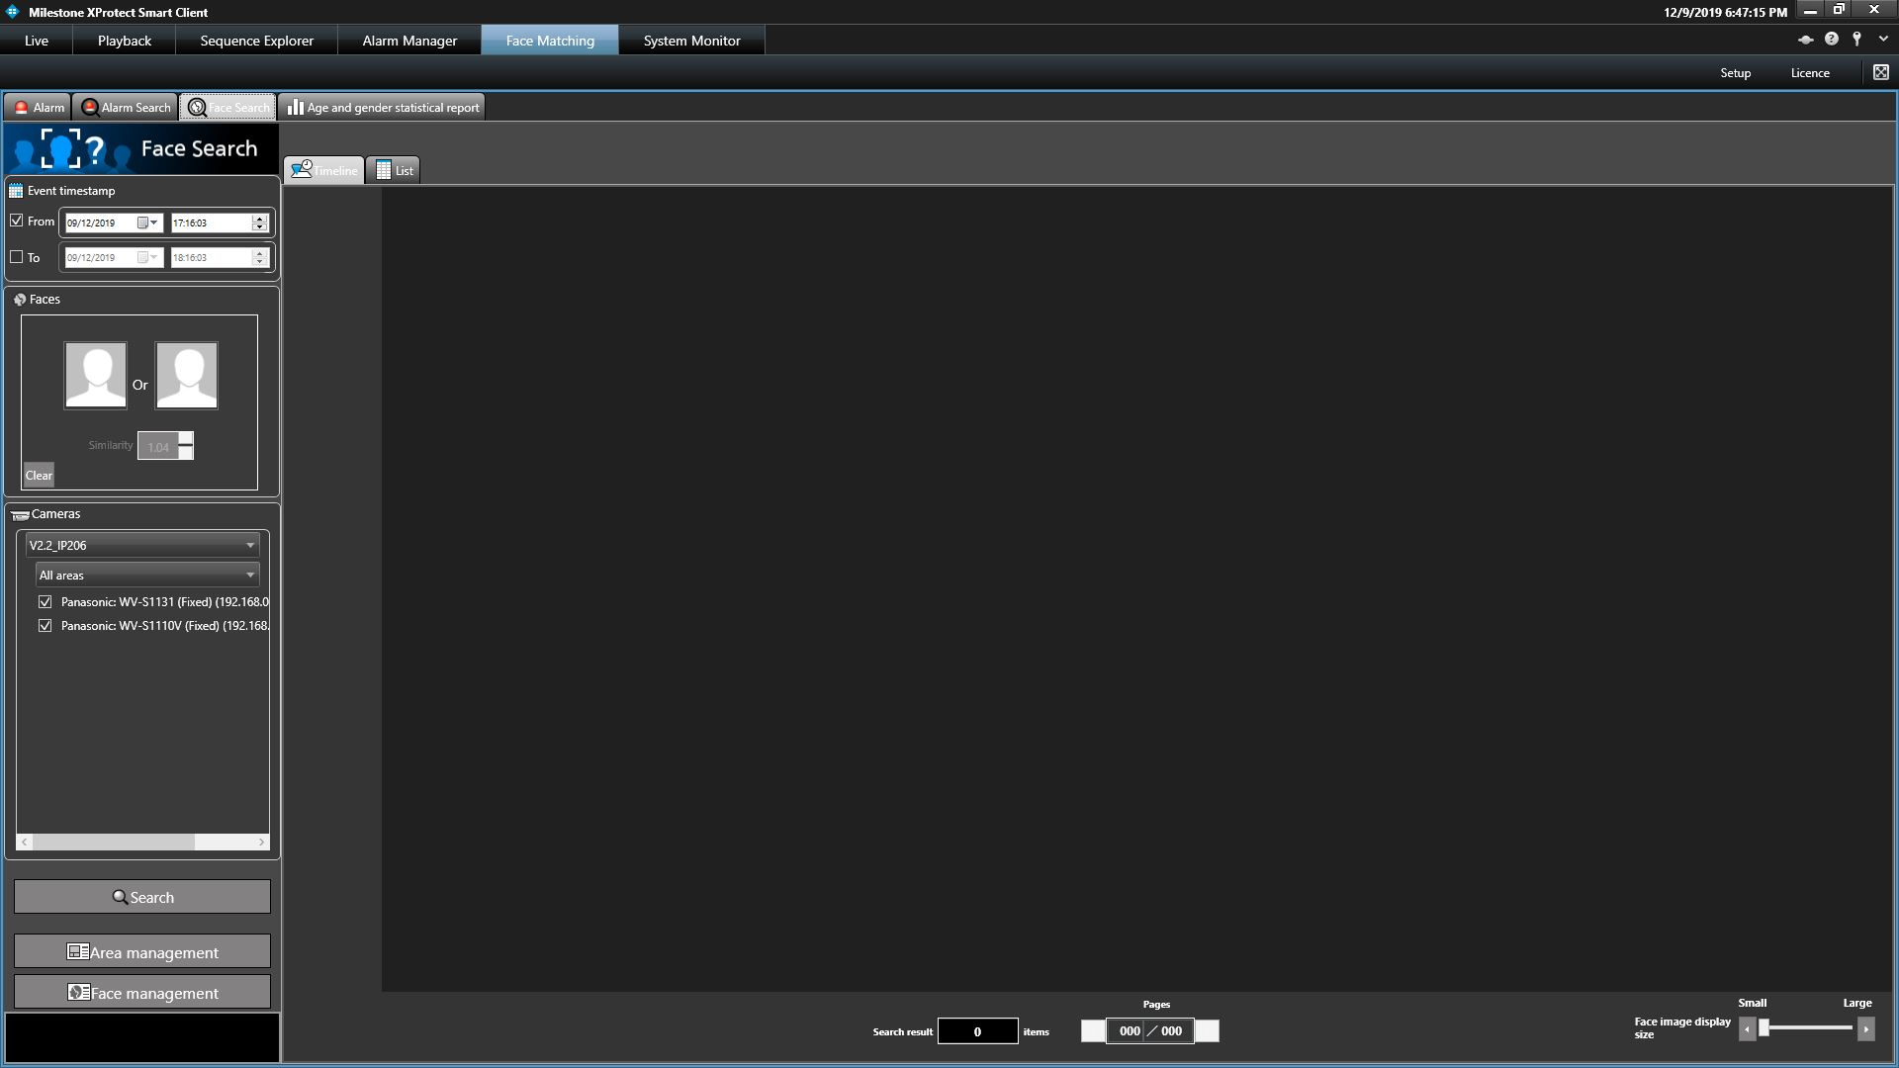

The details are as follows.

■ Person icon

The face image can be configured as follows.

- Display the "List of registered faces" window by left-clicking the person icon, and then select a face image.

- Drag and drop the face image from the search result onto the person icon.

- Right-click the person icon, and then select from the following menu.

[Select from list of registered faces]

[Select face image from snapshot]

■ Similarity

Narrow down the search results by similarity.

Only faces whose similarity are greater than or equal to the set value are output to the result.

■ [Clear] button

Clear the selected face image.

Designate the person (face image) to be searched

- Select from the registered images

Right-click on the person icon and select [Select from list of registered faces] from the menu.

→ The “List of registered faces” window will be displayed.

■ List item

Select a person to be searched from the "List of registered faces" displayed on the right side.

■ [OK] button

Close the "List of registered faces" window applying the setting to the search condition.

■ [Cancel] button

Close the "List of registered faces" window without applying the setting to the search condition.

- Select face image from the snapshot

Right-click on the person icon and select [Select face image from snapshot] from the menu.

→ The “Select face image from snapshot” window will be displayed.

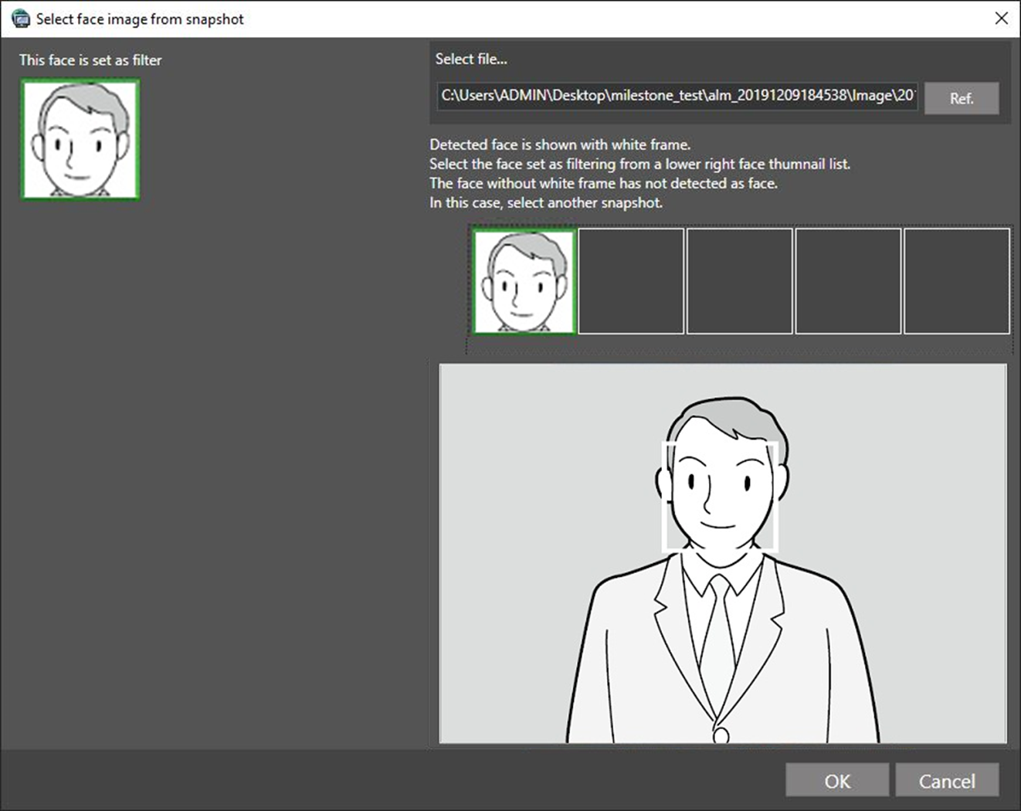

■ [Ref.] button

Select an image file to be read on the "Select face image from the snapshot" window.

The available file formats are JPEG, PNG and BMP.

■ Snapshot display area

When an image file is read out, the face detection process will be carried out and white border frame will be displayed around each face.

The detected faces will be displayed above the image.

■ Image display area for setting the search condition

The selected face image will be displayed.

■ [OK] button

Close the registration window applying the setting to the search condition.

■ [Cancel] button

Close the registration window without applying the setting to the search condition.

Step 3

Click the [Search] button.

→ The search result will be displayed.

Search by designating a camera

Perform the alarm notification search by designating a camera.

Step 1

Click the [Face Search] tab.

Step 2

Check the checkbox of the camera to be searched.

< In the case of WV-ASF950 (version 1.0x) or WV-ASF950 [version 2.00 or later (registered face detection mode)]>

-------------------------------------------------------------------------------

Note:
- The cameras obtained by "Face search - server registration" of the setup window will be displayed in the tree.
- When the checkbox of "Parent node (server)" is checked, the checkboxes of all the child nodes will be checked automatically.
- When the checkbox of "Parent node (server)" is unchecked, the checkboxes of all the child nodes will be unchecked automatically.

-------------------------------------------------------------------------------

<In the case of WV-ASF950 [version 2.00 or later (registered face/unregistered face detection mode)]>

-------------------------------------------------------------------------------

Note:
- The area set in the “Area management” window and the cameras registered in the selected server among the cameras registered in the area will be displayed in the tree. Refer to "☞Set area" about the area.

-------------------------------------------------------------------------------

Step 3

Click the [Search] button.

→ The search result will be displayed.

Display/operation of search result

Display search result

There are two ways of displaying the search result; "Timeline" and "List".

<When displaying in "Timeline">

Click the [Timeline] tab.

The search result will be displayed with mapped face images on a two-axis plane with "time" and "place".

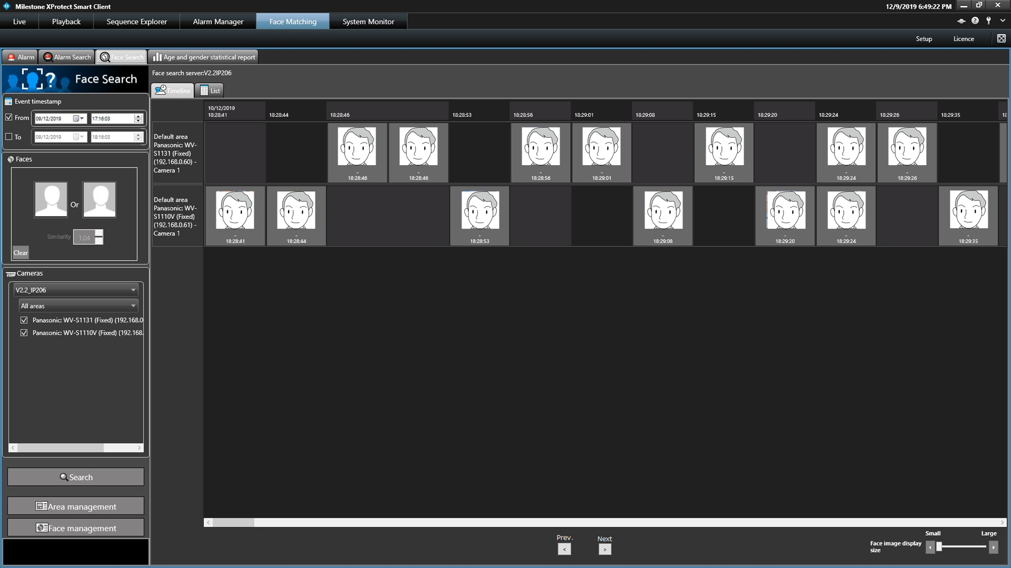

■ Page transition button

When the [Next] button is pressed, the page will be turned to next time search results.

When the [Prev.] button is pressed, the page will be turned to previous time search results.

<When displaying in "List">

Click the [List] tab.

When "Face image" is set for the search condition, the search result will be listed in order of the highest score of similarity.

When "Face image" is not set for the search condition, the search result will be listed from the latest date of the detection.

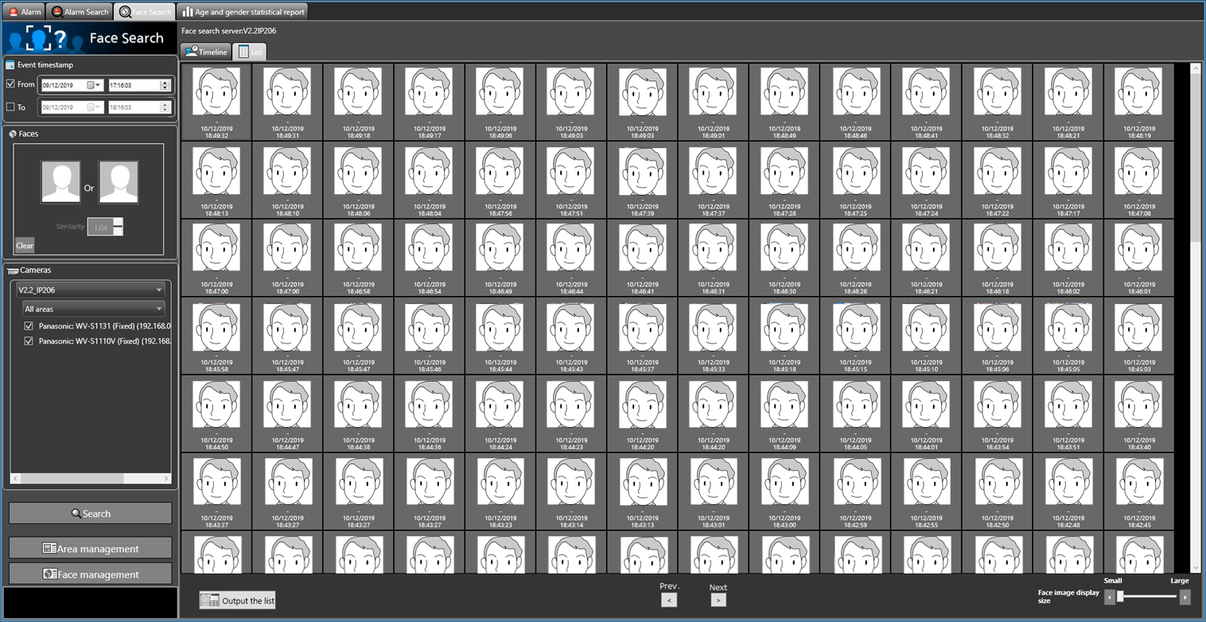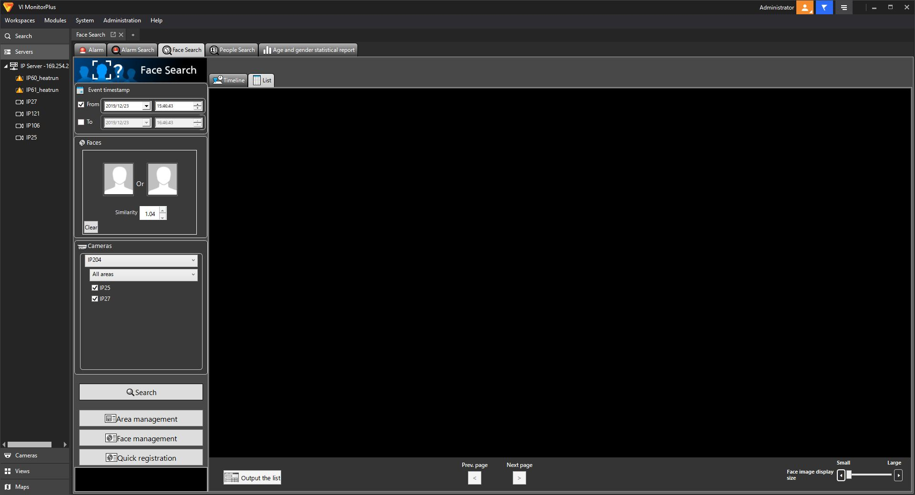

■ Page transition button

When the [Next page] button is pressed, the page will be turned to next time search results.

When the [Prev. page] button is pressed, the page will be turned to previous time search results.

■ Attribute information

In the search result, the face image and the additional information of "Similarity" and "Time & date" (when image is captured) will be displayed.

For “List” display, "Recording date" is also added.

<When displaying in “Timeline”>

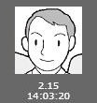

<When displaying in “List”>

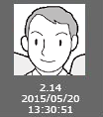

■ Face image display size

The size of the image to be displayed can be changed by operating the bar.

The image size can be selected from 5 different sizes.

1(S): 72x72, 2: 90x90, 3: 120x120, 4: 140x140, 5 (L): 180x180

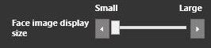

■ Display face image in the original size

The face image can be displayed in its original size.

When the cursor is moved over a face image, a person icon will appear at the lower right of the image.

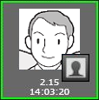

The face image will be displayed in its original size in a newly opened window if the person icon is clicked.

-------------------------------------------------------------------------------

Note:

- The original size image can also be displayed by right-clicking on the face image to show the pop-up menu, selecting the "Display this image in the original size" menu.

- Two original size face images can be displayed at maximum.

- Click the [X] button to close the original size face image.

-------------------------------------------------------------------------------

Operation using face image in search result

The following are available by operation using a face image in the search result.

■ Apply to filter of the face search condition

Right-click on a face image and select [Set Face Search 1] or [Set Face Search 2] from the menu.

→ The selected image will be displayed in the "Faces" section of the search display window.

■ Register as a target person (face) for alarm notification

Right-click on the face image and select "Newly register this face image" or "Additionally register this face image" from the menu.

■ Playback the recorded images

Right-click on the image and select "Play the video" from the menu, or double-click the face image.

→ Image recorded at the alarm occurrence time will be played.

■ Display the image in the original size

Right-click on the image and select "Display this image in the original size" from the menu.

→ The original size face image will be displayed in a newly opened window.

Output search result

The face search result can be output in a HTML file.

Step 1

Click the [List] tab of the [Face Search] tab, and then click the [Output the list] button.

→ The window for specifying the destination folder of the saving file will be displayed.

Step 2

Specify the destination folder of the saving file, name the file, and then click the [OK] button.

→ The window to show the output progress will be displayed.

A dated folder will be automatically created in the specified folder, and a file will be saved there with the specified name.

Step 3

When the file saving process is complete, confirmation window for displaying the result will be displayed.

Click [Yes] button to open the output HTML file in the browser.

Age and gender statistical report

Display statistical result

It is possible to display the people count sorted by age or gender for each camera.

Step 1

Click the [Age and gender statistical report] tab.

→ The age and gender window will be displayed.

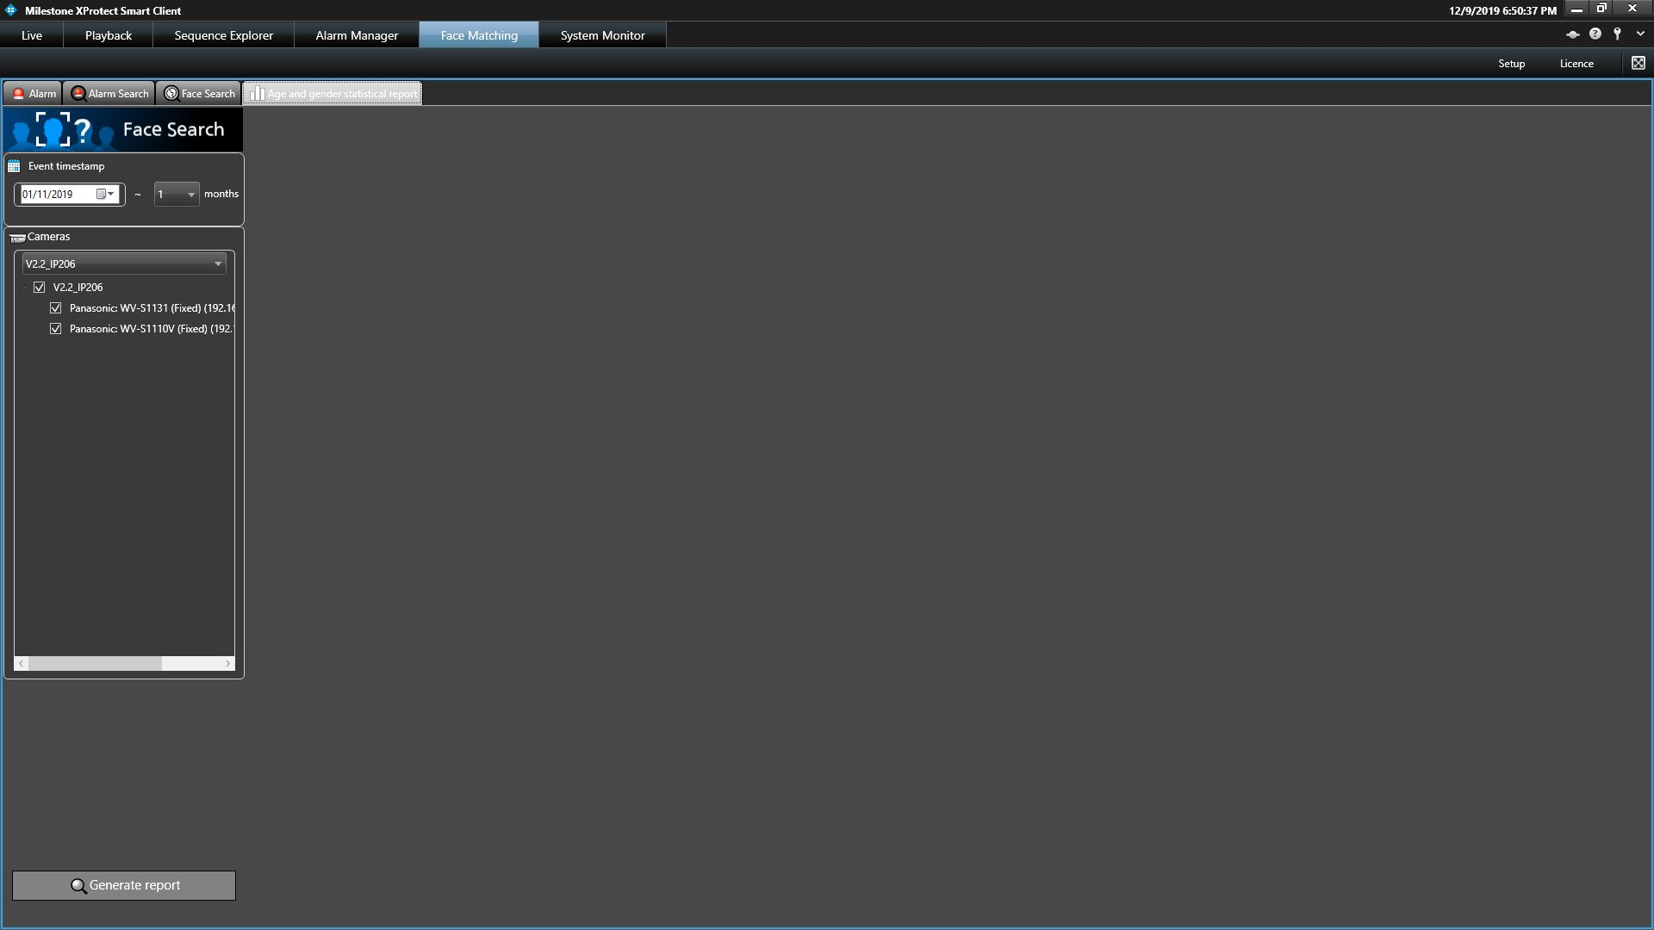

Step 2

Select the start date and the display period in the [Event timestamp] section for the statistics display.

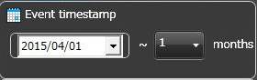

Select the start date from "2005/1/1" to "2034/12/31", and the period from "1" to "12".

Step 3

Select the cameras to display statistics in the [Cameras] section.

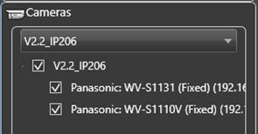

-------------------------------------------------------------------------------

Note:

- When the checkbox "V2.2_IP206" is checked, all the cameras will be selected automatically.

- When the checkbox " V2.2_IP206" is unchecked, all the cameras will be unselected automatically.

- Up to 8 cameras can be selected.

------------------------------------------------------------------------------

Step 4

Click the [Generate report] button.

→ The statistical results will be displayed.

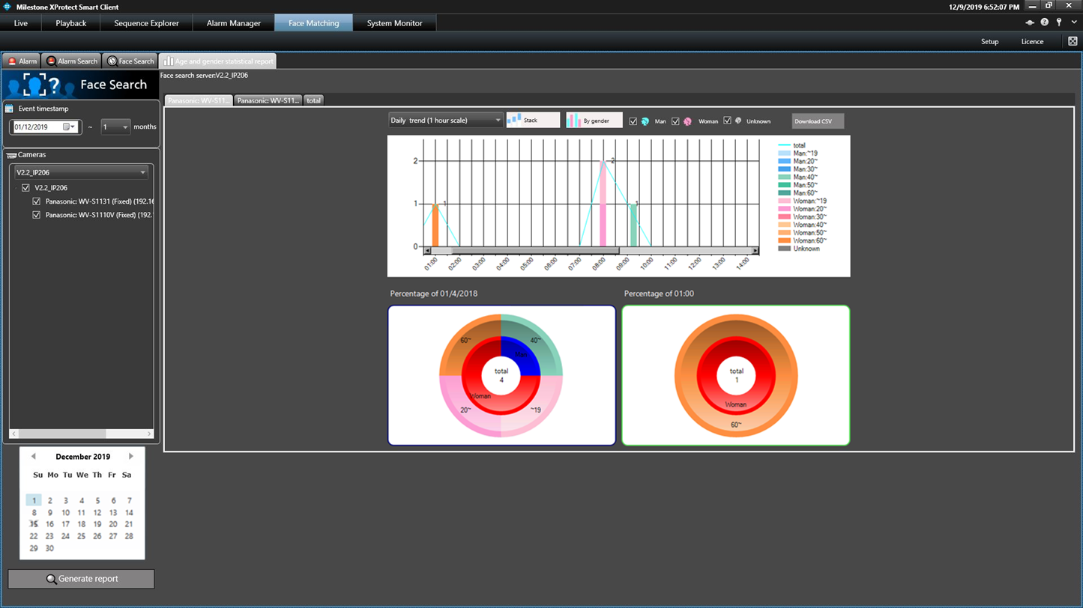

The following display options can be set.

■ Calendar

Select the date to display statistics in the [Calendar] section.

-------------------------------------------------------------------------------

Note:

- The "X" mark will be displayed to indicate that the there is no data for the date.

------------------------------------------------------------------------------

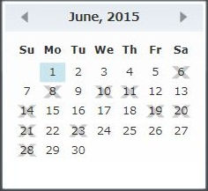

■ Graph type

Select the graph type to be displayed from the following.

Daily trend (15 minute scale)/ Daily trend (30 minute scale)/ Daily trend (1 hour scale)

Weekly trend/ Days trend/ Monthly trend

■ [Stack]/[Ratio] buttons

Switches the graph display based on the accumulated data or the proportional data.

-------------------------------------------------------------------------------

Note:

- The line graph is available only when displaying based on the accumulated data (stack), and the data point labels will be displayed.

------------------------------------------------------------------------------

■ [By gender]/[By total] buttons

Switches the graph display based on the gender or the total number.

■ [Man]/[Woman]/[Unknown] checkboxes

Select the desired gender to be included in the graph display.

■ Circle graph

Select the items to be displayed as the data labels of the circle graph.

Each time click is made on the circle graph area, the label display will be switched in the order of [Head count] → [Ratio] → [Title] → [Head count].

Download statistical result

It is possible to download the statistical data as a CSV file.

Step 1

Click the [download CSV] button on the statistics display window.

→ The folder selection window will be displayed.

-------------------------------------------------------------------------------

Note:

- When a removable HDD formatted on the 32-bit OS is connected to a PC whose OS is the 64-bit edition, it may fail to designate the removable HDD as a saving destination.

-------------------------------------------------------------------------------

Step 2

Select the destination folder of the CSV file to be downloaded, and click the [OK] button.

The statistics data will be saved as the CSV file whose character code is UTF-8 and comma separated.

The name of the downloaded CSV file will be as follow.

"ccccccc_yymmdd000000_yymmdd000000_00_00.csv"

■ ccccccc

:Name of the camera or "total"

■ yymmdd000000 (first half)

: Start date of the period (Year in last 2 digits)

■ yymmdd000000 (latter half)

: End date of the period (Year in last 2 digits)

CSV file format

Output example

#GUID,Aggregated Date,Gender Code,Age Code,Period of time,The number of people

00000000-0000-0000-0000-192168000001,2015/01/10,1,3,0900,15

00000000-0000-0000-0000-192168000001,2015/01/10,1,3,0915,3

00000000-0000-0000-0000-192168000001,2015/01/10,1,3,0930,21

00000000-0000-0000-0000-192168000001,2015/01/10,1,3,0945,0

00000000-0000-0000-0000-192168000001,2015/01/10,1,3,1000,5

...

The data item name and the each 15 minutes summary information will be output on the first line and the second line respectively.

■ GUID

:Camera GUID

■ Aggregated Date

: Date

■ Gender Code

-1: Unknown/ 0: Male/ 1: Female

■ Age Code

-1: Unknown / 1: 10s or younger / 2: 20s / 3: 30s / 4: 40s / 5: 50s / 6: 60s or older

■ Period of time

: Time 15 minutes each

■ The number of people

: Head count

Set area

It is possible to select an operation to notify an alarm when a registered person is detected by the camera and an operation to notify an alarm when an unregistered person is detected by the camera for each area.

The cameras can be set in the area to detect a person.

-------------------------------------------------------------------------------

Note:
- Area setting is possible when using WV-ASF950 version 2.00 or later (registered face/unregistered face detection mode).
- The camera always belongs to one of the areas.

-------------------------------------------------------------------------------

Add area

Step 1
Click the [Area management] button in one of the following tabs, [Alarm], [Alarm search] or [Face search].
- The “Area management” window will be displayed.

-------------------------------------------------------------------------------

Note:
- If a user without authorization of "Area setting in face alarm" is logged in, the [Area management] button will not be displayed.

-------------------------------------------------------------------------------

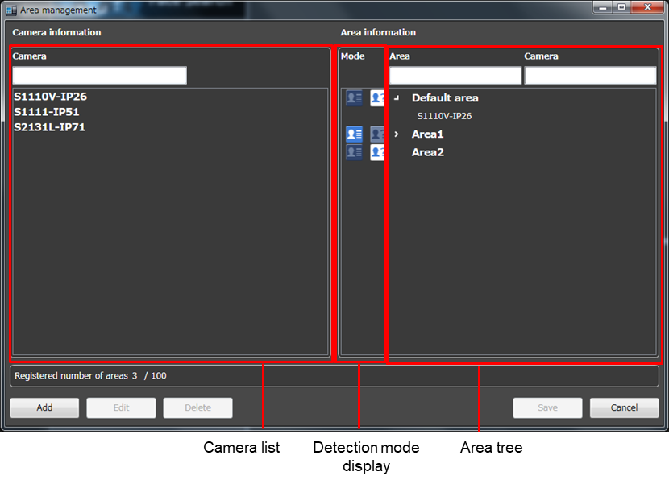
- Camera list

Display all cameras registered on the face search server.

By entering characters in the camera name search field, only the relevant camera will be displayed.

-------------------------------------------------------------------------------

Note:
- Cameras in the camera list can be added by dragging and dropping anywhere in "Area tree". At this time, you can select multiple cameras.

-------------------------------------------------------------------------------

- Detection mode display
Display the detection mode for each area.

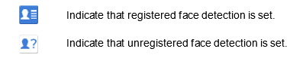

- Area tree
Displays cameras registered in the area in a tree format.
By entering part of the area name or part of the camera name in the search field, the relevant area or relevant camera will be searched for.

Default: There is a default area, and all cameras are registered in the default area.

-------------------------------------------------------------------------------

Note:
- The cameras can be moved between areas by dragging and dropping cameras in "Area tree".
- The display order of areas can be changed by dragging and dropping areas in the area tree. The display order for the camera can be also changed as well.

-------------------------------------------------------------------------------

- [Add] button
Add a new area.

-------------------------------------------------------------------------------

Note:
- Up to 100 areas can be registered.
-------------------------------------------------------------------------------

- [Edit] button
Edit the area name and the detection mode.

- [Delete] button
Delete the created area.

- [Save] button
Save the set content.

- [Cancel] button
Cancel the edited contents and resets the contents to the state before editing.

- Registered number of areas
Number of the registered areas will be displayed.

Step 2
Click the [Add] button.
- The “Add/Edit area” window will be displayed.

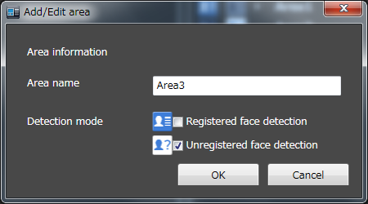

- Area name
Enter the area name within 20 characters.

- Detection mode
Select whether to detect registered faces in the area or unregistered faces in the area.
- Registered face detection: Detects a person registered in the "Registered face detection" area and issues an alarm.
- Unregistered face detection: Detects a person not registered in the "Unregistered face detection" area and issues an alarm.
Initial state: Unregistered face detection

- [OK] button
Complete the settings and close the window.

- [Cancel] button
Cancel the edited contents and close the window.

Step 3
After setting the area information, click the [OK] button.
- Area registration is completed and the window returns to the “Area management” window.

Step 4
Drag and drop the cameras in the camera list to the area in the area tree.
- The camera will be added to the registered area.

-------------------------------------------------------------------------------

Note:
- To move cameras at once, selecting multiple cameras by mouse operation and dragging and dropping them are available.
- When you add a camera to an area tree and drag and drop the same camera from the camera list to a different area, that camera will move automatically in the area tree.
-------------------------------------------------------------------------------

Step 5
Click the [Save] button.
- The settings will be saved. If not registering, click the [Cancel] button.

-------------------------------------------------------------------------------

Note:
- After clicking the [Save] button, restart this software on this PC and other PCs connected to face search servers to reflect the settings.
-------------------------------------------------------------------------------

Edit area

Step 1
Click the [Area management] button in one of the following tabs, [Alarm], [Alarm search] or [Face search].
- The “Area management” window will be displayed.

-------------------------------------------------------------------------------

Note:
- If a user without authorization of "Area setting in face alarm" is logged in, the [Area management] button will not be displayed.

-------------------------------------------------------------------------------

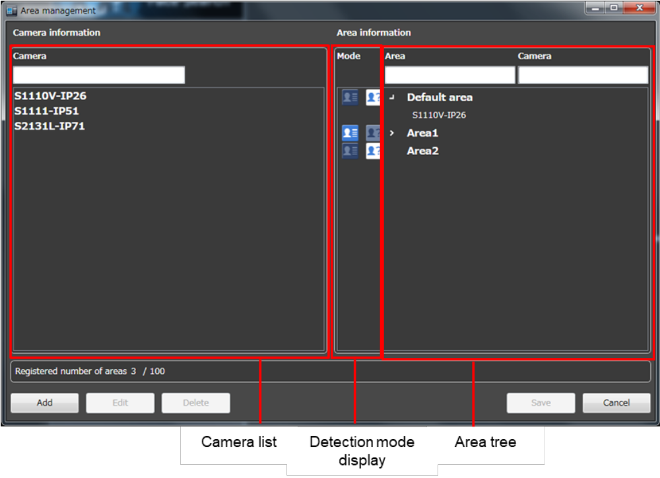

Step 2
After selecting the area to be edited, click the [Edit] button.
- The “Add/Edit area” window will be displayed.

Step 3

Edit the area name. If you change the face detection type of the area, edit the detection mode.

Step 4
Click the [OK] button.
- Area registration is completed and the window returns to the “Area management” window.

Step 5
Click the [Save] button.
- The settings will be saved. If not registering, click the [Cancel] button.

-------------------------------------------------------------------------------

Note:
- If a user without authorization of "Area setting in face alarm" is logged in, the [Area management] button will not be displayed.
-------------------------------------------------------------------------------

Delete area

Step 1

Click the [Area management] button in one of the following tabs, [Alarm], [Alarm search] or [Face search].
- The “Area management” window will be displayed.

-------------------------------------------------------------------------------

Note:
- If a user without authorization of "Area setting in face alarm" is logged in, the [Area management] button will not be displayed.

-------------------------------------------------------------------------------

Step 2
After selecting the area to be deleted, click the [Delete] button.
- The deletion confirmation window is displayed.

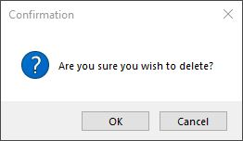

Step 3
Click the [OK] button.
- Area registration is completed and the window returns to the “Area management” window.

-------------------------------------------------------------------------------

Note:
- When a camera is registered in the selected area, the area can not be deleted. After moving the camera to another area, delete the area.
- The default area can not be deleted.

-------------------------------------------------------------------------------

Step 4
After deleting the area, click the [Save] button.

-------------------------------------------------------------------------------

Note:
- After clicking the [Save] button, restart this software on this PC and other PCs connected to face search servers to reflect the settings.
-------------------------------------------------------------------------------

Register a face for the face notification

-------------------------------------------------------------------------------

Note:
- In the "registered face/unregistered face detection" mode, it is necessary to set "Select area" for each registered person.
- In the area where "Detection mode" on the add/edit area window is registered face detection, an alarm is notified when a person registered in the area is detected.

In the area where "Detection mode" on the add/edit area window is unregistered face detection, an alarm is notified when a person not registered in the area is detected.

-------------------------------------------------------------------------------

Newly register a face image

Newly register a face image from alarm search result

Face images selected from the search result of "Face Search" can be newly registered.

Step 1

On the search result window, right-click on a face image and select "Newly register this face image" from the menu.

The face detection will start and white frames will be displayed around the detected face.

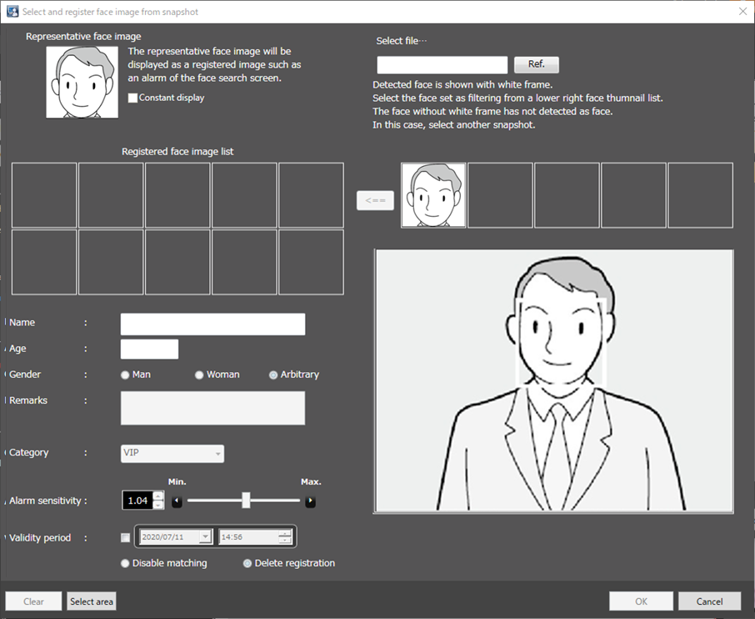

Step 2

Click a face image to be registered from the face image list.

→ A green frame will be displayed on the selected face image.

Step 3

Click the (Add) button.

→ The "Face image Evaluation" window will be displayed.

Check and confirm the face image to be registered by following the displayed instructions, and then click the [OK] button.

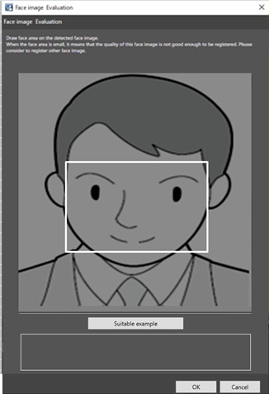

When any of the following check points are recognized, consider to register other image. Otherwise, it may cause performance deterioration of the face detection function.

(Check item 1)

The message of “Please consider to register other face image.” is displayed on the screen.

(Check item 2)

In the face image, the detected face positions (white square) are positioned on the face.

If the point is not in the correct position, register other face image.

Example (Applicable/Not applicable) of the detected face position

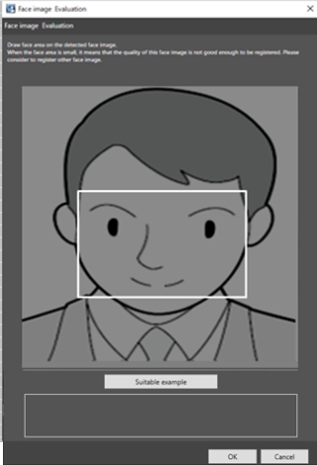

Example1 (Applicable): The position of face is displayed correctly.

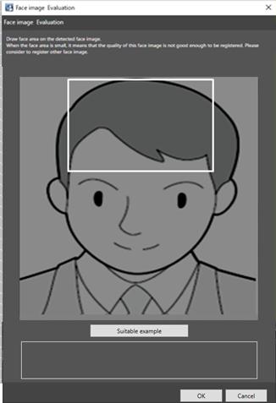

Example2 (Not applicable): The position of face is incorrect.

Step 3

The "Select and register face image from snapshot" window will be displayed.

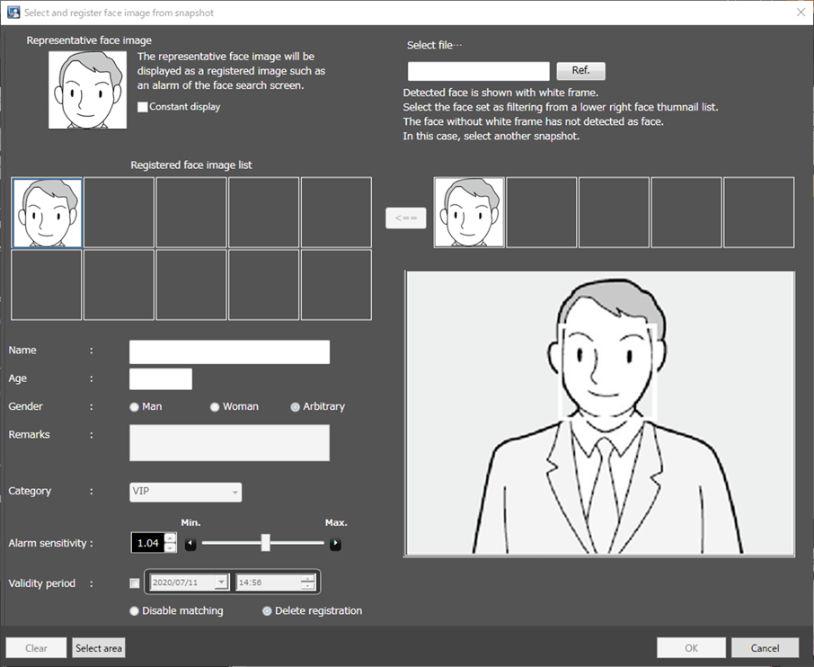

Entering the following information.

■ First name

■ Age

■ Gender

■ Remarks

■ Category

■ Face sensitivity

■ Validity Period

- In the case of WV-ASF950 version less than 2.00 or WV-ASF950 [version 2.00 or later (registered face detection mode)], go to Step5.

- In the case of WV-ASF950 [version 2.00 or later (registered face/unregistered face detection mode)], go to Step4.

Step 4
Click the [Select area] button.
- The "Select area" window is displayed. After selecting the area of the person to register, click the [OK] button.

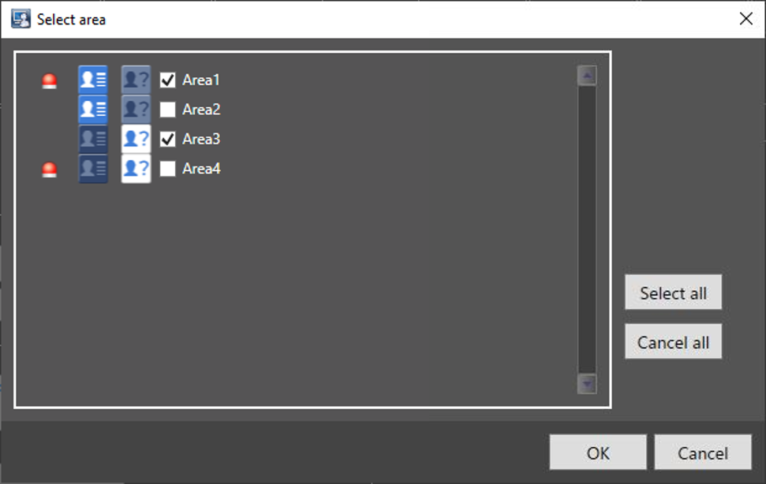

The details of the window are as follows.

- Select area
Display the registered area and the detection mode for each area.
Select areas for the person to be registered. If a face matching alarm will be issued, the following icon is displayed.
Initial state: All areas are not selected.

The following are the examples when selecting areas.

Example 1:
Detection mode | Area name | Checkbox
Registered face detection | Area1 | checked
When the camera of Area1 detects a registered person, a face matching alarm will be issued.

Example 2:
Detection mode | Area name | Checkbox
Registered face detection | Area2 | unchecked
When the camera of Area2 detects a registered person, no alarm is issued.

Example 3:
Detection mode | Area name | Checkbox
Unregistered face detection | Area3 | checked
When the camera of Area3 detects a registered person, no alarm is issued.

Example 4:
Detection mode | Area name | Checkbox
Unregistered face detection | Area4 | unchecked
When the camera of Area4 detects a registered person, an unregistered face detection alarm will be issued.

- [Select all] button
Selects all display areas.

- [Cancel all] button
Deselect all.

- [OK] button
Complete the settings and close the window.

- [Cancel] button
Cancel the edited contents and close the window.

Step 5

Click [OK] button on the "Select and register face image from file" window.

To cancel registration, click the [Cancel] button.

-------------------------------------------------------------------------------

Note:

- The "Face sensitivity" is the sensitivity to be used for face matching of the registered faces.

It can be set for individual person.In the normal operation, keep the default setting.

- The lower the face sensitivity level is, the higher the rate of matching with the registered faces will become.

However, the matching accuracy may drop.

The higher the face sensitivity level is, the lower the rate of false matching with the registered faces will become. However, the matching rate with the registered faces may drop.

- In “Validity Period”, the following two expiration dates can be set.

Disable matching: After the expiration date, this person's face will not be detected.

Delete registration: After the expiration date, we will delete the registration itself of this person.

-------------------------------------------------------------------------------

Newly register a face image from face search result

Face images selected from the search result of "Face Search" can be newly registered.

Step 1

On the search result window, right-click on a face image and select "Newly register this face image" from the menu.

Step 2

The "Face image Evaluation" window will be displayed.

Check and confirm the face image to be registered by following the displayed instructions, and then click the [OK] button.

When any of the following check points are recognized, consider to register other image. Otherwise, it may cause performance deterioration of the face detection function.

(Check item 1)

The message of “Please consider to register other face image.” is displayed on the screen.

(Check item 2)

In the face image, the detected face positions (white square) are positioned on the face.

If the point is not in the correct position, register other face image.

Example (Applicable/Not applicable) of the detected face position

Example1 (Applicable): The position of face is displayed correctly.

Example2 (Not applicable): The position of face is incorrect.

Step 3

The "Select and register face image from snapshot" window will be displayed.

After entering the following information.

■ First name

■ Age

■ Gender

■ Remarks

■ Category

■ Face sensitivity

■ Validity Period

- In the case of WV-ASF950 version less than 2.00 or WV-ASF950 [version 2.00 or later (registered face detection mode)], go to Step5.

- In the case of WV-ASF950 [version 2.00 or later (registered face/unregistered face detection mode)], go to Step4.

Step 4
Click the [Select area] button.
- The "Select area" window is displayed. After selecting the area of the person to register, click the [OK] button.

Step 5

Click [OK] button on the "Select and register face image from file" window.

To cancel registration, click the [Cancel] button.

-------------------------------------------------------------------------------

Note:

- The "Face sensitivity" is the sensitivity to be used for face matching of the registered faces.

It can be set for individual person. In the normal operation, keep the default setting.

- The lower the face sensitivity level is, the higher the rate of matching with the registered faces will become.

However, the matching accuracy may drop.

The higher the face sensitivity level is, the lower the rate of false matching with the registered faces will become. However, the matching rate with the registered faces may drop.

- In “Validity Period”, the following two expiration dates can be set.

Disable matching: After the expiration date, this person's face will not be detected.

Delete registration: After the expiration date, we will delete the registration itself of this person.

-------------------------------------------------------------------------------

Newly register a face image using a still image

A face image can be registered using a still image whose format is JPEG, PNG or BMP.

Step 1

Click the [Face management] button on the "Face", “Face Search" or "Face Search" window.

→ The "List of registered faces" window will be displayed.

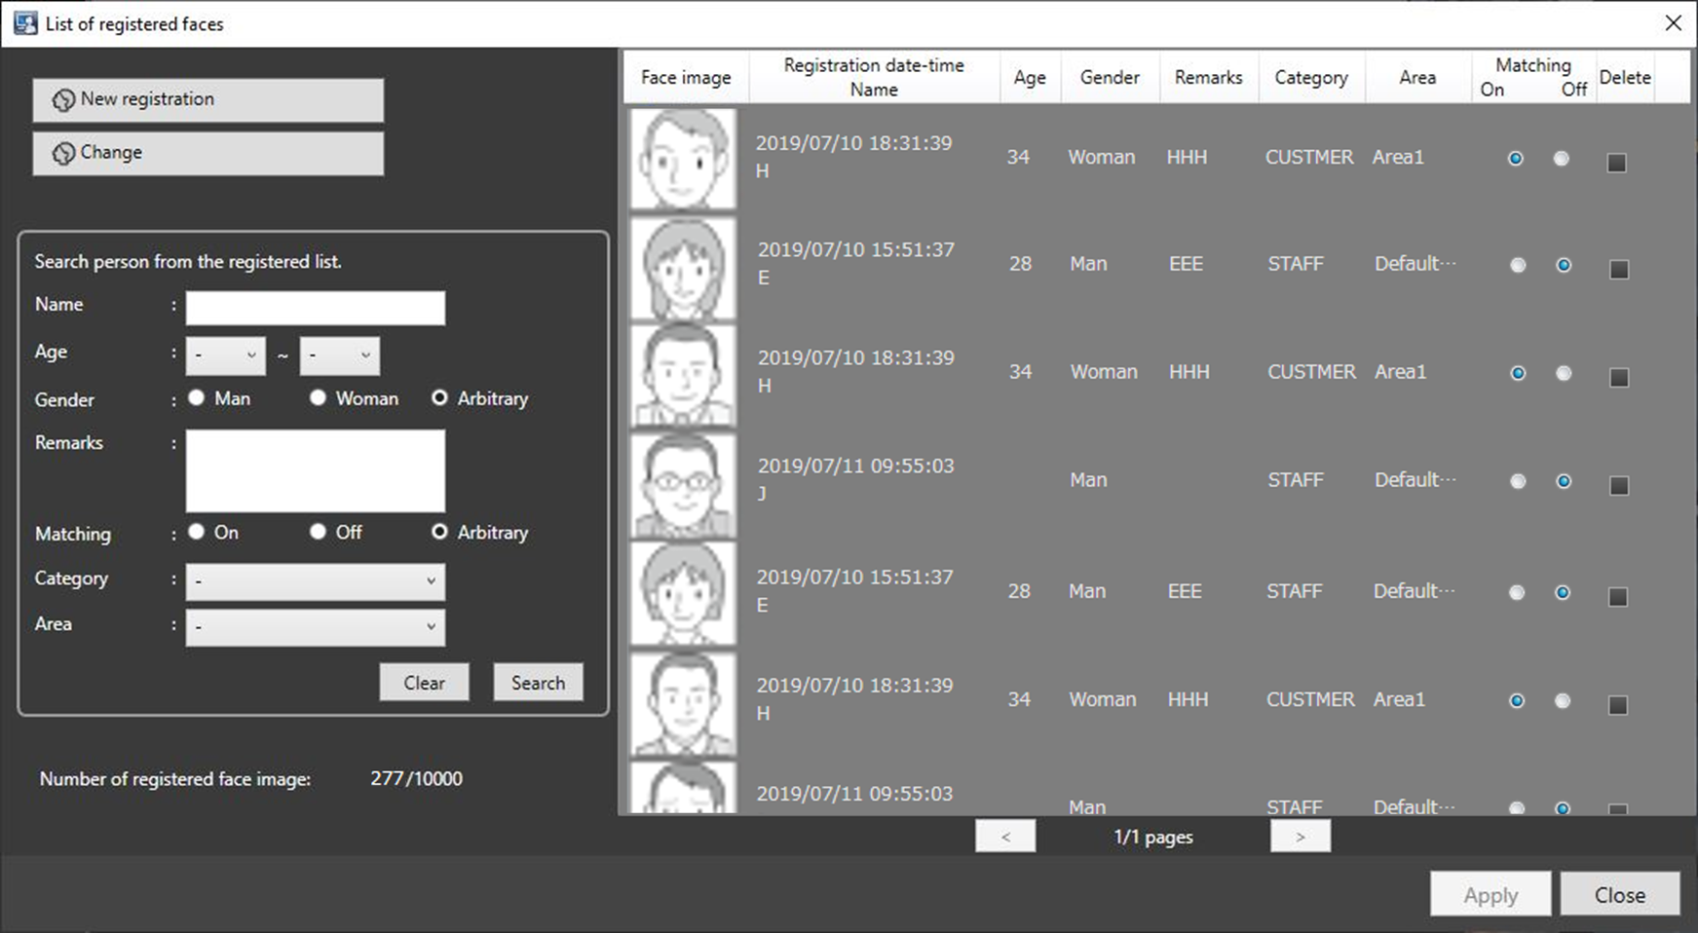

Step 2

Click the [New registration] button.

→ The "Select and register face image from snapshot" window will be displayed.

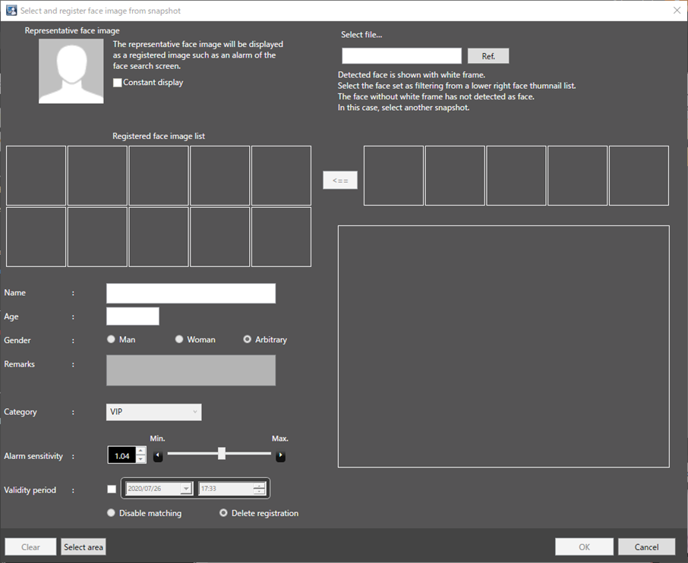

Step 3

Click the [Ref.] button.

Select an image file to be read on the file selection window.

→ The face detection will start using the loaded image, and white frames will be displayed around all the detected faces.

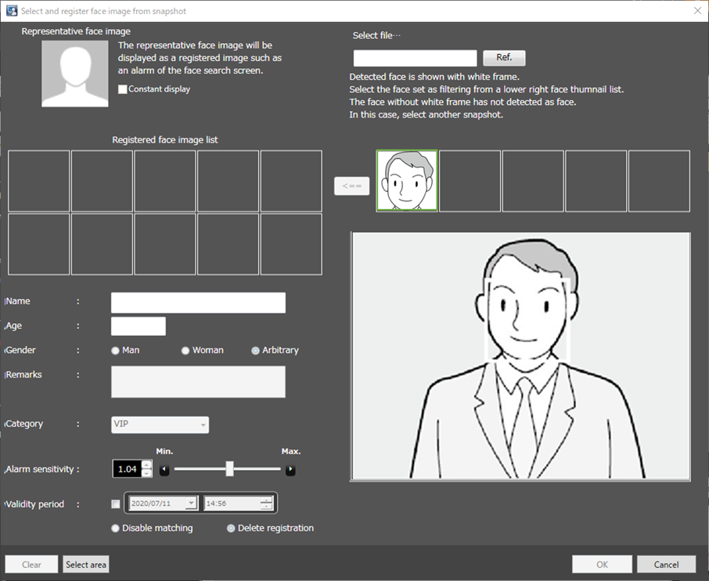

Step 4

Click a face image to be registered from the face image list.

→ A green frame will be displayed on the selected face image.

Step 5

Click the (Add) button.

→ The "Face image Evaluation" window will be displayed.

Check and confirm the face image to be registered by following the displayed instructions, and then click the [OK] button.

When any of the following check points are recognized, consider to register other image. Otherwise, it may cause performance deterioration of the face detection function.

(Check item 1)

The message of “Please consider to register other face image.” is displayed on the screen.

(Check item 2)

In the face image, the detected face positions (white square) are positioned on the face.

If the point is not in the correct position, register other face image.

Example (Applicable/Not applicable) of the detected face position

Example1 (Applicable): The position of face is displayed correctly.

Example2 (Not applicable): The position of face is incorrect.

Step 6

After entering the following information.

■ First name

■ Age

■ Gender

■ Remarks

■ Category

■ Face sensitivity

■ Validity Period

- In the case of WV-ASF950 version less than 2.00 or WV-ASF950 [version 2.00 or later (registered face detection mode)], go to Step5.

- In the case of WV-ASF950 [version 2.00 or later (registered face/unregistered face detection mode)], go to Step4.

Step 4
Click the [Select area] button.
- The "Select area" window is displayed. After selecting the area of the person to register, click the [OK] button.

Step 5

Click [OK] button on the "Select and register face image from file" window.

To cancel registration, click the [Cancel] button.

-------------------------------------------------------------------------------

Note:

- The "Face sensitivity" is the sensitivity to be used for face matching of the registered faces. It can be set for individual person. In the normal operation, keep the default setting.

- The lower the face sensitivity level is, the higher the rate of matching with the registered faces will become. However, the matching accuracy may drop.

The higher the face sensitivity level is, the lower the rate of false matching with the registered faces will become. However, the matching rate with the registered faces may drop.

- In “Validity Period”, the following two expiration dates can be set.

Disable matching: After the expiration date, this person's face will not be detected.

Delete registration: After the expiration date, we will delete the registration itself of this person.

-------------------------------------------------------------------------------

Step 7

The registered person (face) will be displayed in the list on the "List of registered faces" window.

Click the [OK] button.

Additional registration of face image

Additionally register a face image from face search result

Face images selected from the search result of "Face", "Face Search" can be additionally registered.

Step 1

On the search result window, right-click on a face image and select "Additionally register this face image" from the menu.

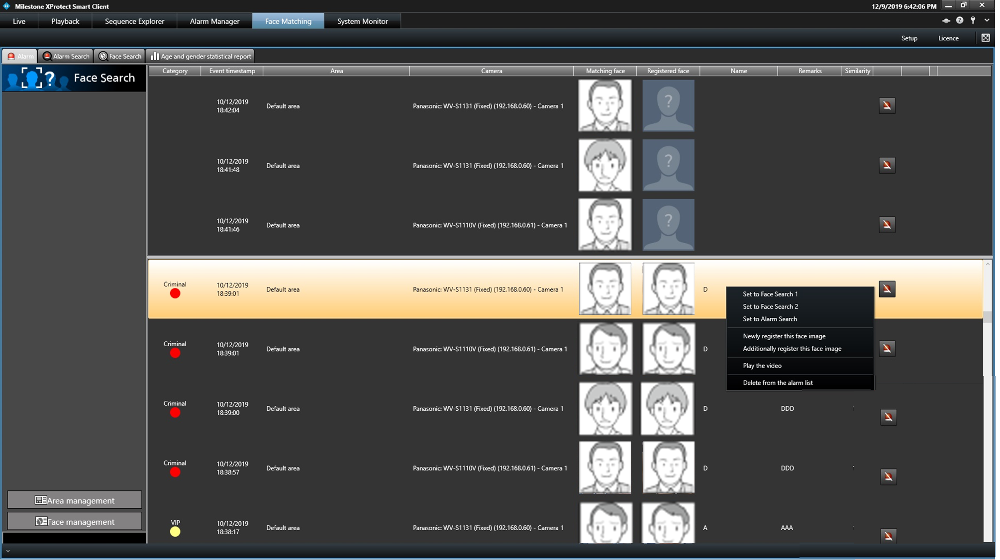

Step 2

From the registered persons, select a person whose face image is to be additionally registered and click the [OK] button.

-------------------------------------------------------------------------------

Note:

- When 10 face images are already registered for the selected person, an error message to notify that the attempted registration is impossible will be displayed.

-------------------------------------------------------------------------------

Step 3

The face detection will start and white frames will be displayed around the detected face.

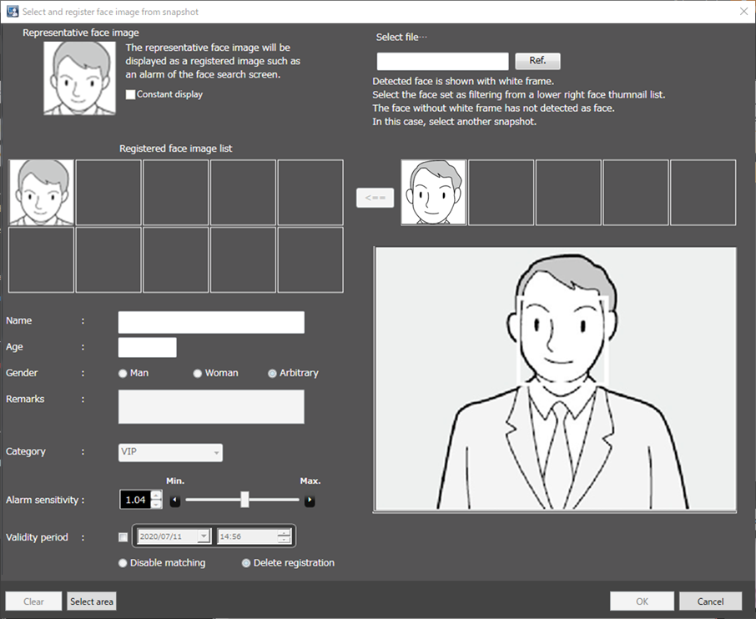

Step 4

Click a face image to be registered from the face image list.

→ A green frame will be displayed on the selected face image.

Step 5

Click the (Add) button.

Step 6

The "Face image Evaluation" window will be displayed.

Refer to the "Newly register this face image" for further information about the face image evaluation window.

Step 7

Confirm that the additionally registered face image is displayed, and then click the [OK] button.

To set the additionally registered face image as the "Representative face image", right-click on the additionally registered face image and select "Set as the representative face image" from the menu, and then click the [OK] button.

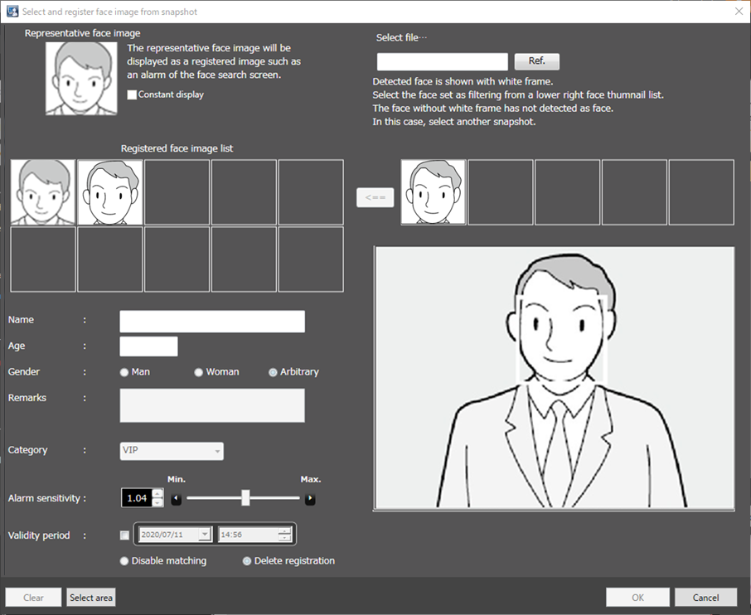

■ Representative face image

When 2 or more face images are registered for a same person, it is possible to set the representative face image.

The representative face image will be set as the face image to be displayed on the registered face image list table.

■ Registered face image list

A list of multiple face images registered for a same person will be displayed.

Up to 10 face images can be registered.

When right-clicking on a registered face image, "Set as the representative face image", "Delete face image" and "Check the face area" will be displayed on the menu. When "Set as the representative face image" is selected, the representative face image will be displayed with a blue frame. When "Delete face image" is selected, the face image will be deleted and the face images following the deleted one will shift to the left to fill the vacant space. When "Check the face area" is selected, the face image evaluation window will be displayed and the face area can be checked on it.

Additionally register a face image from face search result

Face images selected from the search result of "Face Search" can be additionally registered.

Step 1

On the search result window, right-click on a face image and select "Additionally register this face image" from the menu.

Step 2

From the registered persons, select a person whose face image is to be additionally registered and click the [OK] button.

-------------------------------------------------------------------------------

Note:

- When 10 face images are already registered for the selected person, an error message to notify that the attempted registration is impossible will be displayed.

-------------------------------------------------------------------------------

Step 3

The "Face image Evaluation" window will be displayed.

Refer to the "Newly register this face image" for further information about the face image evaluation window.

Step 4

Confirm that the additionally registered face image is displayed, and then click the [OK] button.

To set the additionally registered face image as the "Representative face image", right-click on the additionally registered face image and select "Set as the representative face image" from the menu, and then click the [OK] button.

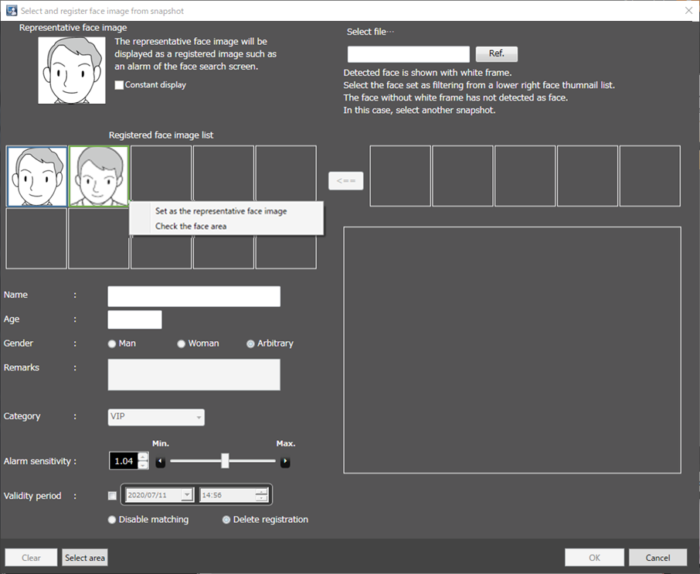

■ Representative face image

When 2 or more face images are registered for a same person, it is possible to set the representative face image.

The representative face image will be set as the face image to be displayed on the registered face image list table.

■ Registered face image list

A list of multiple face images registered for a same person will be displayed.

Up to 10 face images can be registered.

When right-clicking on a registered face image, "Set as the representative face image", "Delete face image" and "Check the face area" will be displayed on the menu. When "Set as the representative face image" is selected, the representative face image will be displayed with a blue frame. When "Delete face image" is selected, the face image will be deleted and the face images following the deleted one will shift to the left to fill the vacant space. When "Check the face area" is selected, the face image evaluation window will be displayed and the face area can be checked on it.

Additionally register a face image using a still image

A face image can be registered using a still image whose format is JPEG, PNG or BMP.

Step 1

Click the [Face management] button on the "Face", "Face Search" or "Face Search" window.

→ The "List of registered faces" window will be displayed.

Step 2

Select a registered face image from the list, and then click the [Change] button.

→ The "Select and register face image from snapshot" window will be displayed.

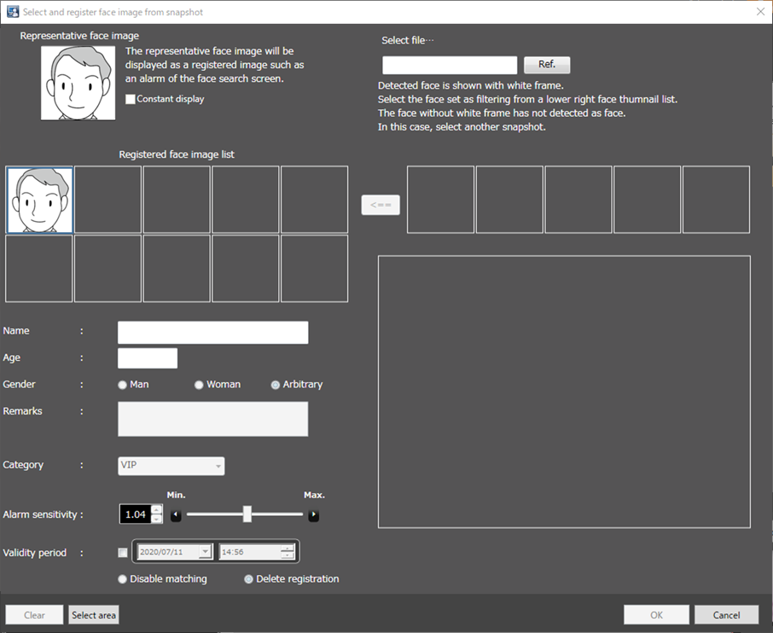

■ Representative face image

When 2 or more face images are registered for a same person, it is possible to set the representative face image.

The representative face image will be set as the face image to be displayed on the registered face image list table.

■ Registered face image list

A list of multiple face images registered for a same person will be displayed.

Up to 10 face images can be registered.

When right-clicking on a registered face image, "Set as the representative face image", "Delete face image" and "Check the face area" will be displayed on the menu. When "Set as the representative face image" is selected, the representative face image will be displayed with a blue frame. When "Delete face image" is selected, the face image will be deleted and the face images following the deleted one will shift to the left to fill the vacant space. When "Check the face area" is selected, the face image evaluation window will be displayed and the face area can be checked on it.

Step 3

Click the [Ref.] button.

Select an image file to be read on the file selection window.

→ The face detection will start using the loaded image, and white frames will be displayed around all the detected faces.

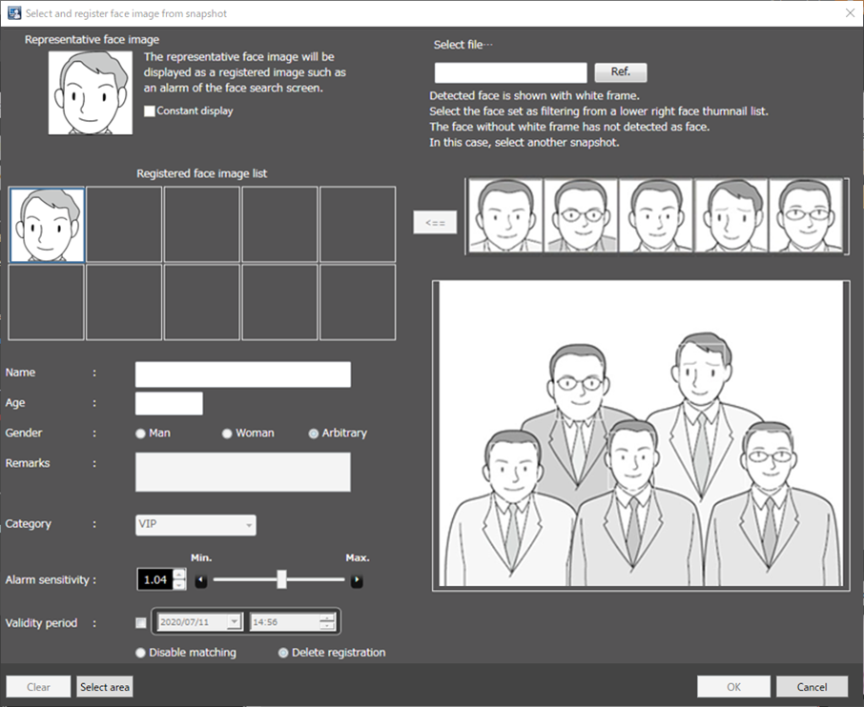

Step 4

Click a face image to be additionally registered from the face image list.

→ A green frame will be displayed on the selected face image.

Step 5

Click the (Add) button to add the selected face image to the registered face image list. The "Face image Evaluation" window will be displayed during this process. Refer to "Newly register this face image" for further information about the face image evaluation window.

-------------------------------------------------------------------------------

The available right-click menu on the added face image are "Set as the representative face image" and "Check the face area".

-------------------------------------------------------------------------------

Step 6

Click the [OK] button.

Video playback control

The video can be played 5 seconds before the face displayed by face matching event search or face detection search is captured.

Step 1
Right-click on the face displayed by face matching event search or face detection search, and then select [Play the video] from the menu.

The playback control window appears and the video will be played automatically from 5 seconds before the selected face was captured.

Note)
If playback is executed immediately after the face is generated, the playback control window will be displayed but the screen will remain gray and playback may not start. In that case, press the Pause button and then press Play button.

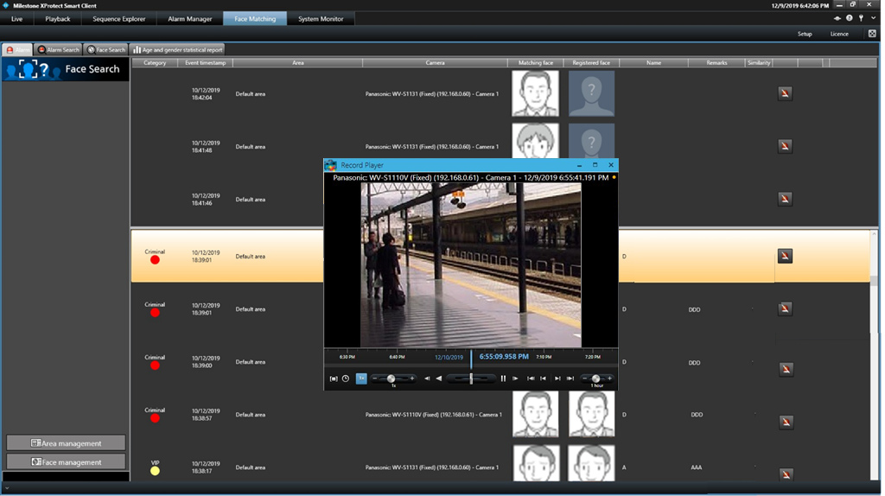

Step 2
Operate the playback control buttons to change the playback speed.
To close the video playback area, click the [X] button.

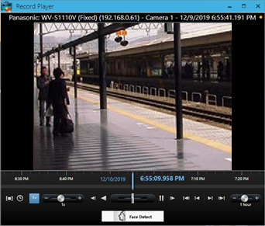

■ Camera title
The camera title is indicated at the upper of the video display window.

■ Date

Indicate the date and time of the video being played.

■ Minimize button (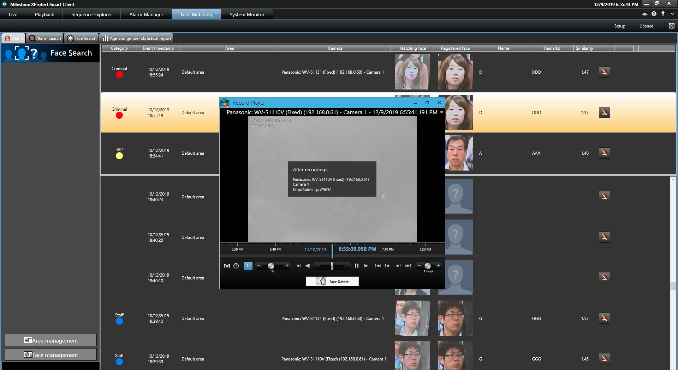)

Minimize the video display area.

■ Maximize button ()

Maximize the video display area.

■ Close button ()

Close the video displays area.

■ Play button ()

Appears when the video is paused. When it is pressed, the video playback will start.

■ Pause button ()

Appears when the video is being played. When it is pressed, the video playback will be paused.

■ Play button ()

When it is pressed, the video playback will be reversed.

■ Step Forward button ()
When it is pressed, 1 frame after the current image will be displayed.

■ Step Back button ()
When it is pressed, 1 frame before the current image will be displayed.

■ Step Forward button ()
When it is pressed, the next recording period playback will start.

■ Step Back button ()
When it is pressed, the previous recording period playback will start.

■ Step Forward button ()
When it is pressed, the latest recording period playback will start.

■ Step Back button ()
When it is pressed, the oldest recording period playback will start.

■ Change playback speed ()
When it is scrolled, the width of recording timeline will be changed in the following order: 1 minute,2minutes, 5minutes, 10minutes, 20minutes, 1hour, 2hour, 4hour, 8hour, 12hour, 16hour, 20hour, 1day, 2days, 4days, 1week, 2weeks, 4weeks

■ Change playback speed ()
When it is scrolled, the video playback speed will be changed in the following order: 0.1x,1/4x,1/2x,1x,2x,4x,8x,16x,32x

■ Playback period designate by selecting time ()
Play the specified date and time of the recorded video.
When it is pressed, the following window will displayed.
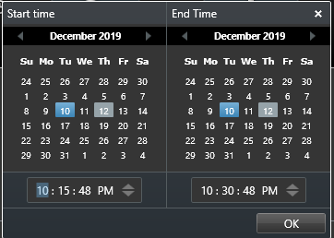
After Select the Start time and End time, pressed [OK] button. The video will be played from start time to end time that you select.

■ Playback period designate by selecting the range of the recording timeline ()
Play the specified date and time of the recorded video by selecting the range of the recording timeline.

Search for designated people

Search by face

Perform the face search by designating the face.

Step 1

Click the [People Search] tab.

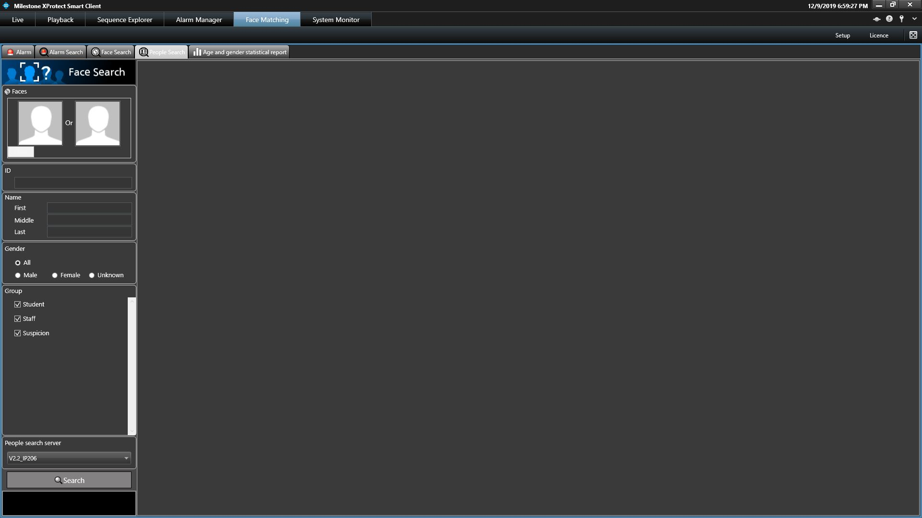

Step 2

Designate a face image.

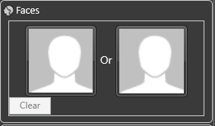

■ Person icon

The face image setting can be configured as follows.

• Display the "Select face image from snapshot" window by left-clicking the person icon, and then select a face image. For details, refer to "How to set up a face image from snapshot".

• Right-click on the person icon, and then select from the following menu.

[Select face image from the snapshot]

[Select from list of registered faces]

• Select a face image from the displayed "List of registered faces".

■ [Clear] button

Clear both the images of filter 1 and filter 2.

Step 3

Click the [Generate Report] button.

The search result will be displayed.

How to set up a face image from snapshot

Left-click on a person icon on the "Faces" of the "People Search" page.

The "Select face image from snapshot" window will be displayed.

■ [Ref.] button

Select an image file to be read on the "Select face image from snapshot" window.

Note:

• The available file formats are JPEG, PNG and BMP.

■ Snapshot display area

When an image file is read out, the face detection process will be carried out and white border frame will be displayed around each face.

The detected faces will be displayed above the image.

■ Image display area for setting the search condition

The selected face image will be displayed.

■ [OK] button

Close the registration window and apply the search condition.

■ [Cancel] button

Click this button to quit the registration window. The search condition will not be updated.

Step 1

Click the [Generate Report] button.

The search result will be displayed.

Note:

The search result will be listed in order of the highest score of similarity.

Up to 100 search results will be displayed.

The search can be filtered by "Name", "Gender", "Group", or "ID".

The filter items "Name", "Gender", "Group", or "ID" may not be displayed depending on the settings of the people search server.

Right-click on the target person and select [Set to Face Search 1] or [Set to Face Search 2] from the right-click menu.

The selected image will be displayed in the section of "Faces" of the search display window.

Search by ID

Perform the face search by designating ID.

Step 1

Click the [People Search] tab on the face search monitor.

Step 2

Enter the ID.

Step 3

Click the [Generate Report] button.

The search result will be displayed.

Note:

• The front part matching is available for search by ID (full number does not need to be entered).

• The "ID" may not be displayed depending on the settings of the people search server.

Search by name

Perform the people search by designating the name.

Step 1

Click the [People Search] tab.

Step 2

Enter the name.

Step 3

Click the [Generate report] button.

The search result will be displayed.

Note:

• The front part matching is available for search by name (full name does not need to be entered).

• There may be multiple fields to enter for the last name and for the first name. Fill the required fields.

• The "Name" may not be displayed depending on the settings of the people search server.

Check the details of people search window

Display the details of people search.

Select and double-click a person you wish to check the details for from the list displayed in the "People Search" page.

The "Details of person" window will be displayed

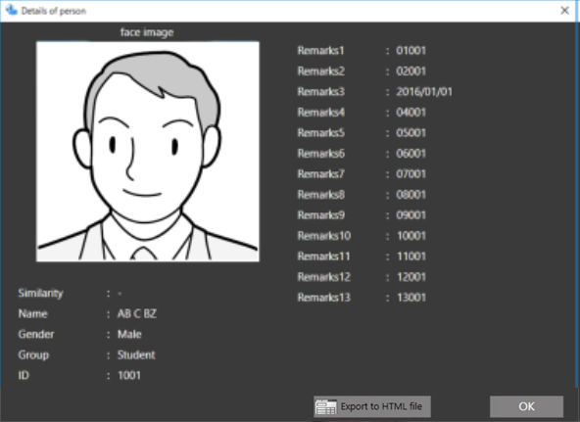

Output search result of the people search

Step 1

Click the [Export to HTML file] button in the "Details of person" window.

The window for specifying the destination folder of the saving file will be displayed.

Step 2

Specify the destination folder of the saving file, name the file, and then click the [Save] button.

The window to show the output progress will be displayed.

A dated folder will be automatically created in the specified folder, and a file will be saved there with the specified name.

Step 3

When the file saving process is complete, confirmation window for displaying the result will be displayed.

Click [Yes] button to open the output HTML file in the browser.

Troubleshooting

Problem | Cause and solution
When launching the plugin, all screens are empty. | Check that PC installed with XProtect Smart Client is registered in WV-ASF950.
[Registration of license] is displayed when face search plugin is activated | Check if the license is registered.  If [Registration of license] is displayed when face search plugin is activated, it indicates that the license has not been registered.
No camera is displayed on [Cameras] on [Alarm Search], [Face Search] or [Age and Gender Statistical Report] screens. | Register the camera registered in WV-ASF950 to XProtect Management Server.
Face notification is not functioning. | Check if XProtect Smart Client is registered for WV-ASF950.

Open source software

Apache

Apache License

Version 2.0, January 2004

http://www.apache.org/licenses/

TERMS AND CONDITIONS FOR USE, REPRODUCTION, AND DISTRIBUTION

1. Definitions.

"License" shall mean the terms and conditions for use, reproduction,

and distribution as defined by Sections 1 through 9 of this document.

"Licensor" shall mean the copyright owner or entity authorized by

the copyright owner that is granting the License.

"Legal Entity" shall mean the union of the acting entity and all

other entities that control, are controlled by, or are under common

control with that entity. For the purposes of this definition,

"control" means (i) the power, direct or indirect, to cause the

direction or management of such entity, whether by contract or

otherwise, or (ii) ownership of fifty percent (50%) or more of the

outstanding shares, or (iii) beneficial ownership of such entity.

"You" (or "Your") shall mean an individual or Legal Entity

exercising permissions granted by this License.

"Source" form shall mean the preferred form for making modifications,

including but not limited to software source code, documentation

source, and configuration files.

"Object" form shall mean any form resulting from mechanical

transformation or translation of a Source form, including but

not limited to compiled object code, generated documentation,

and conversions to other media types.

"Work" shall mean the work of authorship, whether in Source or

Object form, made available under the License, as indicated by a

copyright notice that is included in or attached to the work

(an example is provided in the Appendix below).

"Derivative Works" shall mean any work, whether in Source or Object

form, that is based on (or derived from) the Work and for which the

editorial revisions, annotations, elaborations, or other modifications

represent, as a whole, an original work of authorship. For the purposes

of this License, Derivative Works shall not include works that remain

separable from, or merely link (or bind by name) to the interfaces of,

the Work and Derivative Works thereof.

"Contribution" shall mean any work of authorship, including

the original version of the Work and any modifications or additions

to that Work or Derivative Works thereof, that is intentionally

submitted to Licensor for inclusion in the Work by the copyright owner

or by an individual or Legal Entity authorized to submit on behalf of

the copyright owner. For the purposes of this definition, "submitted"

means any form of electronic, verbal, or written communication sent

to the Licensor or its representatives, including but not limited to

communication on electronic mailing lists, source code control systems,

and issue tracking systems that are managed by, or on behalf of, the

Licensor for the purpose of discussing and improving the Work, but

excluding communication that is conspicuously marked or otherwise

designated in writing by the copyright owner as "Not a Contribution."

"Contributor" shall mean Licensor and any individual or Legal Entity

on behalf of whom a Contribution has been received by Licensor and

subsequently incorporated within the Work.

2. Grant of Copyright License. Subject to the terms and conditions of

this License, each Contributor hereby grants to You a perpetual,

worldwide, non-exclusive, no-charge, royalty-free, irrevocable

copyright license to reproduce, prepare Derivative Works of,

publicly display, publicly perform, sublicense, and distribute the

Work and such Derivative Works in Source or Object form.

` 3. Grant of Patent License. Subject to the terms and conditions of

this License, each Contributor hereby grants to You a perpetual,

worldwide, non-exclusive, no-charge, royalty-free, irrevocable

(except as stated in this section) patent license to make, have made,

use, offer to sell, sell, import, and otherwise transfer the Work,

where such license applies only to those patent claims licensable

by such Contributor that are necessarily infringed by their

Contribution(s) alone or by combination of their Contribution(s)

with the Work to which such Contribution(s) was submitted. If You

institute patent litigation against any entity (including a

cross-claim or counterclaim in a lawsuit) alleging that the Work

or a Contribution incorporated within the Work constitutes direct

or contributory patent infringement, then any patent licenses

granted to You under this License for that Work shall terminate

as of the date such litigation is filed.

4. Redistribution. You may reproduce and distribute copies of the

Work or Derivative Works thereof in any medium, with or without

modifications, and in Source or Object form, provided that You

meet the following conditions:

(a) You must give any other recipients of the Work or

Derivative Works a copy of this License; and

(b) You must cause any modified files to carry prominent notices

stating that You changed the files; and

(c) You must retain, in the Source form of any Derivative Works

that You distribute, all copyright, patent, trademark, and

attribution notices from the Source form of the Work,

excluding those notices that do not pertain to any part of

the Derivative Works; and

(d) If the Work includes a "NOTICE" text file as part of its

distribution, then any Derivative Works that You distribute must

include a readable copy of the attribution notices contained

within such NOTICE file, excluding those notices that do not

pertain to any part of the Derivative Works, in at least one

of the following places: within a NOTICE text file distributed

as part of the Derivative Works; within the Source form or

documentation, if provided along with the Derivative Works; or,

within a display generated by the Derivative Works, if and

wherever such third-party notices normally appear. The contents

of the NOTICE file are for informational purposes only and

do not modify the License. You may add Your own attribution

notices within Derivative Works that You distribute, alongside

or as an addendum to the NOTICE text from the Work, provided

that such additional attribution notices cannot be construed

as modifying the License.

You may add Your own copyright statement to Your modifications and

may provide additional or different license terms and conditions

for use, reproduction, or distribution of Your modifications, or

for any such Derivative Works as a whole, provided Your use,

reproduction, and distribution of the Work otherwise complies with

the conditions stated in this License.

5. Submission of Contributions. Unless You explicitly state otherwise,

any Contribution intentionally submitted for inclusion in the Work

by You to the Licensor shall be under the terms and conditions of

this License, without any additional terms or conditions.

Notwithstanding the above, nothing herein shall supersede or modify

the terms of any separate license agreement you may have executed

with Licensor regarding such Contributions.

6. Trademarks. This License does not grant permission to use the trade

names, trademarks, service marks, or product names of the Licensor,

except as required for reasonable and customary use in describing the

origin of the Work and reproducing the content of the NOTICE file.

7. Disclaimer of Warranty. Unless required by applicable law or

agreed to in writing, Licensor provides the Work (and each

Contributor provides its Contributions) on an "AS IS" BASIS,

WITHOUT WARRANTIES OR CONDITIONS OF ANY KIND, either express or

implied, including, without limitation, any warranties or conditions

of TITLE, NON-INFRINGEMENT, MERCHANTABILITY, or FITNESS FOR A

PARTICULAR PURPOSE. You are solely responsible for determining the

appropriateness of using or redistributing the Work and assume any

risks associated with Your exercise of permissions under this License.

8. Limitation of Liability. In no event and under no legal theory,

whether in tort (including negligence), contract, or otherwise,

unless required by applicable law (such as deliberate and grossly

negligent acts) or agreed to in writing, shall any Contributor be

liable to You for damages, including any direct, indirect, special,

incidental, or consequential damages of any character arising as a

result of this License or out of the use or inability to use the

Work (including but not limited to damages for loss of goodwill,

work stoppage, computer failure or malfunction, or any and all

other commercial damages or losses), even if such Contributor

has been advised of the possibility of such damages.

9. Accepting Warranty or Additional Liability. While redistributing

the Work or Derivative Works thereof, You may choose to offer,

and charge a fee for, acceptance of support, warranty, indemnity,

or other liability obligations and/or rights consistent with this

License. However, in accepting such obligations, You may act only

on Your own behalf and on Your sole responsibility, not on behalf

of any other Contributor, and only if You agree to indemnify,

defend, and hold each Contributor harmless for any liability

incurred by, or claims asserted against, such Contributor by reason

of your accepting any such warranty or additional liability.

END OF TERMS AND CONDITIONS

APPENDIX: How to apply the Apache License to your work.

To apply the Apache License to your work, attach the following

boilerplate notice, with the fields enclosed by brackets "[]"

replaced with your own identifying information. (Don't include

the brackets!) The text should be enclosed in the appropriate

comment syntax for the file format. We also recommend that a

file or class name and description of purpose be included on the

same "printed page" as the copyright notice for easier

identification within third-party archives.

Copyright [yyyy] [name of copyright owner]

Licensed under the Apache License, Version 2.0 (the "License");

you may not use this file except in compliance with the License.

You may obtain a copy of the License at

http://www.apache.org/licenses/LICENSE-2.0

Unless required by applicable law or agreed to in writing, software

distributed under the License is distributed on an "AS IS" BASIS,

WITHOUT WARRANTIES OR CONDITIONS OF ANY KIND, either express or implied.

See the License for the specific language governing permissions and

limitations under the License.

=========================================================================

== Example NOTICE file for use with the Apache License, Version 2.0, ==

== in this case for the Apache httpd-2.0 distribution. ==

=========================================================================

Apache HTTP Server

Copyright 1999-2006 The Apache Software Foundation

This product includes software developed at

The Apache Software Foundation (http://www.apache.org/).

Portions of this software were developed at the National Center

for Supercomputing Applications (NCSA) at the University of

Illinois at Urbana-Champaign.

This software contains code derived from the RSA Data Security

Inc. MD5 Message-Digest Algorithm, including various

modifications by Spyglass Inc., Carnegie Mellon University, and

Bell Communications Research, Inc (Bellcore).

Regular expression support is provided by the PCRE library package,

which is open source software, written by Philip Hazel, and copyright

by the University of Cambridge, England. The original software is

available from

ftp://ftp.csx.cam.ac.uk/pub/software/programming/pcre/

OpenCV

License Agreement

For Open Source Computer Vision Library

(3-clause BSD License)

Copyright (C) 2000-2019, Intel Corporation, all rights reserved.

Copyright (C) 2009-2011, Willow Garage Inc., all rights reserved.

Copyright (C) 2009-2016, NVIDIA Corporation, all rights reserved.

Copyright (C) 2010-2013, Advanced Micro Devices, Inc., all rights reserved.

Copyright (C) 2015-2016, OpenCV Foundation, all rights reserved.

Copyright (C) 2015-2016, Itseez Inc., all rights reserved.

Third party copyrights are property of their respective owners.

Redistribution and use in source and binary forms, with or without modification, are permitted provided that the following conditions are met:

•Redistributions of source code must retain the above copyright notice, this list of conditions and the following disclaimer.

•Redistributions in binary form must reproduce the above copyright notice, this list of conditions and the following disclaimer in the documentation and/or other materials provided with the distribution.

•Neither the names of the copyright holders nor the names of the contributors may be used to endorse or promote products derived from this software without specific prior written permission.

This software is provided by the copyright holders and contributors “as is” and any express or implied warranties, including, but not limited to, the implied warranties of merchantability and fitness for a particular purpose are disclaimed. In no event shall copyright holders or contributors be liable for any direct, indirect, incidental, special, exemplary, or consequential damages (including, but not limited to, procurement of substitute goods or services; loss of use, data, or profits; or business interruption) however caused and on any theory of liability, whether in contract, strict liability, or tort (including negligence or otherwise) arising in any way out of the use of this software, even if advised of the possibility of such damage.

Microsoft Public License (Ms-PL)

This license governs use of the accompanying software. If you use the software, you accept this

license. If you do not accept the license, do not use the software.

1. Definitions

The terms "reproduce," "reproduction," "derivative works," and "distribution" have the same meaning

here as under U.S. copyright law.

A "contribution" is the original software, or any additions or changes to the software.

A "contributor" is any person that distributes its contribution under this license.

"Licensed patents" are a contributor's patent claims that read directly on its contribution.

2. Grant of Rights

(A) Copyright Grant- Subject to the terms of this license, including the license conditions and limitations

in section 3, each contributor grants you a non-exclusive, worldwide, royalty-free copyright

license to reproduce its contribution, prepare derivative works of its contribution, and distribute

its contribution or any derivative works that you create.

(B) Patent Grant- Subject to the terms of this license, including the license conditions and limitations

in section 3, each contributor grants you a non-exclusive, worldwide, royalty-free license

under its licensed patents to make, have made, use, sell, offer for sale, import, and/or otherwise

dispose of its contribution in the software or derivative works of the contribution in the software.

3. Conditions and Limitations

(A) No Trademark License- This license does not grant you rights to use any contributors' name,

logo, or trademarks.

(B) If you bring a patent claim against any contributor over patents that you claim are infringed by

the software, your patent license from such contributor to the software ends automatically.

(C) If you distribute any portion of the software, you must retain all copyright, patent, trademark,

and attribution notices that are present in the software.

(D) If you distribute any portion of the software in source code form, you may do so only under this

license by including a complete copy of this license with your distribution. If you distribute any

portion of the software in compiled or object code form, you may only do so under a license that

complies with this license.

(E) The software is licensed "as-is." You bear the risk of using it. The contributors give no express

warranties, guarantees or conditions. You may have additional consumer rights under your local

laws which this license cannot change. To the extent permitted under your local laws, the contributors

exclude the implied warranties of merchantability, fitness for a particular purpose and

non-infringement.

[Notice1]

THIS PRODUCT IS LICENSED UNDER THE VC-1 PATENT PORTFOLIO LICENSE FOR THE PERSONAL USE OF A CONSUMER OR OTHER USES IN WHICH IT DOES NOT RECEIVE REMUNERATION TO (i) ENCODE VIDEO IN COMPLIANCE WITH THE AVC STANDARD (“VC-1 VIDEO”) AND/OR (ii) DECODE AVC VIDEO THAT WAS ENCODED BY A CONSUMER ENGAGED IN A PERSONAL ACTIVITY AND/OR WAS OBTAINED FROM A VIDEO PROVIDER LICENSED TO PROVIDE AVC VIDEO. NO LICENSE IS GRANTEDOR SHALL BE IMPLIED FOR ANY OTHER USE. ADDITIONAL INFORMATION MAY BE OBTAINED FROM MPEG LA, L.L.C.

SEE HTTP://WWW.MPEGLA.COM

[Notice2]

This product is protected by certain intellectual property rights of Microsoft Corporation and third parties. Use or distribution of such technology outside of this products is prohibited without a license from Microsoft or an authorized Microsoft subsidiary and third parties.

